|  |
| --- |
| ***Quarterly Statistical Release*** |

**March 2019 N° 76**

***This release and other statistical***

***releases are available on Efama’s***

***website (***[***www.efama.org***](http://www.efama.org)***)***

***Trends in the European Investment Fund Industry***

***in the Fourth Quarter of 2018***

***&***

***Results for the Full Year of 2018***

|  |
| --- |
| **This report was prepared by Bernard Delbecque, Thomas Tilley and Hailin Yang**  **EFAMA**  **The European Fund and Asset Management Association**  **Rue Montoyer 47 - B-1000 BRUXELLES - Tel. 32-2-513.39.69 - e-mail: info@efama.org** |

**Highlights**

**2018 was a difficult year for the European asset management industry. The steep fall in world stock markets at the end of the year resulted, for the first time since 2011, in a decrease in the net assets of UCITS and AIFs, from 15,625 billion at end 2017 to EUR 15,157 billion at end 2018. Such a decline in net assets had not occurred since 2011.**

**Investors’ caution over a growth slowdown, trade tensions, political uncertainty, stock-market volatility and reduced monetary policy stimulus led to a drop in net sales of UCITS to EUR 117 billion from EUR 740 billion in 2017. Net sales of AIFs also slowed down to EUR 128 billion from EUR 208 billion in 2017.**

The main developments in 2018 can be summarized as follows:

* **Net sales of UCITS and AIFs totaled EUR 245 billion in 2018 (EUR 948 billion in 2017).**
  + **UCITS net sales amounted to EUR 117 billion (EUR 740 billion in 2017).**
    - Long-term UCITS net sales totaled EUR 128 billion (EUR 671 billion in 2017).
    - Money market funds registered net outflows of EUR 11 billion (compared to net inflows of EUR 68 billion in 2017).
  + **AIFs recorded net sales of EUR 128 billion (EUR 208 billion in 2017).**
    - Sales of long-term AIFs totaled EUR 136 billion (EUR 208 billion in 2017).
    - Money market AIFs registered net outflows of EUR 8 billion (compared to net outflows of EUR 3 billion in 2017).
* **Net assets of UCITS and AIFs decreased by 3% in 2018 to EUR 15,157 billion.**



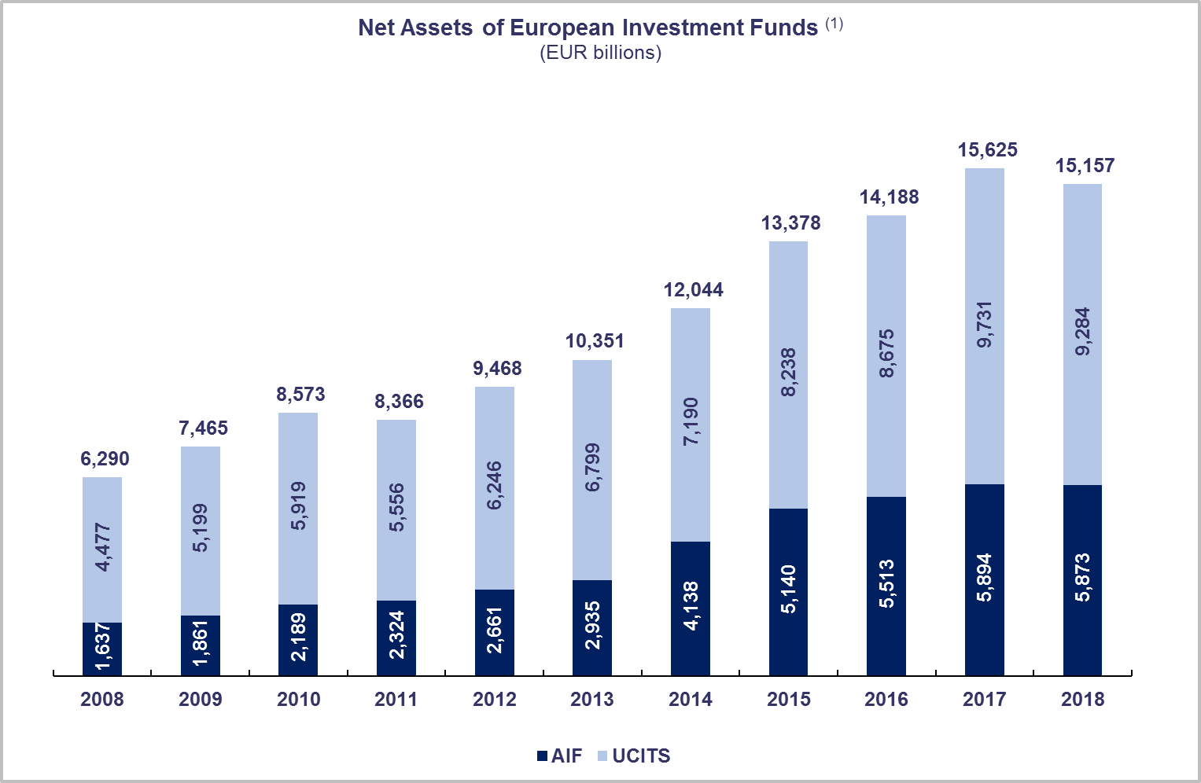

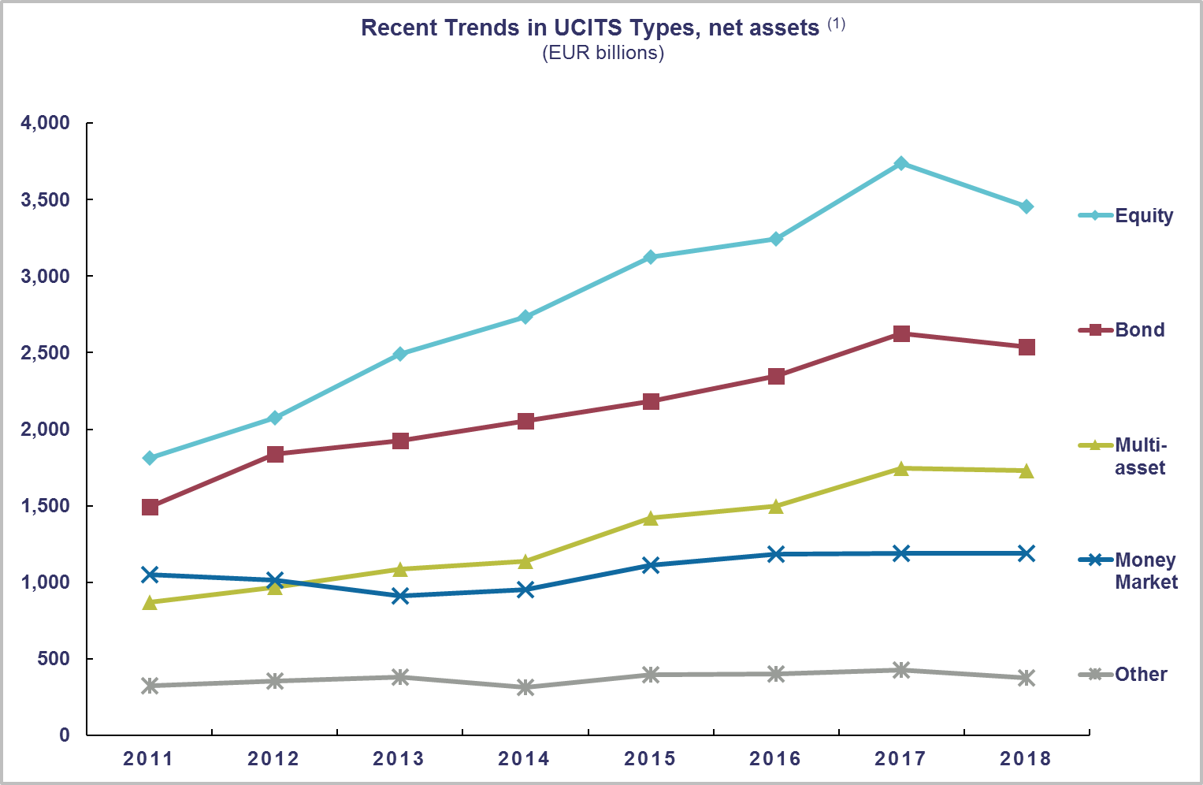

(1) Source: EFAMA database, annual data. Total net asset figures in 2008-2014 include data on funds domiciled in the Netherlands, whereas Dutch-domiciled funds are not included in UCITS/AIFs categories and asset classes due to unavailability of data.

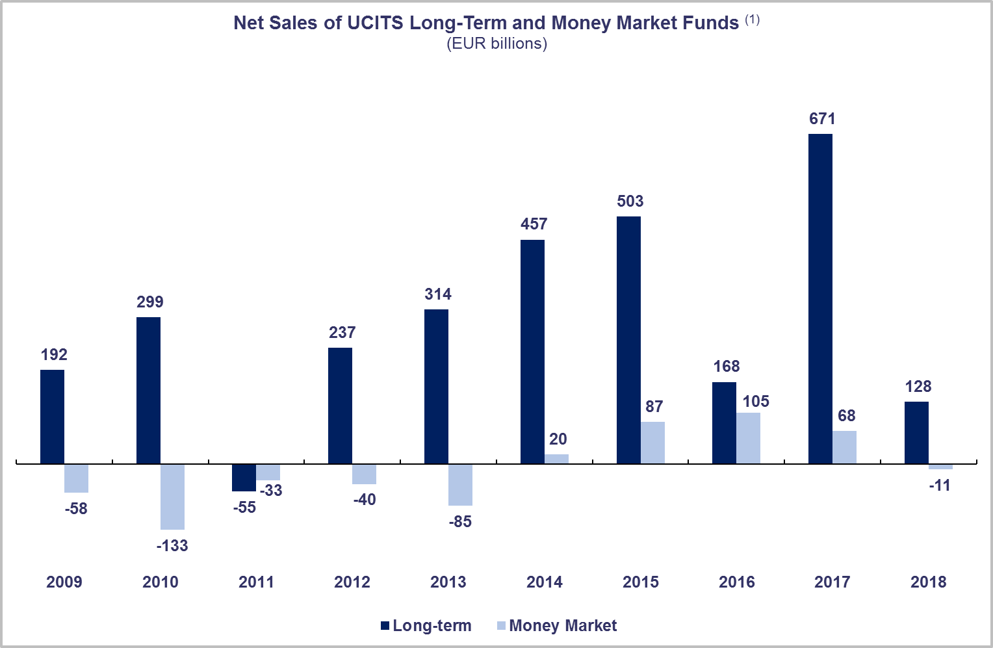

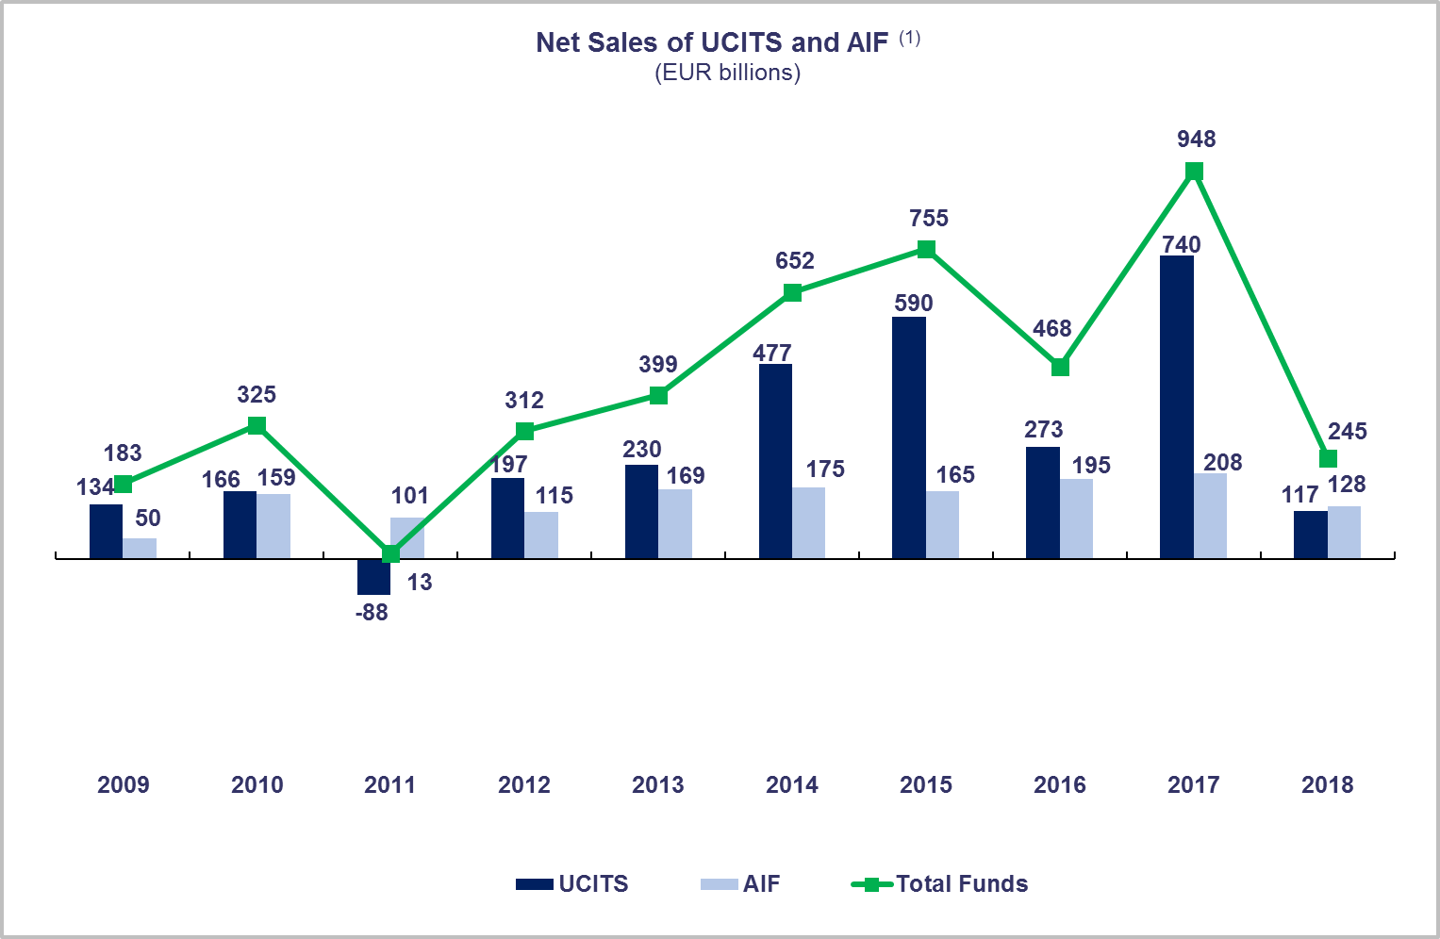

**Top Ten Domiciles in 2018**

(1) Source: EFAMA database, aggregated quarterly data for 2017 and 2018, annual data for 2009-2016.

Data for 2018 excludes data on Belgian net sales due to unavailability.

***Largest Domiciles in terms of Net Assets and Net Sales***

*Funds domiciled in Switzerland that fulfill the UCITS criteria are classified as UCITS.

**UCITS FUNDS**

**Net Assets at End 2018**

**(EUR billion)**

**ALTERNATIVE INVESTMENT FUNDS**

**Net Sales in 2018**

**(EUR billion)**

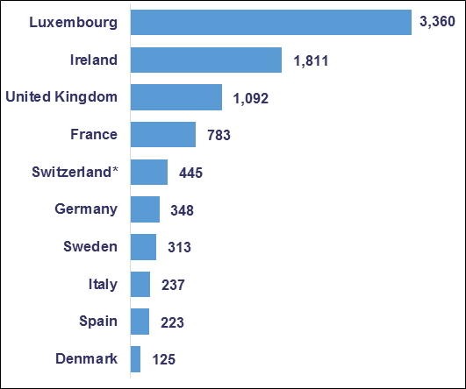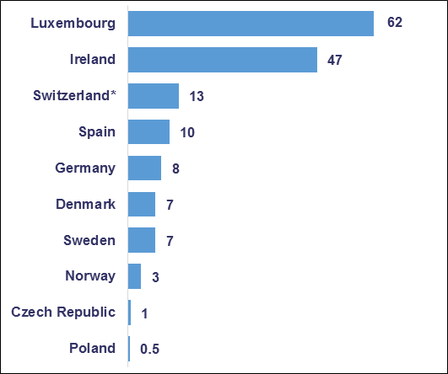

**Net Sales in 2018**

**(EUR billion)**

**Net Assets at End 2018**

**(EUR billion)**

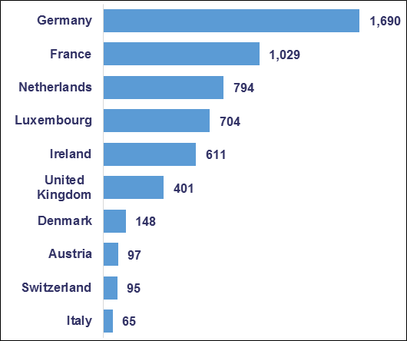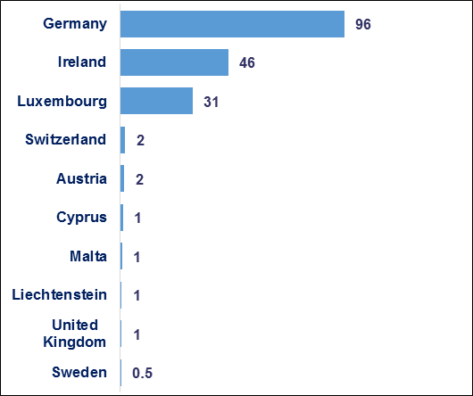

**Trends in the UCITS Market**

***Net Sales by Investment Type***

**UCITS recorded net outflows of EUR 71 billion in Q4 2018, compared to net inflows of EUR 2 billion in Q3 2018. In 2018, UCITS attracted net sales of EUR 117 billion, compared to annual net sales of EUR 740 billion in 2017.**

Long-term UCITS registered net outflows of EUR 93 billion in Q4 2018, compared to net inflows of EUR 16 billion in Q3 2018. Equity funds recorded net outflows of EUR 6 billion, compared to net inflows of EUR 20 billion in Q3 2018. Multi-asset funds registered net outflows of EUR 17 billion, compared to net inflows of EUR 11 billion in Q3 2018. Bond funds recorded net outflows of EUR 46 billion in Q4 2018, compared to EUR 6 billion in Q3 2018. Money market funds recorded positive inflows of EUR 23 billion in Q4 2018, the first positive quarterly inflows since Q3 2017.

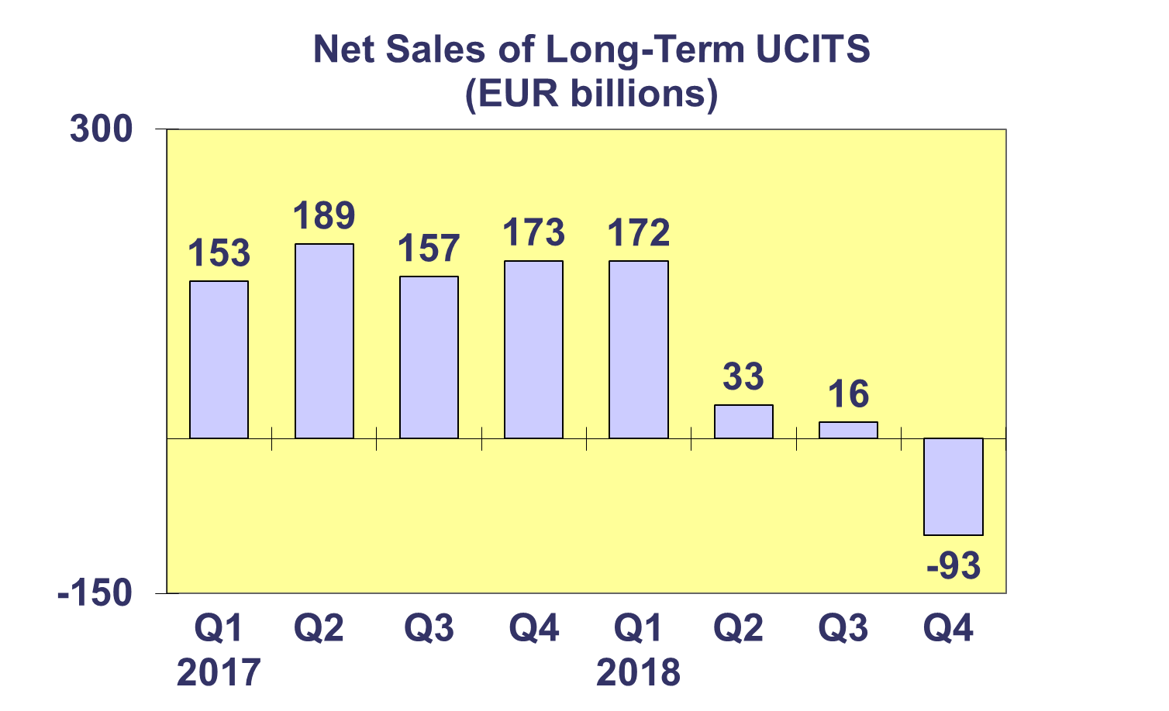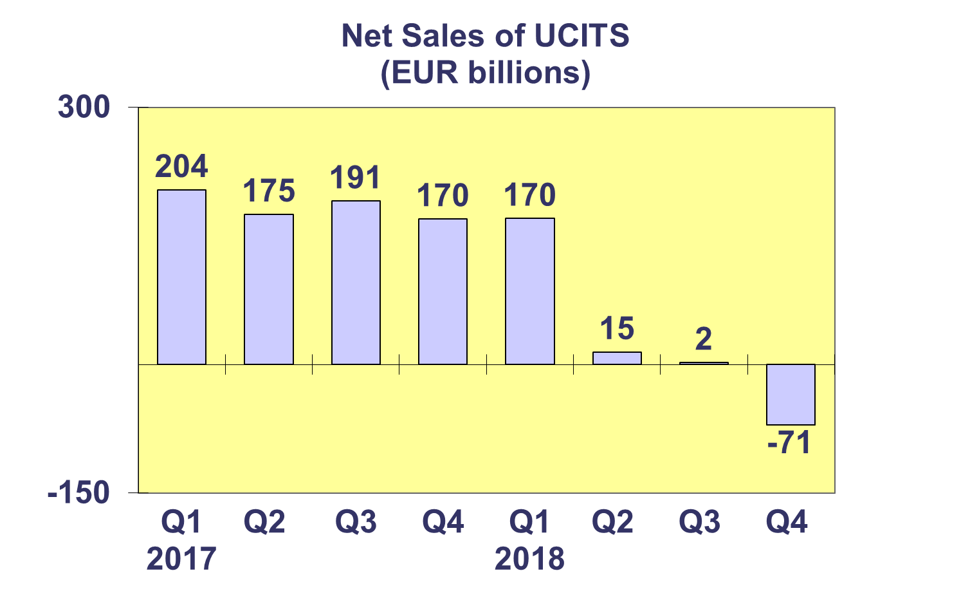

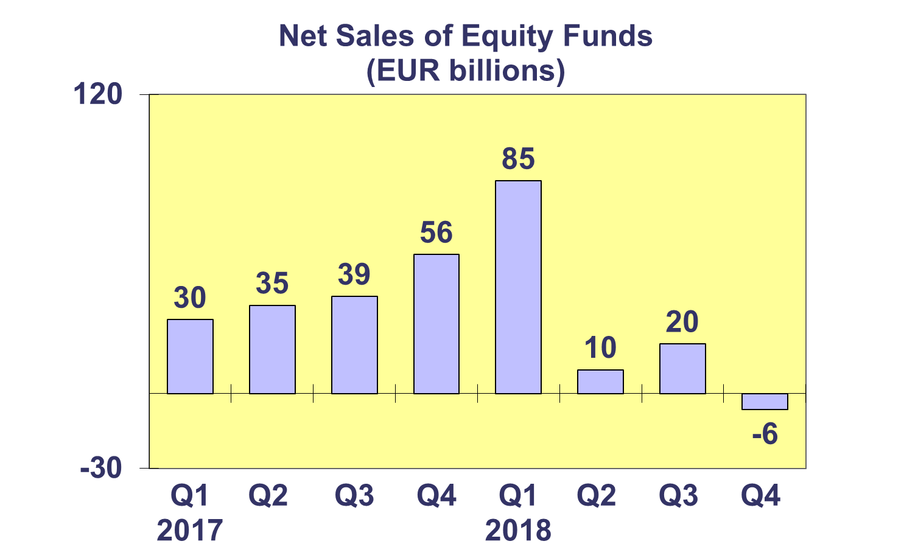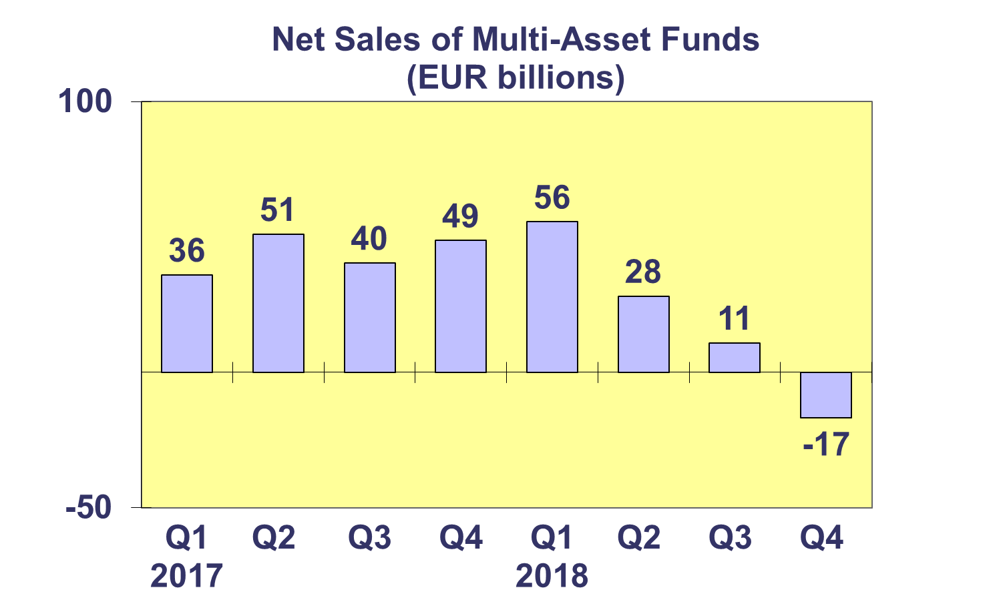

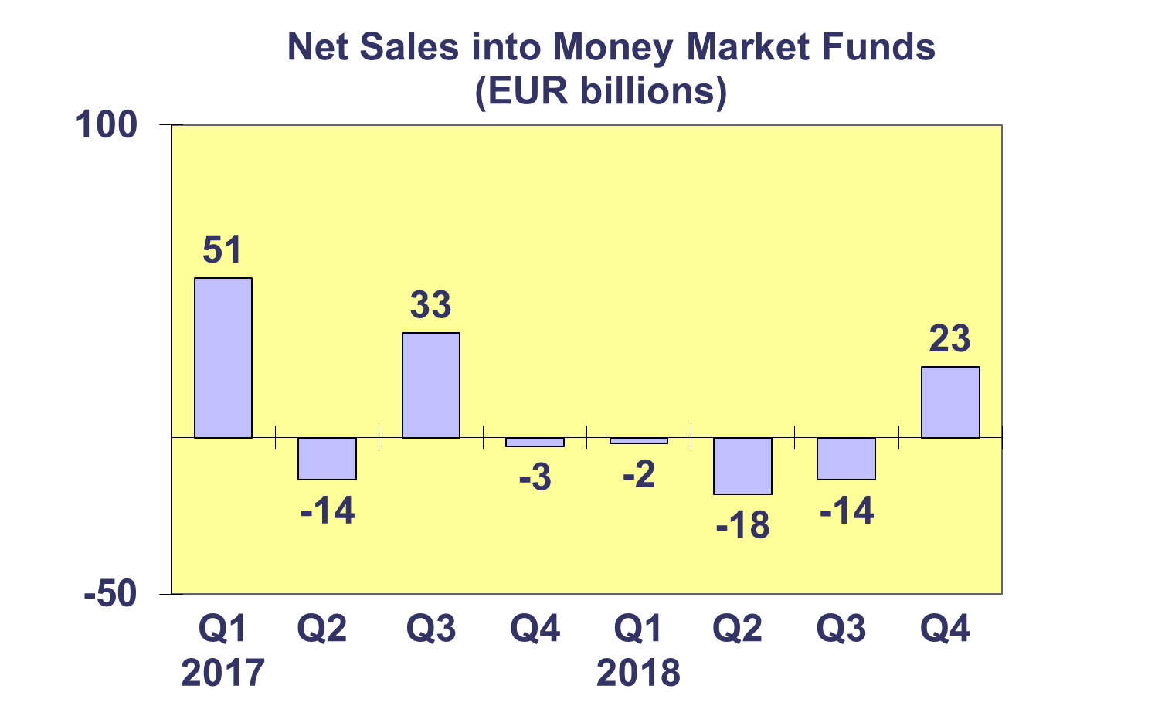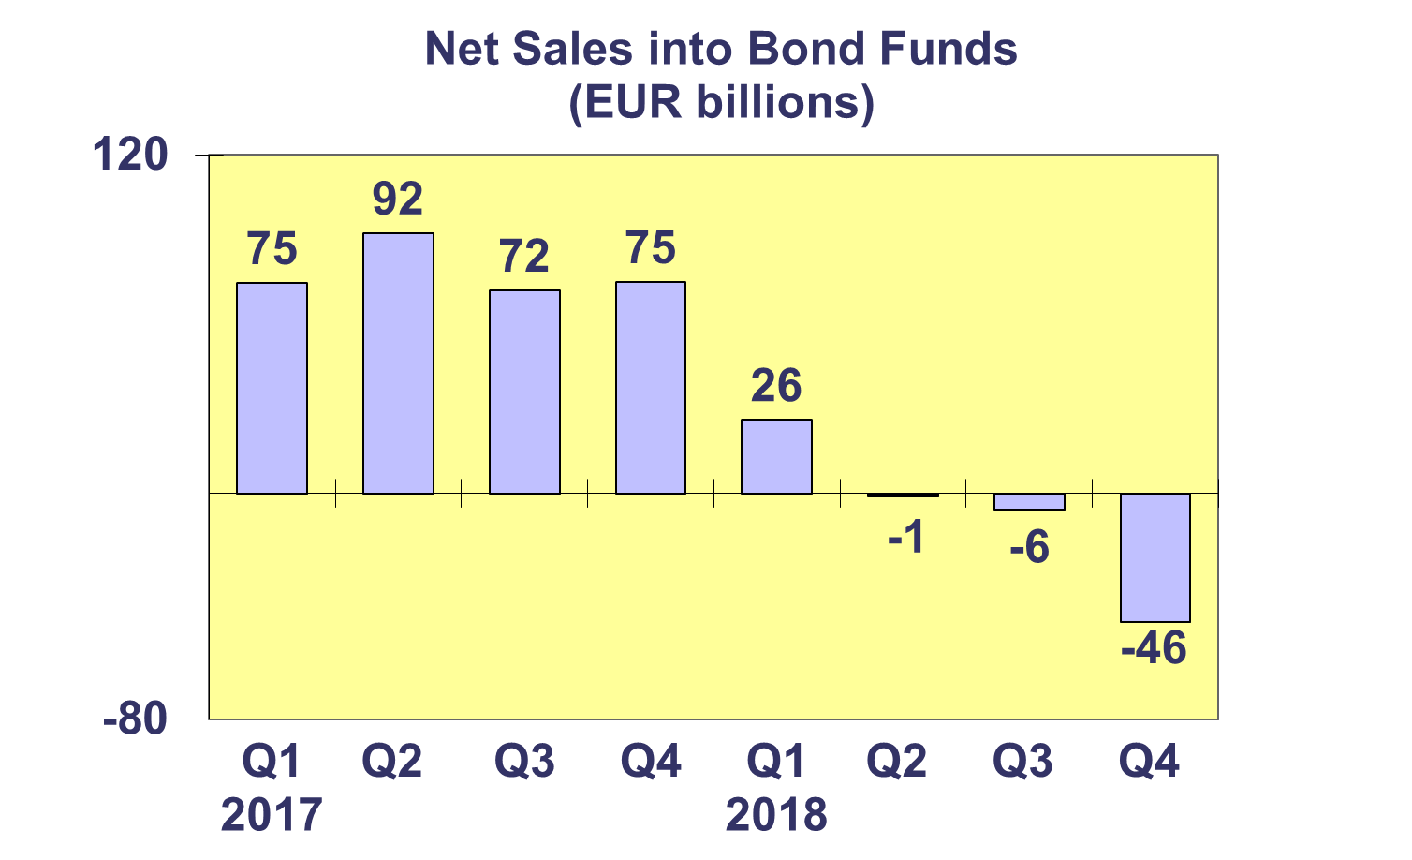

**Trends in the UCITS Market**

***Net Sales by Country of Domiciliation and Investment Type***

**Ten countries registered net inflows into UCITS in Q4 2018, with two countries recording net sales above EUR 1 billion.**

In Q4 2018, the five domiciles with the largest net sales were Switzerland (EUR 2.2 billion), followed by Sweden (EUR 2.1 billion), Denmark (EUR 0.8 billion), Germany (EUR 0.5 billion) and Liechtenstein (EUR 0.2 billion).

In 2018, four domiciles attracted net sales larger than EUR 10 billion: Luxembourg (EUR 61.6 billion), Ireland (EUR 47.4 billion), Switzerland (EUR 12.7 billion) and Spain (EUR 10.3 billion).

**Trends in the UCITS Market**

***Net Sales and Net Assets of ETF by Country of Domiciliation***

**Net sales of UCITS ETF amounted to EUR 2.8 billion in Q4 2018, down from EUR 11.9 billion in Q3 2018. UCITS ETF attracted net sales of EUR 18.1 billion in 2018.**

UCITS ETF domiciled in Ireland registered the largest net sales during the quarter (EUR 5.8 billion), whereas France recorded the largest net outflow (EUR 5.4 billion).

Looking at total net sales in 2018, Ireland and Luxembourg attracted the largest net inflows, EUR 31.2 billion and EUR 30.3 billion, respectively. France experienced net outflows amounting to EUR 43 billion.



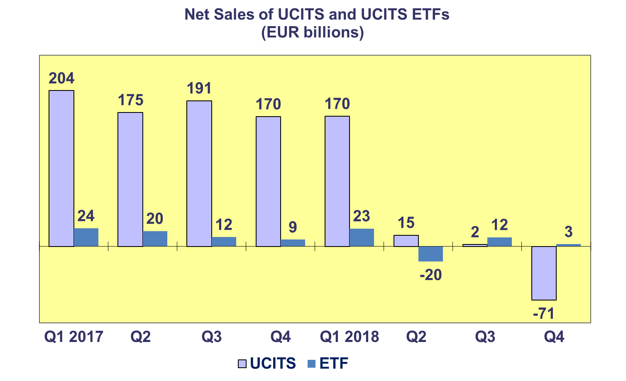

**Trends in the UCITS Market**

***Net Assets and Number of Funds by Investment Type***

**Net assets of UCITS by 6.9% in Q4 2018 to EUR 9,284 billion. UCITS net assets decreased by 4.6 percent in 2018.**

Of the major fund categories, only money market funds recorded an increase in net assets in Q4 2018 (1.9%). The other types of funds registered decreases in net assets. Equity funds recorded the largest decrease in net assets (11.9%), followed by guaranteed/protected funds (11.5%), other UCITS funds (10.1%), multi-asset funds (6.5%) and bond funds (3.1%).

In 2018, almost all fund categories, experienced a decrease in net assets. The largest drop was registered for guaranteed/protected funds (36.9%), followed by other UCITS funds (11.6%), equity (7.6%), bond (3.4%) and multi-asset funds (1.1%). Money market funds was the only major fund category for which net assets edged up slightly (0.002%). Net assets of ETFs increased by 1.7% in 2018.

The number of UCITS funds increased from 32,026 at end Q4 2017 to 33,359 at end Q4 2018.



**Trends in the UCITS Market**

***Net Assets by Country of Domiciliation***

**Net assets of UCITS decreased in almost all European countries in Q4 2018.**

Three countries did record positive asset growth in Q4 2018. Turkey recorded the largest growth (11.4%), followed by Bulgaria (1.8%) and Portugal (0.7%).

Among the large UCITS domiciles, the UK recorded the largest net asset decrease in Q4 2018 (11.6%), followed by France (8.5%), Luxembourg (6.0%), and Ireland (5.1%). In Western Europe, large decreases were recorded in Germany (9%) and the Netherlands (8.6%). The Nordic countries all experienced a net asset decrease during the quarter. Apart from Portugal, all domiciles in the Southern European region also recorded a drop in net assets.

In 2018, 5 countries registered an increase in net UCITS assets: Cyprus (18.6%), Bulgaria (10.4%), Croatia (3.7%), Belgium (3.6%) and Sweden (0.1%). The UK recorded the largest net asset decrease amongst the major UCITS domiciles in 2018 (10.9%), followed by France (10.3%) and Luxembourg (3.6%).



**Trends in the AIF Market**

***Net Sales by Investment Type***

**AIFs recorded net sales of EUR 23 billion in Q4 2018. Over the course of 2018, AIFs attracted net sales of EUR 128 billion.**

Long-term AIFs recorded net sales of EUR 27 billion in Q4 2018, down from EUR 38 billion in Q3 2018. Equity funds registered net inflows of EUR 4 billion in Q4 2018, compared to net outflows of EUR 3 billion in Q3 2018. In the fourth quarter of 2018, multi-asset funds recorded the same level of net sales as in Q3 2018 (EUR 10 billion). Bond funds continued to suffer from net outflows, EUR 1 billion compared to EUR 4 billon in Q3 2018. Net sales of other funds decreased from EUR 30 billion in Q3 2018 to EUR 8 billion in Q4 2018.

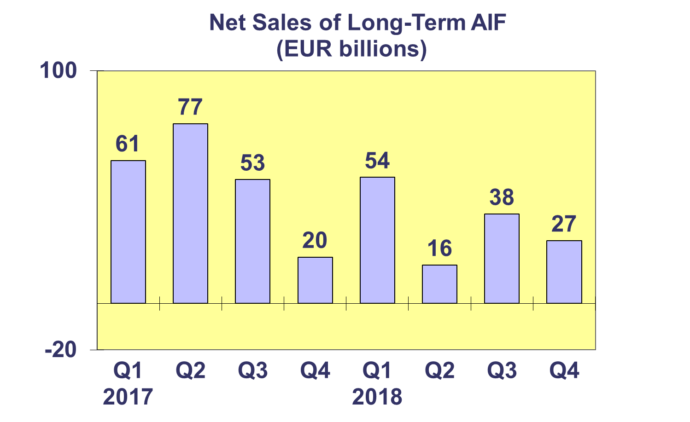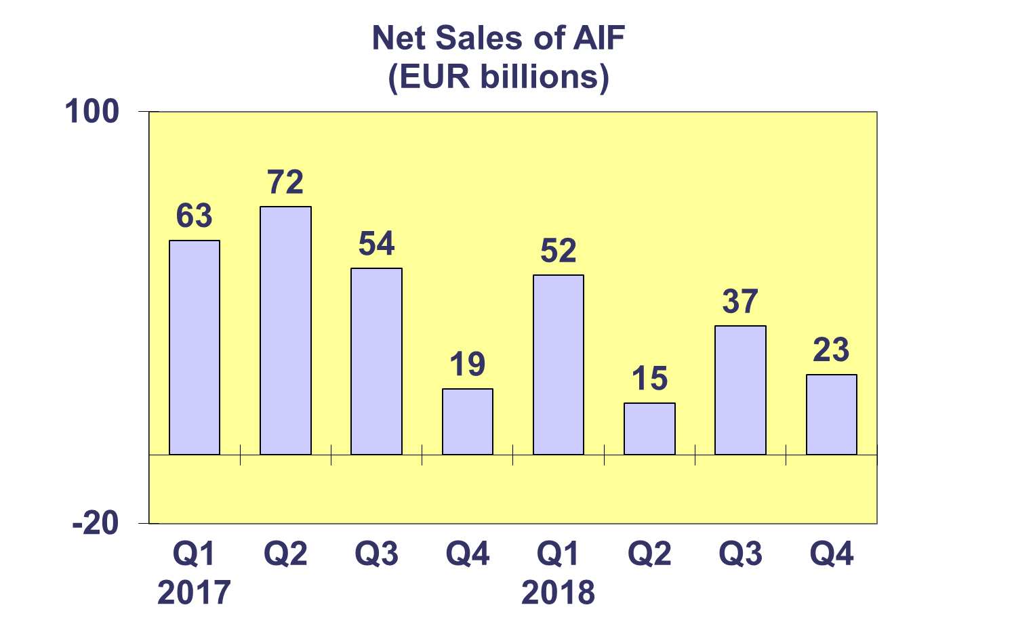

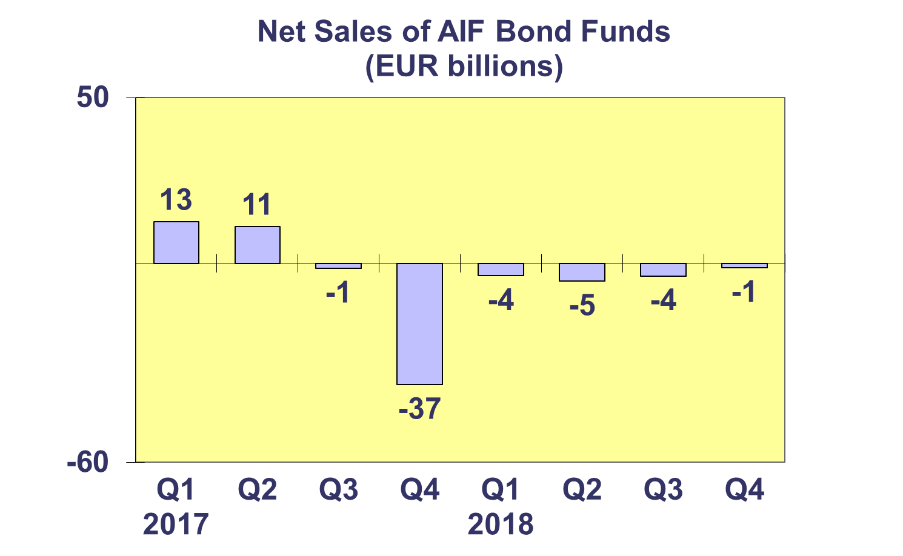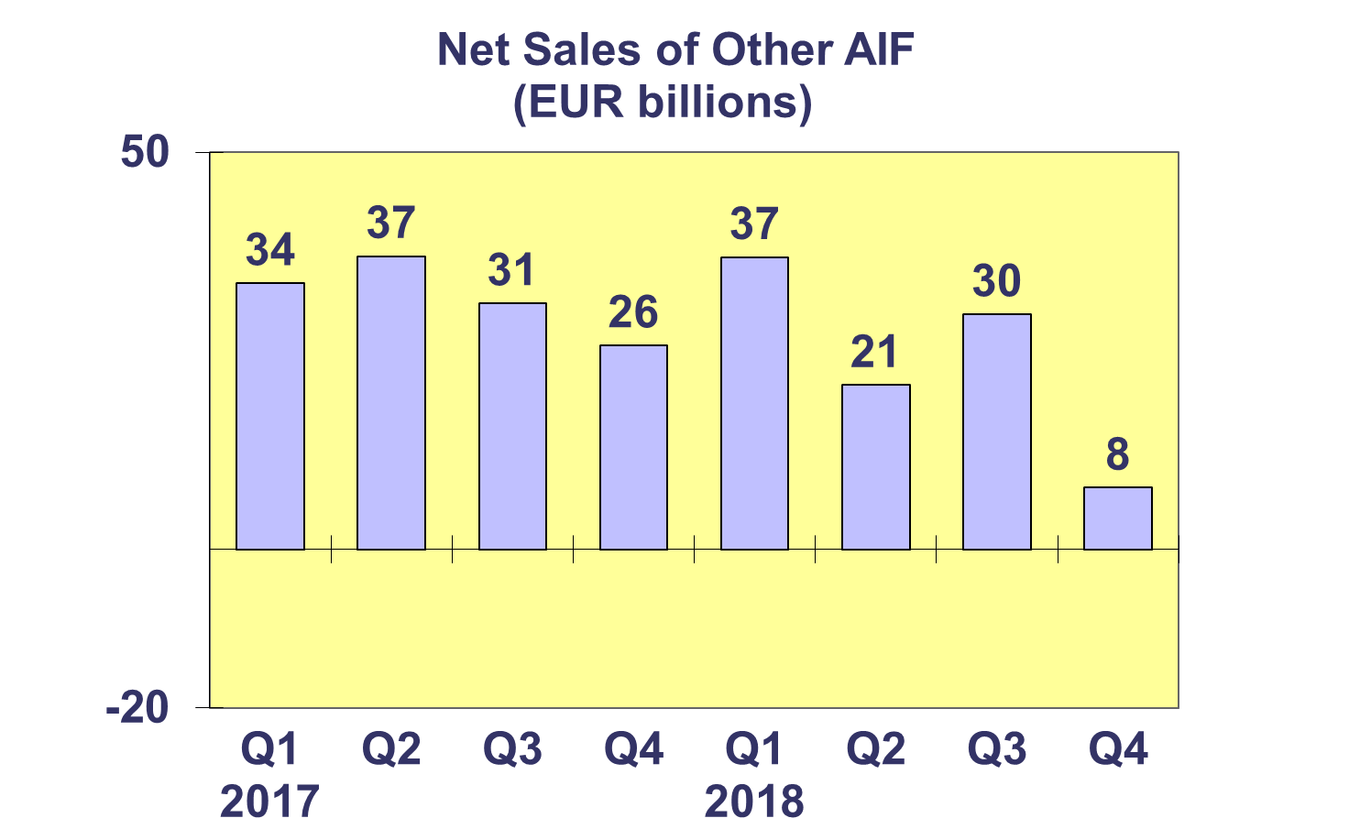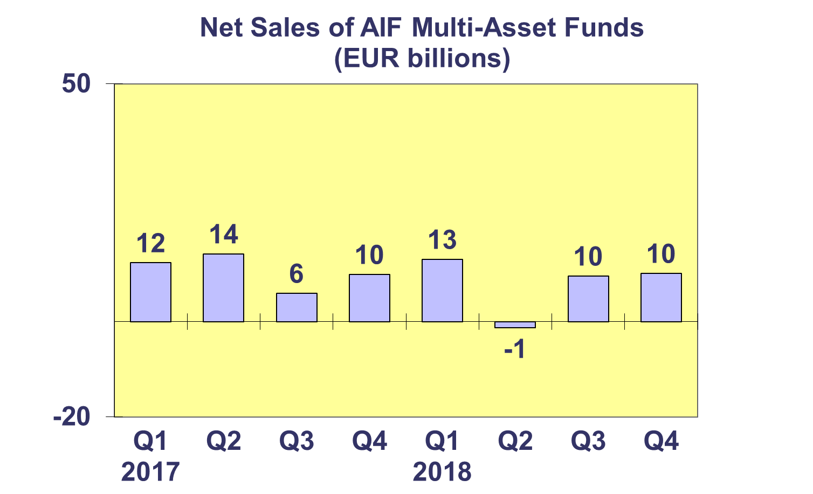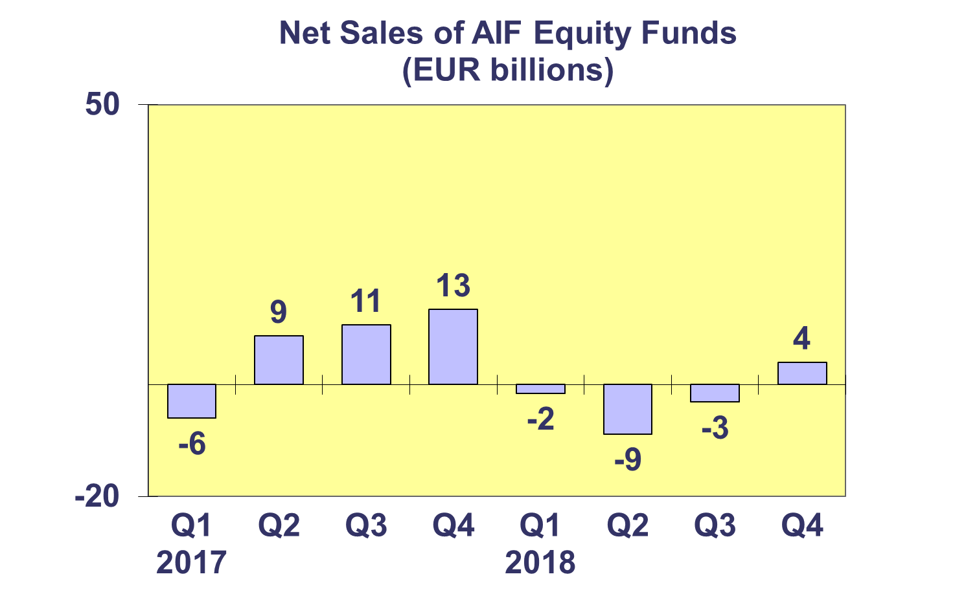**Trends in the AIF Market**

***Net Sales by Country of Domiciliation and Investment Type***

**Fourteen domiciles experienced net inflows into AIFs in Q4 2018, with four countries recording net sales higher than EUR 1 billion.**

In Q4 2018, net sales above EUR 1 billion were registered in Germany (EUR 32.3 billion), Luxembourg (EUR 4.2 billion), France (1.6 billion) and the United Kingdom (EUR 1 billion).

In 2018, three countries attracted net sales greater than EUR 10 billion: Germany (EUR 95.6 billion), Ireland (EUR 46.3 billion) and Luxembourg (EUR 30.8 billion).

The largest net outflows in 2018 were registered in the Netherlands (EUR 18.3 billion) and Denmark (EUR 18.1 billion), followed by France (EUR 13 billion).



**Trends in the AIF Market**

***Net Assets and Number of Funds by Investment Type***

**Net assets of AIFs declined by3.1% in Q4 2018, a drop of 3.1% compared to the previous quarter. Net assets of AIFs decreased by 0.4% in 2018.**

Two fund categories recorded a net asset growth in Q4 2018: real estate funds (2%) and guaranteed/protected funds (1%). Decreases in net assets were recorded for equity funds (10%), money market funds (4.5%), multi-asset funds (3.7%), other funds (3%) and bond funds (0.6%).

In 2018, real estate funds registered the largest increase in net assets (10.1%), followed by other funds (3.8%). Money market funds saw the largest net asset decrease (9.3%), followed by equity funds (7.6%), guaranteed/protected funds (7.4%) multi-asset funds (3.9%) and bond funds (3.3%).

The number of Alternative Investment Funds increased from 28,353 at end Q4 2017 to 28,635 at end Q4 2018.



**Trends in the AIF Market**

***Net Sales and Assets of Institutional AIFs***

**Net assets of institutional AIFs, which are AIFs reserved for institutional investors, decreased by 1.5% to EUR 2,959 billion at end Q4 2018.**

In Q4 2018, institutional funds recorded an increase in real estate funds (3%), other funds and money market funds increased by 0.8% and 0.4%, respectively. Equity, multi-asset and bond funds experienced a decrease in net assets (6.5%, 2.7% and 0.3% respectively).

In 2018, the largest increase in net assets was recorded for real estate funds (16.1%), followed by other funds (11.5%). Decreases were registered for equity funds (7%), followed by money market funds (4.5%), bond funds (1.5%) and multi-asset fund (0.6%).

Institutional AIFs attracted net sales of EUR 31.1 billion in Q4 2018. For the year as a whole, total net sales reached EUR 149.6 billion.



\**Trends in the AIF Market**

***Net Assets by Country of Domiciliation***

**Net assets of AIFs declined in the vast majority of countries in Q4 2018, as well as over the course of the whole year 2018.**

In Q4 2018, only three countries recorded an increase in net assets compared to the previous quarter: Turkey (18.7%), the Czech Republic (9.1%) and Slovakia (3.2%). The five largest domiciles all recorded net asset decreases, with a significant decrease of 6.9% in the UK, followed by France (2.9%), Ireland (2.7%), Germany (1.4%) and Luxembourg (0.2%). Elsewhere in Europe, net assets decreased strongly in Sweden (10.8%) and Poland (9.6%).

Eight countries recorded positive asset growth in 2018. Among the largest AIF domiciles, the largest net asset growth was seen in Ireland (8%), followed by Luxembourg (4.6%) and Germany (1.4%). Elsewhere in Europe, strong asset growth was registered in Cyprus (48.3%), the Czech Republic (31.7%) and Malta (11.4%).



**Trends in the European Investment Fund Industry**

***Net Sales by Investment Type***

**UCITS and AIFs, recorded net outflows of EUR 47 billion during Q4 2018, compared to net inflows of EUR 40 billion in Q3 2018. Over the course of 2018, these funds attracted net sales of EUR 245 billion, compared to EUR 948 billion in 2017.**

In Q4 2018, equity funds recorded net outflows of EUR 3 billion, compared to net inflows of EUR 17 billion in the previous quarter. Bond funds suffered from large net outflows (EUR 47 billion, compared to EUR 10 billion in Q3 2018). Multi-asset funds experienced net outflows of EUR 7 billion, compared to net inflows of EUR 21 billion in Q3 2018. Money market funds attracted net inflows of EUR 19 billion, compared to net outflows of EUR 14 billion in Q3 2018. Other funds (including real estate, guaranteed/protected funds and other funds which do not fit any of the categories below or for which information is not available) registered outflows of EUR 10 billion, compared to net inflows of EUR 27 billion in Q3 2018.

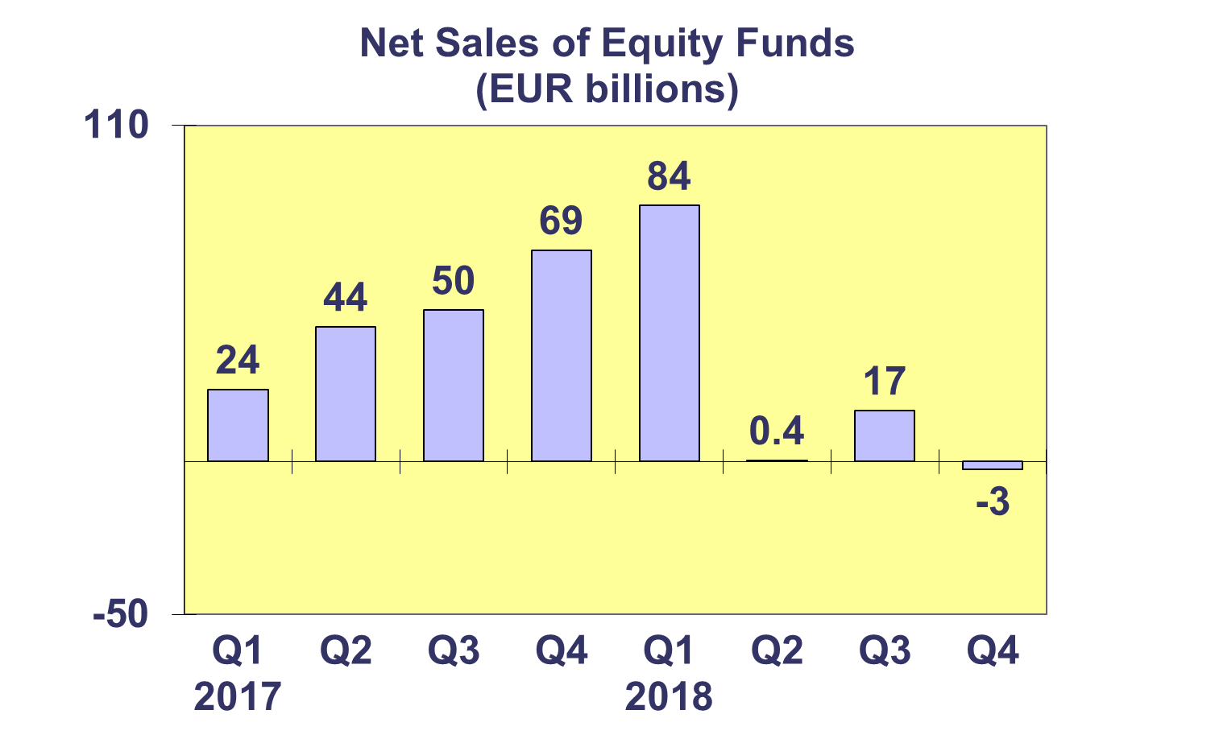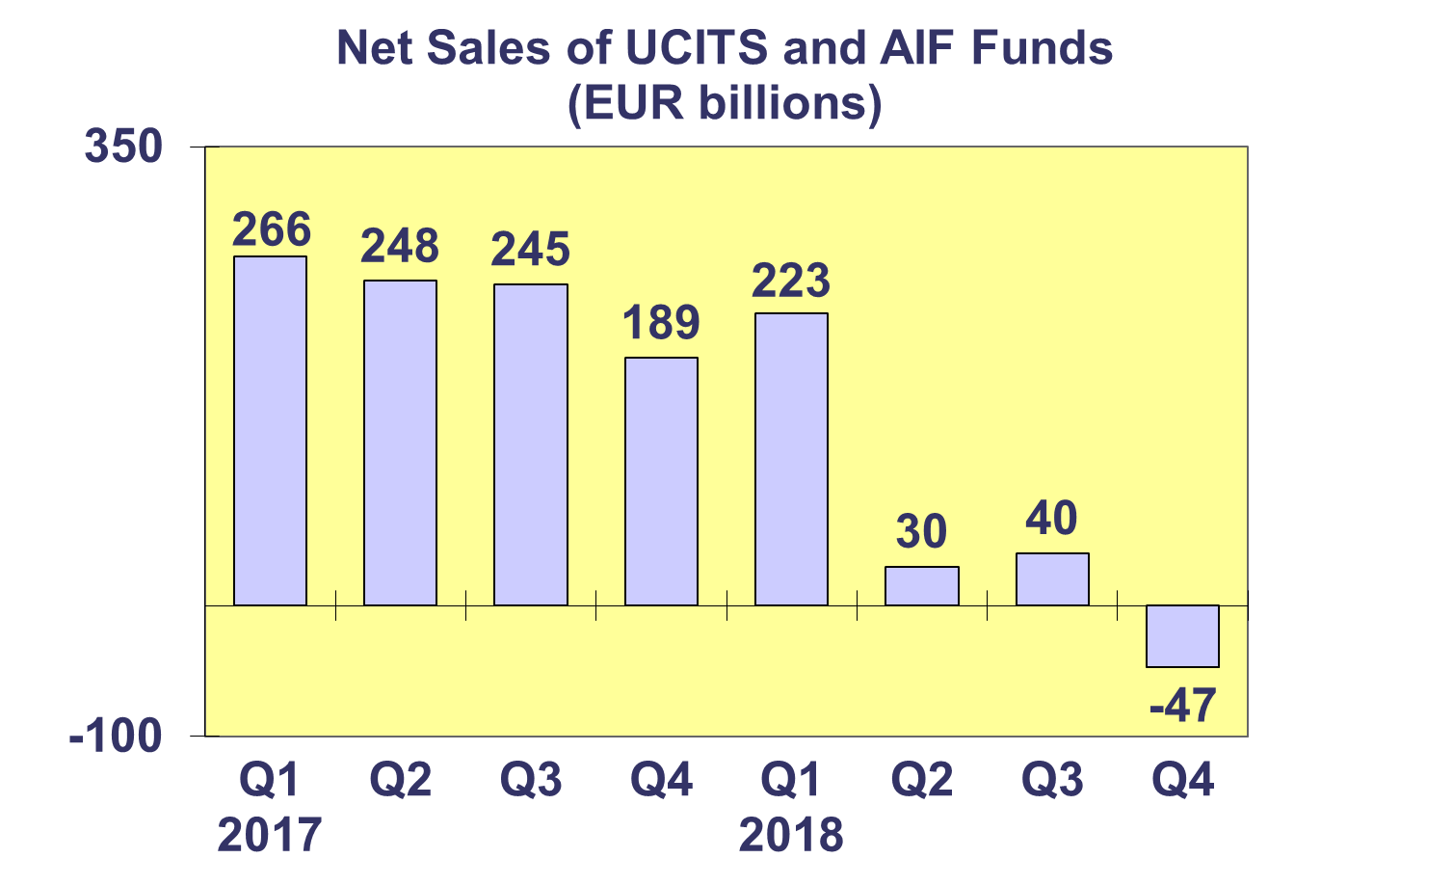

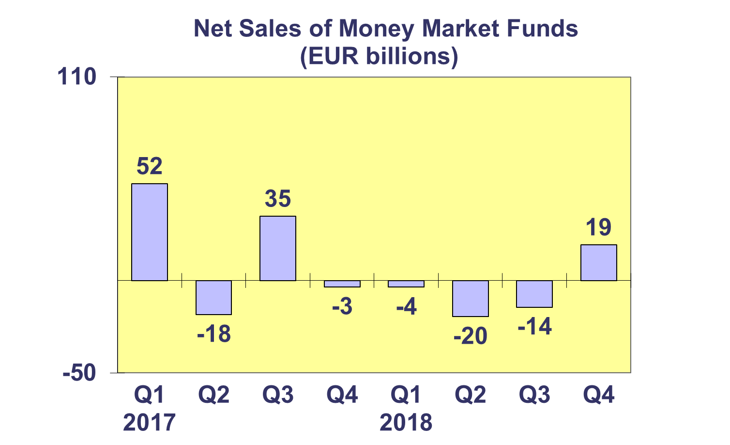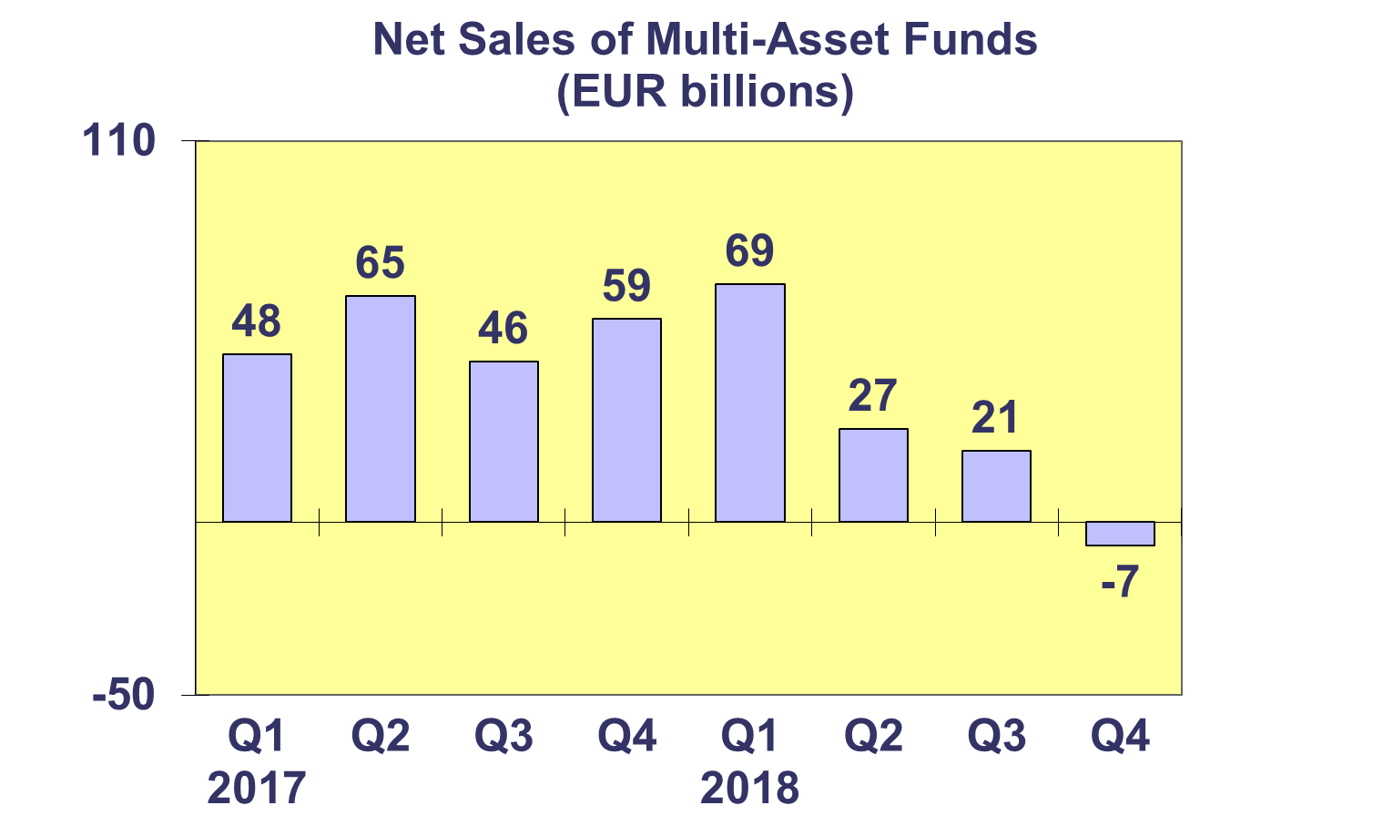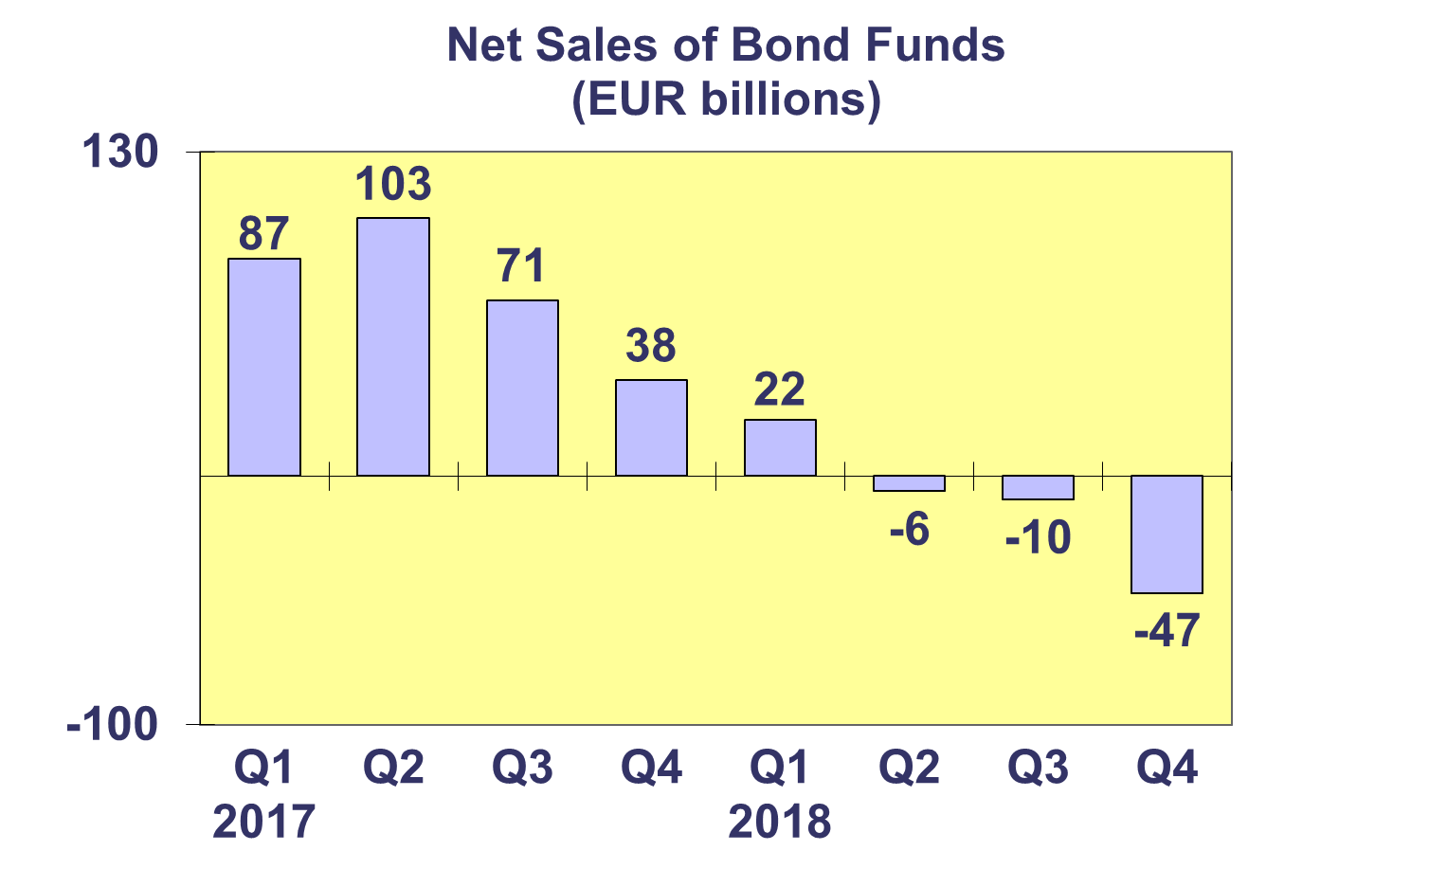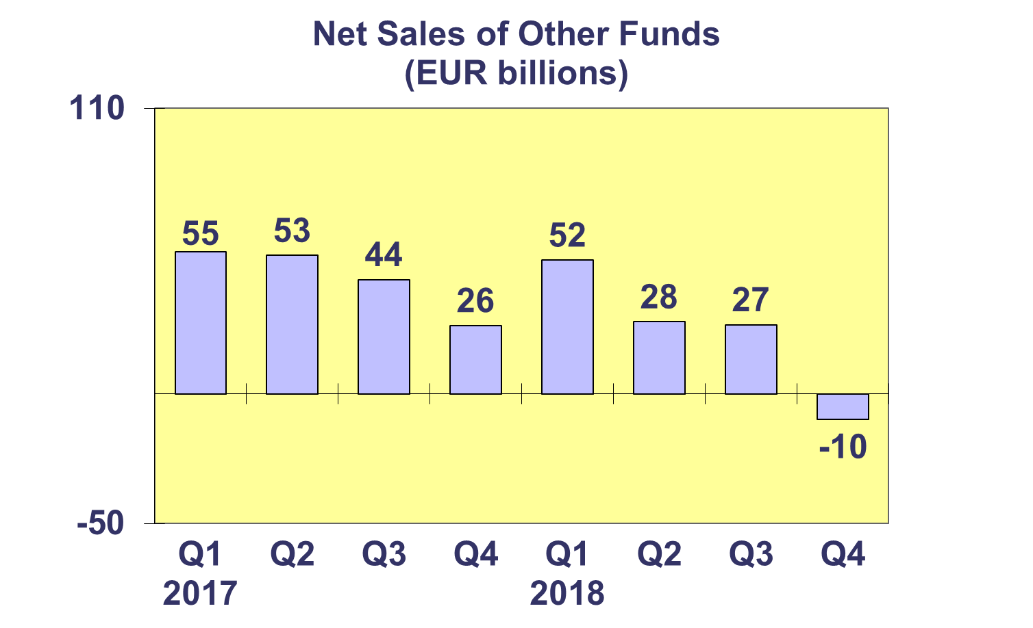

**Trends in the European Investment Fund Industry**

***Net Assets by Country of Domiciliation***

**Total net assets of UCITS and AIFs decreased by 5.5% in Q4 2018 and by 3% in 2018.**

With EUR 9,284 billion invested in UCITS, this segment accounted for 61.3% of total European investment fund assets at end Q4 2018. The remaining 38.7% of the total (equivalent to EUR 5,873 billion) came from AIFs.

 **Trends in the European Investment Fund Industry**

***Number of Funds by Country of Domiciliation***

**The total number of UCITS and AIFs increased 0.8% in Q4 2018 to end the year at 61,994 funds.**

At the end of 2018, UCITS accounted for 33,359 funds or 53.8% of the number of funds in the European market. AIFs accounted for 28,635 funds, or 46.2% of the total number of European funds.

