|  |
| --- |
| ***Quarterly Statistical Release*** |

**March 2018 N° 72**

***This release and other statistical***

***releases are available on Efama’s***

***website (***[***www.efama.org***](http://www.efama.org)***)***

***Trends in the European Investment Fund Industry***

***in the Fourth Quarter of 2017***

***&***

***Results for the Full Year of 2017***

|  |
| --- |
| **This report was prepared by Alex Carroll, Thomas Tilley and Bernard Delbecque**  **EFAMA**  **The European Fund and Asset Management Association**  **Rue Montoyer 47 - B-1000 BRUXELLES - Tel. 32-2-513.39.69 Fax: 32-2-513.26.43 - e-mail: info@efama.org** |

**Highlights**

**2017 was an exceptional year for the European investment fund industry, with net assets of UCITS and AIF surpassing the EUR 15 trillion mark. Net sales of UCITS and AIF reached their highest level yet (EUR 949 billion), breaking the prior record set in 2015 (EUR 756 billion).**

The main developments in 2017 can be summarized as follows:

* **Net sales of UCITS and AIF reached EUR 949 billion in 2017 (EUR 461 billion in 2016).**
* **UCITS net sales amounted to EUR 738 billion (EUR 270 billion in 2016).**
* **Long-term UCITS net sales totaled EUR 670 billion (EUR 159 billion in 2016).**
  + Equity funds enjoyed net inflows of EUR 159 billion (compared to net outflows of EUR 9 billion in 2016).
  + Bond funds registered net sales of EUR 316 billion (EUR 110 billion in 2016).
  + Multi-assets funds registered net sales of EUR 190 billion (EUR 49 billion in 2016).
  + Other UCITS funds registered net sales of EUR 5 billion (EUR 9 billion in 2016).
* **Money market funds registered net sales of EUR 68 billion (EUR 111 billion in 2016).**
* **AIF recorded net sales of EUR 211 billion (EUR 191 billion in 2016), reaching its highest point yet.**
  + Money market AIF funds registered net outflows of EUR 3 billion (compared to net inflows of EUR 1 billion in 2016).
  + Real estate funds registered net sales of EUR 28 billion (EUR 20 billion in 2016).
* **Net assets of UCITS and AIF increased to EUR 15,623 billion (EUR 14,190 billion at end 2016).**



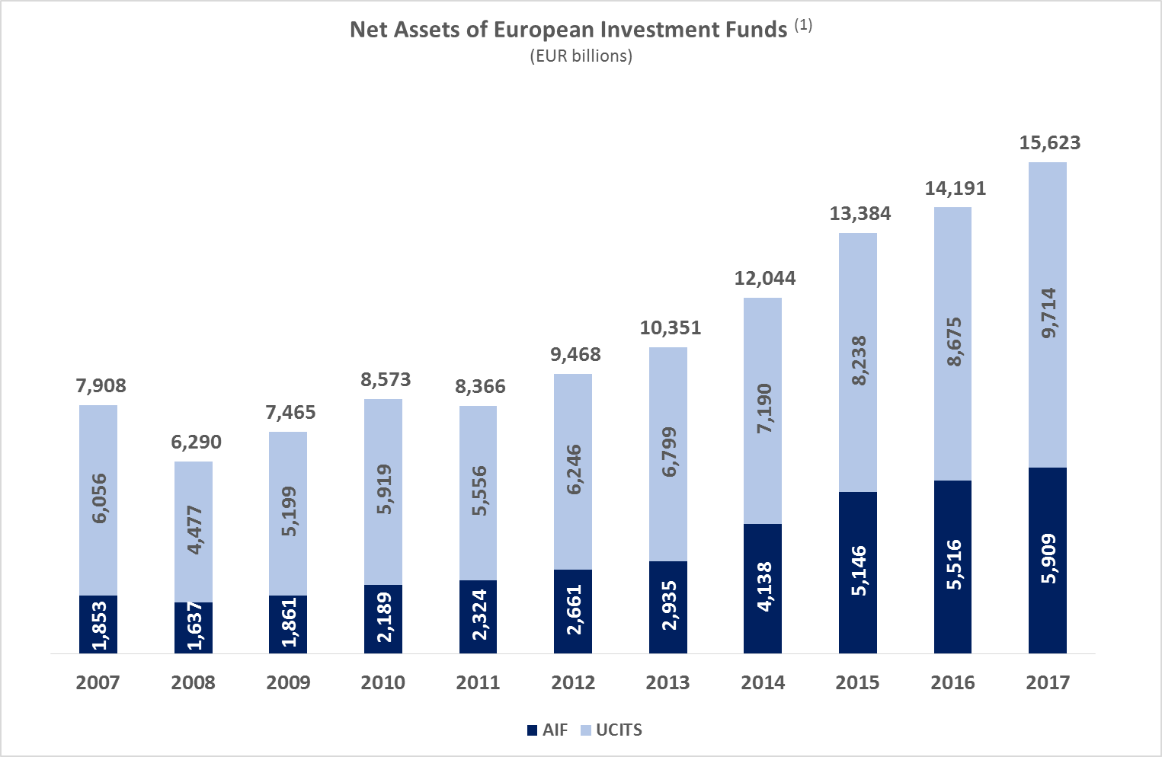

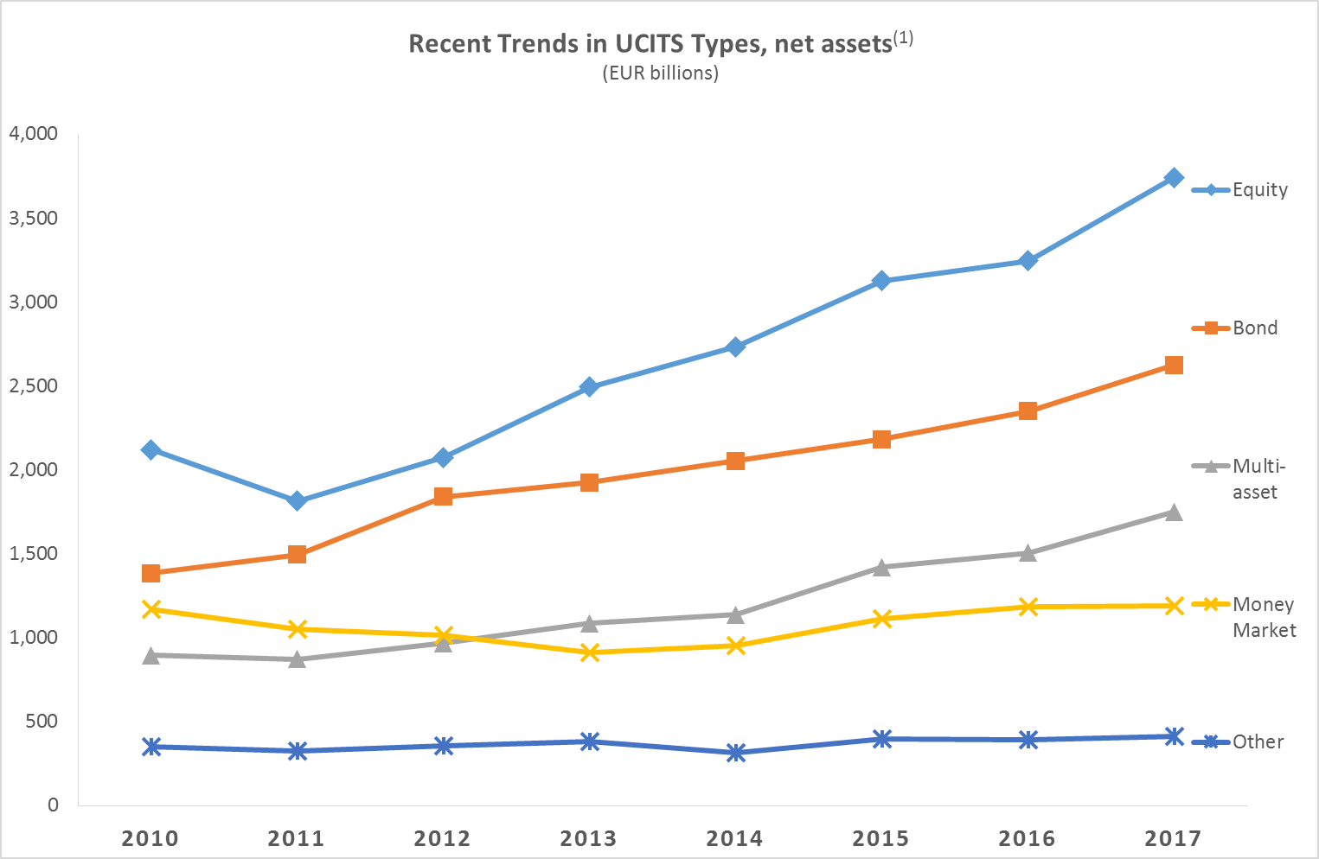

(1) Source: EFAMA database, annual data. Total net asset figures in 2008-2014 include data on funds domiciled in the Netherlands, whereas Dutch-domiciled funds are not included in UCITS/AIF categories and asset classes due to unavailability of data.

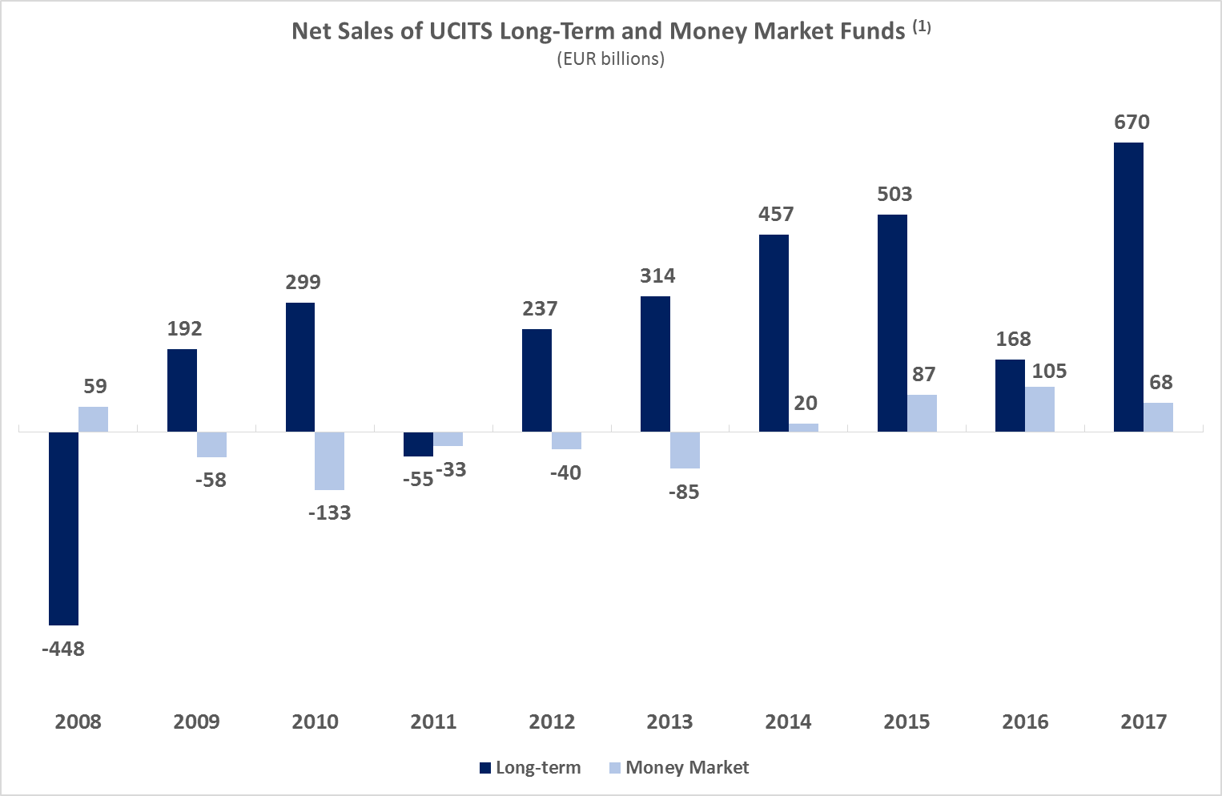

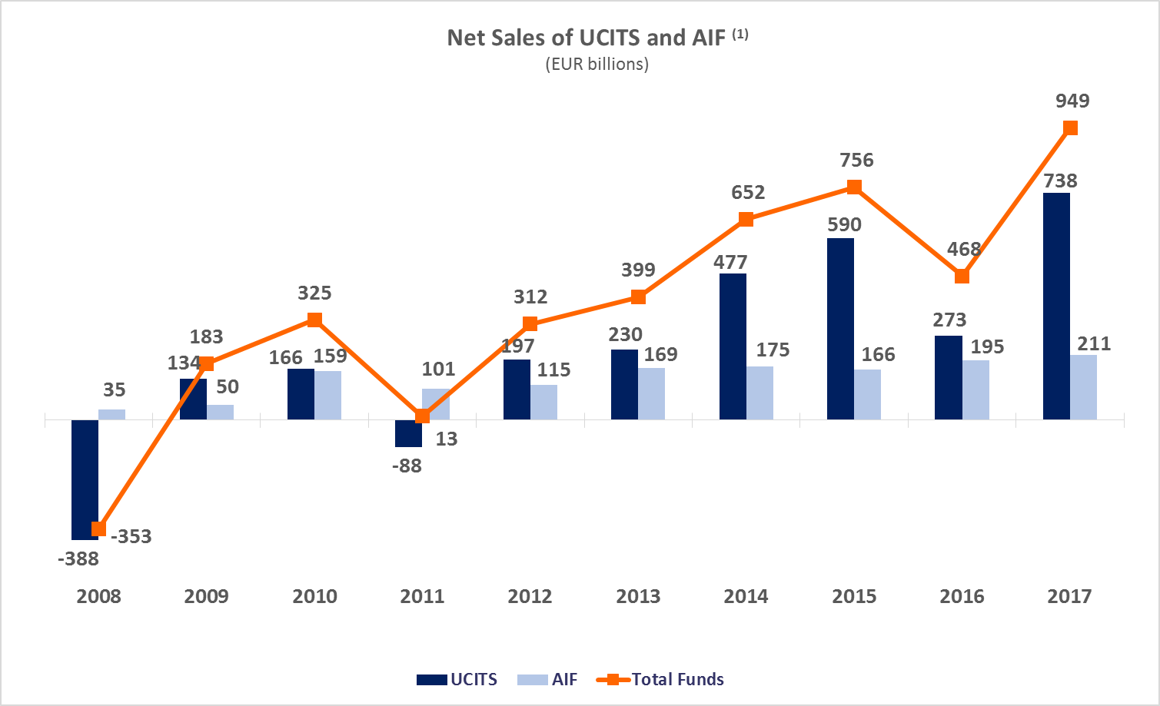

**Top Ten Domiciles in 2017**

(1) Source: EFAMA database, annual data. Data for 2017 excludes data on Belgian net sales due to unavailability.

***Largest Domiciles in terms of Net Assets and Net Sales***

*Funds domiciled in Switzerland that fulfill the UCITS criteria are classified as UCITS.

**UCITS FUNDS**

**Net Assets at End 2017**

**(EUR billion)**

**Net Sales in 2017**

**(EUR billion)**

**Net Assets at End 2017**

**(EUR billion)**

**Net Sales in 2017**

**(EUR billion)**

**AIF FUNDS**

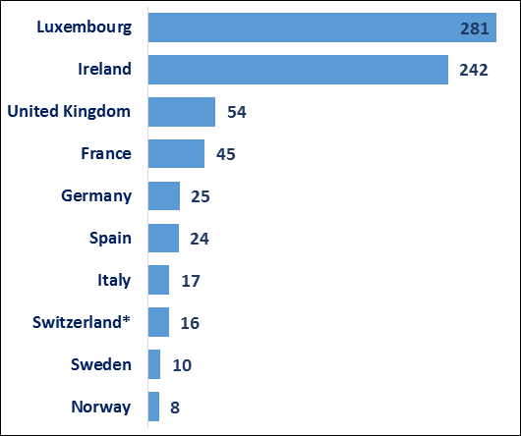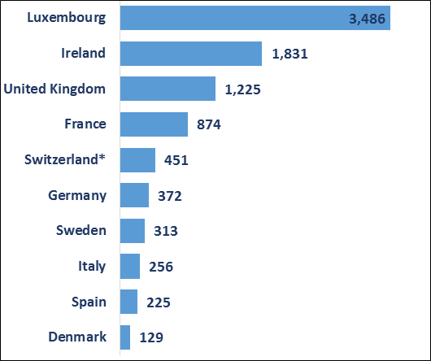

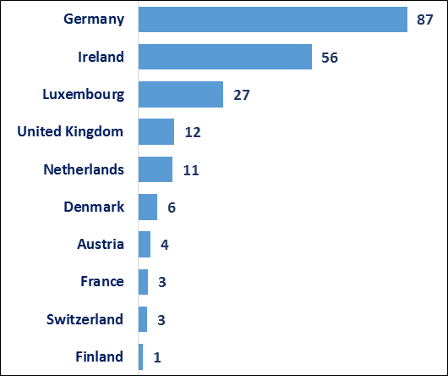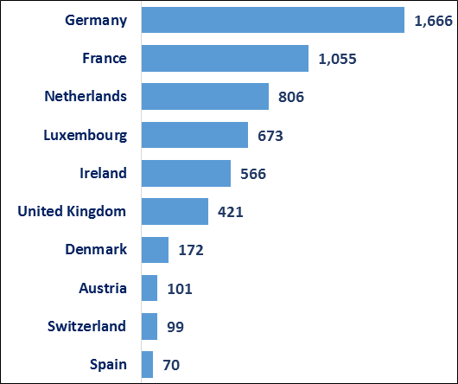

**Trends in the UCITS Market**

***Net Sales by Investment Type***

**UCITS recorded net sales of EUR 170 billion in Q4 2017, compared to EUR 191 billion in the third quarter of 2017. In 2017, UCITS attracted cumulative net sales of EUR 738 billion, compared to annual net sales of EUR 273 billion in 2016.**

Long-term UCITS recorded net sales of EUR 172 billion in Q4 2017, up from EUR 157 billion in Q3 2017. Net sales of equity funds amounted to EUR 56 billion, compared to EUR 39 billion in Q3 2017. Net sales of multi-asset funds increased from EUR 43 billion in Q3 2017 to EUR 54 billion in Q4 2017. Net sales of bond increased from EUR 72 billion in Q3 2017 to EUR 75 billion in Q4 2017. Reflecting cyclical end-of-year withdrawals from French money market funds, net sales of total European money market reversed from net inflows of EUR 33 billion in Q3 2017 to net outflows of EUR 3 billion in Q4 2017.

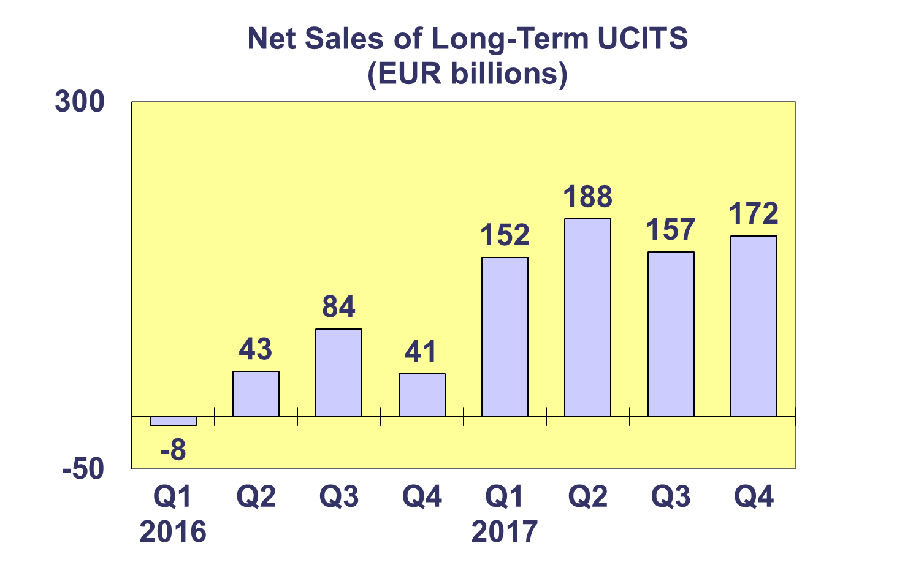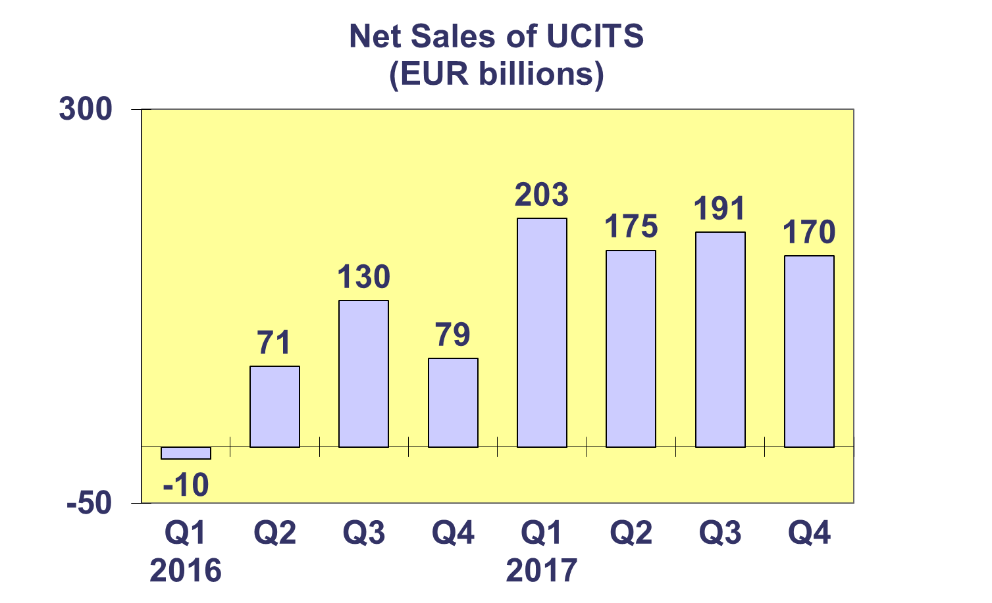

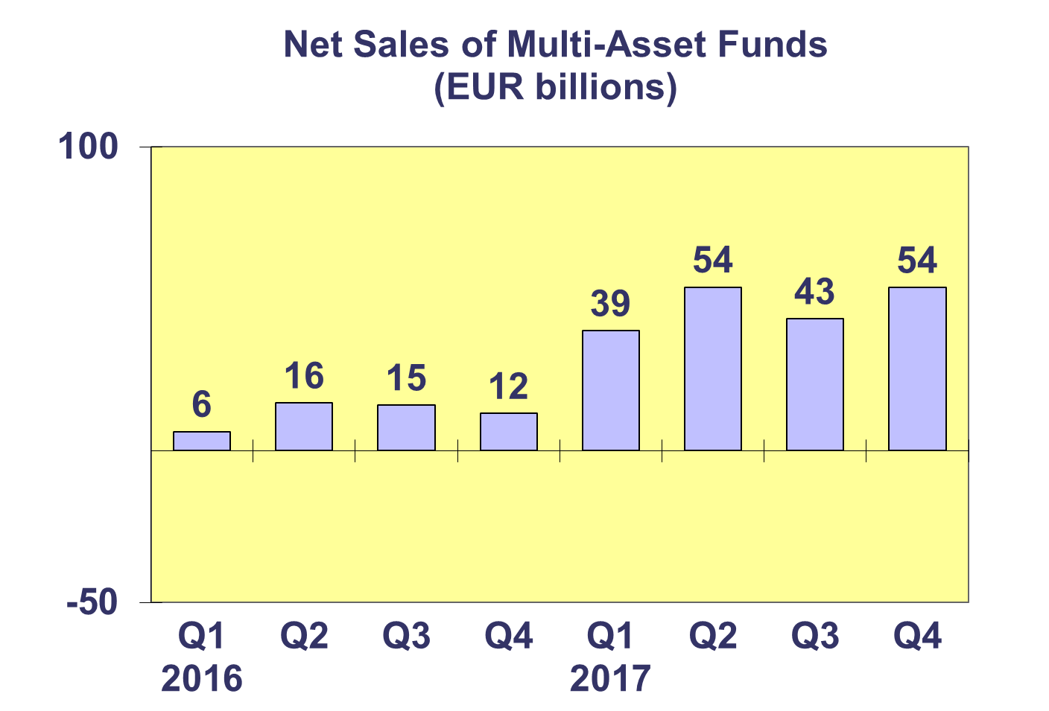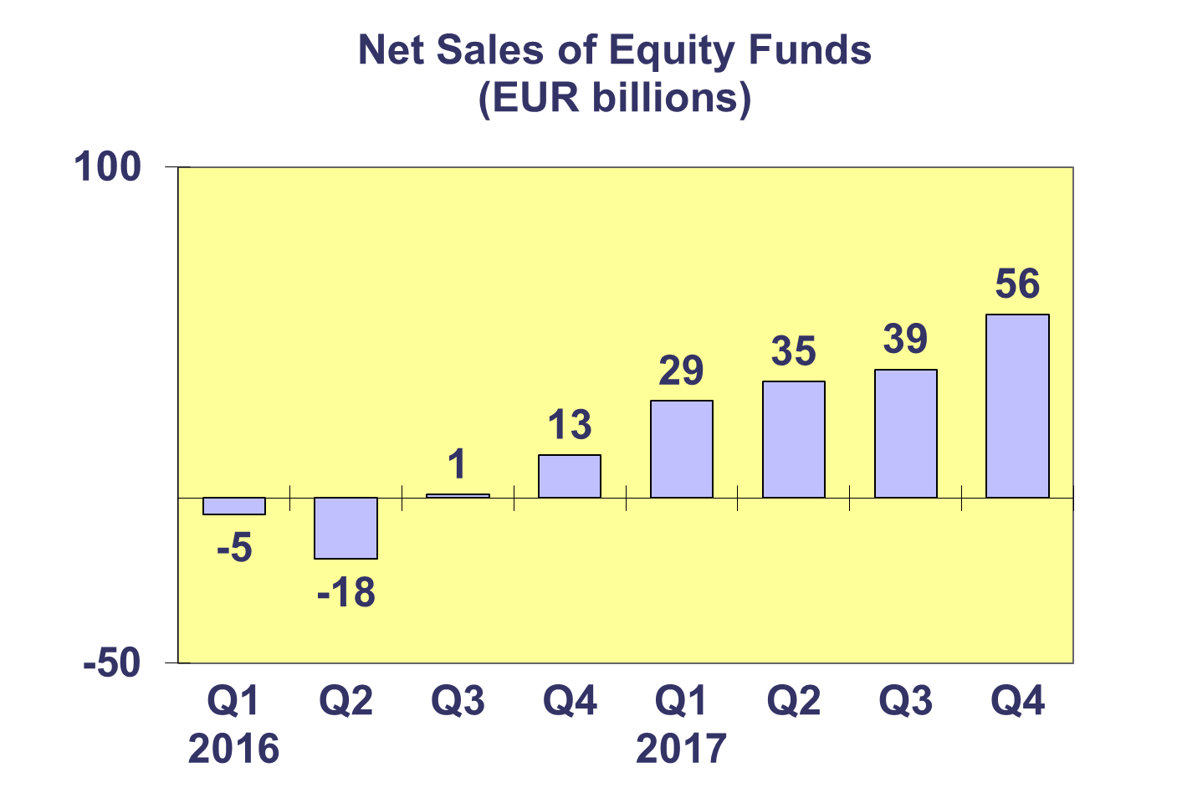

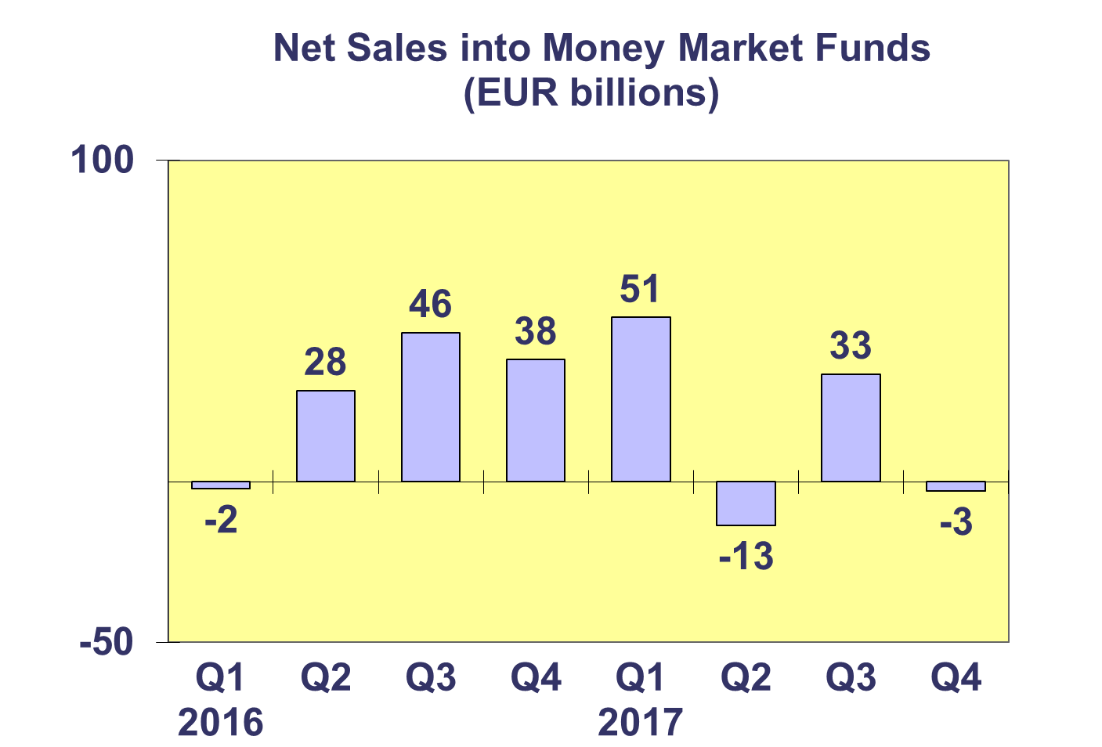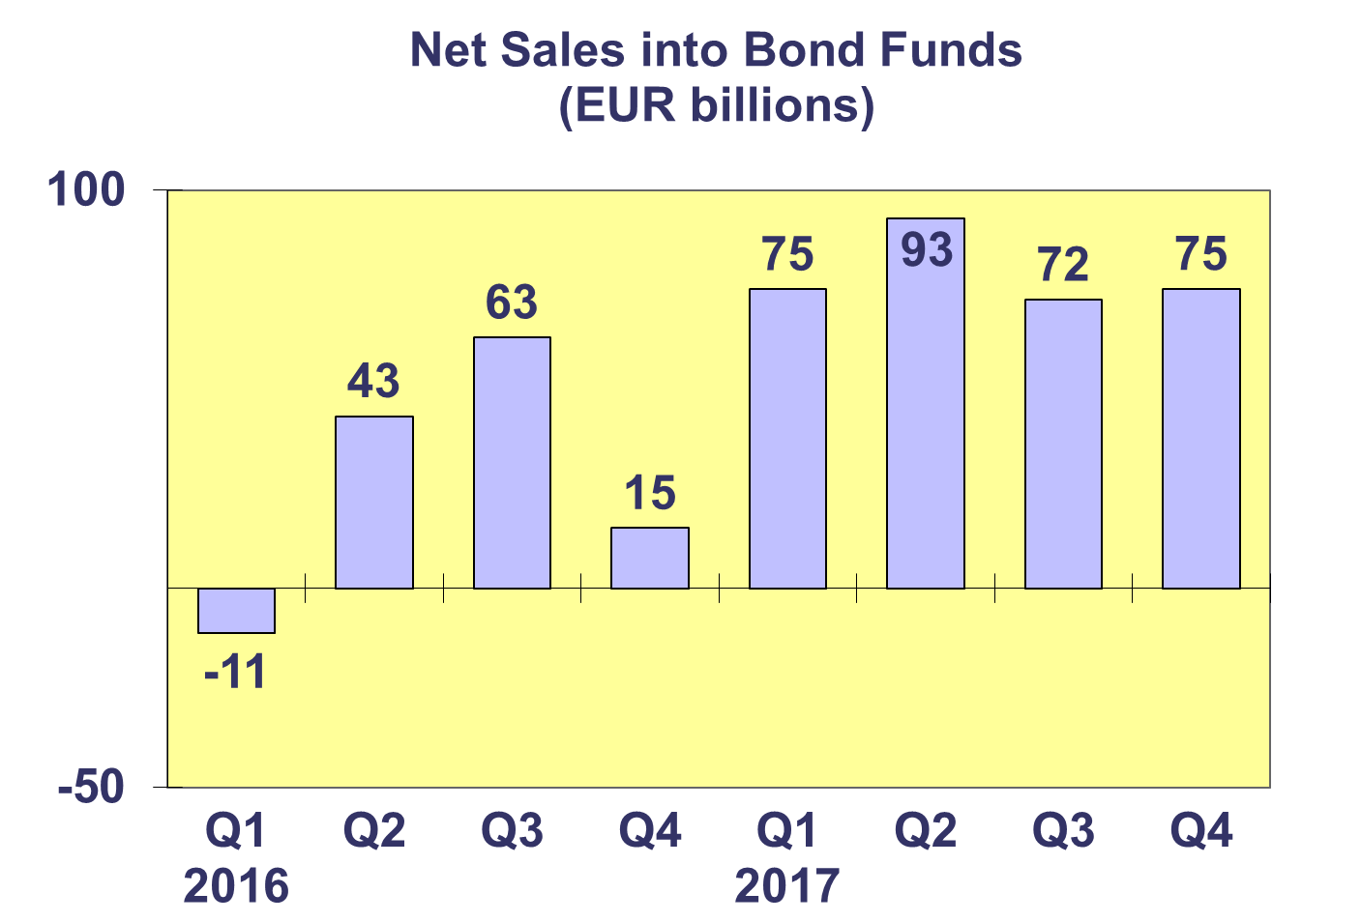

**Trends in the UCITS Market**

***Net Sales by Country of Domiciliation and Investment Type***

**Twenty countries registered net inflows into UCITS in the fourth quarter of 2017, with nine countries recording net sales above EUR 1 billion.**

In Q4 2017, the five domiciles with the largest net sales were Luxembourg (EUR 73.9 billion), followed by Ireland (EUR 67.7 billion), United Kingdom (EUR 12.8 billion), Spain (EUR 7.5 billion), and Switzerland (EUR 6.5 billion).

In 2017, eight domiciles attracted net sales larger than EUR 10 billion: Luxembourg (EUR 280.9 billion), Ireland (EUR 242.1 billion), the United Kingdom (EUR 54.1 billion), France (EUR 45.4 billion), Germany (EUR 25 billion), Spain (EUR 24.4 billion), Italy (EUR 16.9 billion) and Switzerland (EUR 16.4 billion).

**Trends in the UCITS Market**

***Net Sales and Net Assets of ETF by Country of Domiciliation***

**Net sales of UCITS ETF amounted to EUR 8.8 billion in Q4 2017, down from EUR 12.1 billion in the third quarter. UCITS ETF attracted net sales of EUR 64.5 billion in 2017.[1]**

UCITS ETF domiciled in Ireland registered the largest net sales during the quarter (EUR 14.0 billion), reflecting the size of the ETF market, whereas France recorded net outflows (EUR 4.9 billion). Looking at total net sales in 2017, Ireland attracted the largest net sales (EUR 56.6 billion), followed by France (EUR 4.4 billion) and Germany (EUR 3.7 billion)



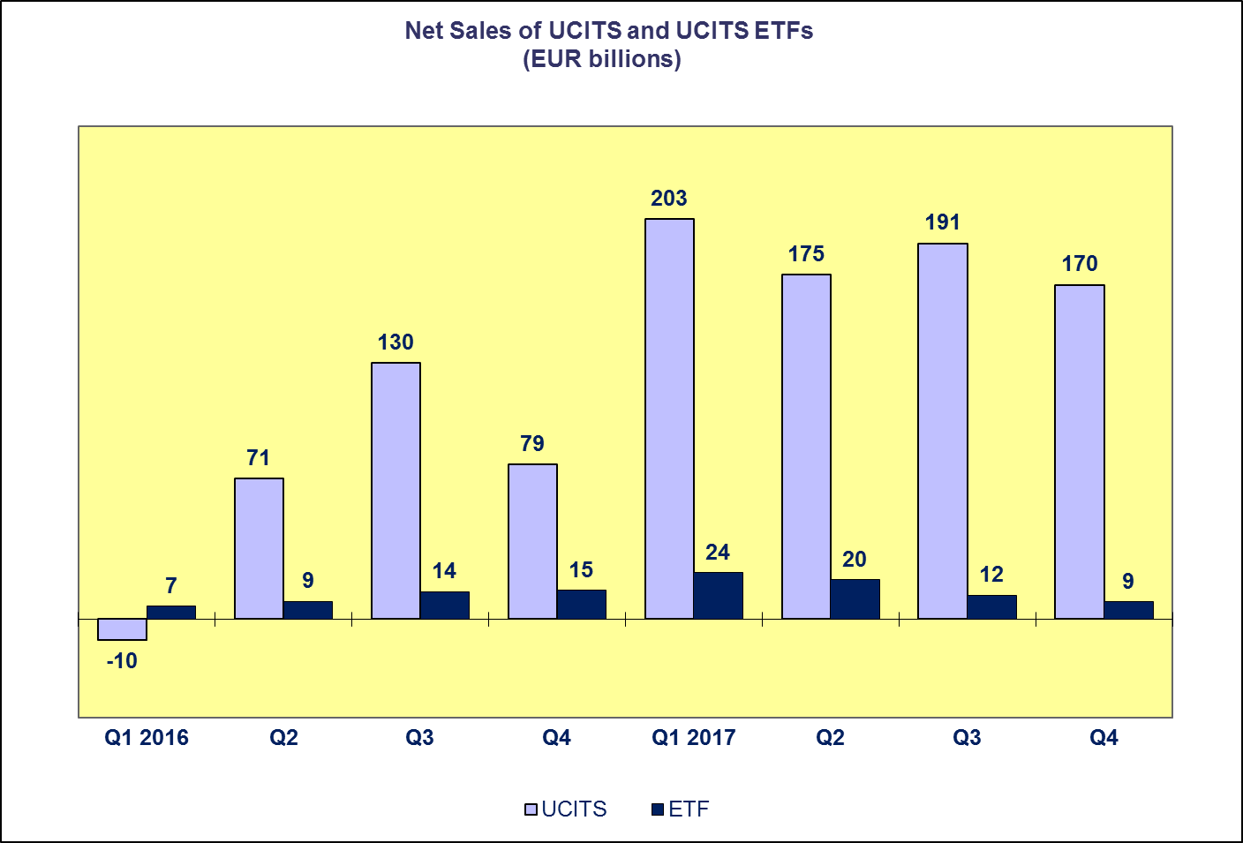**Trends in the UCITS Market**

***Net Assets by Investment Type***

**Net assets of UCITS increased by 3.0% since end Q3 2017 to reach EUR 9,714 billion at end Q4 2017. Over the course of the year 2017, UCITS net assets grew by 12%.**

In Q4 2017, multi-asset funds recorded the largest increase in net assets (4.7%), followed by equity (4.5%), and bond funds (2.4%). Guaranteed/protected funds saw the largest decrease in net assets (6.1%), followed by money market funds (1.0%). Other UCITS funds recorded net asset decreases of 1.9%.

In 2017, the largest net asset increase was seen in multi-asset funds (16.1%), followed by equity (15.3%), bond (11.8%), and money market funds (0.4%). The largest net asset decrease was registered in guaranteed/protected funds (18.7%). Other UCITS funds increased by 5.7%.

The number of UCITS funds increased from 60,683 at end Q4 2016 to 31,974 at end Q4 2017.



**Trends in the UCITS Market**

***Net Assets by Country of Domiciliation***

**Twenty-four domiciles recorded net asset growth at end Q4 2017, with net assets of UCITS reaching EUR 9,714 billion at end Q4 2017.**

In Western Europe, Belgium recorded the largest net asset growth in Q4 2017 (12.5%), followed by Ireland (4.8%) and the UK (4.1%). With the exception of Turkey, all domiciles in the Southern European region experienced net asset growth with the largest growth in Cyprus (16.0%), followed by Greece (4.4%), Portugal (4.4%), and Spain (4.2%). With the exception of Norway, net asset growth was also positive in the Nordic countries, with the largest net asset increase registered in Finland (4.6%). In Central and Eastern Europe, the largest increase in net assets was recorded in Czechia (6.7%).

Of the largest UCITS domiciles, Ireland recorded the largest net asset increases in 2017 (15.9%), followed by Luxembourg (11.9%), the UK (11.6%), and France (9.8%). Elsewhere in Europe, net asset growth greater than 20% was recorded in Cyprus, Belgium, Czechia, Bulgaria, Poland, Portugal, and Malta.



**Trends in the AIF Market**

***Net Sales by Investment Type***

**AIF recorded net sales of EUR 19 billion in Q4 2017. In 2017, AIF attracted net sales of EUR 211 billion, the highest amount in any given year so far.**

Long-term AIF recorded net sales of EUR 20 billion in Q4 2017, down from EUR 53 billion in Q3 2017. Net sales of equity funds increased from EUR 11 billion in the third quarter to EUR 13 billion in the fourth quarter. Net sales of multi-asset funds increased from EUR 6 billion in Q3 2017 to EUR 10 billion in Q4 2017. Net outflows from bond funds increased from EUR 1 billion in Q3 2017 to EUR 37 billion in Q4 2017, mostly due to withdrawals after a restructuring of pension fund investment portfolios in the Netherlands. Net sales of other funds decreased from EUR 31 billion in Q3 2017 to EUR 25 billion in Q4 2017.

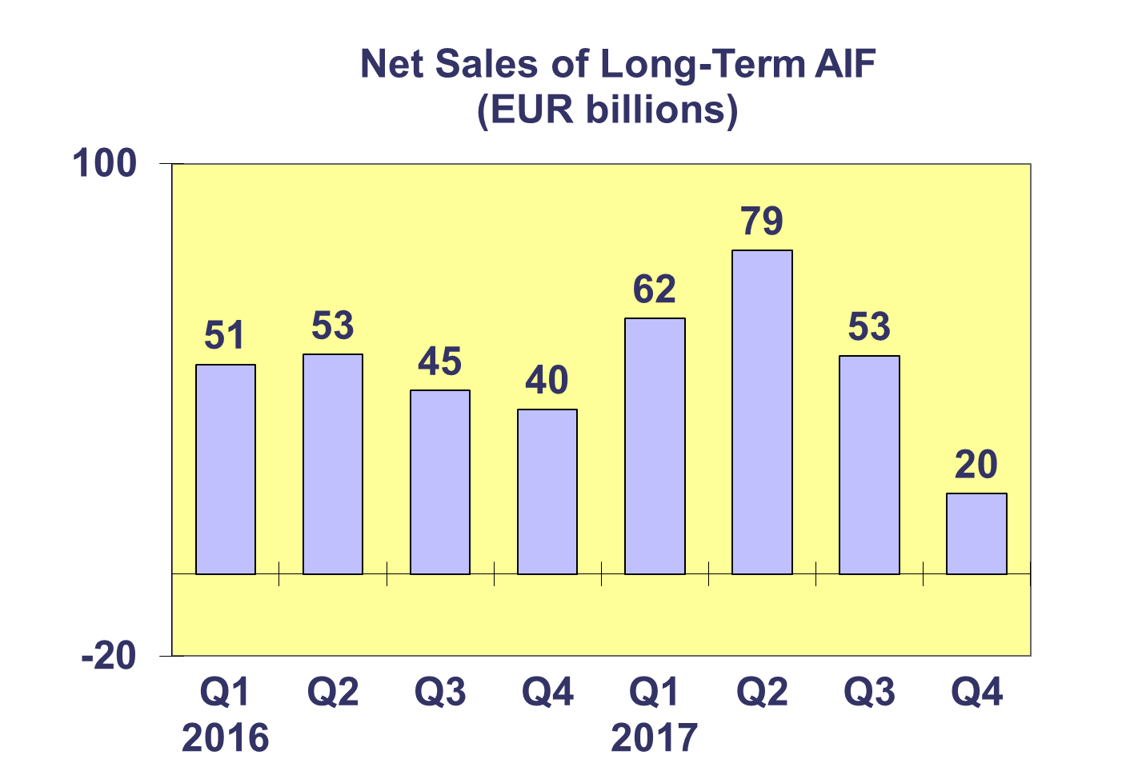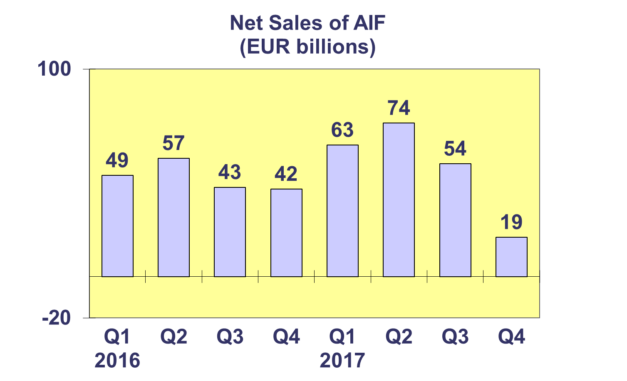

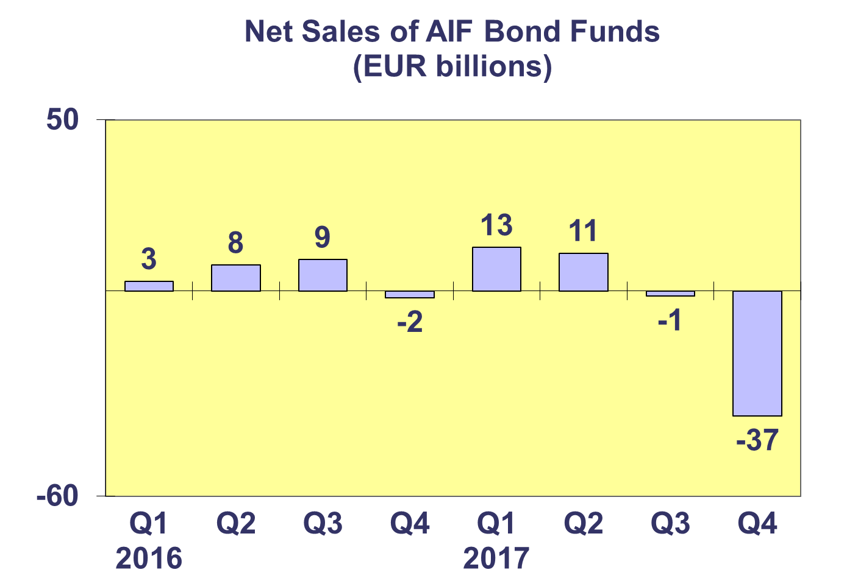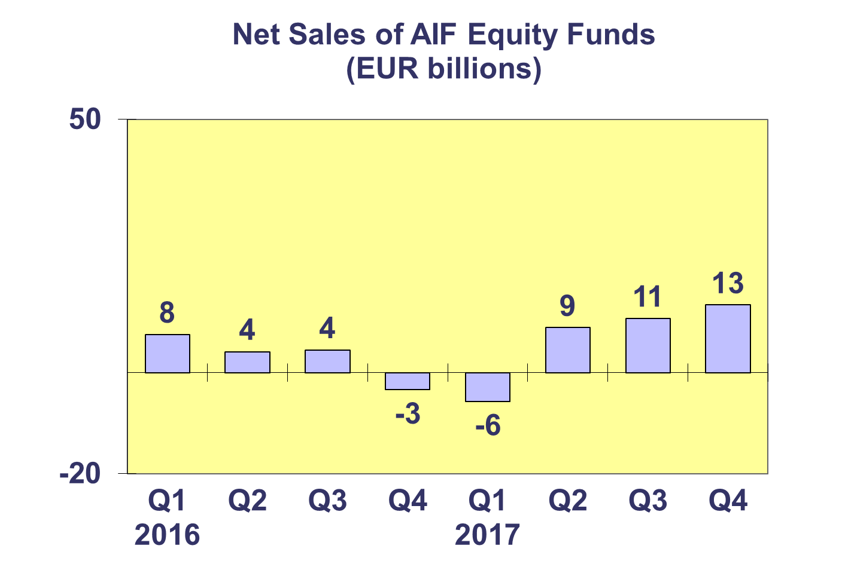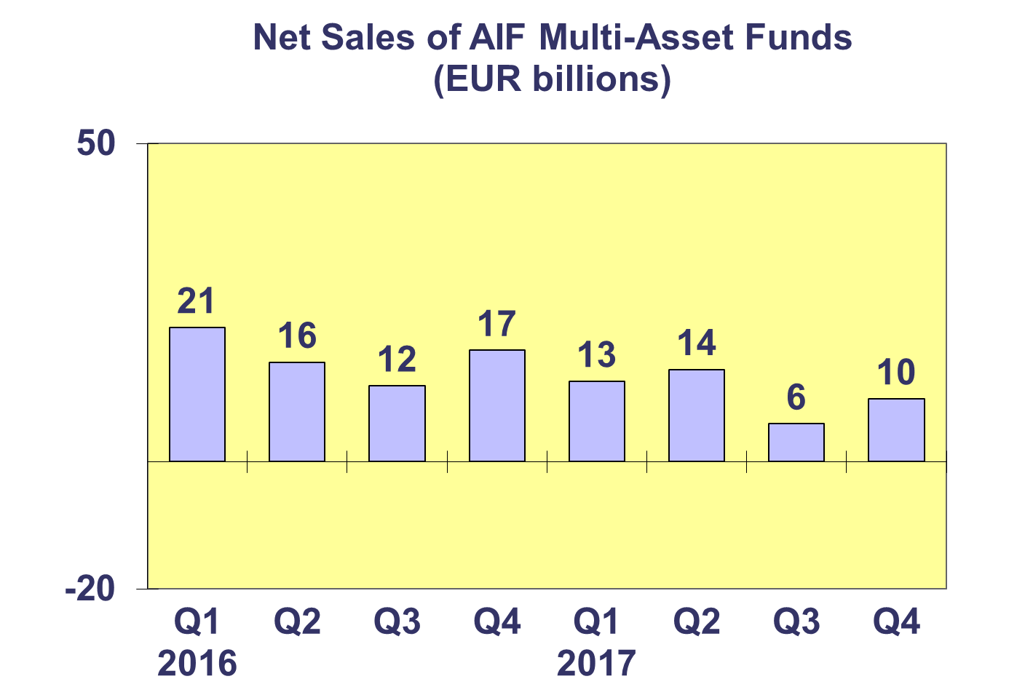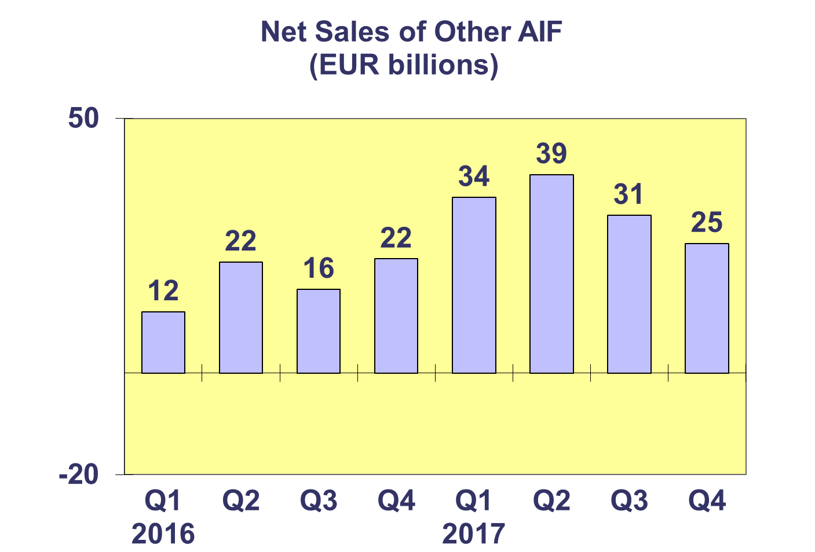**Trends in the AIF Market**

***Net Sales by Country of Domiciliation and Investment Type***

**Eighteen domiciles experienced net inflows into AIF in Q4 2017, with seven countries recording net sales higher than EUR 1 billion.**

In Q4 2017, net sales above EUR 1 billion were registered in Germany (EUR 26 billion), Luxembourg (EUR 6.6 billion), the United Kingdom (EUR 2.9 billion), Ireland (2.1 billion), Switzerland (EUR 1.7 billion), Austria (EUR 1.0 billion) and Denmark (EUR 1.1 billion).

In 2017, five countries attracted net sales greater than EUR 10 billion: Germany (EUR 86.9 billion), Ireland (EUR 56.0 billion), Luxembourg (EUR 27.4 billion), the United Kingdom (EUR 11.6 billion), and the Netherlands (EUR 11.0 billion).



**Trends in the AIF Market**

***Net Assets by Investment Type***

**Net assets of AIF increased by 1.3% in the fourth quarter to reach EUR 5,909 billion. Since end Q4 2016 net assets of AIF grew by 7.1%.**

In Q4 2017, equity funds recorded the largest asset growth (4.3%), followed by real estate (2.9%), and multi-asset funds (0.2%). Decreases in net assets were recorded in bond funds (3.5%), guaranteed/protected funds (2.7%) and money market funds (1.0%). Other AIF funds recorded net asset growth of 3.5%.

Equity funds registered the largest increase in net assets in 2017 (12.6%), followed by “other” AIF funds (16.0%). Money market funds saw the largest net asset decrease (7.3%), followed by guaranteed/protected funds (6.8%).

The number of AIF funds increased from 28,144 funds at end Q4 2016 to 28,231 funds at end Q4 2017.



**Trends in the AIF Market**

***Net Sales and Assets of Institutional AIF***

**Net assets of institutional AIF, which are AIF reserved for institutional investors, increased 1.9% to EUR 2,860 billion at end Q4 2017.**

Net assets of institutional money market funds increased by 5.4% in Q4 2017, followed by equity (4.5%) and real estate (2.3%). Net assets of institutional multi-asset funds stayed the same as the previous quarter, while net assets of bond funds decreased by 0.5%. Net assets of other AIF funds increased by 7.8%.

In 2017, the largest increase in the net assets was recorded in equity and money market funds (14.6% and 14.7%, respectively), followed by real estate funds (13.2%).

In Q4 2017, institutional AIF recorded approximately the same level of net sales as in Q3 and Q1 2017 (EUR 38 billion).



**Trends in the AIF Market**

***Net Assets by Country of Domiciliation***

**Net assets of AIF increased 1.3% compared to the previous quarter and 7.1% compared to end 2016.**

In the largest AIF domiciles, the largest net asset growth in Q4 2017 was seen in Luxembourg and Ireland (2.6%), followed by United Kingdom (2.0%), Germany (1.0%), France (0.8%) and the Netherlands (0.3%). Elsewhere in Europe, net assets grew strongly in Cyprus (16.8%), Belgium (12.5%), and Czechia (9.0%).

Of the five largest AIF domiciles, Luxembourg recorded net asset growth of 15.1%, followed by Ireland (11.8%), Germany (6.9%), Netherlands (5.6%), and France (5.2%). Elsewhere in Europe, strong growth was seen in Czechia (41.2%), Cyprus (24.7%), Croatia (24.6%), Sweden (12.3%), and Belgium (11.5%).



**Trends in the European Investment Fund Industry**

***Net Sales by Investment Type***

**The combined net sales of the investment industry market in Europe, i.e. the market for UCITS and AIF, recorded net sales of EUR 189 billion during Q4 2017, compared to EUR 245 billion in Q3 2017. In 2017, European investment funds attracted net sales of EUR 949 billion, marking 2017 as a record year.**

In Q4 2017, net sales of equity funds increased to EUR 69 billion, compared to EUR 50 billion in the previous quarter. Net sales of bond funds decreased from EUR 71 billion in Q3 2017 to EUR 39 billion in Q4 2017. Net sales of multi-asset funds totalled EUR 64 billion in Q4 2017, up from EUR 49 billion in the previous quarter. Money market funds experienced net outflows of EUR 3 billion, compared to net inflows of EUR 35 billion in the third quarter of 2017. Net sales of other funds (including real estate, guaranteed/protected funds and other funds which do not fit any of the categories below or for which information is not available) totalled EUR 21 billion, down from EUR 41 billion during the previous quarter.

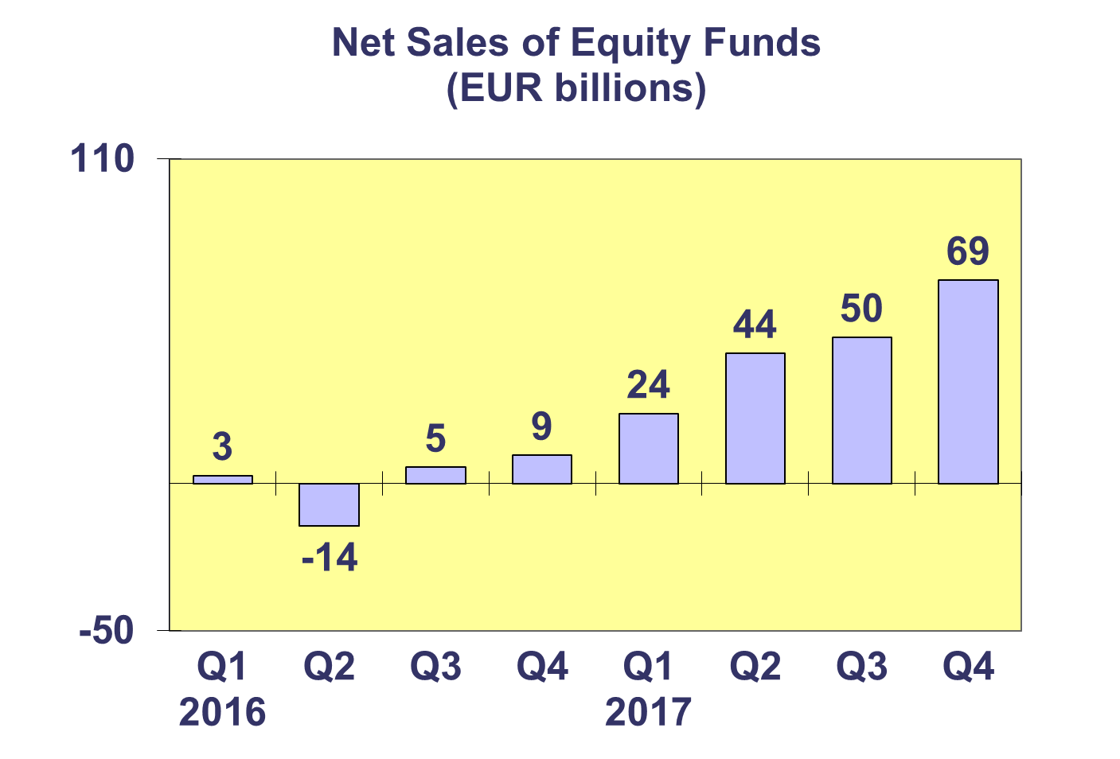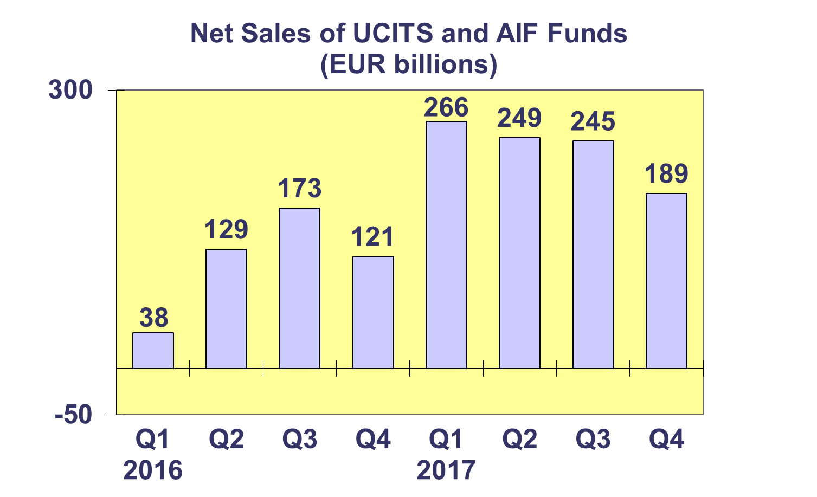

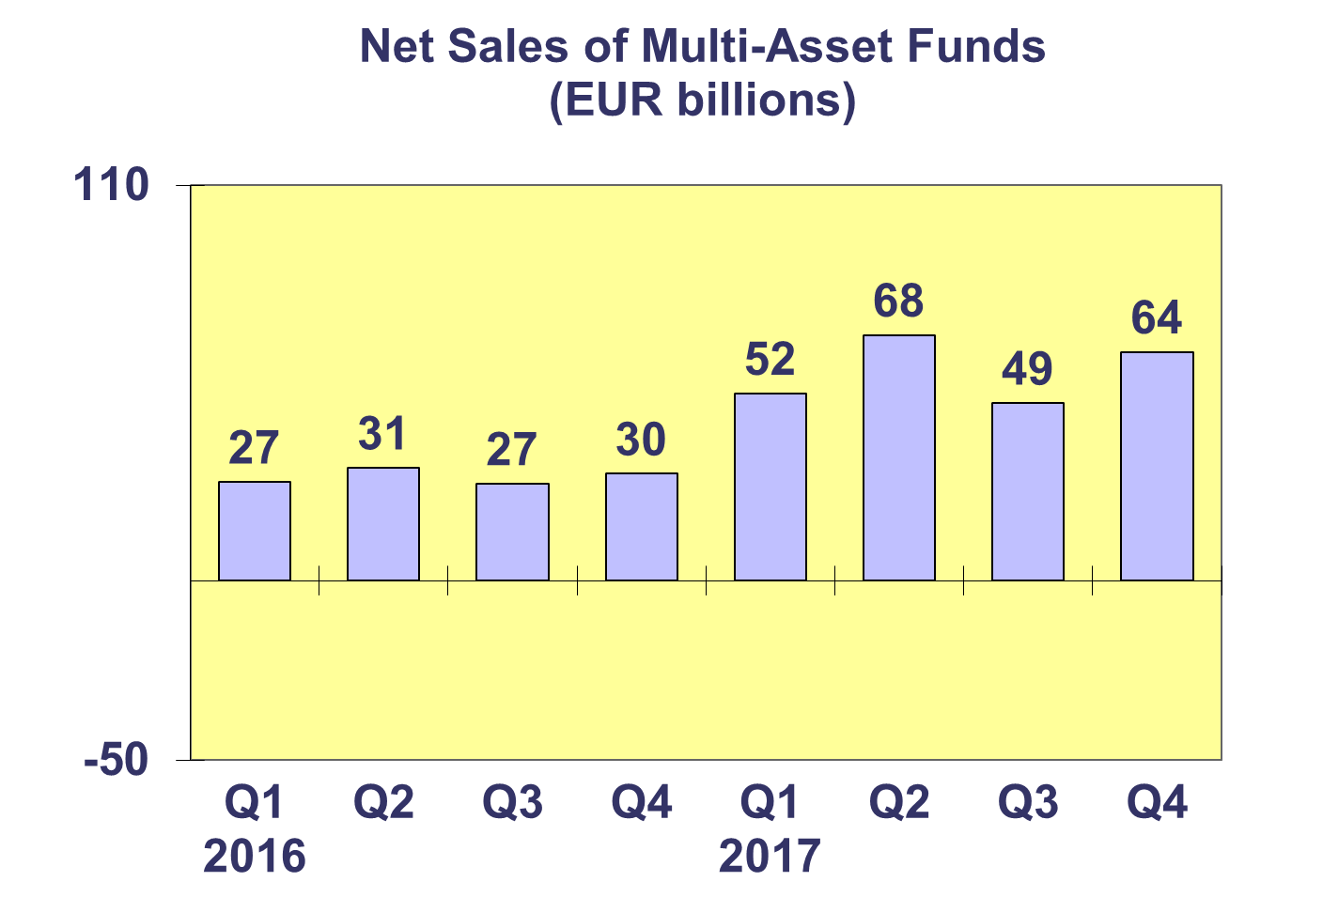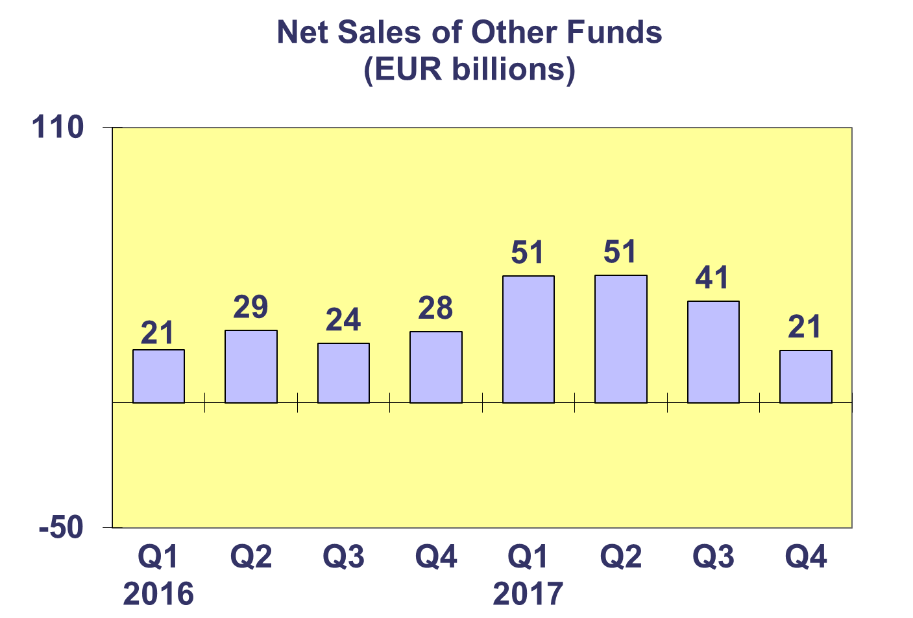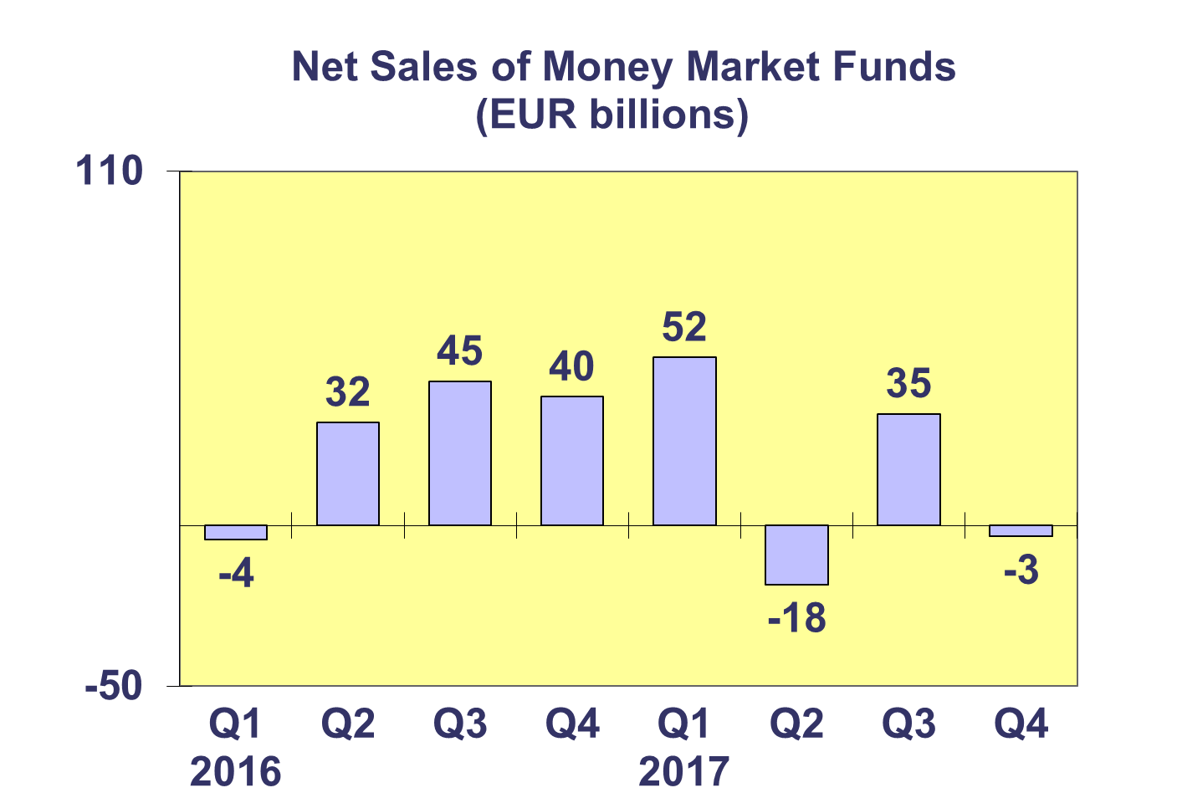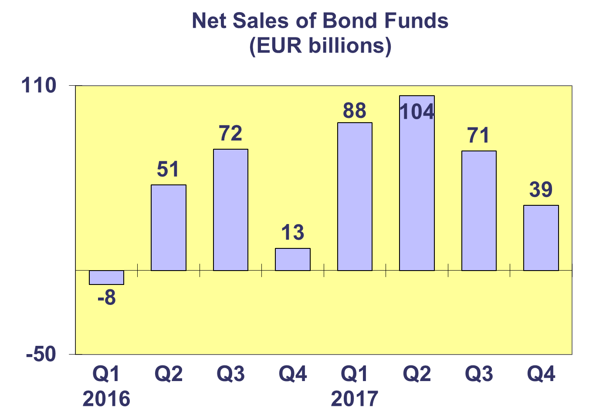

**Trends in the European Investment Fund Industry**

***Net Assets by Country of Domiciliation***

**Total net assets of the European investment increased to EUR 15,623 billion at end Q4 2017, representing net asset growth of 2.3% since Q3 2017 and 10.1% since end 2016.**

With EUR 9,715 billion invested in UCITS, this segment accounted for 62.2% of total European investment fund assets at end Q4 2017, with the remaining 37.8% (equivalent to EUR 5,909 billion) coming from AIF.



**Trends in the European Investment Fund Industry**

***Number of Funds by Country of Domiciliation***

**The total number of UCITS and AIF funds increased 0.6% by end Q4 2017 to end the year at 60,205.**

At the end of the fourth quarter of 2017, UCITS accounted for 31,974 funds or 53.1% of the number of funds in the European market. AIF accounted for 28,231 funds, or 46.9% of the amount of funds in the market.



1. Please note that this data does not include net sales of UCITS ETF domiciled in Luxembourg.