|  |
| --- |
| ***Quarterly Statistical Release*** |

**December 2018 N° 75**

***This release and other statistical***

***releases are available on Efama’s***

***website (***[***www.efama.org***](http://www.efama.org)***)***

***Trends in the European Investment Fund Industry***

***in the Third Quarter of 2018***

|  |
| --- |
| **This report was prepared by Bernard Delbecque, Thomas Tilley and Hailin Yang**  **EFAMA**  **The European Fund and Asset Management Association**  **Rue Montoyer 47 - B-1000 BRUXELLES - Tel. 32-2-513.39.69 Fax: 32-2-513.26.43 - e-mail: info@efama.org** |

**Trends in the UCITS Market**

***Net Sales by Investment Type***

**UCITS recorded net sales of EUR 3 billion during Q3 2018, compared to EUR 15 billion in the second quarter of 2018. During the first three quarters of 2018, UCITS have attracted cumulative net sales of EUR 189 billion, compared to EUR 570 billion of first three quarters of 2017.**

Long-term UCITS recorded net sales of EUR 16 billion in Q3 2018, down from EUR 33 billion in Q2 2018. Net sales of equity funds amounted to EUR 20 billion, up from EUR 10 billion in Q2 2018. Net sales of multi-asset funds decreased from EUR 28 billion in Q2 2018 to EUR 11 billion in Q3 2018. Bond funds recorded net outflows of EUR 6 billion in Q3 2018, compared to net outflows of EUR 1 billion in Q2 2018. Net sales of money market fund remained negative, with net outflows of EUR 13 billion in Q3 2018, compared to EUR 18 billion in Q2 2018.

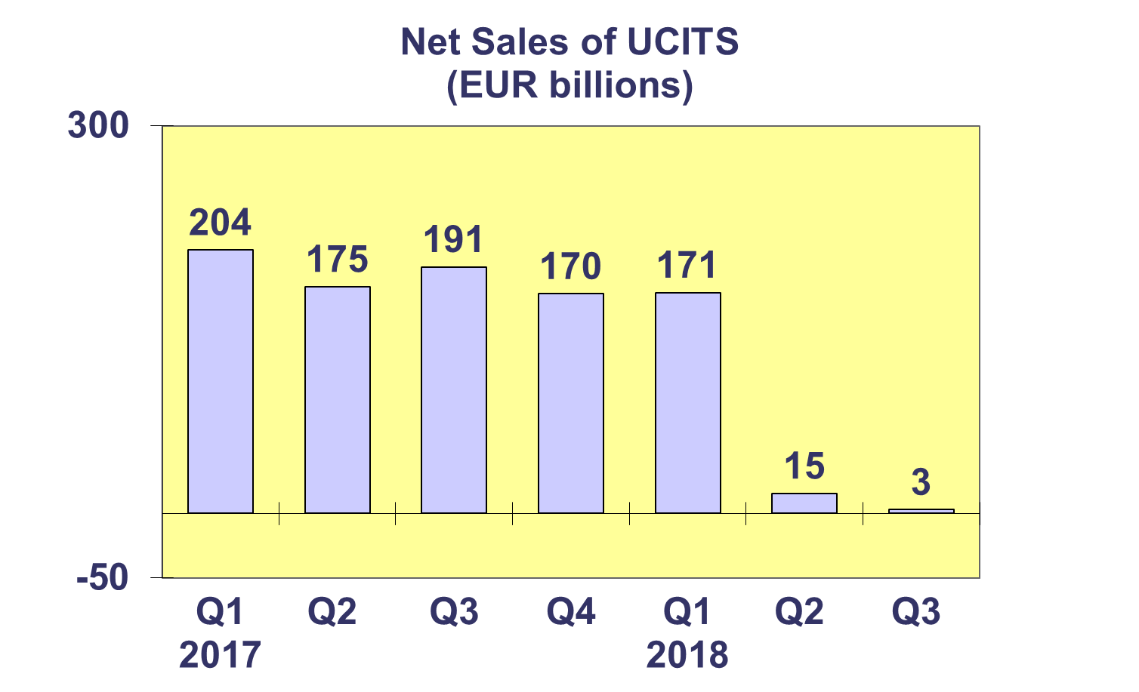

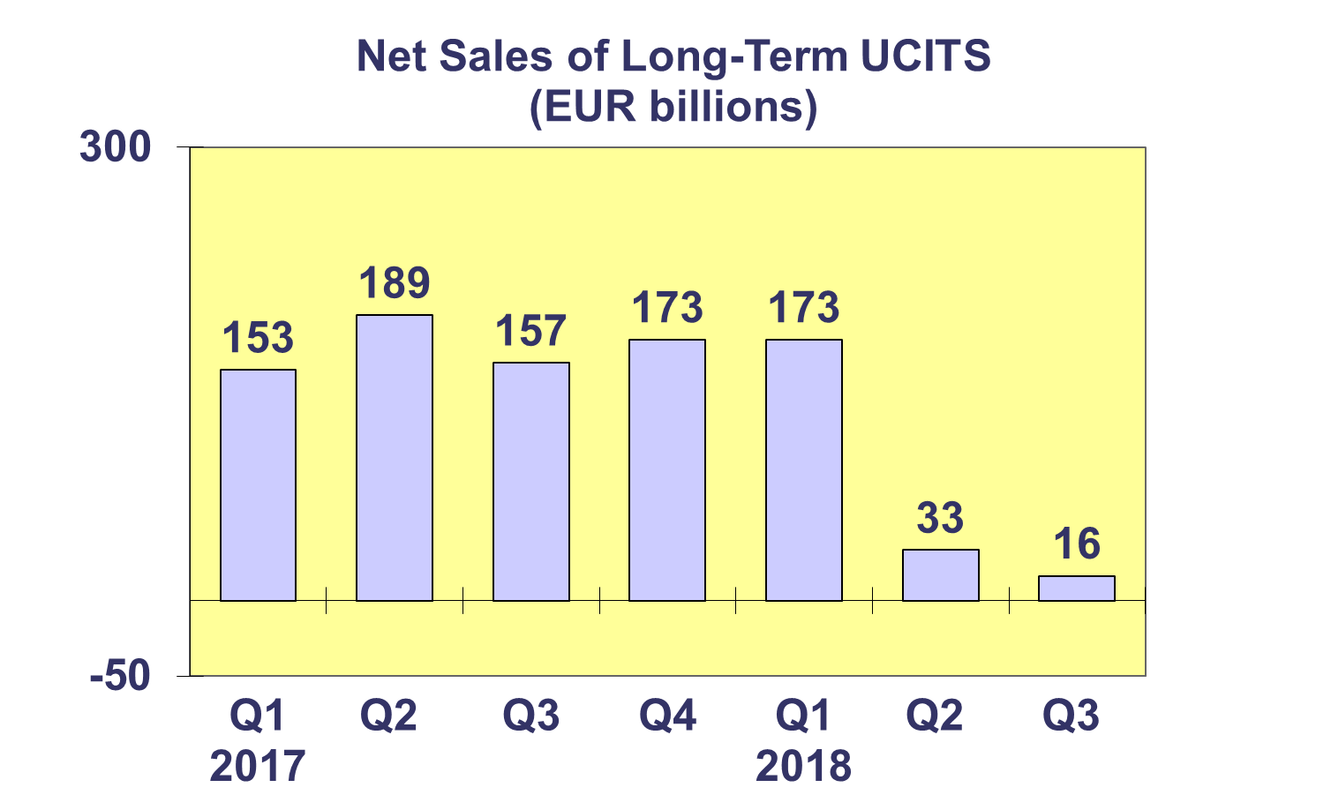

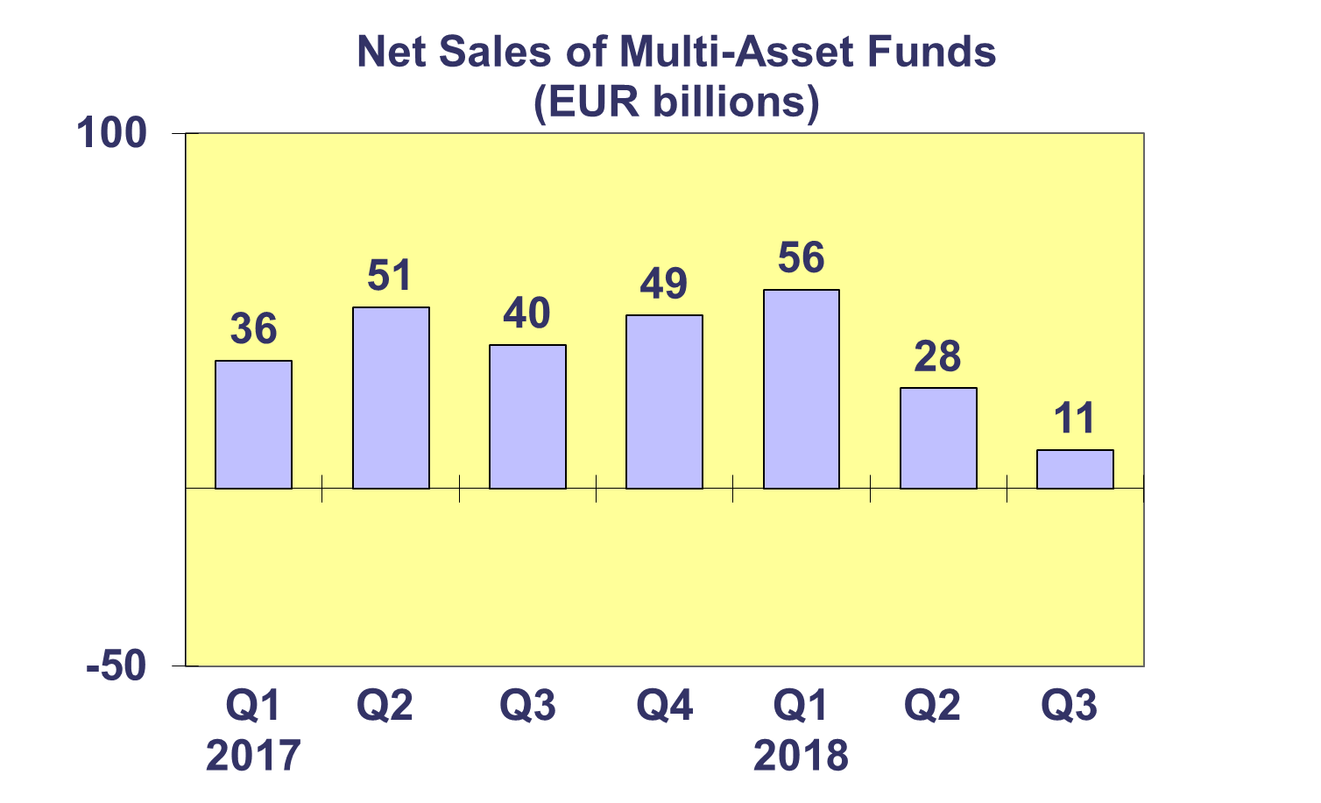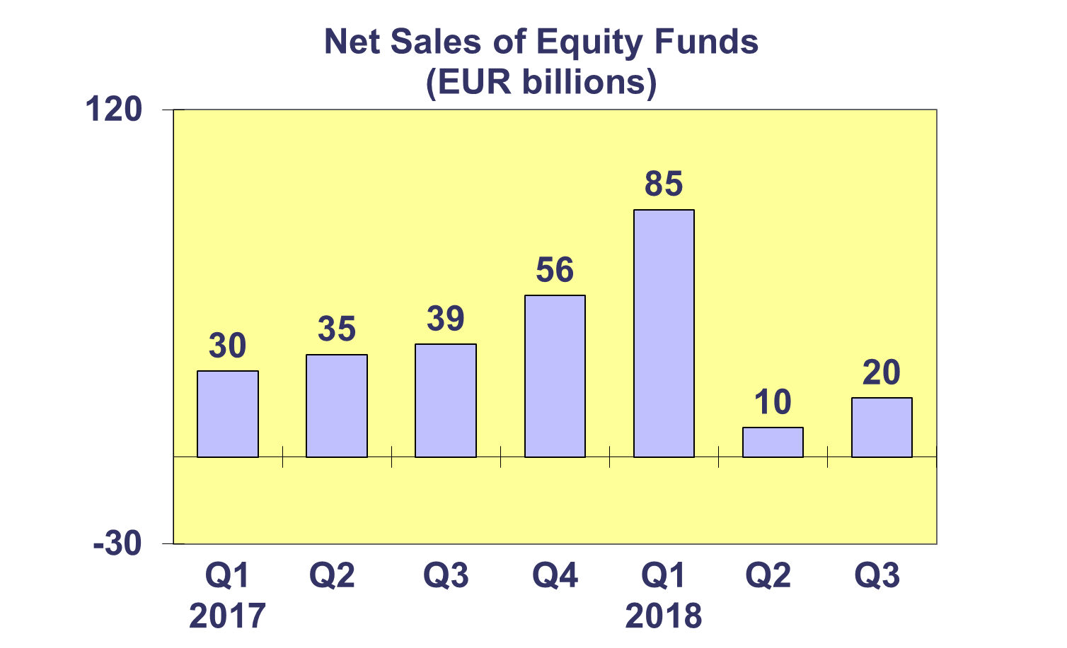

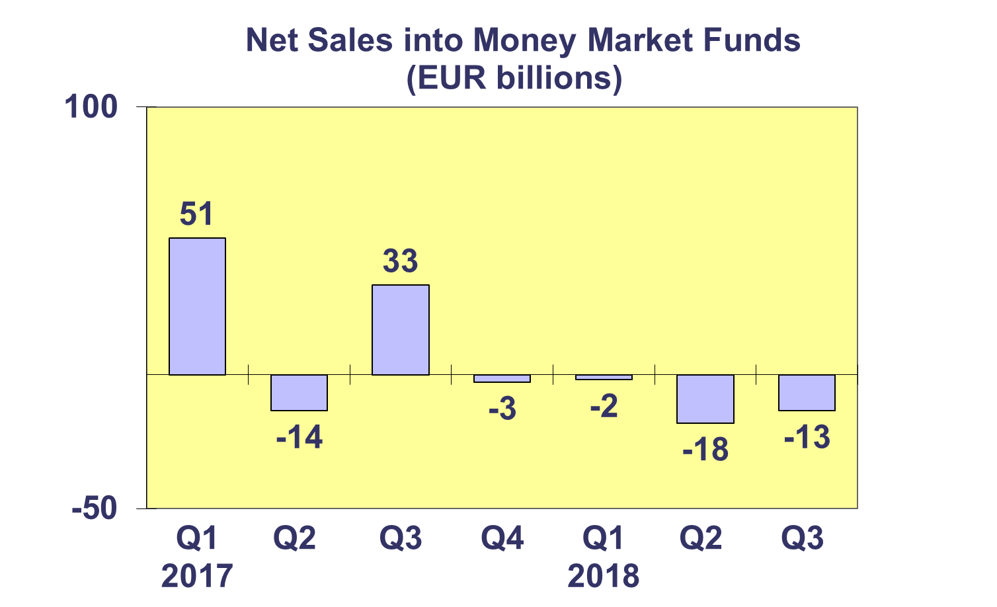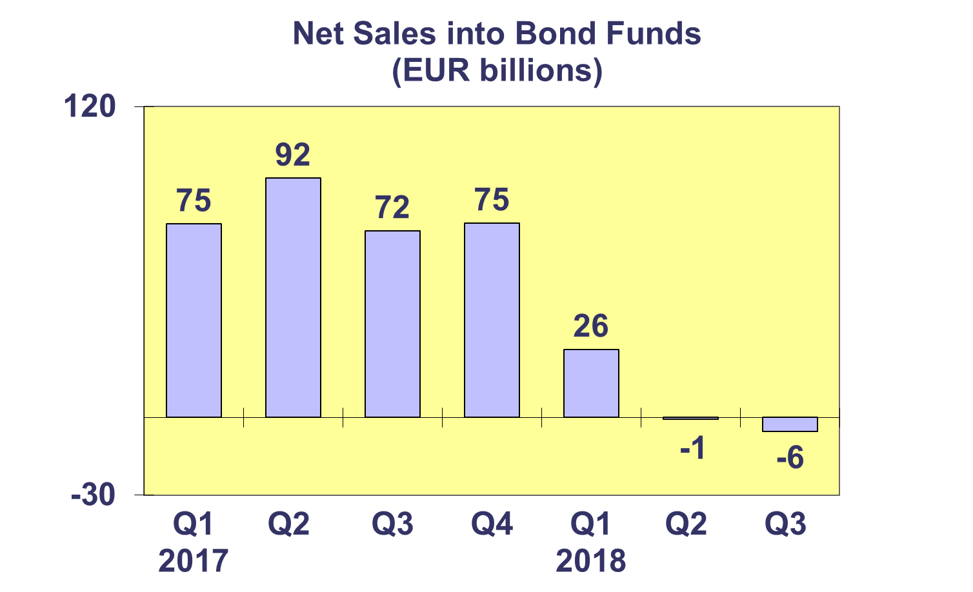**Trends in the UCITS Market**

***Net Sales by Country of Domiciliation and Investment Type***

**Fifteen countries registered net inflows into UCITS in the third quarter of 2018, with seven countries recording net sales above EUR 1 billion.**

The seven domiciles with net sales of UCITS above EUR 1 billion were Ireland (EUR 4.1 billion), followed by Switzerland (EUR 3.7 billion), Luxembourg (EUR 3.2 billion), Germany (EUR 2.1 billion), Sweden (EUR 1.7 billion), Norway (EUR 1.4 billion) and Denmark (EUR 1.1 billion).

During the first three quarters of 2018, twenty countries registered net inflows, with the largest inflows in Luxembourg (EUR 76.1 billion), Ireland (EUR 49.5 billion), France (EUR 19.7 billion), Spain (EUR 14 billion) and Switzerland (EUR 10.5 billion).

**Trends in the UCITS Market**

***Net Sales and Net Assets of ETF by Country of Domiciliation***

**Net sales of UCITS ETF amounted to EUR 12 billion in Q3 2018, compared to net outflows of EUR 20 billion in the second quarter. UCITS ETF have attracted net sales of EUR 15 billion so far this year.**

UCITS ETF domiciled in Ireland registered the largest net sales during the quarter (EUR 7.3 billion), followed by Luxembourg (EUR 5.3 billion). Looking at net sales in Q1-Q3 2018, Luxembourg attracted the largest net sales (EUR 28.3 billion), followed by Ireland (EUR 25.4 billion), whereas France has experienced net outflows (EUR 37.6 billion).



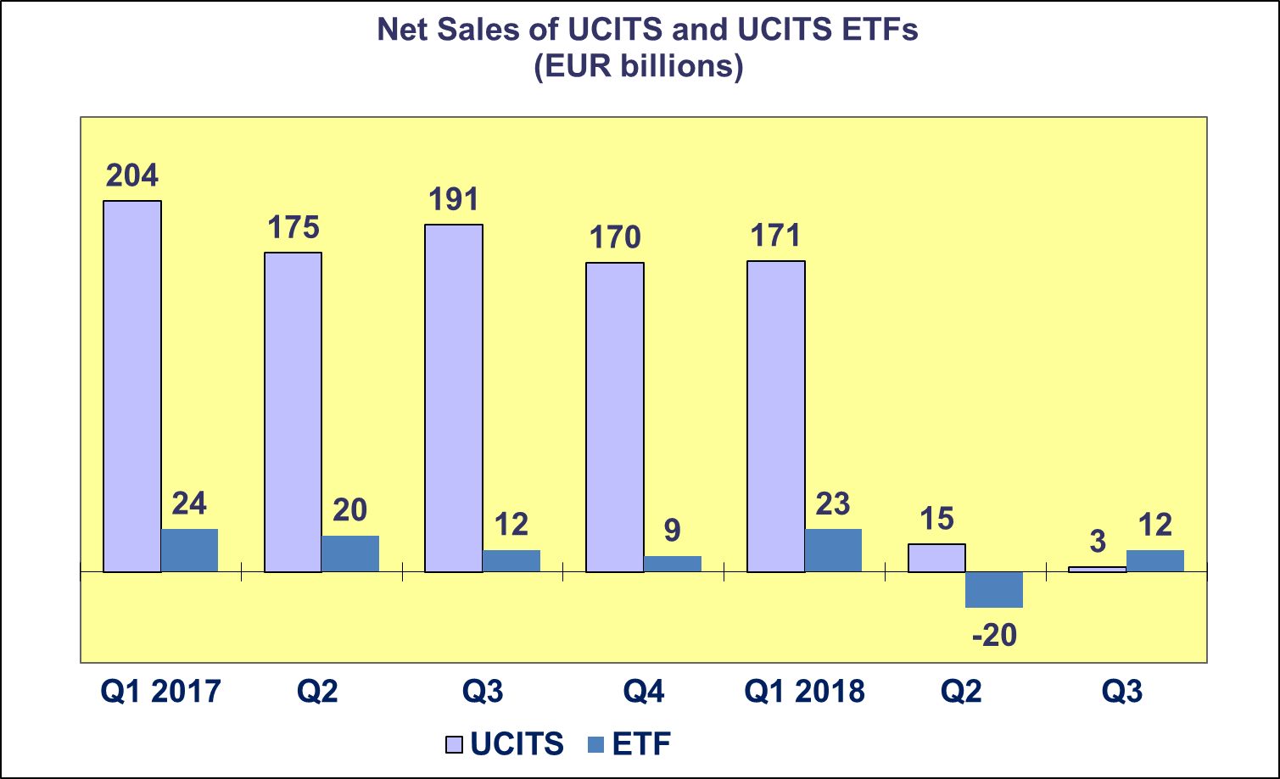

**Trends in the UCITS Market**

***Net Assets and Number of Funds by Investment Type***

**Net assets of UCITS increased by 1.1% in Q3 to reach EUR 9,968 billion.**

Equity funds recorded the largest increase in net assets (2.3%) in Q3 2018, followed by multi-asset funds (1.7%), and bond funds (0.3%). Decreases in net assets were registered in guaranteed/protected funds (5.0%), money market funds (0.9%) and other funds (0.6%).

The number of UCITS increased by 0.8% from 32,727 at end Q2 2018 to 32,987 at end Q3 2018.



**Trends in the UCITS Market**

***Net Assets by Country of Domiciliation***

**Twenty domiciles recorded net asset growth in Q3 2018, with net assets of UCITS reaching EUR 9,968 billion.**

Among the major domiciles, Ireland recorded the largest net asset growth (1.7 %), followed by Germany (1.4%), Luxembourg (0.9%) and the United Kingdom (0.4%). France recorded a small decrease in net assets (0.4%)

Net asset growth was also seen in all Nordic countries, with the largest increase in Sweden (6.2%), followed by Norway (3.8%), Denmark (2.2%). In Southern Europe, the largest growth was recorded in Cyprus (5.5%), followed by Malta (2.0%). In Central and Eastern Europe, large increases in net assets were recorded in Bulgaria (5.4%), Croatia (3.5%) and the Czech Republic (3.1%).



**Trends in the AIF Market**

***Net Sales by Investment Type***

**AIFs recorded net inflows of EUR 37 billion in Q3 2018, up from EUR 15 billion in Q2 2018. During the first three quarters of 2018, AIFs attracted net sales of EUR 104 billion.**

Long-term AIFs recorded net sales of EUR 38 billion, up from EUR 17 billion in Q2 2018. Equity funds registered net outflows of EUR 3 billion in the third quarter of 2018, compared to net outflows of EUR 9 billion in Q2 2018. Net sales of multi-asset funds reversed in Q3 2018, from outflows of EUR 1 billion in Q2 2018 to inflows of EUR 10 billion. Net outflows of bond funds amounted to EUR 4 billion at the end of the third quarter, compared to EUR 5 billion in the previous quarter. Net sales of other funds increased from EUR 21 billion in Q2 2018 to EUR 30 billion in Q3 2018.

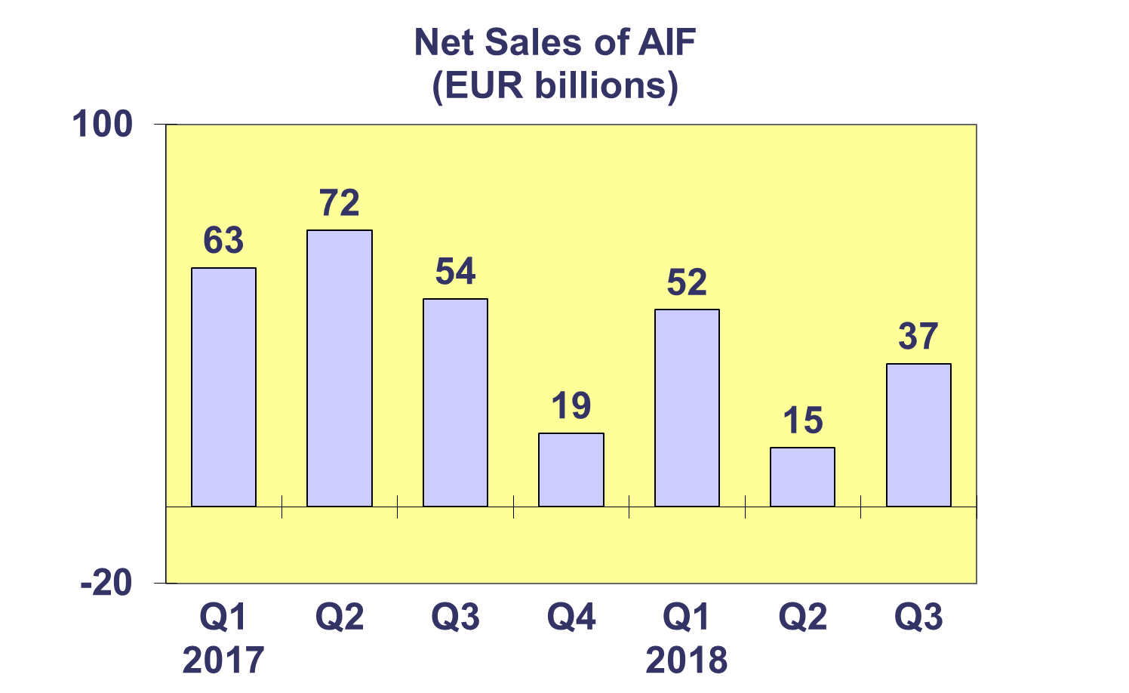

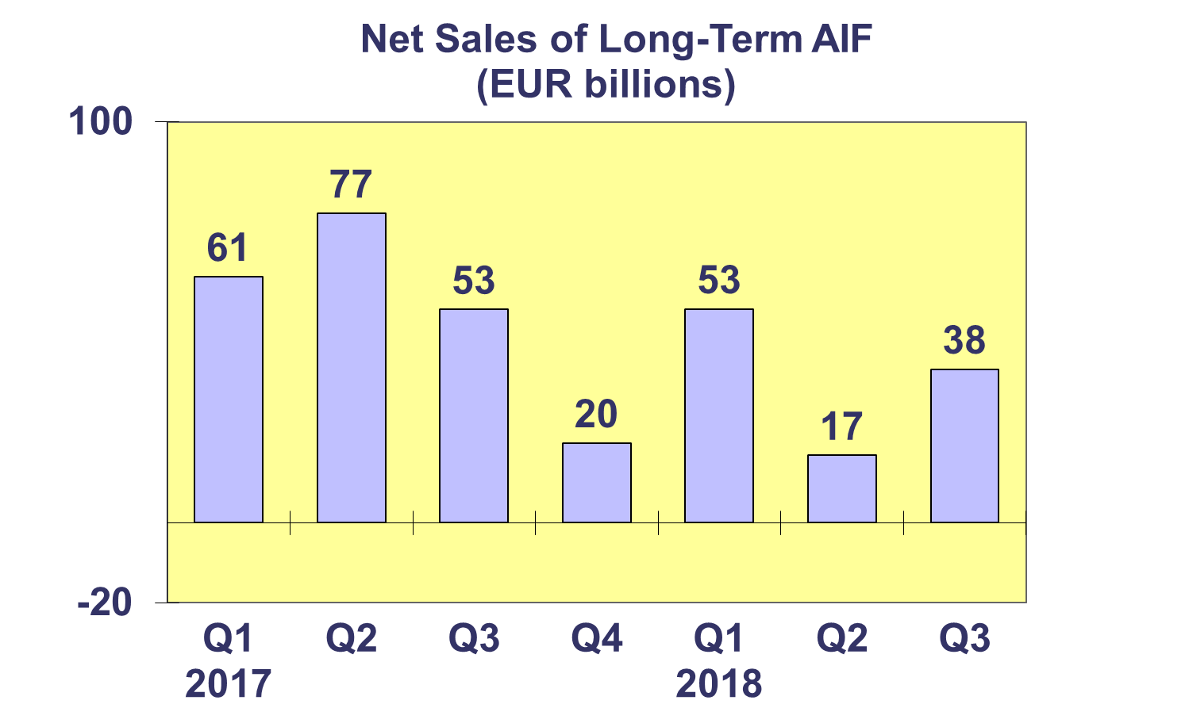

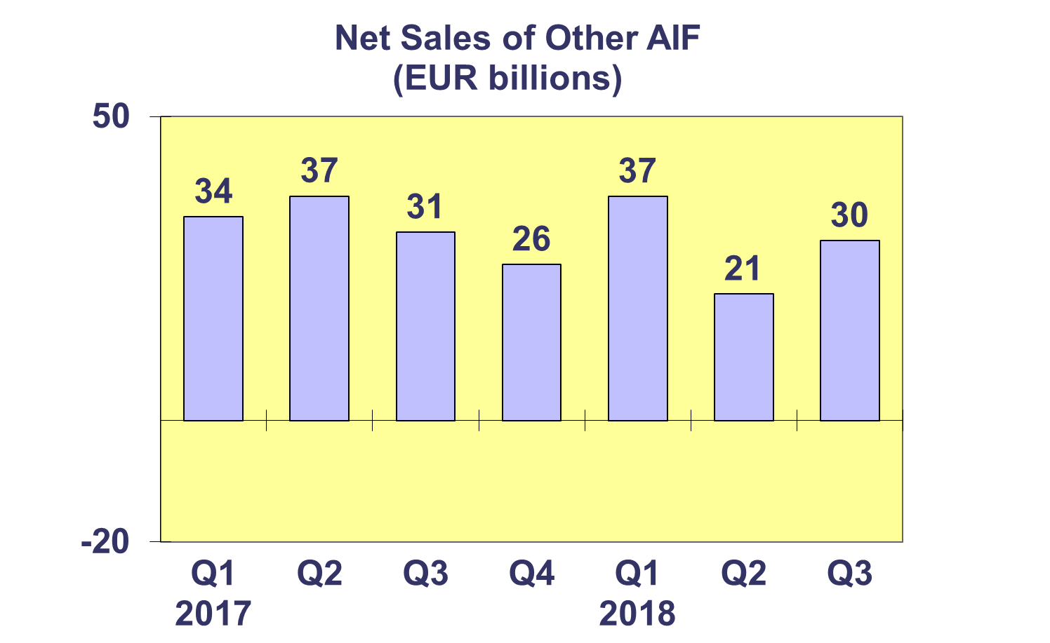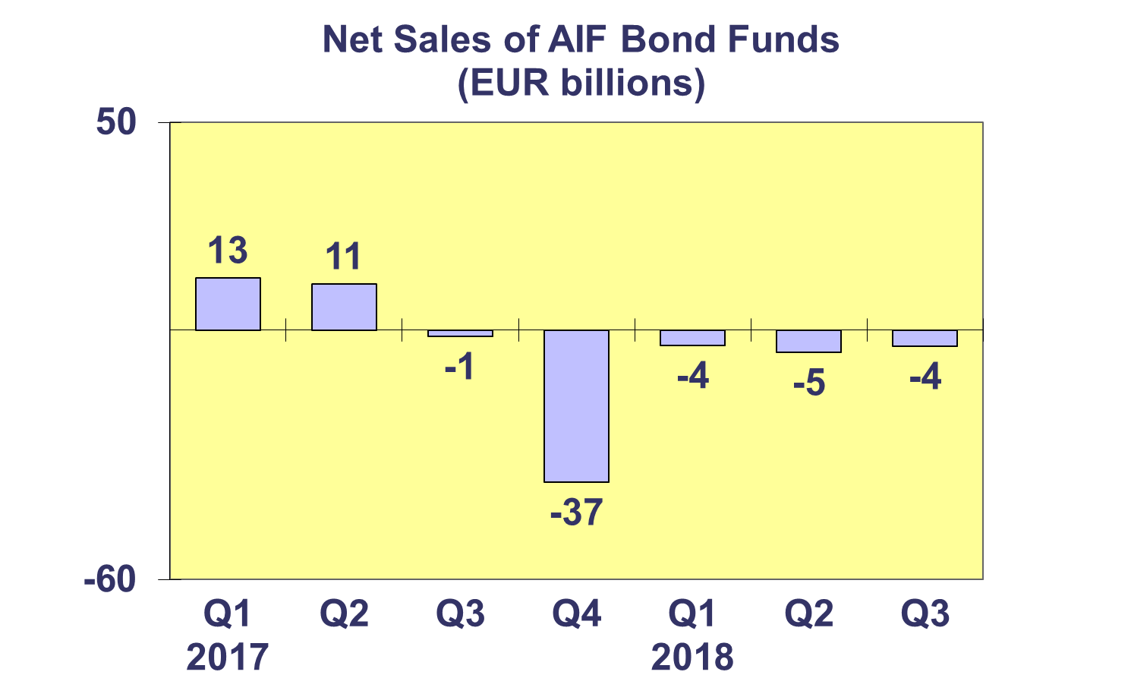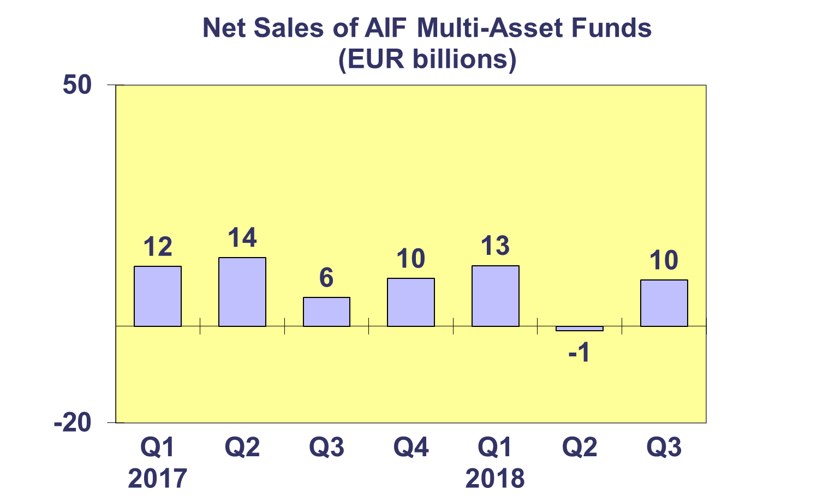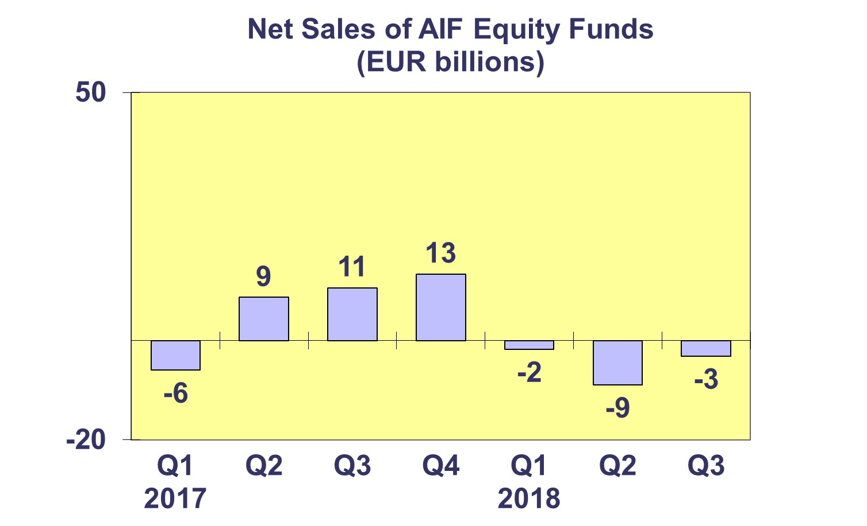**Trends in the AIF Market**

***Net Sales by Country of Domiciliation and Investment Type***

**Sixteen countries experienced net inflows into AIFs in Q3 2018, with five countries recording net sales higher than EUR 1 billion.**

Net sales above EUR 1 billion were registered in Germany (EUR 20.9 billion), Ireland (EUR 14.7 billion), Luxembourg (EUR 8.2 billion), the Netherlands (EUR 4.8 billion) and the United Kingdom (EUR 2.4 billion).

During the first three quarters of 2018, fifteen countries registered net inflows into AIFs, with particularly strong inflows in Germany (EUR 62.6 billion), Ireland (EUR 49.8 billion) and Luxembourg (EUR 26.6 billion).

**Trends in the AIF Market**

***Net Assets and Number of Funds by Investment Type***

**Net assets of AIFs increased by 1.4% in the third quarter of 2018 to reach EUR 6,064 billion.**

In Q3 2018, other funds recorded the largest asset growth (2.5%), followed by equity funds (2.1%), real estate funds (1.9%) and multi-asset funds (1.1%). Decreases in net assets were seen in guaranteed/protected funds (1.6%), money market funds (1.3%) and bond funds (0.9%).

There were 28,581 alternative investment funds at end Q3 2018, compared to 28,452 at end Q2 2018 and 28,353 at end 2017.



**Trends in the AIF Market**

***Net Sales and Assets of Institutional AIFs***

**Net assets of institutional AIFs, which are AIFs reserved for institutional investors, increased 1.4% to EUR 3,005 billion at end Q3 2018.**

Net assets of institutional funds recorded large increases in real estate fund (3.9%) and other funds (3.5%), to end the quarter at EUR 211 billion and EUR 401 billion, respectively. Multi-asset funds increased 1.4% to finish the quarter at EUR 1,037 billion and money market funds increased by 0.6% to EUR 10 billion. Both institutional equity funds and bond funds experienced a decrease in net assets, 0.2% and 1.5%, respectively.

Institutional AIFs recorded net sales of EUR 32.5 billion in Q3 2018, higher than in Q2 2018 (EUR 28.6 billion), but lower than in Q1 2018 (EUR 57.3 billion).



**Trends in the AIF Market**

***Net Assets by Country of Domiciliation***

**Nineteen domiciles recorded net asset growth in Q3 2018, with net assets of AIFs reaching EUR 6,064 billion.**

In the largest AIF domiciles, the largest net asset growth in Q3 2018 was seen in Ireland (2.8%), followed by the Netherlands (2.2%), the United Kingdom (1.7%), Germany (1.6%), Luxembourg (1.5%) and France (1.2%).

Elsewhere in Europe, net assets grew strongly in Czech Republic (9%), Sweden (7.0%) and Croatia (6.6%).



**Trends in the European Investment Fund Industry**

***Net Sales by Investment Type***

**The combined net sales of the investment industry market in Europe, i.e. the market for UCITS and AIFs, recorded net sales of EUR 40 billion during Q3 2018, up from EUR 31 billion in Q2 2018. From January until September 2018, European investment funds attracted net sales of EUR 293 billion.**

Net sales of equity funds increased to EUR 17 billion in Q3 2018, compared to EUR 1 billion in the previous quarter. Bond funds recorded net outflows of EUR 10 billion in Q3 2018, compared to net outflows of EUR 6 billion in Q2 2018. Net sales of multi-asset funds totalled EUR 20 billion in Q3 2018, down from EUR 27 billion in the previous quarter. Money market funds experienced net outflows of EUR 14 billion, compared to net outflows of EUR 19 billion in Q2 2018. Net sales of other funds (including real estate, guaranteed/protected funds and other funds which do not fit any of the categories below or for which information is not available) totalled EUR 27 billion, slightly lower than EUR 28 billion in Q2 2018.

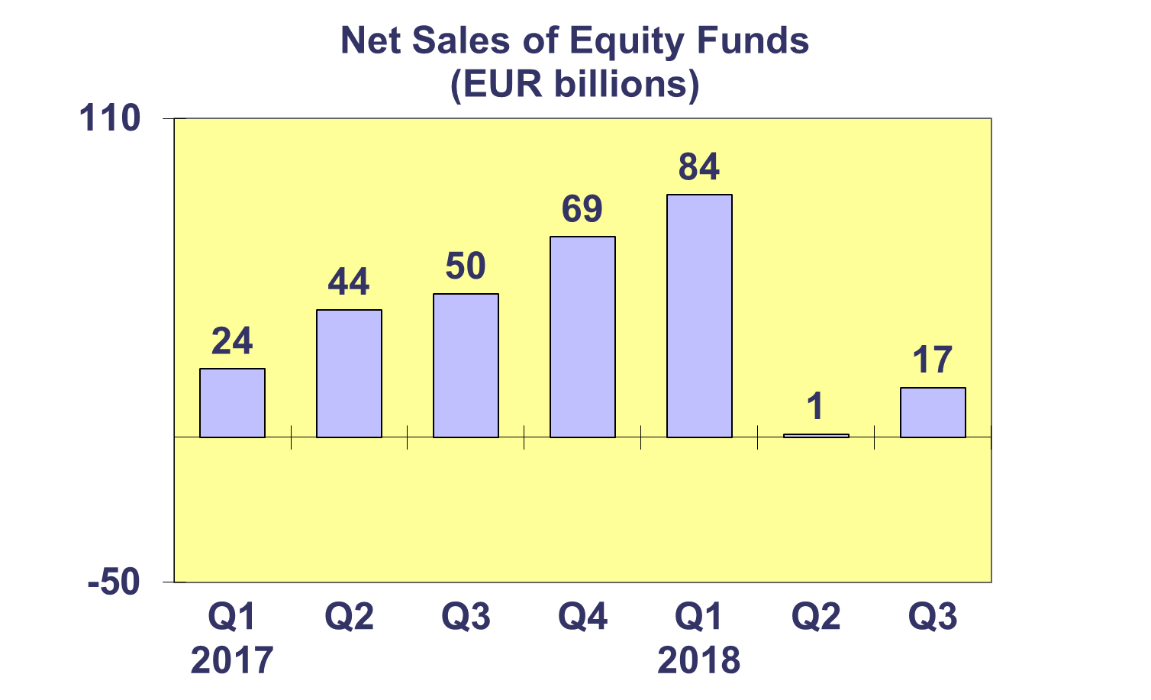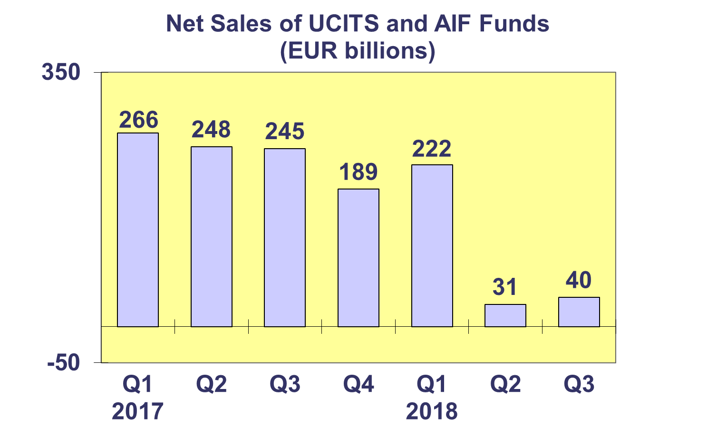

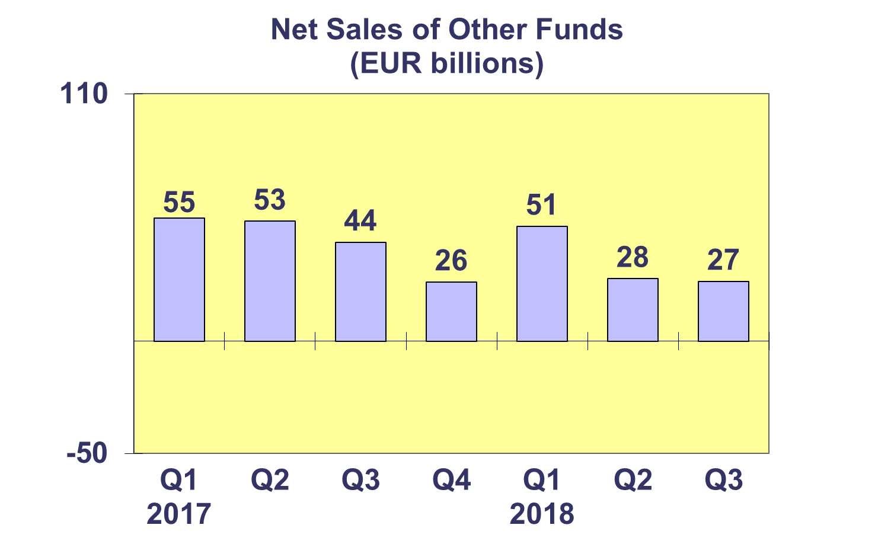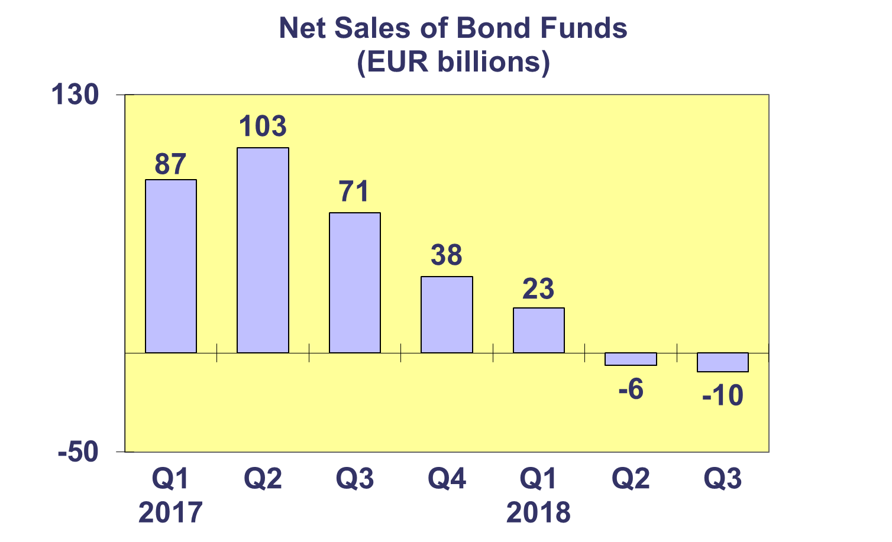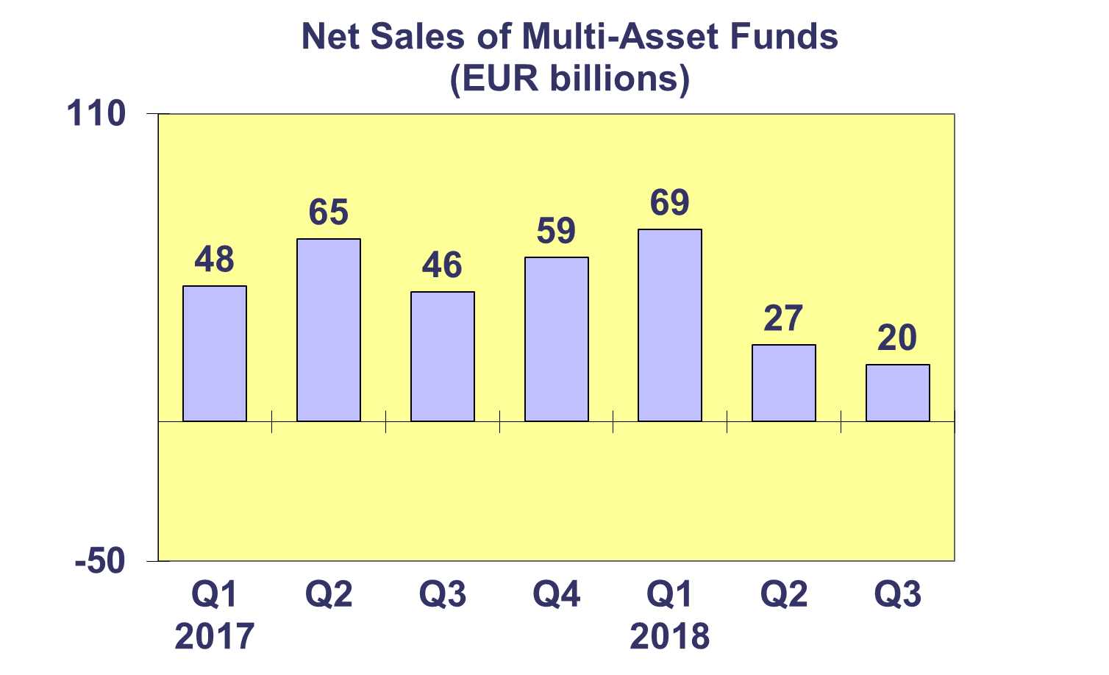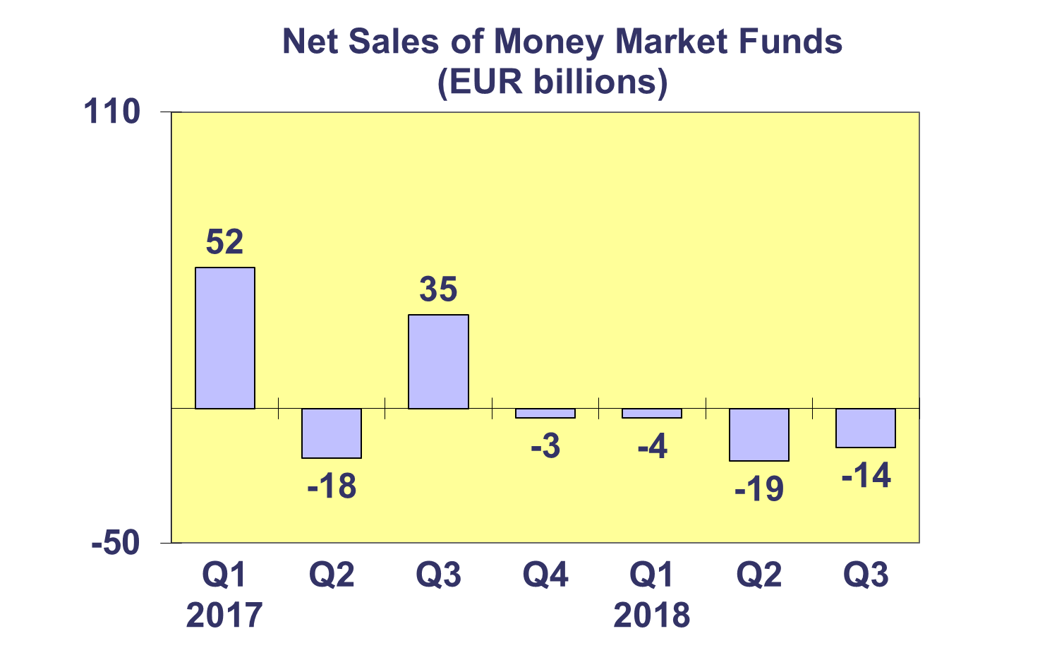**Trends in the European Investment Fund Industry**

***Net Assets by Country of Domiciliation***

**Total net assets of European investment funds increased by 1.2% in Q3 2018 to reach EUR 16,032 billion.**

With EUR 9,968 billion invested in UCITS, this segment accounted for 62.2 % of total European investment fund assets at end Q3 2018; with the remaining 37.8 % (EUR 6,064 billion) coming from AIFs.



**Trends in the European Investment Fund Industry**

***Number of Funds by Country of Domiciliation***

**In Q3 2018, the total number of UCITS and Alternative Investment Funds (AIFs) increased by 0.6% to 61,568.**

At the end of the third quarter of 2018, UCITS accounted for 32,987 funds or 53.6% of the European investment fund market, while AIFs accounted for 28,581 funds, or 46.4% of the market.

