|  |
| --- |
| ***Quarterly Statistical Release*** |

**December 2017 N° 71**

***This release and other statistical***

***releases are available on Efama’s***

***website (***[***www.efama.org***](http://www.efama.org)***)***

***Trends in the European Investment Fund Industry***

***in the Third Quarter of 2017***

|  |
| --- |
| **This report was prepared by Alex Carroll, Thomas Tilley and Bernard Delbecque**  **EFAMA**  **The European Fund and Asset Management Association**  **Rue Montoyer 47 - B-1000 BRUXELLES - Tel. 32-2-513.39.69 Fax: 32-2-513.26.43 - e-mail: info@efama.org** |

**Trends in the UCITS Market**

***Net Sales by Investment Type***

**UCITS recorded net sales of EUR 190 billion during Q3 2017, compared to EUR 175 billion in the second quarter of 2017. During the first three quarters of 2017, UCITS have attracted cumulative net sales of EUR 568 billion, compared to annual net sales of EUR 271 billion in 2016 and EUR 602 billion in 2015.**

Long-term UCITS recorded net sales of EUR 157 billion in Q3 2017, down from EUR 188 billion in Q2 2017. Net sales of equity funds amounted to EUR 39 billion, compared to EUR 35 billion in Q2 2017. Net sales of multi-asset funds decreased from EUR 54 billion in Q2 2017 to EUR 43 billion in Q3 2017. Net sales of bond decreased from EUR 93 billion in Q2 to EUR 72 billion in Q3 2017. Net sales of money market funds saw a reversal in net flows, increasing from net outflows of EUR 13 billion in Q2 to net inflows of EUR 33 billion in Q3 2017.

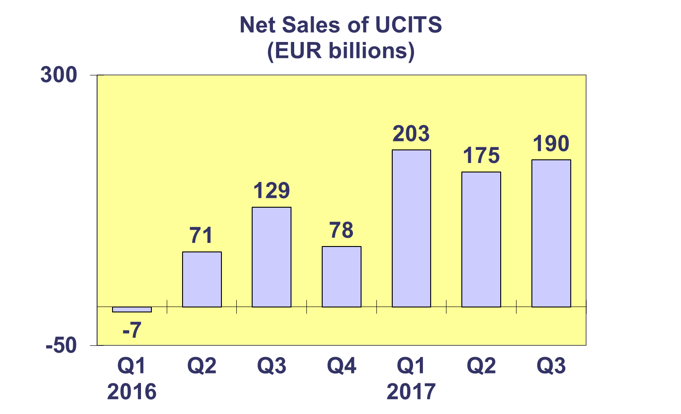

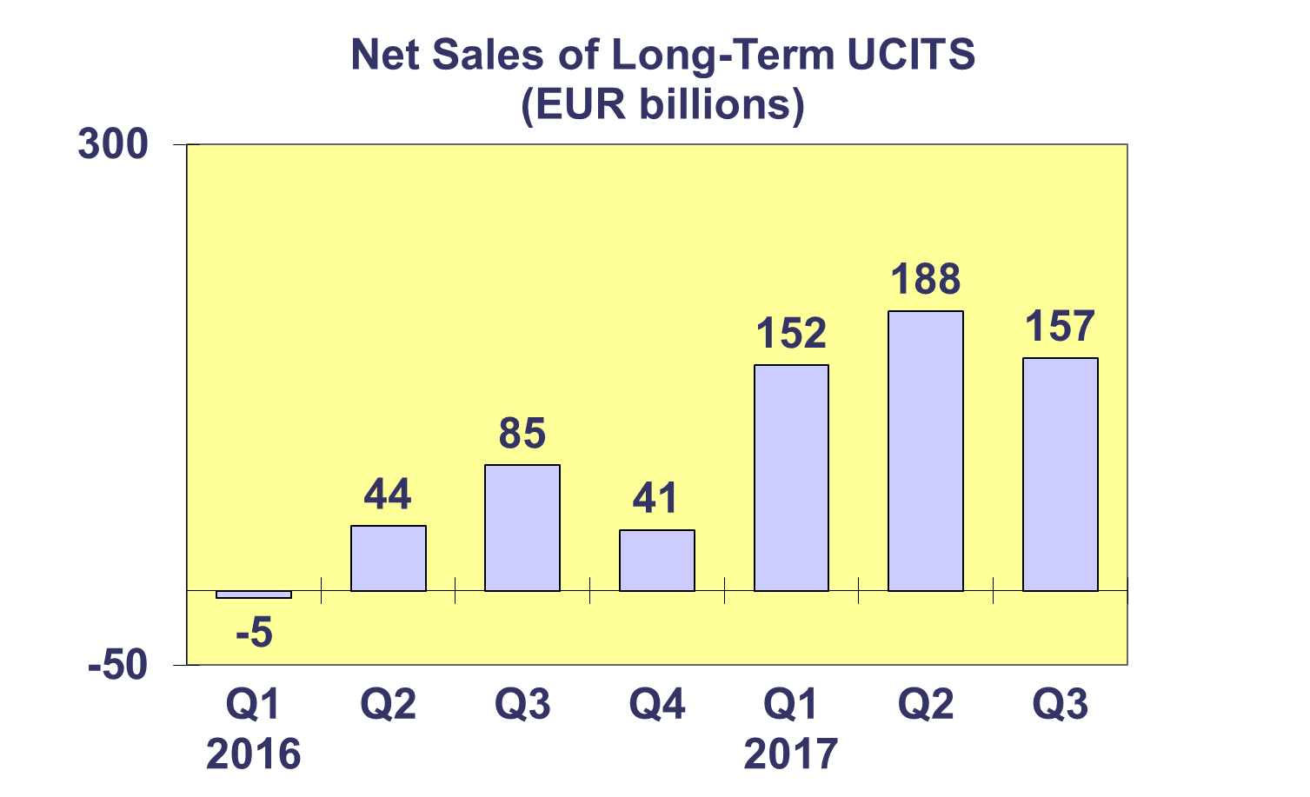

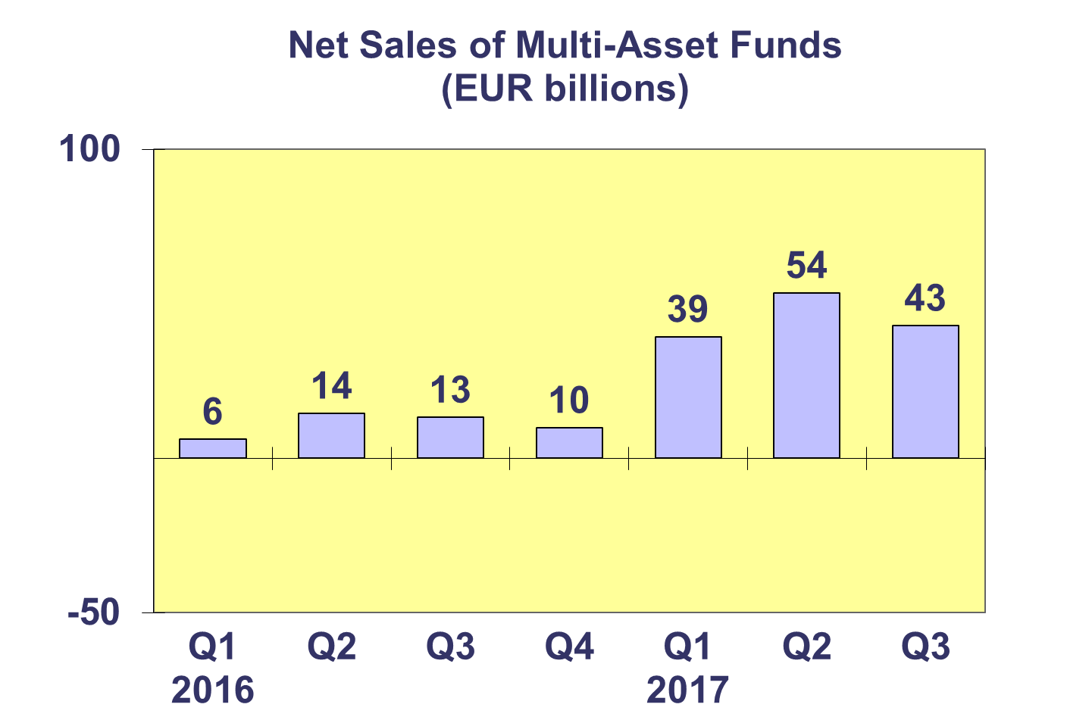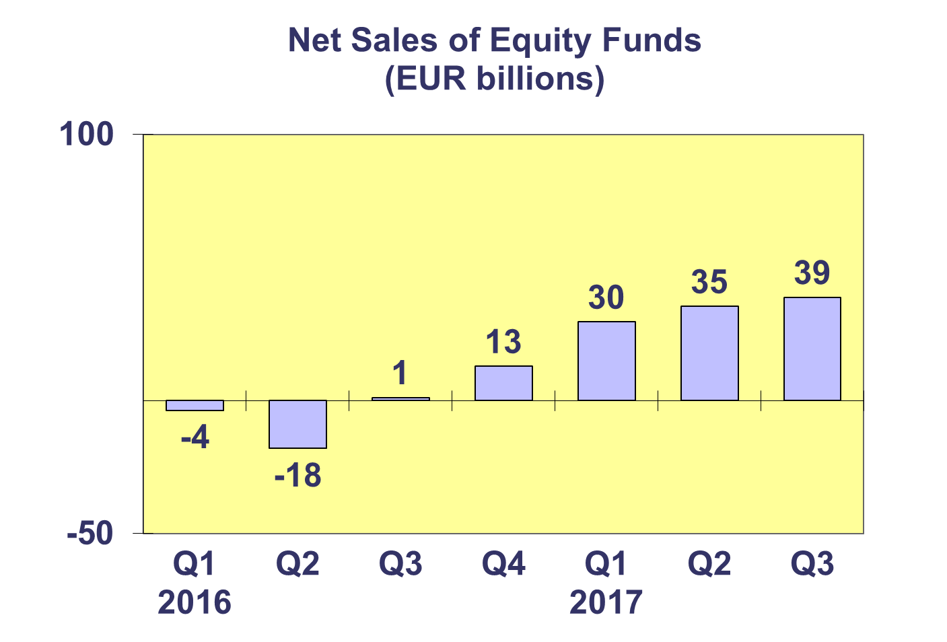

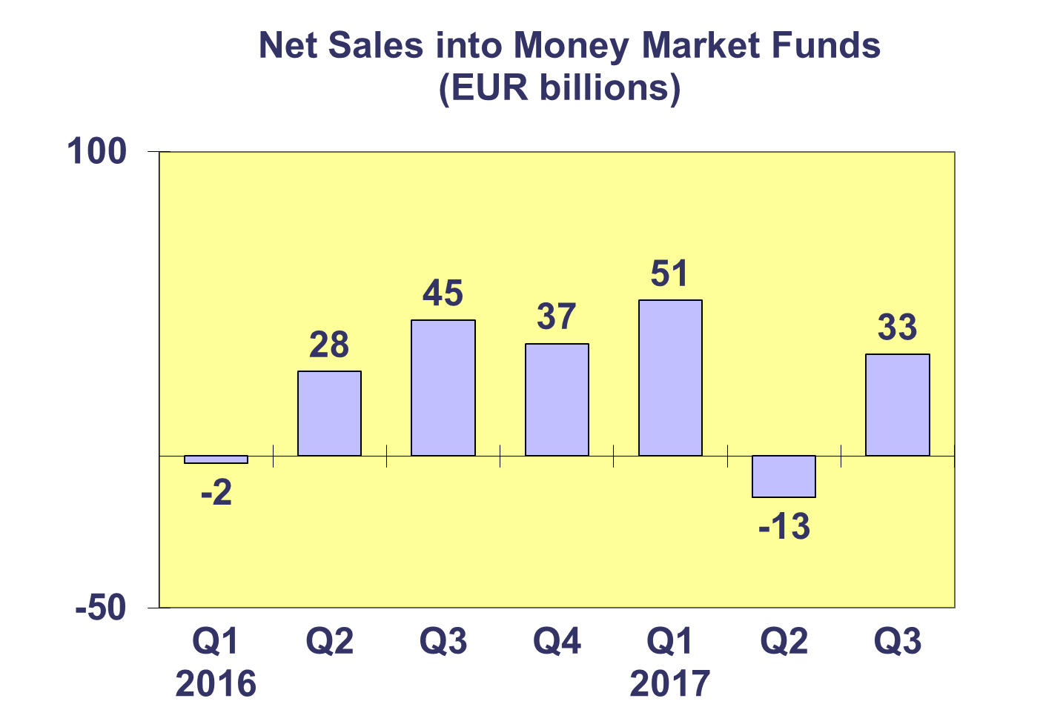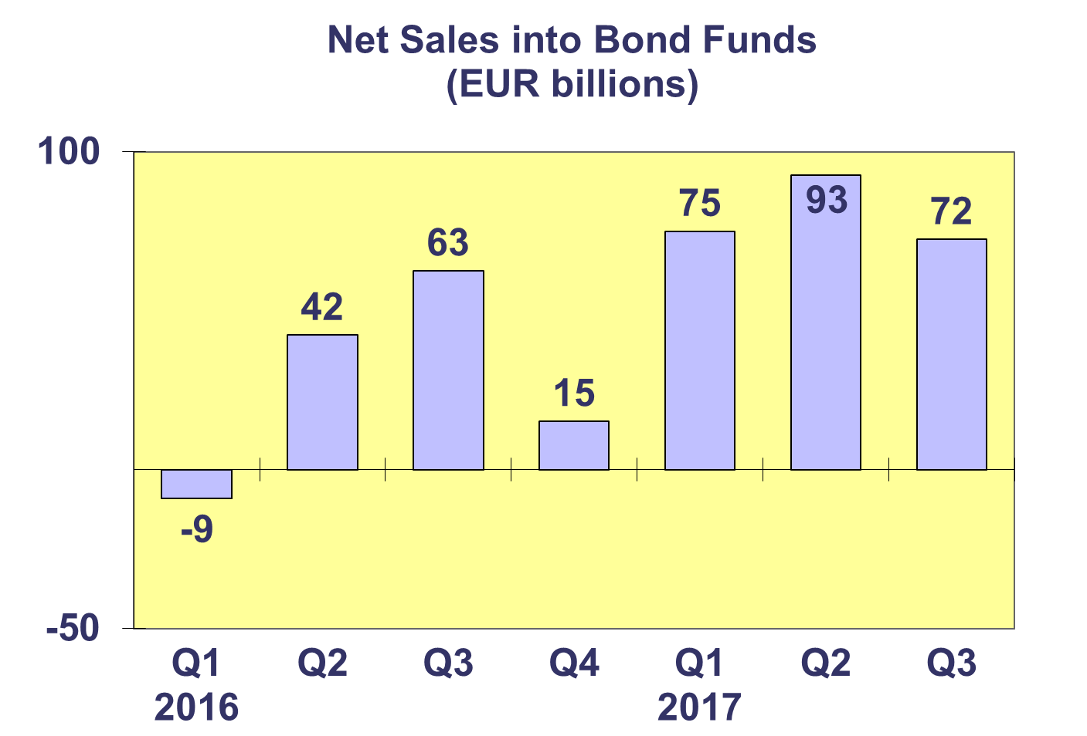**Trends in the UCITS Market**

***Net Sales by Country of Domiciliation and Investment Type***

**Twenty-six countries registered net inflows into UCITS in the third quarter of 2017, with ten countries recording net sales above EUR 1 billion.**

The five domiciles with the largest net sales into UCITS were Luxembourg (EUR 75.3 billion), followed by Ireland (EUR 51.3 billion), France (EUR 25.4 billion), the United Kingdom (EUR 12.5 bn), and Germany (EUR 9.4 bn).

**Trends in the UCITS Market**

***Net Sales and Net Assets of ETF by Country of Domiciliation***

**Net sales of UCITS ETF amounted to EUR 12.1 billion in Q3 2017, down from EUR 20 billion in the second quarter. UCITS ETF have attracted net sales of EUR 55.7 billion so far this year.[1]**

UCITS ETF domiciled in Ireland registered the largest net sales during the quarter (EUR 10.3 billion) reflecting the size of their ETF market, followed by Germany (EUR 2.4 billion). Looking at cumulative year-to-date net sales, Ireland has so far attracted the largest net sales (EUR 42.6 billion).



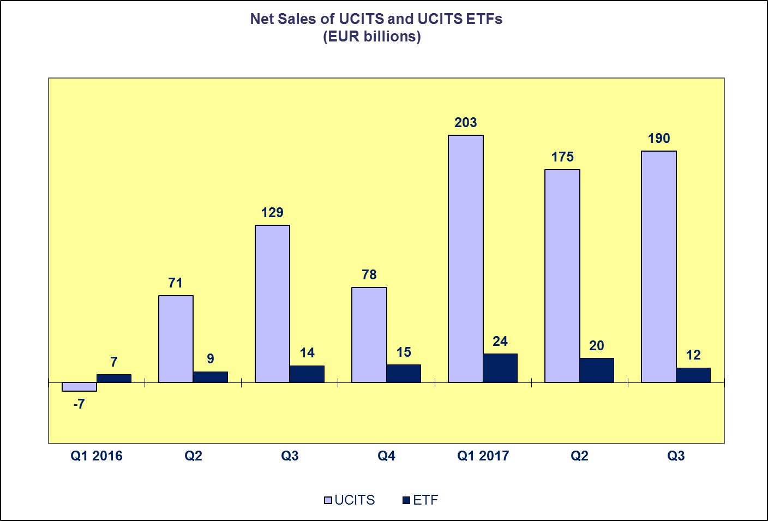**Trends in the UCITS Market**

***Net Assets by Investment Type***

**Net assets of UCITS increased by 2.6% to reach EUR 9,416 billion in Q3 2017.**

All categories of UCITS funds experienced an increase in net assets in Q3 2017, with the exception of guaranteed funds which experienced a net asset decrease of 3.5%. Net assets of equity funds and multi-asset funds increased 2.9%, followed by bond funds (2.5%), and money market funds (1.8%). Other UCITS funds increased 1% in Q3 2017.

The number of UCITS funds increased to 31,491 at end Q3 2017.



**Trends in the UCITS Market**

***Net Assets by Country of Domiciliation***

**Twenty-three domiciles recorded net asset growth at end Q3 2017, with net assets of UCITS reaching EUR 9,416 billion.**

In Western Europe, the Netherlands recorded the largest net asset growth (4.7%), followed by Germany (4.0%) and France (3.9%). With the exception of Greece, all domiciles in the Southern European region experienced net asset growth with the largest growth in Cyprus (18.0%). Net asset growth was seen across the board in the Nordic countries, with the largest net asset increase registered in Norway (5.1%). In Central and Eastern Europe, the largest increase in net assets was recorded in Bulgaria (8.7%).



**Trends in the AIF Market**

***Net Sales by Investment Type***

**AIF recorded net sales of EUR 56 billion in Q3 2017. During the first three quarters of 2017, AIF attracted net sales of EUR 193 billion, higher than the total net sales of EUR 186 billion in 2016 and EUR 161 billion in 2015.**

Long-term AIF recorded net sales of EUR 55 billion, down from EUR 79 billion in Q2 2017. Net sales of equity funds increased from EUR 8 billion in the second quarter to EUR 10 billion in the third quarter. Net sales of multi-asset funds decreased from EUR 14 billion in Q2 2017 to EUR 6 billion in Q3 2017. Net sales of bond funds amounted to EUR 1 billion at the end of the quarter, lower than in the previous quarter (EUR 11 billion). Net sales of other funds decreased from EUR 39 billion in Q2 2017 to EUR 31 billion in Q3 2017.

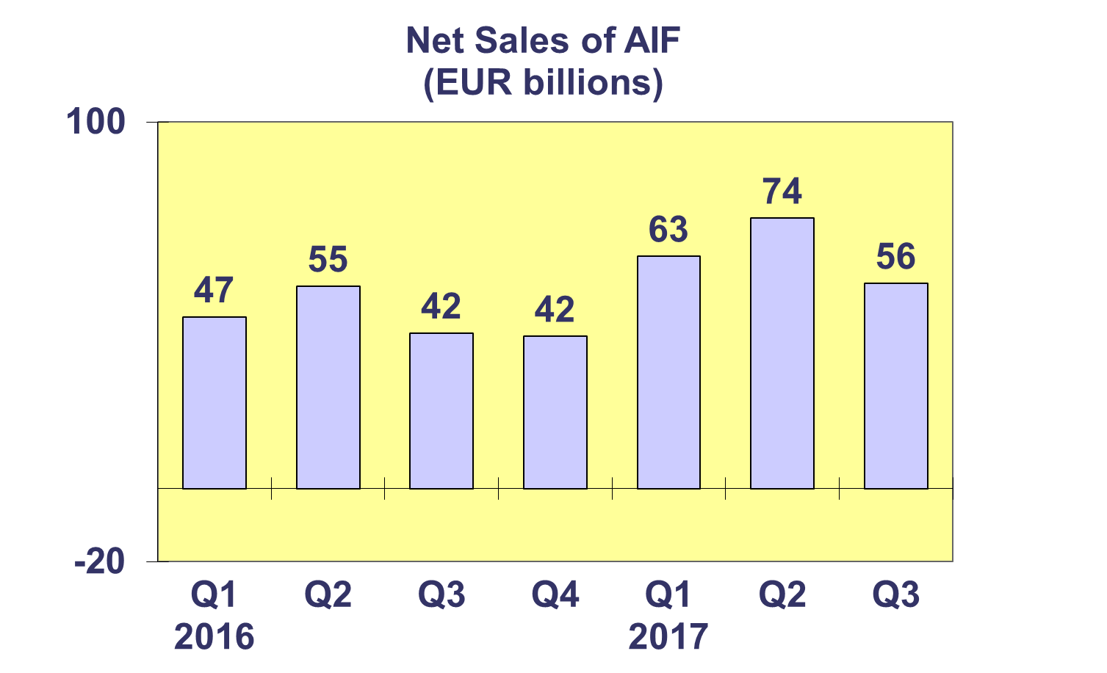

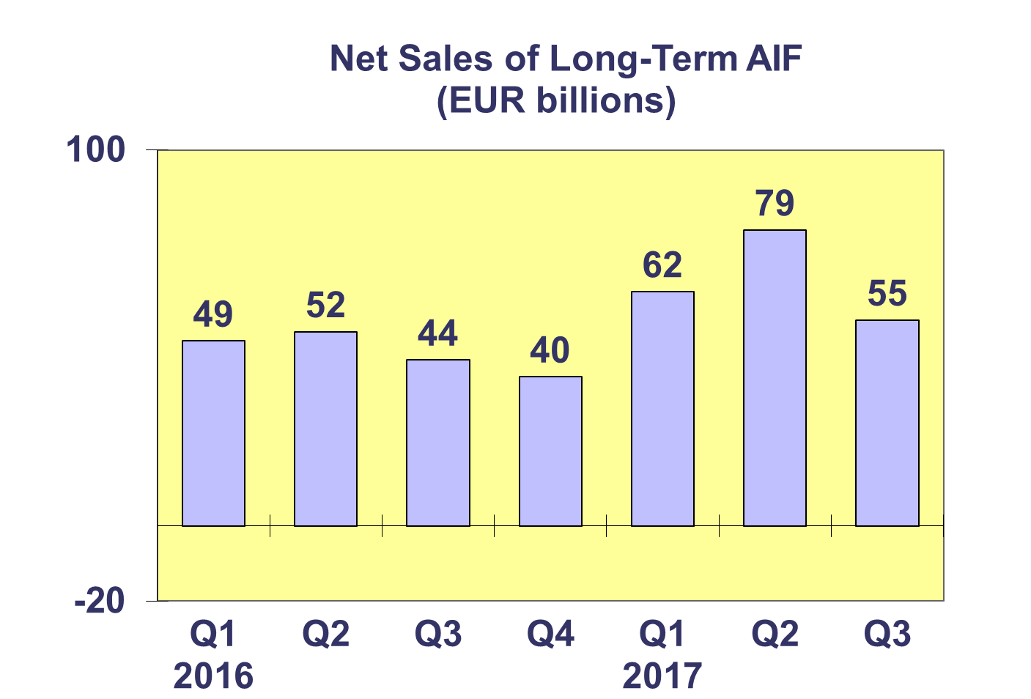

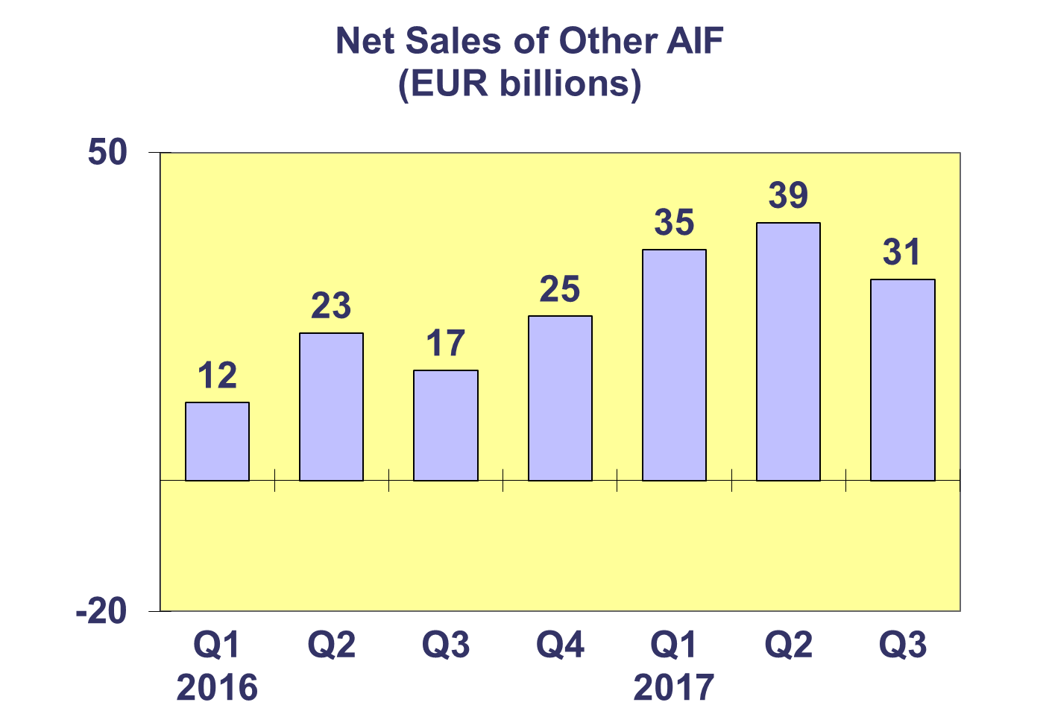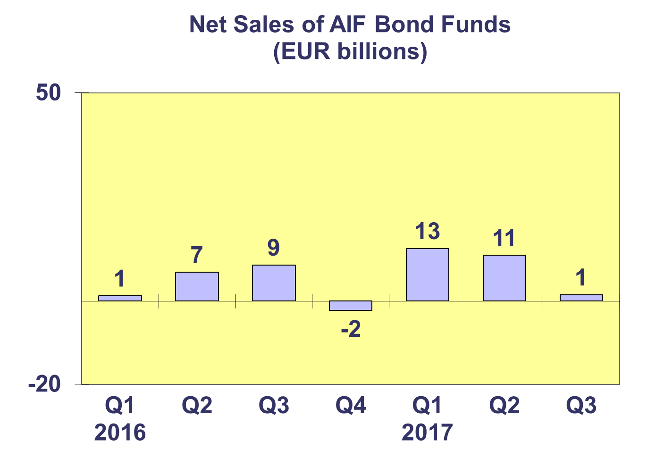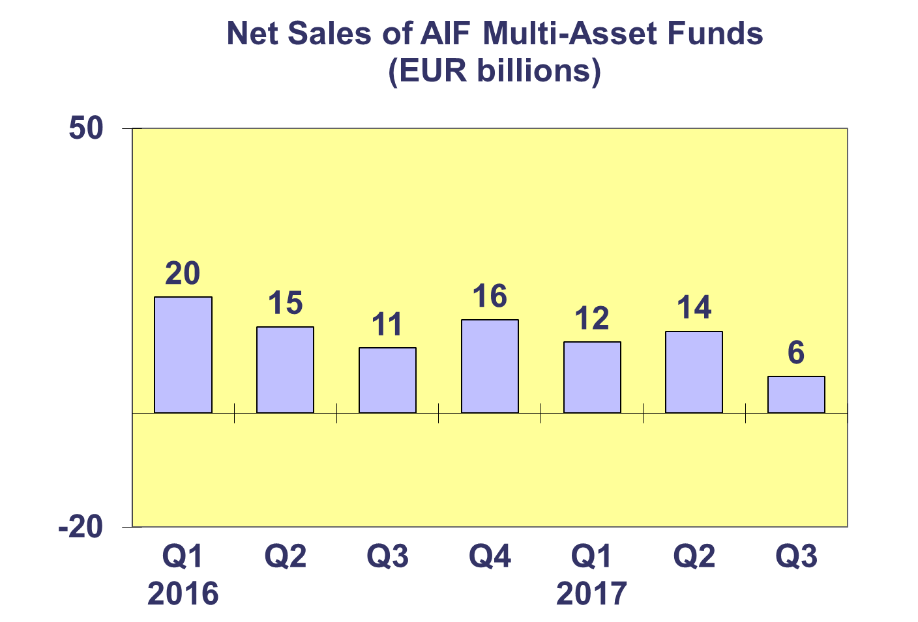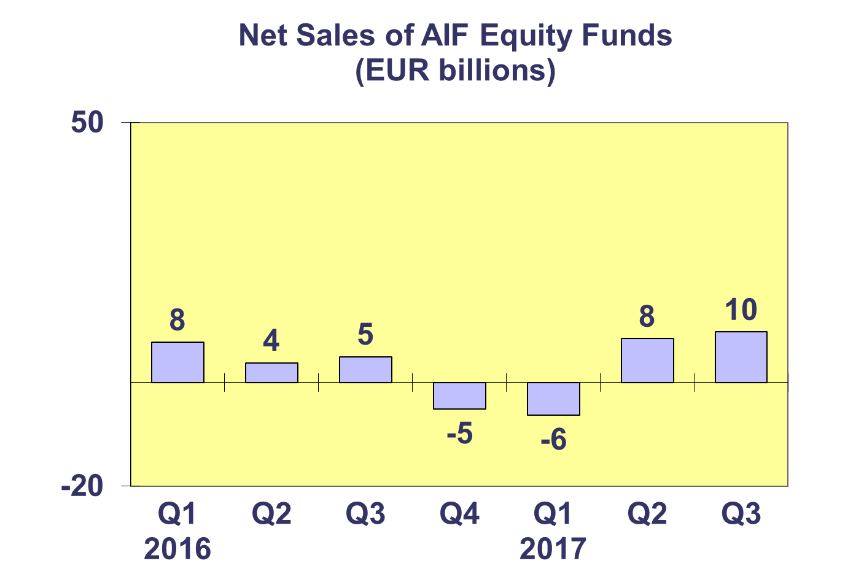**Trends in the AIF Market**

***Net Sales by Country of Domiciliation and Investment Type***

**Seventeen countries experienced net inflows into AIF in Q3 2017, with seven countries recording net sales higher than EUR 1 billion.**

Net sales above EUR 1 billion were registered in Germany (EUR 16.7 billion), the Netherlands (EUR 16.5 billion), Ireland (EUR 15.5 billion), the United Kingdom (EUR 2.9 billion), Denmark (EUR 2.3 billion), Austria (1.8 billion) and Luxembourg (EUR 1.0 billion).

All categories of AIF funds registered net inflows during Q3 2017, with other funds experiencing large inflows in particular.



**Trends in the AIF Market**

***Net Assets by Investment Type***

**Net assets of AIF increased by 1.7% in the third quarter to reach EUR 5,847 billion.**

In Q3 2017, equity funds recorded the largest asset growth (3.6%), followed by other funds (2.4%), money market funds (1.6%), real estate funds (1.5%) and multi-asset funds (1.3%). Net assets of bond funds remained stable during Q3 2017 at EUR 1,044 billion.

The net assets of exchange-traded AIF funds grew briskly during Q3 2017 (6.3%), however their share as a percentage of total AIF remains very small (0.2%).

The number of AIF funds increased to 28,447 at end Q3 2017.



**Trends in the AIF Market**

***Net Sales and Assets of Institutional AIF***

**Net assets of institutional AIF, which are AIF reserved for institutional investors, increased 2.1% to EUR 2,808 billion at end Q3 2017.**

Net assets of institutional funds recorded large increases in money market funds (6.2%) and other funds (4.6%), to end the quarter at EUR 10 billion and EUR 323 billion, respectively. Real estate funds increased 2.8% to finish the quarter at EUR 179 billion and institutional equity funds increased by 2.7% to EUR 230 billion. Multi-asset funds experienced net asset growth of 1.7% to reach EUR 1,015 billion. Net assets of bond funds remained more or less stable at EUR 573 billion.

Institutional AIF recorded net sales of EUR 38.6 billion in Q3 2017, lower than in Q2 2017 (EUR 46.0 bn) but higher than in Q1 2017 (EUR 38.8 bn).



**Trends in the AIF Market**

***Net Assets by Country of Domiciliation***

**Net assets of AIF increased 1.7% compared to the previous quarter and 6.3% compared to end 2016.**

In the largest AIF domiciles, the largest net asset growth in Q3 2017 was seen in the United Kingdom (2.8%), followed by the Netherlands (2.7%), Ireland (2.6%), Germany (2.1%), France (1.2%) and Luxembourg (0.1%). Elsewhere in Europe, net assets grew strongly in Croatia (10.3%), the Czech Republic (7.0%) and Belgium (5.2%).



**Trends in the European Investment Fund Industry**

***Net Sales by Investment Type***

**The combined net sales of the investment industry market in Europe, i.e. the market for UCITS and AIF, recorded net sales of EUR 246 billion during Q3 2017, compared to EUR 249 billion in Q2 2017. From January until September 2017, European investment funds have attracted net sales of EUR 761 billion, setting 2017 on course to outperform the previous record-breaking year of 2015 (EUR 763 billion).**

Net sales of equity funds increased to EUR 48 billion in Q3 2017, compared to EUR 44 billion in the previous quarter. Net sales of bond funds decreased from EUR 104 billion in Q2 to EUR 74 billion in Q3 2017. Net sales of multi-asset funds totalled EUR 49 billion in Q3 2017, down from EUR 68 billion in the previous quarter. Money market funds experienced net inflows amounting to EUR 35 billion, compared to net outflows of EUR 18 billion in the second quarter of 2017. Net sales of other funds (including real estate, guaranteed/protected funds and other funds which do not fit any of the categories below or for which information is not available) totalled EUR 40 billion, lower than EUR 52 billion during the previous quarter.

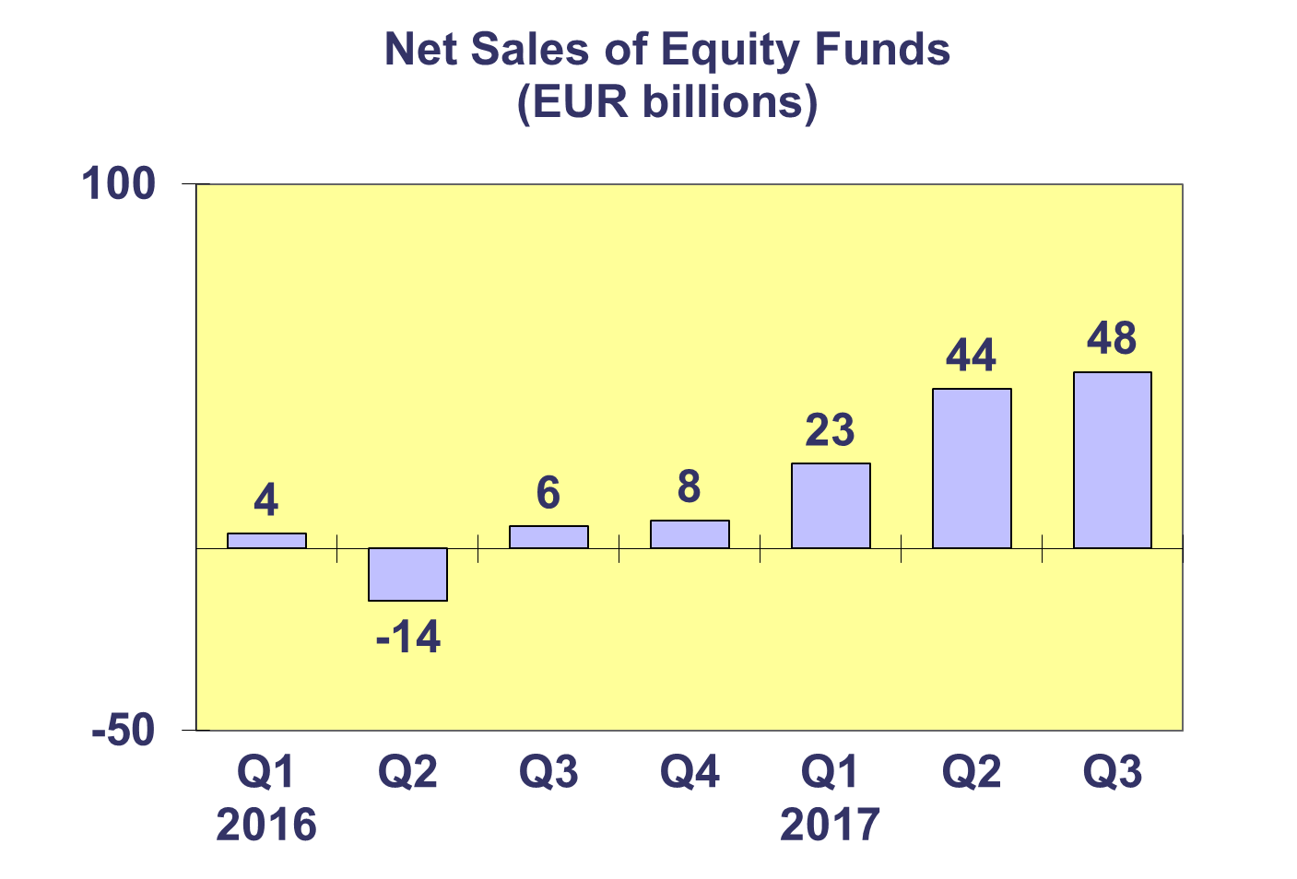

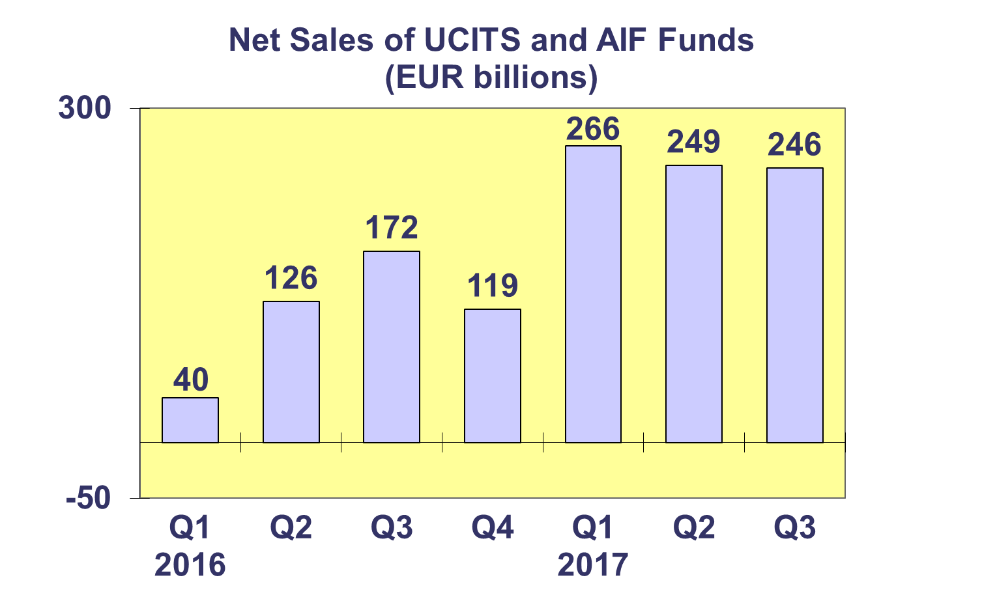

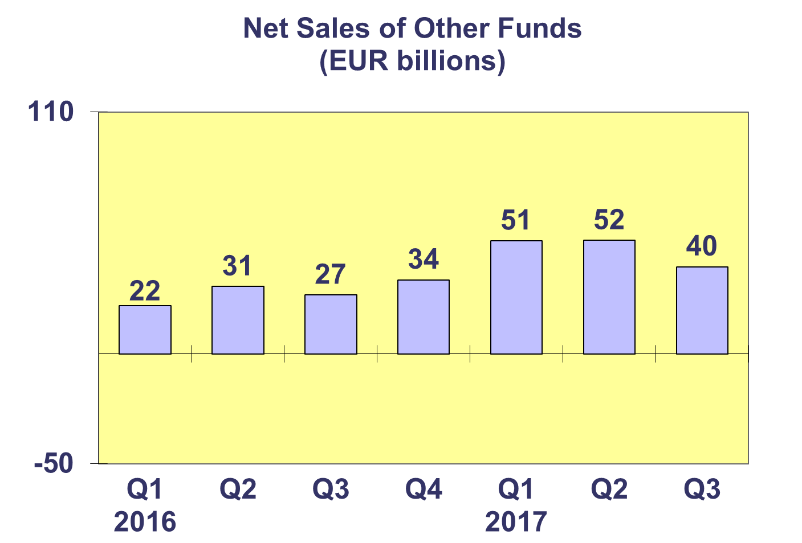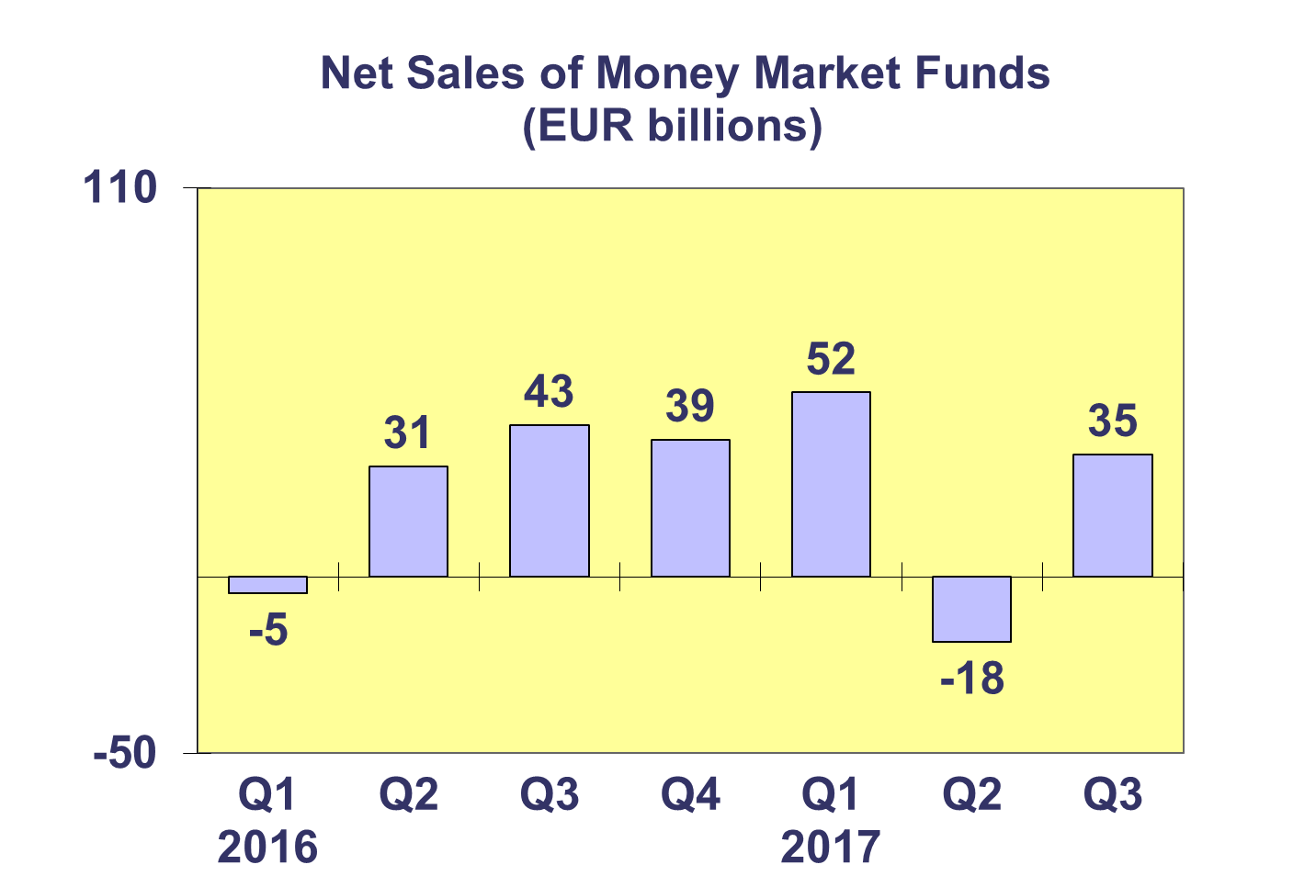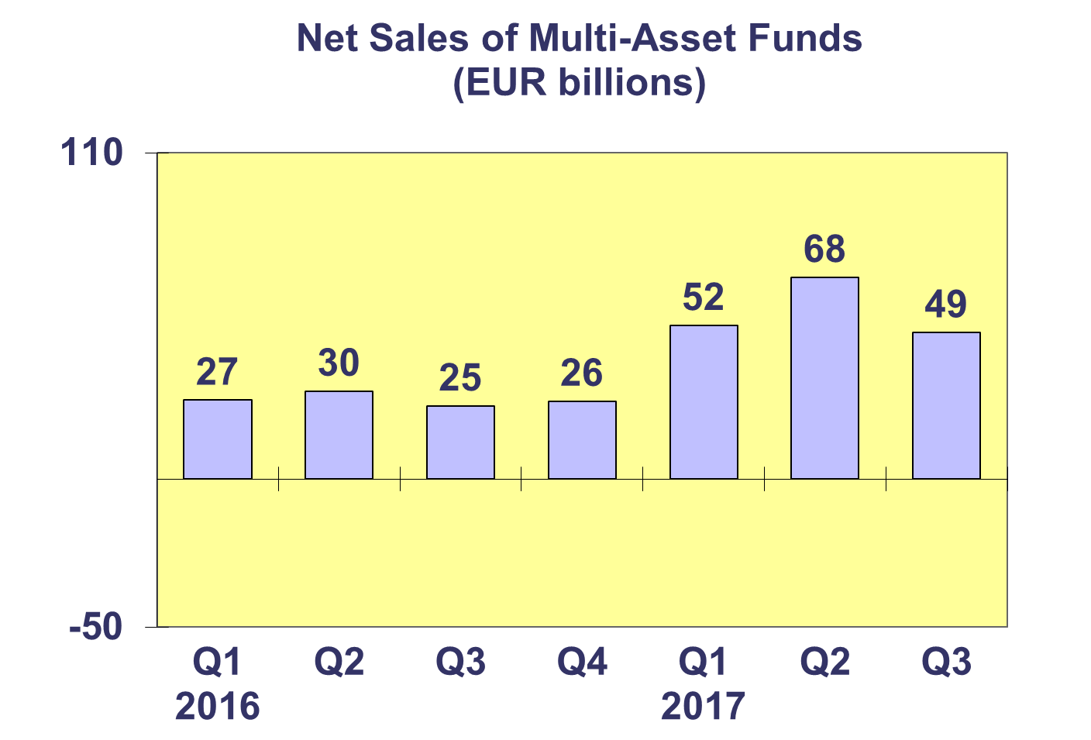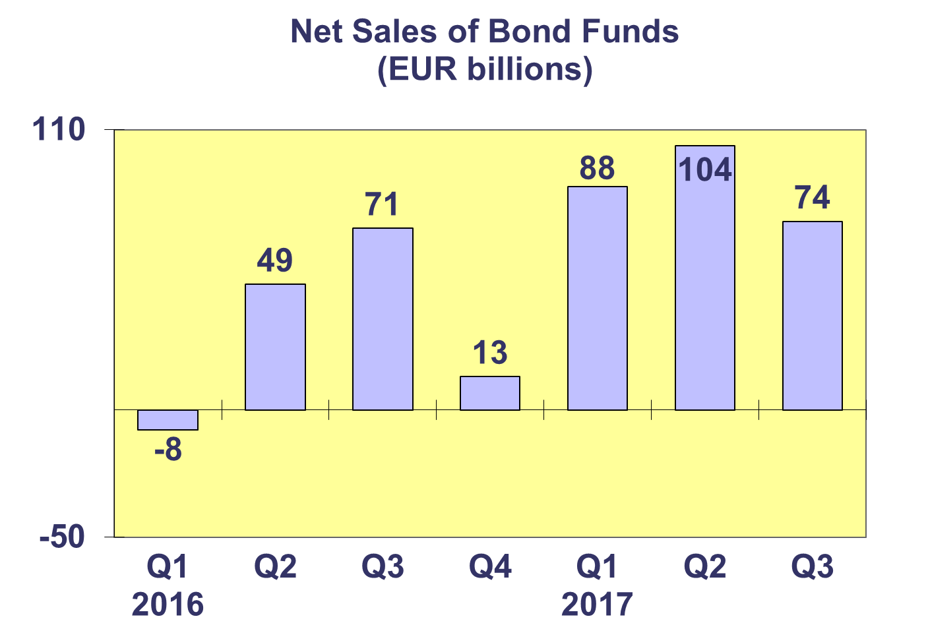

**Trends in the European Investment Fund Industry**

***Net Assets by Country of Domiciliation***

**Total net assets of the European investment increased to EUR 15,263 billion at end Q3 2017, representing net asset growth of 2.2% since Q2 2017 and 7.8% since end 2016.**

With EUR 9,416 billion invested in UCITS, this segment accounted for 61.7% of total European investment fund assets at end Q3 2017, with the remaining 38.3% (equivalent to EUR 5,847 billion) coming from AIF.



**Trends in the European Investment Fund Industry**

***Number of Funds by Country of Domiciliation***

**In Q3 2017, the total number of UCITS and AIF funds increased by 0.3% to 59,941.**

At the end of the third quarter of 2017, UCITS accounted for 31,491 funds or 52.5% of the European investment fund market, while AIF accounted for 28,447 funds, or 47.5% of the market.



1. Please note that this data does not include net sales of UCITS ETF domiciled in Luxembourg.