Quarterly Statistical Release

December 2016, N° 67

This release and other statistical
releases are available on Efama’s
website (www.efama.org)

Trends in the European Investment Fund Industry

in the Third Quarter of 2016

This report introduces new information about net sales of UCITS and AIF as well as UCITS ETF.

This report was prepared by Bernard Delbecque and Alex Carroll

EFAMA
The European Fund and Asset Management Association

Rue Montoyer 47 - B-1000 BRUXELLES - Tel. 32-2-513.39.69 Fax: 32-2-513.26.43 - e-mail: info@efama.org

Trends in the UCITS Market

Net Sales by Investment Type

UCITS recorded net inflows of EUR 129 billion during Q3 2016, compared to EUR 71 billion in the second quarter of 2016.

Long-term UCITS recorded net inflows of EUR 84 billion in Q3 2016, up from EUR 44 billion in Q2 2016. Net sales of equity funds amounted to EUR 1 billion, against net outflows of EUR 18 billion in Q2 2016. Net sales of multi-asset funds slightly decreased from EUR 14 billion in Q2 to EUR 13 billion in Q3 2016. Net sales of bond increased from EUR 42 billion in Q2 to EUR 63 billion in Q3 2016. Net sales of money market funds increased from EUR 28 billion in Q2 to EUR 45 billion in Q3 2016.
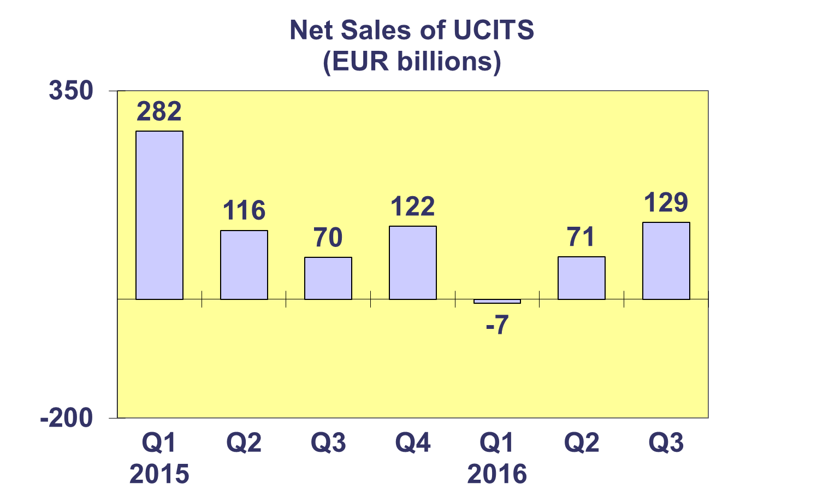
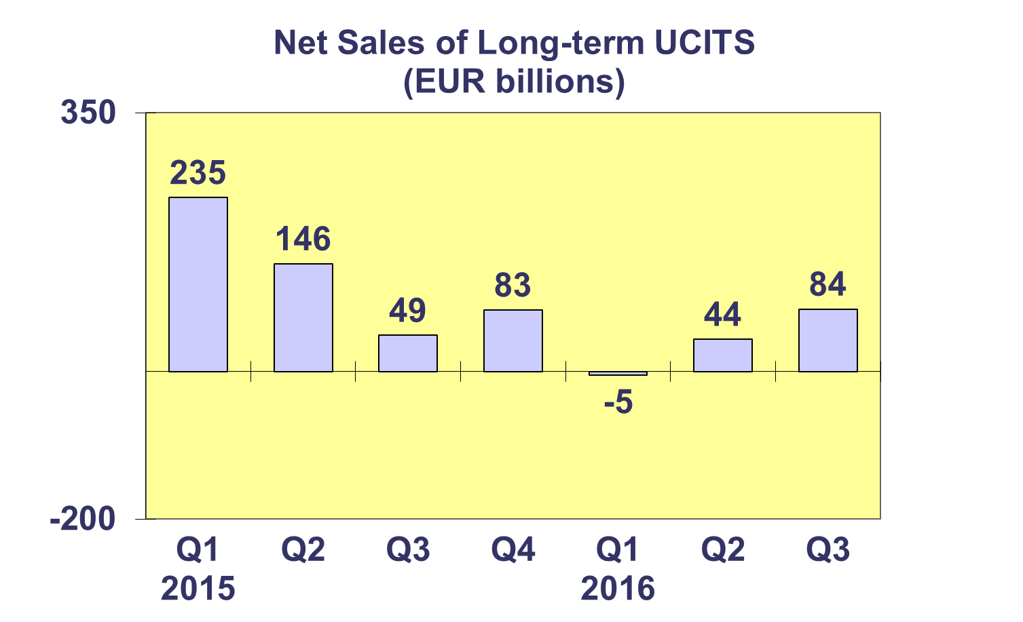

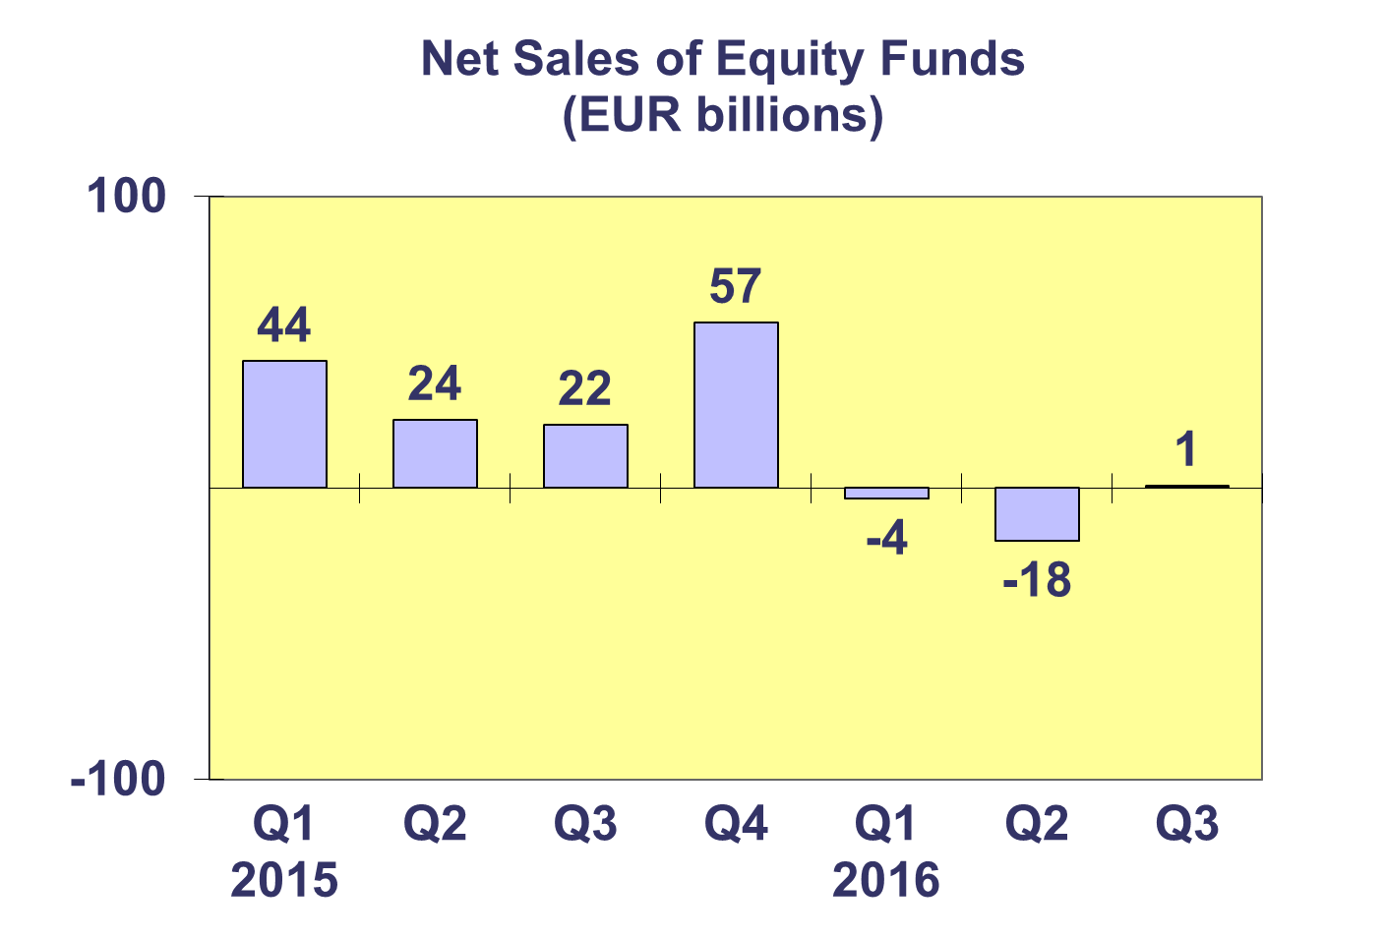
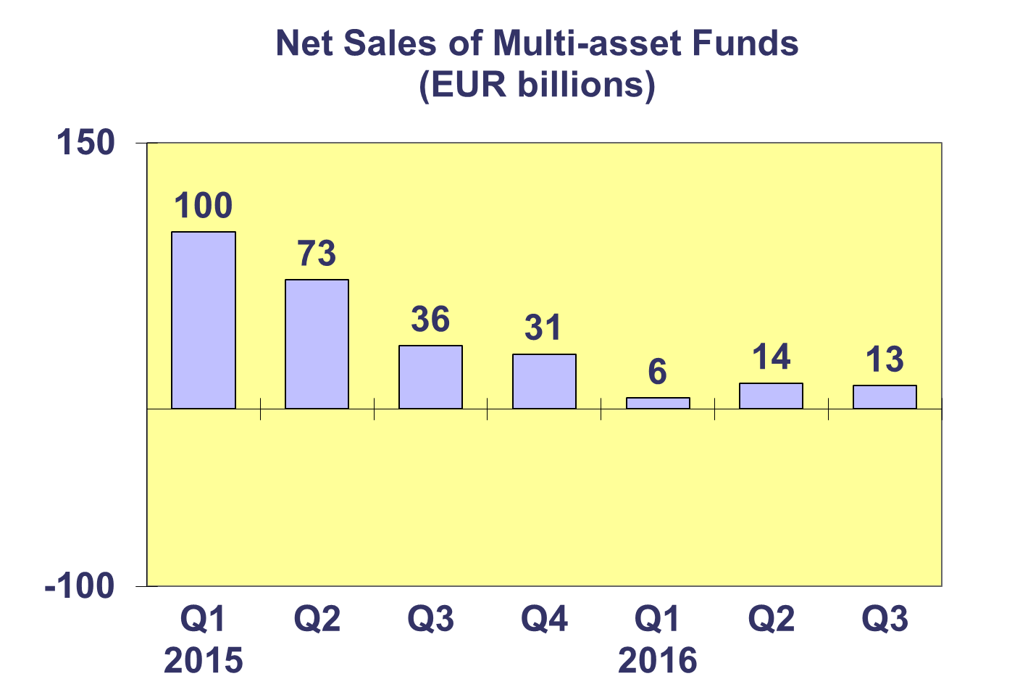

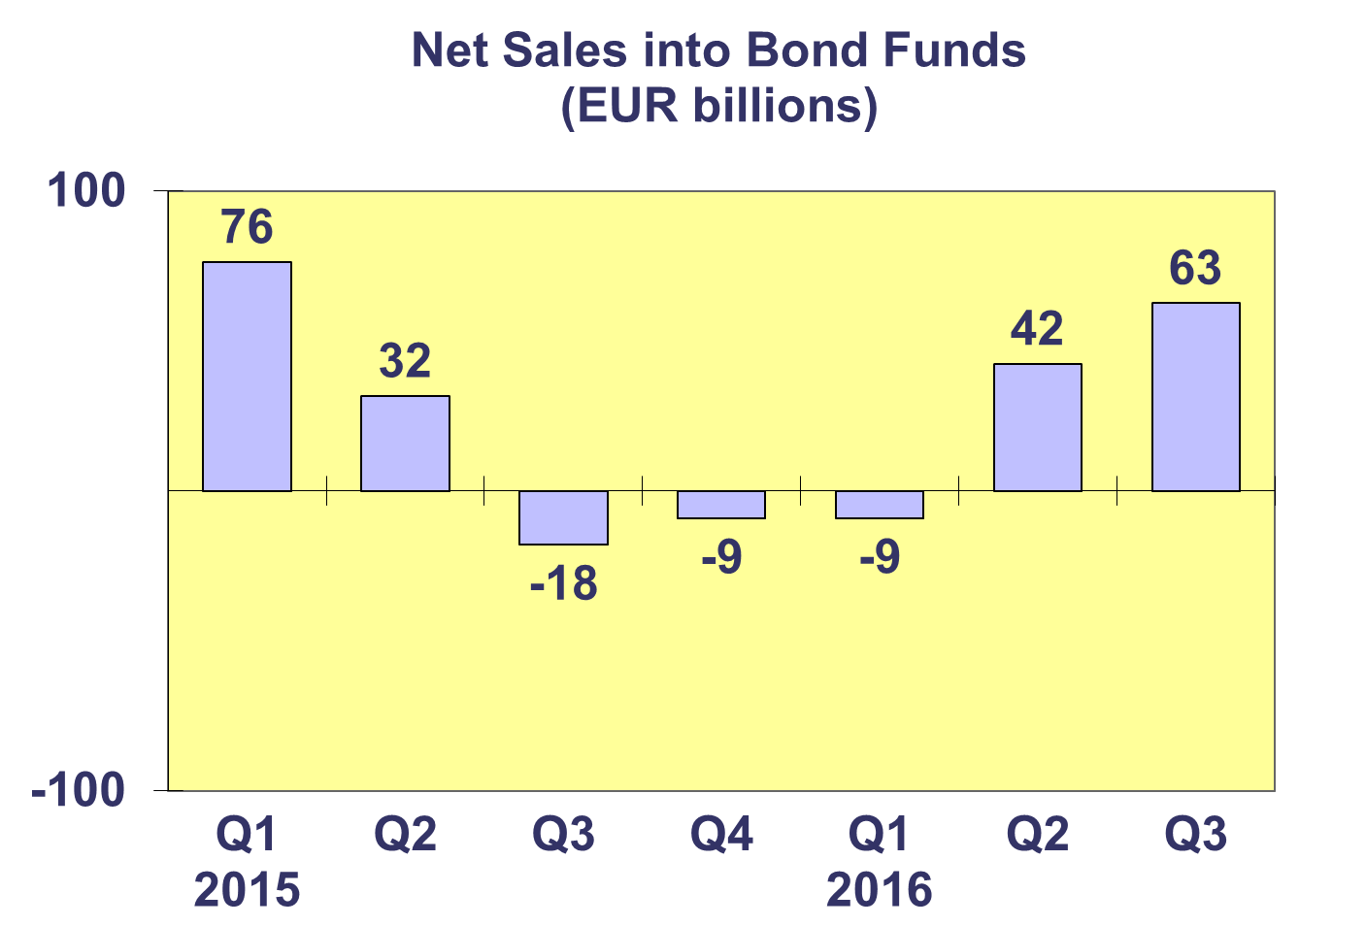
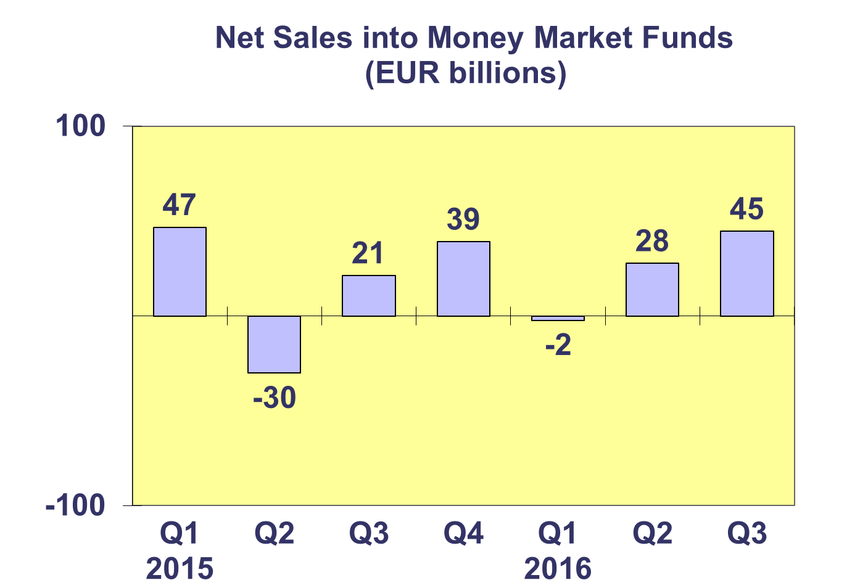

Trends in the UCITS Market
Net Sales by Country of Domiciliation and Investment Type

Twenty-four countries registered net inflows into UCITS in the third quarter of 2016, with eleven countries recording net inflows above EUR 1 billion.

Among the largest UCTIS domiciles, Luxembourg attracted net sales of EUR 74.6 billion in Q3 2016, driven by strong net inflows into money market funds (EUR 36.9 billion) and bond funds (EUR 30.8 billion). Ireland experienced net inflows of EUR 20 billion, mainly due to strong net inflows into bond funds. France recorded net sales of EUR 15.2 billion, also due to strong inflows into money market funds. The UK attracted net inflows of EUR 3.4 billion while Germany recorded net inflows of EUR 2.7 billion.

Strong net inflows into UCITS funds were also seen in Italy (EUR 3.6 billion), Spain (EUR 2.9 billion) and Denmark (EUR 2.5 billion).

Trends in the UCITS Market
Net Sales and Net Assets of ETF by Country of Domiciliation

Net sales of UCITS ETF reached EUR 14 billion in Q3 2016, compared to EUR 9 billion in Q2 2016. UCITS ETF have attracted over EUR 29 billion in new net flows so far this year.

UCITS0 ETF domiciled in Ireland registered the largest inflows during the quarter (EUR 16 billion) reflecting the size of their ETF market. The largest outflows were seen in France (EUR 2 billion). Looking at cumulative year-to-date net sales, Ireland has so far attracted the largest net inflows (EUR 33 billion) whereas Germany has so far experienced the largest net outflows from ETF funds (EUR 3 billion).

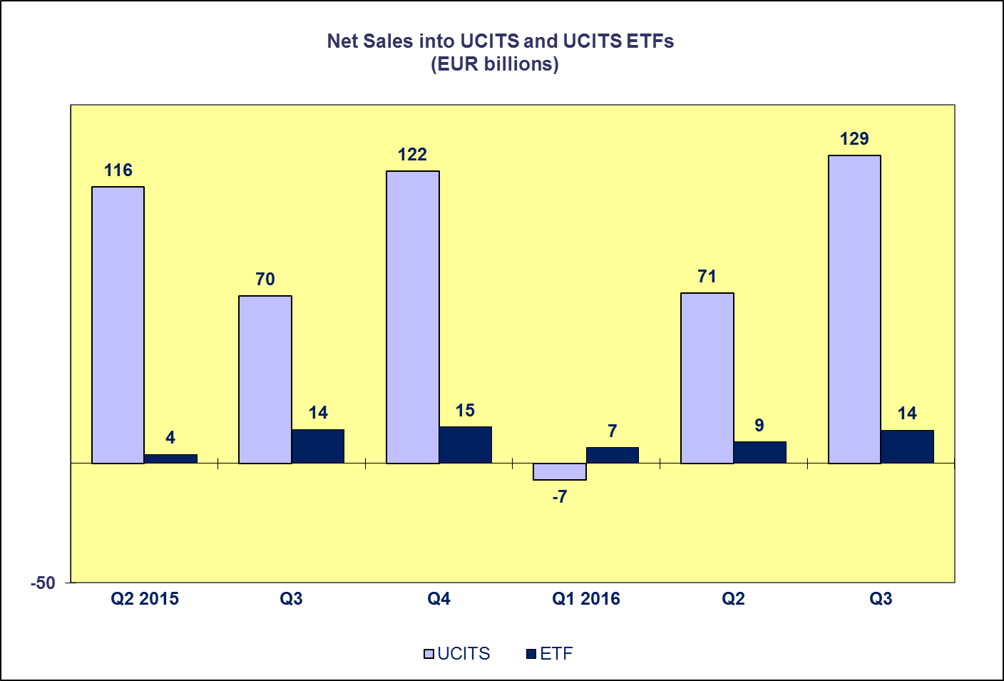

Trends in the UCITS Market

Net Assets by Investment Type

UCITS net assets increased by 3.4 percent in Q3 2016 to reach EUR 8,345 billion at end September.

All categories of UCITS funds experienced an increase in net assets in Q3 2016, with the exception of guaranteed funds and “other” UCITS funds which experienced net asset decreases of 3.7% and 6.5% respectively. Net assets of equity funds increased 5.1% to reach EUR 3,019 billion in Q3 2016. Bond funds increased 4.1% to EUR 2,315 billion in Q3 2016. Money market funds and multi-asset funds follow in this ranking, increasing 3.1% and 2.5% respectively.

The number of UCITS funds increased from 30,293 at end Q2 2016 to 30,486 at end Q3 2016.

Trends in the UCITS Market
Net Assets by Country of Domiciliation

The vast majority of domiciles recorded net asset growth at end Q3 2016 as net assets of UCITS reached EUR 8,345 billion at end September.

All major domiciles recorded net asset growth in the third quarter of 2016. Net assets of UCITS funds domiciled in Luxembourg increased by 5.0 percent, followed by Germany (3.9%), France (3.8%), the UK (3.2%) and Ireland (0.1%). The Nordic countries also experienced net asset growth in Q3 2016. The largest growth was seen in Norway (7.1%), followed by Finland (5.9%), Denmark (4.8%) and Sweden (4.3%). In Southern Europe, the largest net asset growth was seen in Cyprus (26.2%), followed by Spain (3.2%), Italy (3.0%), Greece (1.5%), and Portugal (1.0%) while Malta recorded a decrease in net assets of 8.8 percent since Q2 2016. Strong increases in net assets were also seen in Central and Eastern Europe, with the largest increase in Croatia (10.1%) followed by Bulgaria (7.6%), Slovakia (6.8%), Poland (5.8%), Romania (5.8%), the Czech Republic (5.3%), Hungary (4.9%) and Slovenia (4.5%).

Trends in the AIF Market

Net Sales by Investment Type

AIF recorded net inflows of EUR 41 billion during Q3 2016, down from EUR 56 billion in the second quarter of 2016.

Long-term AIF recorded net inflows of EUR 43 billion, down from net inflows of EUR 52 billion in Q2 2016. Net sales of equity funds increased slightly from EUR 4 billion in the second quarter to EUR 5 billion in the third. Net sales of multi-asset funds decreased from EUR 15 billion in Q2 to EUR 10 billion in Q3 2016. Bond funds finished the quarter at EUR 9 billion, slightly higher than the previous quarter (EUR 7 billion). Net sales of real estate funds remained the same as last quarter (EUR 3 billion).

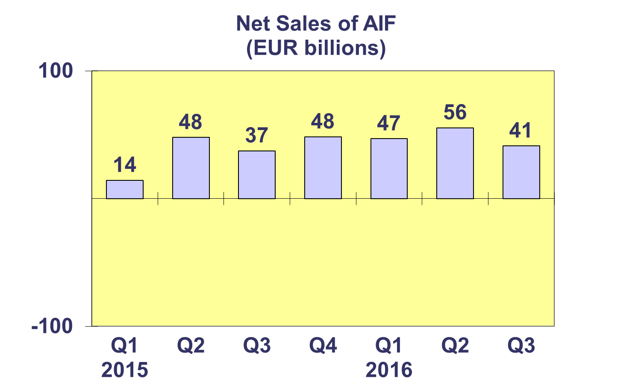
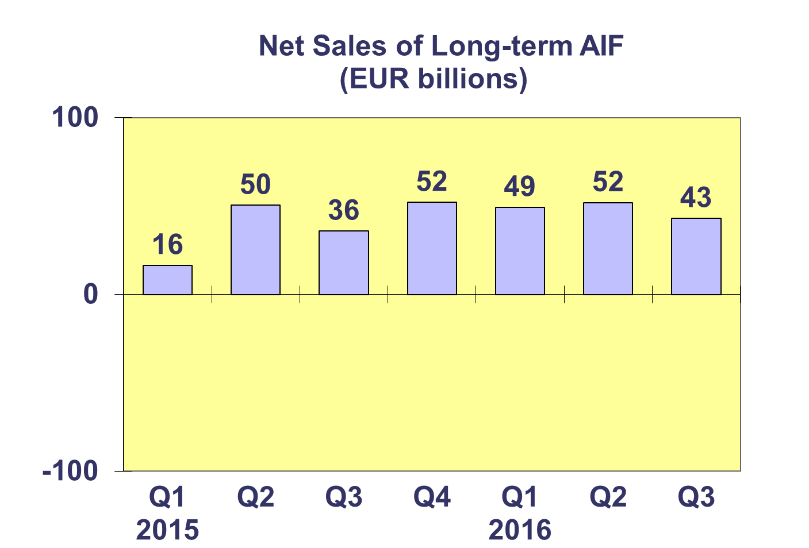

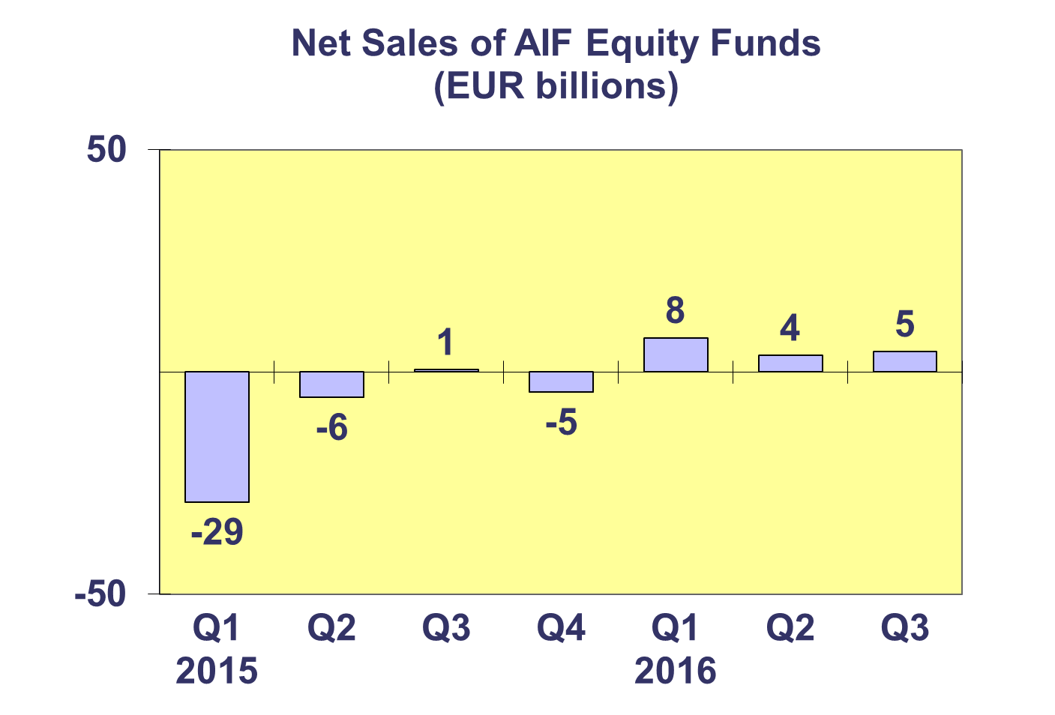
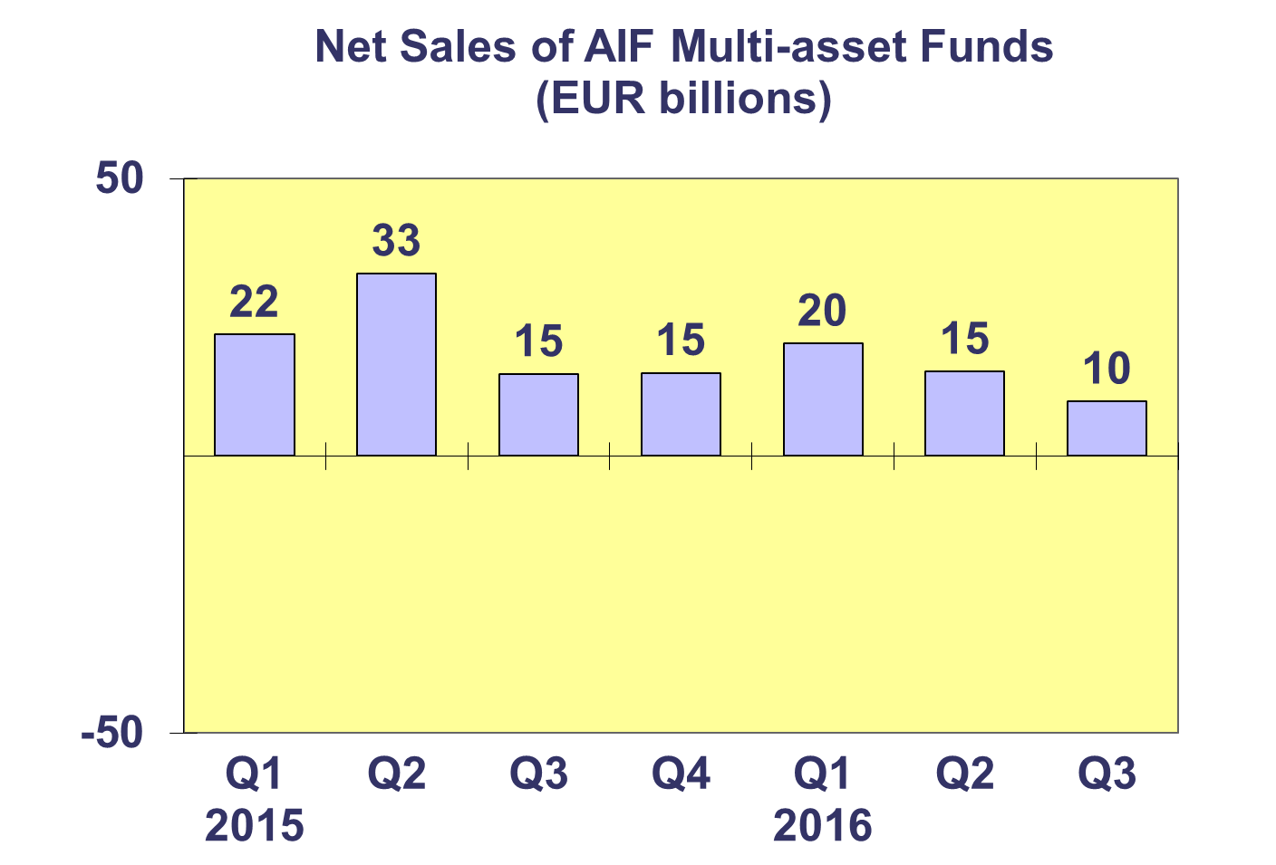
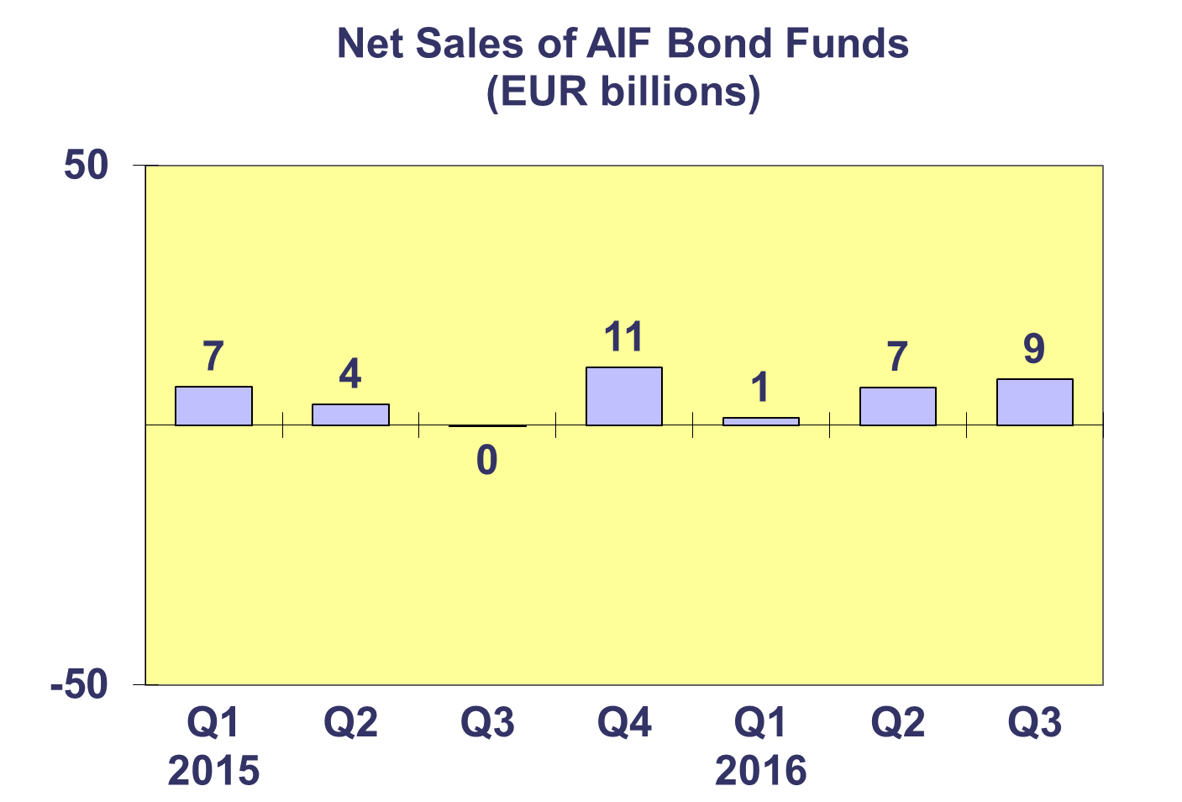
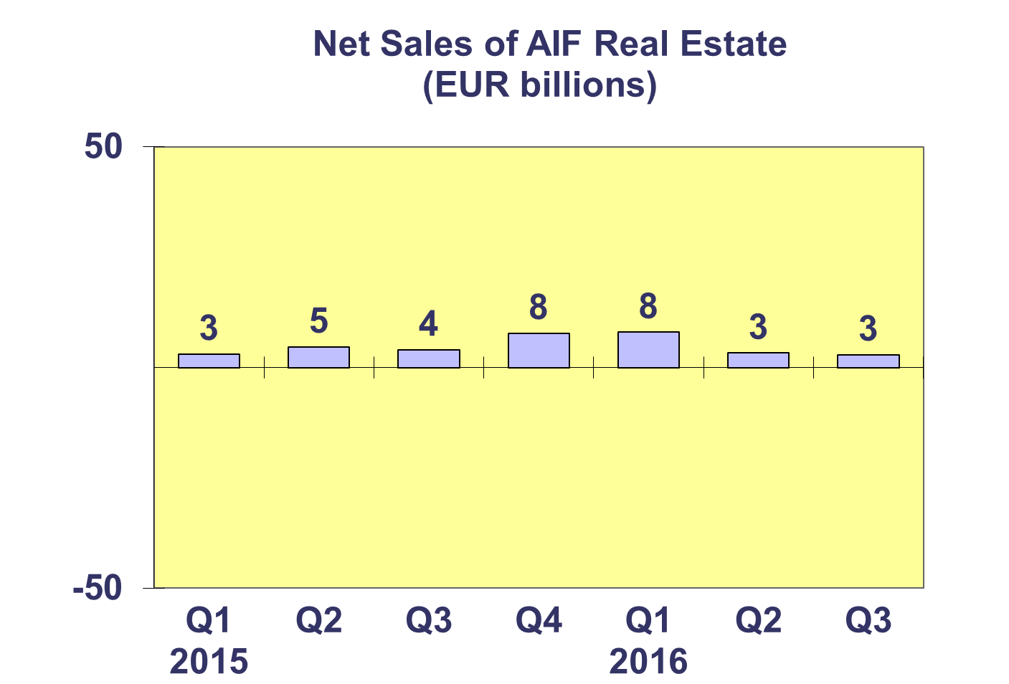

Trends in the AIF Market
Net Sales by Country of Domiciliation and Investment Type

Net sales of AIF totaled EUR 41 billion in Q3 2016, compared to 56 billion in Q2 2016.

All categories of long-term AIF funds registered positive net inflows during Q3 2016 while money market funds registered net outflows.

Seventeen countries experienced net inflows into AIF in Q3 2016, with five countries recording net inflows higher than EUR 1 billion. Of the largest domiciles, net inflows above EUR 1 billion were registered in Germany (EUR 17 billion), Ireland (EUR 8 billion) and Luxembourg (EUR 4 billion). Elsewhere in Europe, net sales greater than EUR 1 billion were recorded in the Netherlands (EUR 8 billion) and Spain (EUR 4 billion). The largest outflows during the quarter were registered in France (EUR 4 billion).

Trends in the AIF Market
Net Assets by Investment Type

Net assets of AIF increased by 2.5 percent during the third quarter to EUR 5,357 billion at end September 2016.

In Q3 2016, all but one category of long-term AIF recorded net asset growth. Equity funds recorded the largest growth (5.6%), followed by bond funds (2.3%), real estate (1.9%) and multi-asset funds (0.6%). Decreases in net assets were seen in guaranteed/protected funds (2.1%) and money market funds (1.9%). Net assets of other AIF, which include AIF funds for which no breakdown according to the underlying fund categories is available, grew 3.8%.

There were 27,954 AIF funds at end Q3 2016, compared to 27,822 at end Q2 2016 and 27,742 at end Q4 2015.

Trends in the AIF Market
Net Sales and Assets of Institutional AIF

Net assets of institutional AIF, which are AIF reserved for institutional investors, increased 2.6% to EUR 2,583 billion at end Q3 2016.

Net assets of institutional equity funds increased 5.3% to finish the quarter at EUR 208 billion. Institutional multi-asset fund net assets decreased by 0.4% to reach EUR 940 billion. Net assets of institutional bond funds increased 3.2% to EUR 584 billion, and real estate fund net assets increased 3.6% to EUR 158 billion. Other institutional funds experienced net asset growth of 5.3% to reach EUR 259 billion at end Q3 2016.

Institutional AIF recorded net sales of EUR 28 billion in Q3 2016, lower than both Q2 2016 (EUR 33 billion) and Q4 2015 (EUR 51 billion).

Trends in the AIF Market
Net Assets by Country of Domiciliation

Net assets of AIF increased 2.5 percent during the third quarter to EUR 5,357 billion at end September 2016.

The five largest domiciles all recorded net asset growth in Q3 2016, with the largest growth in Ireland (5.5%) followed by the UK (3.6%), Luxembourg (2.8%), France (2.1%) and Germany (1.3%). Elsewhere in Europe, it is worth nothing net assets grew strongly in the Czech Republic (7.3%), Spain (5.0%) and Poland (4.9%). Decreases in net assets were seen in Cyprus (15.0%), Slovakia (7.7%), Portugal (1.9%), Croatia (0.8%) and Italy (0.3%).

Trends in the European Investment Fund Industry

Net Sales by Investment Type

The combined net sales of the investment fund market in Europe, i.e. the market for UCITS and AIF, recorded net inflows of EUR 170 billion during Q3 2016, compared to EUR 127 billion in Q2.

Equity funds saw a reversal in flows, registering net inflows of EUR 6 billion in Q3 2016 compared to net outflows of EUR 14 billion in Q2 2016. Net sales of bond funds increased from EUR 50 billion in Q2 to EUR 71 billion in Q3 2016. Net sales of multi-asset funds totalled EUR 23 billion in Q3 2016, down from EUR 30 billion in the previous quarter. Net sales of money market funds increased from EUR 31 billion in Q2 2016 to EUR 43 billion in Q3. Net sales of other funds (including real estate, guaranteed/protected funds and other funds which do not fit any of the categories below or for which information is not available) totalled EUR 28 billion during the quarter, slightly less than EUR 30 billion last quarter.

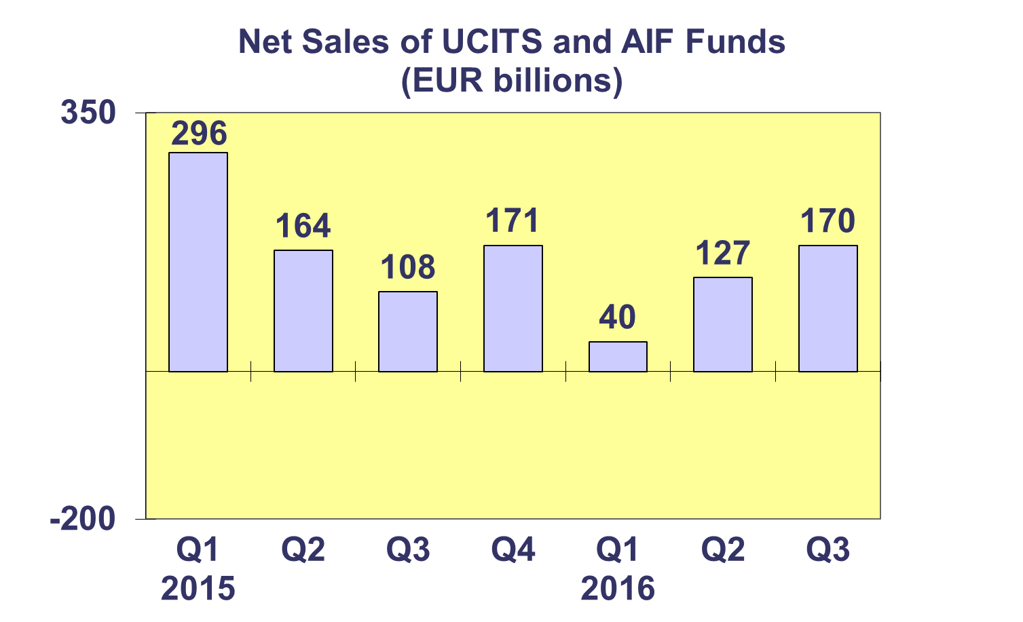
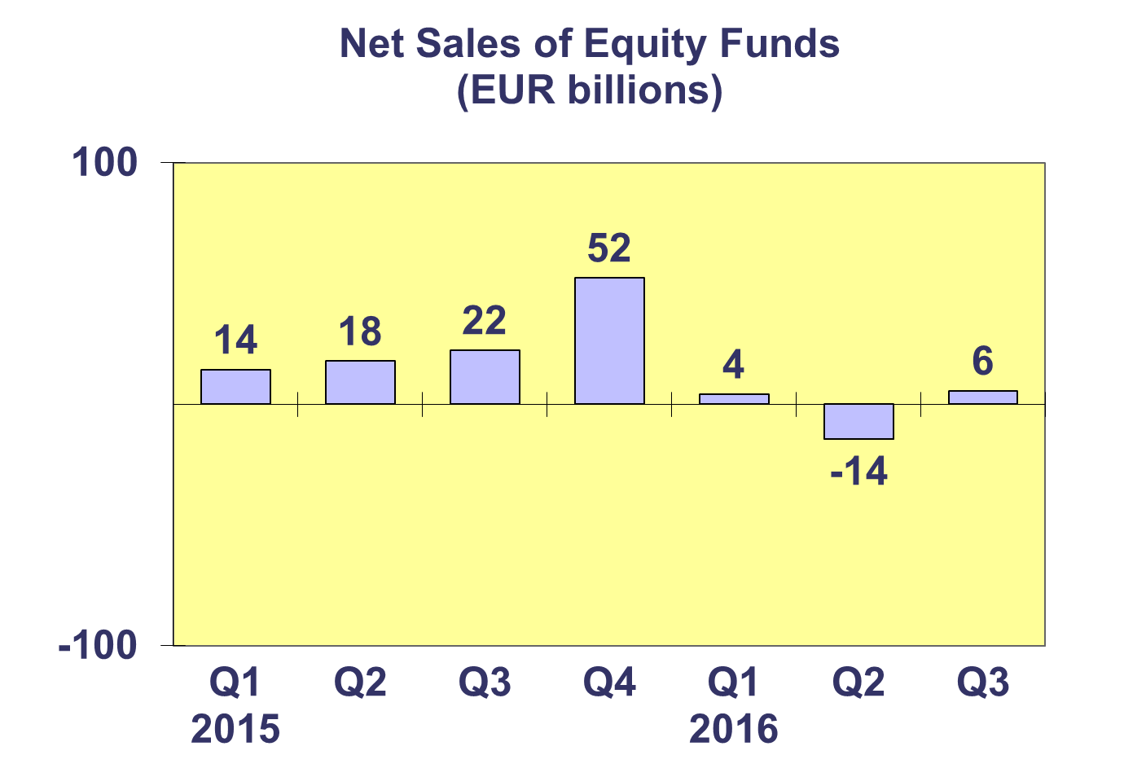
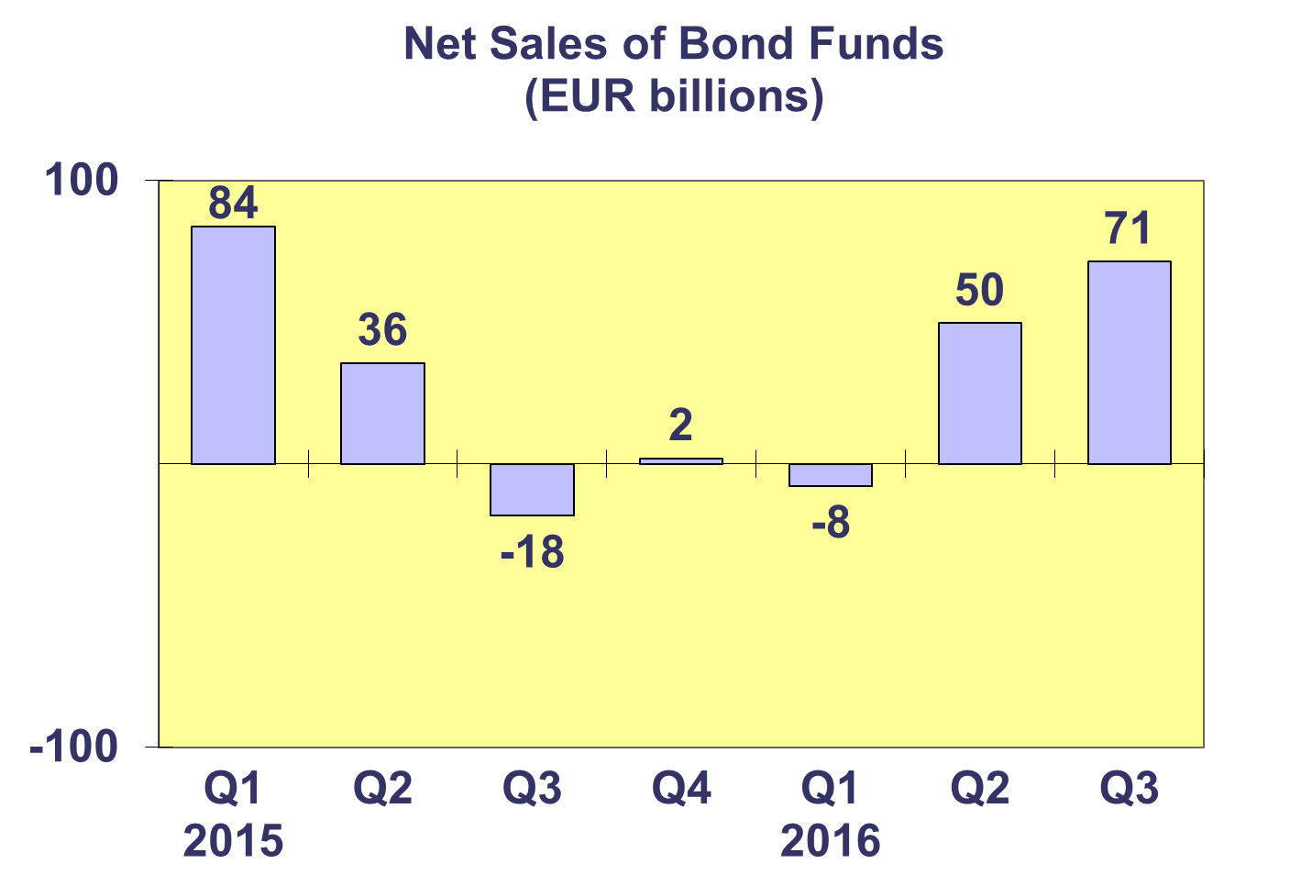
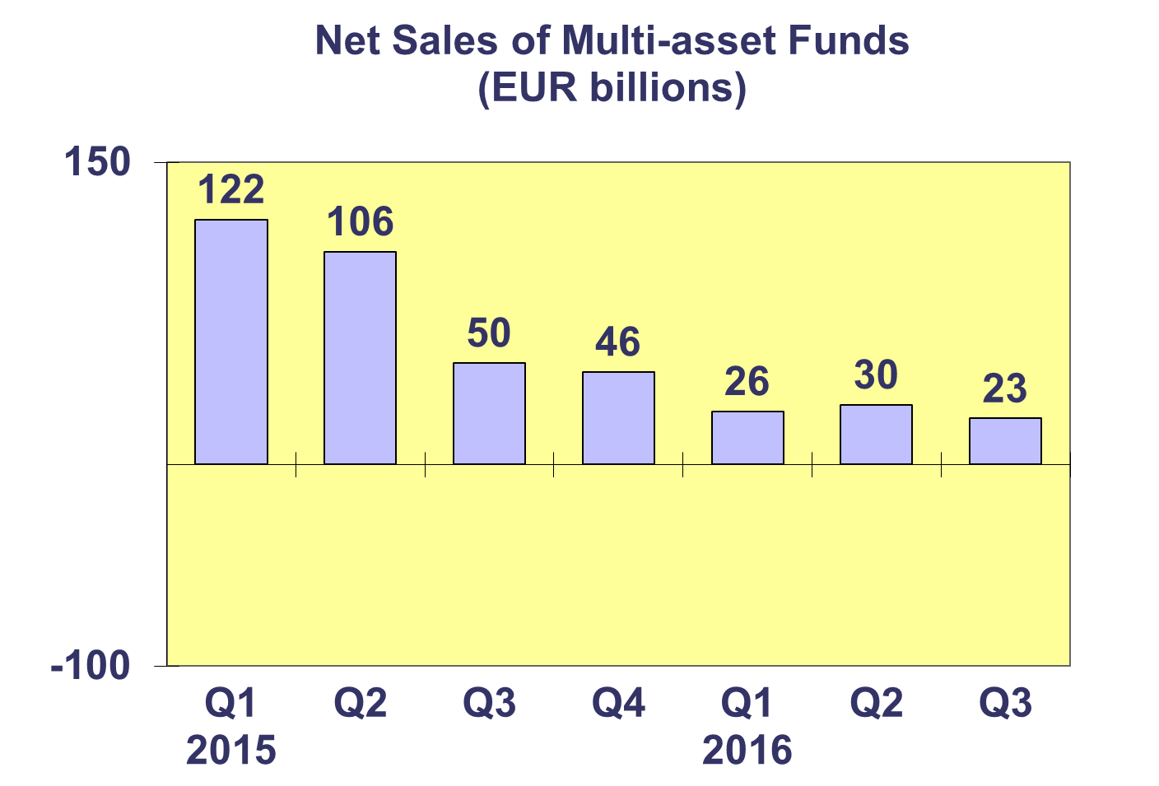
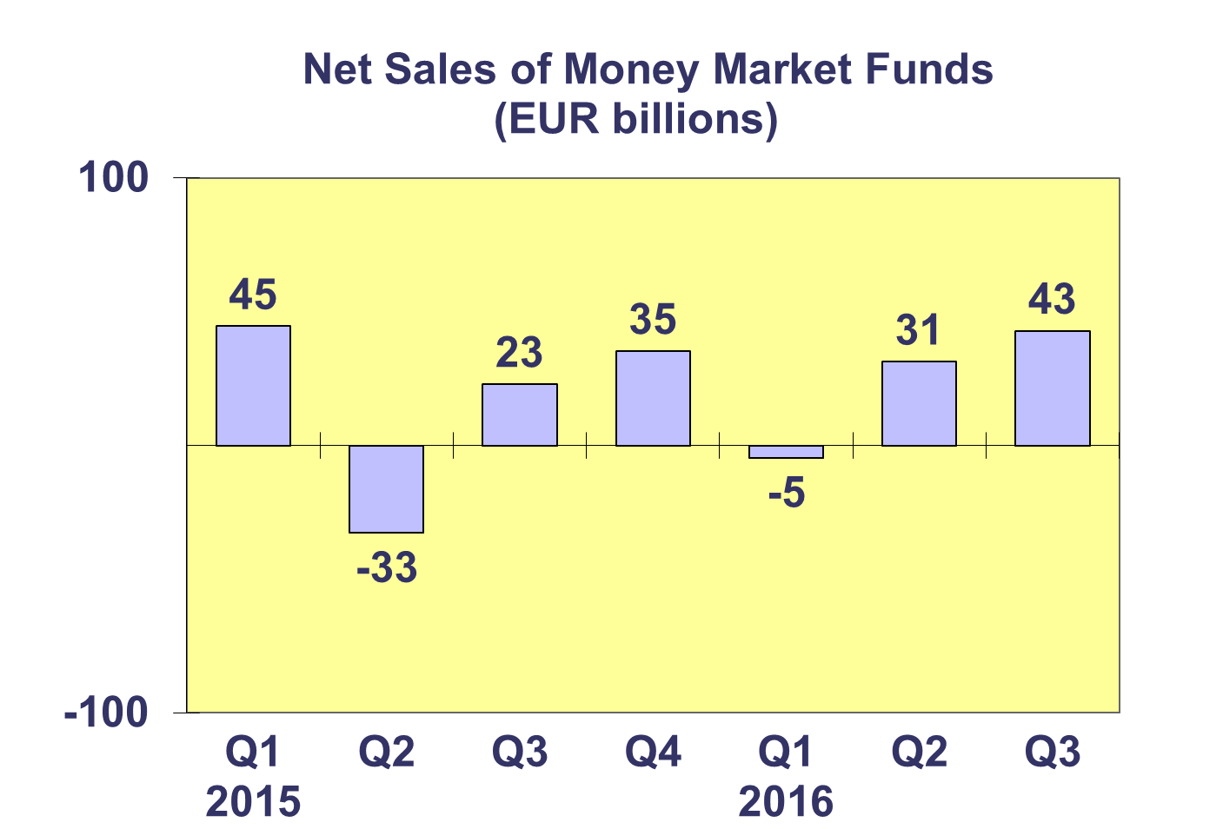
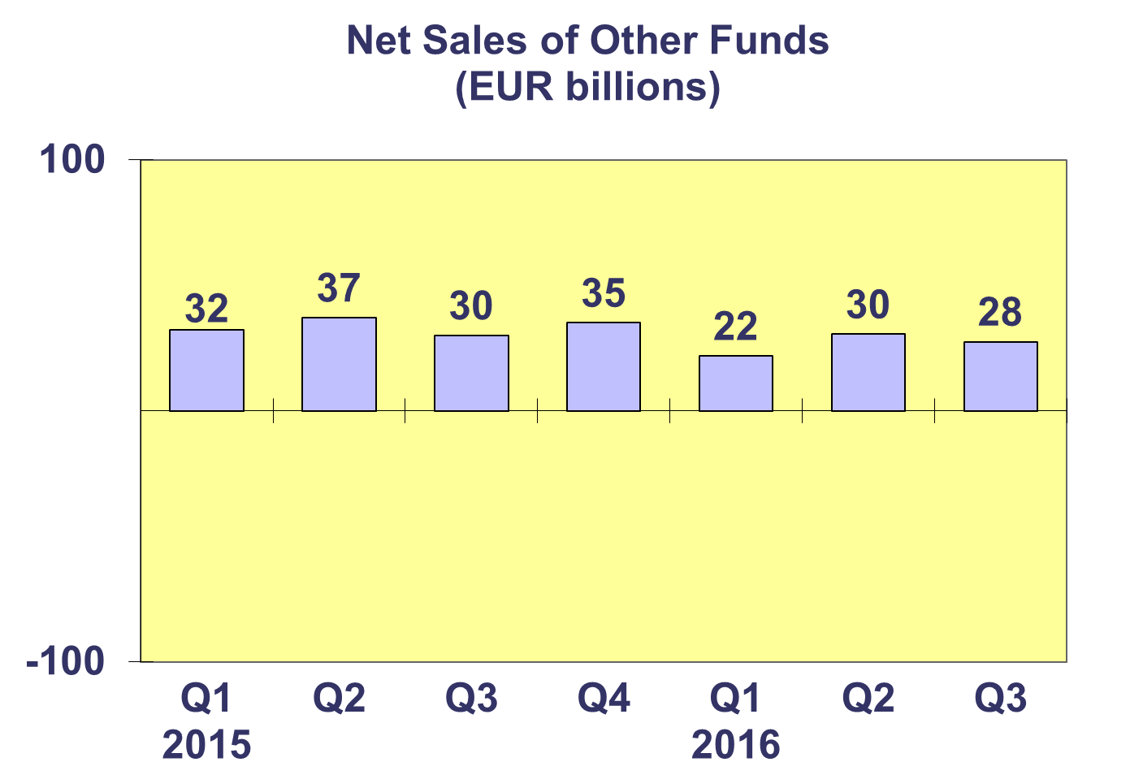
Trends in the European Investment Fund Industry
Net Assets by Country of Domiciliation

Net assets of the European investment fund industry increased by 3.1% to EUR 13,702 billion at end Q3 2016.

With EUR 8,345 billion invested in UCITS, this segment accounted for 61% of total European investment fund assets at end Q3 2016, with the remaining 39% (equivalent to EUR 5,357 billion) coming from AIF.

Trends in the European Investment Fund Industry
Number of Funds by Country of Domiciliation

In Q3 2016, the total number of UCITS and AIF increased by 0.6% to 58,448.

At the end of the third quarter of 2016, UCITS accounted for 30,494 funds or 52.2% of the European investment fund market, while AIF accounted for 27,954 funds, or 47.8% of the market.

Please note that this data does not include net sales of UCITS ETF domiciled in Luxembourg.

