|  |
| --- |
| ***Quarterly Statistical Release*** |

**September 2019 N° 78**

***This release and other statistical***

***releases are available on Efama’s***

***website (***[***www.efama.org***](http://www.efama.org)***)***

***Trends in the European Investment Fund Industry***

***in the Second Quarter of 2019***

|  |
| --- |
| **This report was prepared by Bernard Delbecque, Thomas Tilley and Hailin Yang**  **EFAMA**  **The European Fund and Asset Management Association**  **Rue Montoyer 47 - B-1000 BRUXELLES - Tel. 32-2-513.39.69 - e-mail: info@efama.org** |

**Trends in the UCITS Market**

***Net Sales by Investment Type***

**UCITS recorded net inflows of EUR 41 billion in Q2 2019, down from EUR 51 billion in Q1 2019. During the first half of 2019, UCITS funds attracted EUR 92 billion in net new money, compared to EUR 185 billion in first 6 months of 2018.**

Long-term UCITS recorded net sales of EUR 37 billion in Q2 2019, down from EUR 40 billion in Q1 2019. Equity funds registered net outflows of EUR 32 billion, compared to net outflows of EUR 27 billion in Q1 2019. Bond funds recorded net inflows of EUR 78 billion, comparable to EUR 79 billion in Q1 2019. Multi-asset funds also recorded approximately the same level of net sales as in Q1 2019 (EUR 2 billion). Net sales of money market fund amounted to EUR 4 billion in Q2 2019, down from EUR 11 billion in Q1 2019.

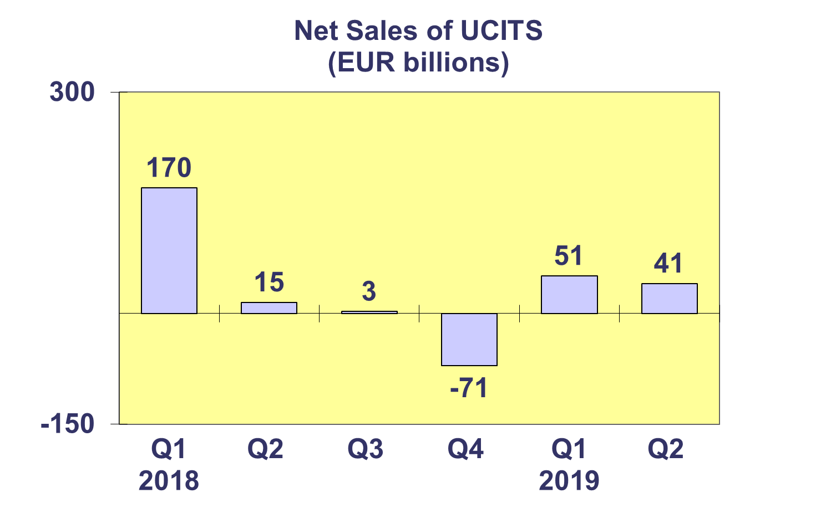

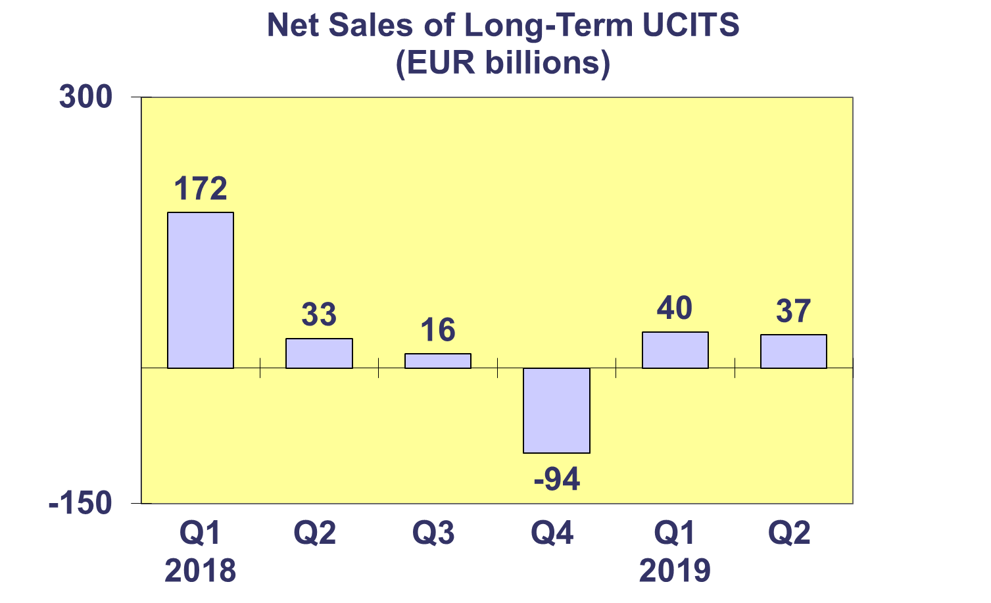

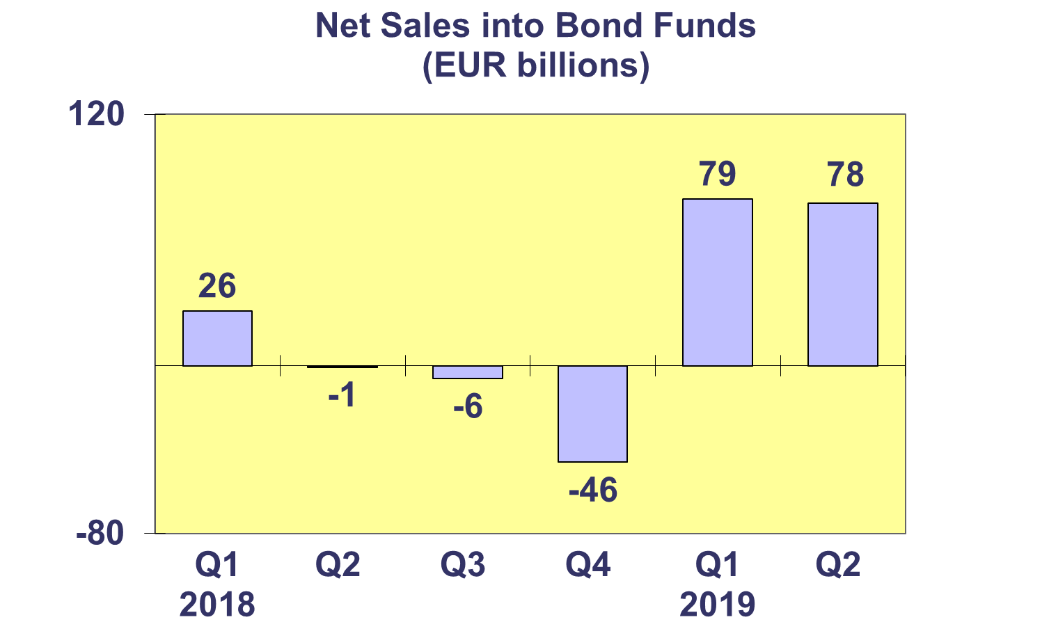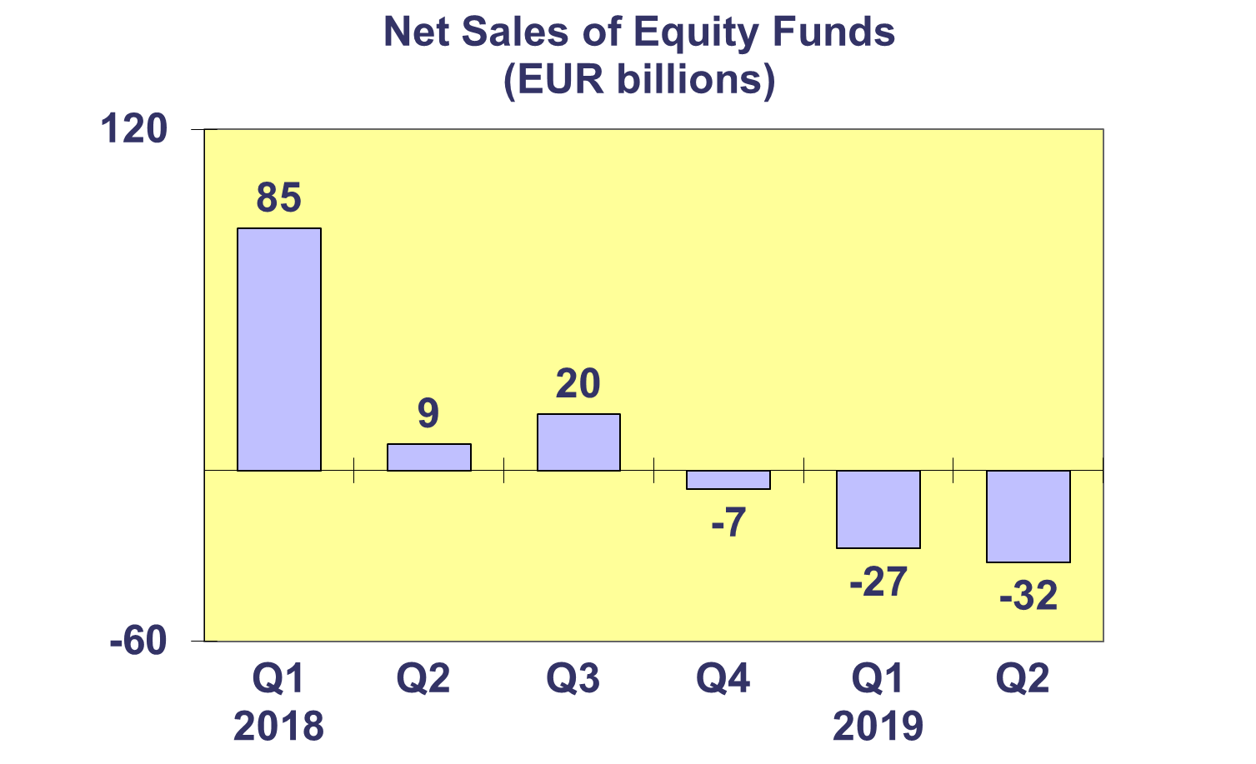

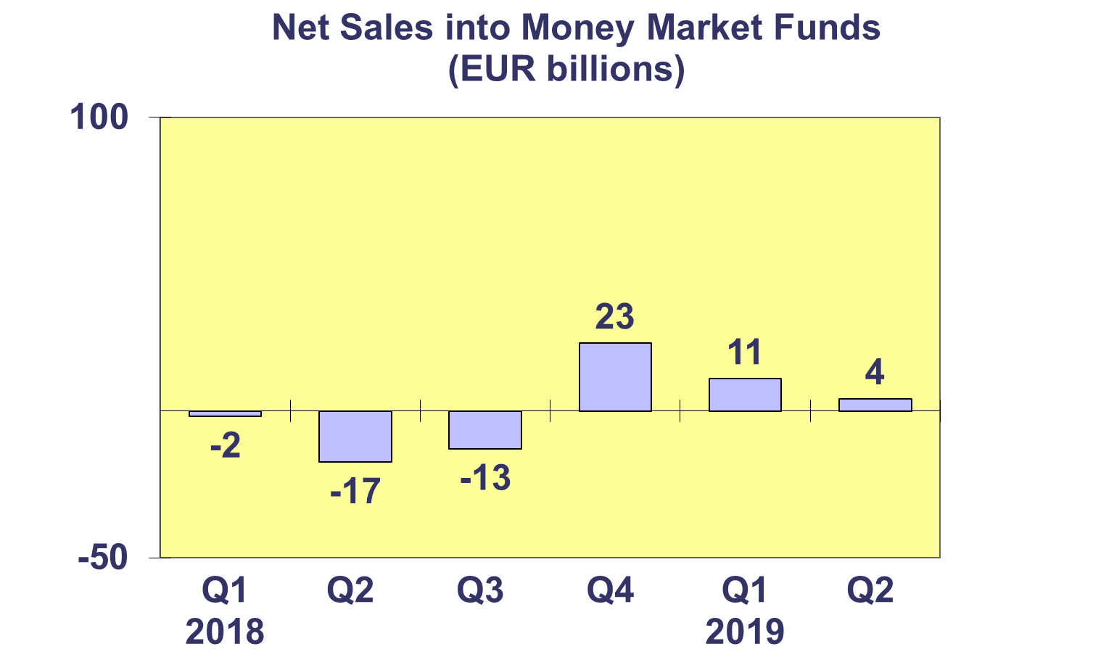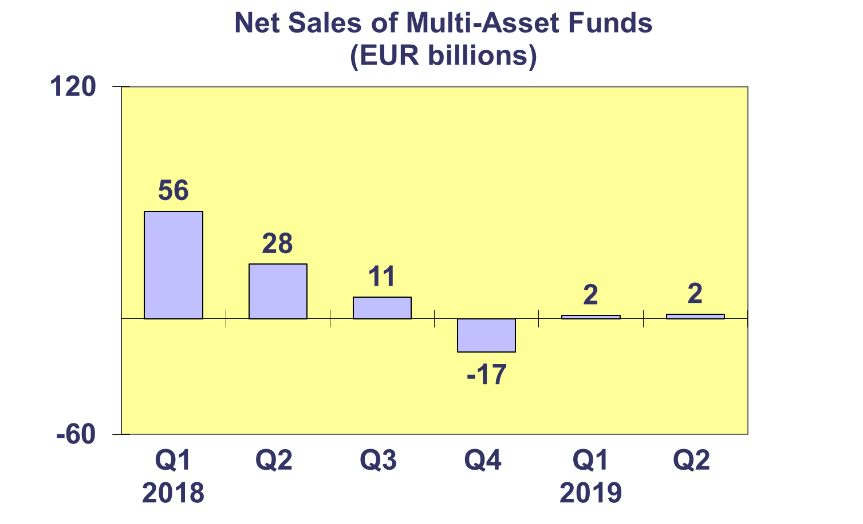**Trends in the UCITS Market**

***Net Sales by Country of Domiciliation and Investment Type***

**Twenty-one countries registered net inflows into UCITS in Q2 2019, with five countries recording net inflows above EUR 1 billion.**

The largest net inflows into UCITS were recorded in Ireland (EUR 53 billion), mainly due to strong inflows into bond funds (EUR 36 billion). Sweden took second place (EUR 5 billion), followed by Norway (EUR 3 billion), Denmark (EUR 2 billion) and Switzerland (EUR 1 billion). The largest net outflows were recorded in France (EUR 20 billion), primarily due to the usual end-of-quarter withdrawals from money market funds.

So far in 2019, bond funds have attracted the highest level of net sales (EUR 157 billion). Equity funds on the other hand, recorded outflows of 60 billion in the first half of the year.

 **Trends in the UCITS Market**

***Net Sales and Net Assets of ETF by Country of Domiciliation***

**Net sales of UCITS ETF reached EUR 9 billion in Q2 2019, down from EUR 26 billion in Q1 2019. UCITS ETF attracted net sales of EUR 35 billion so far this year, compared to EUR 3 billion the first half of 2018.**

UCITS ETF domiciled in Ireland registered the highest net inflows during the quarter (EUR 12 billion). On the other hand, the main net outflows were seen in Germany (EUR 1.5 billion) and Luxembourg (EUR 1.2 billion).

Looking at cumulative year-to-date net sales, Ireland has so far attracted the largest net inflows (EUR 38 billion), whereas France experienced the largest net outflows (EUR 8 billion).



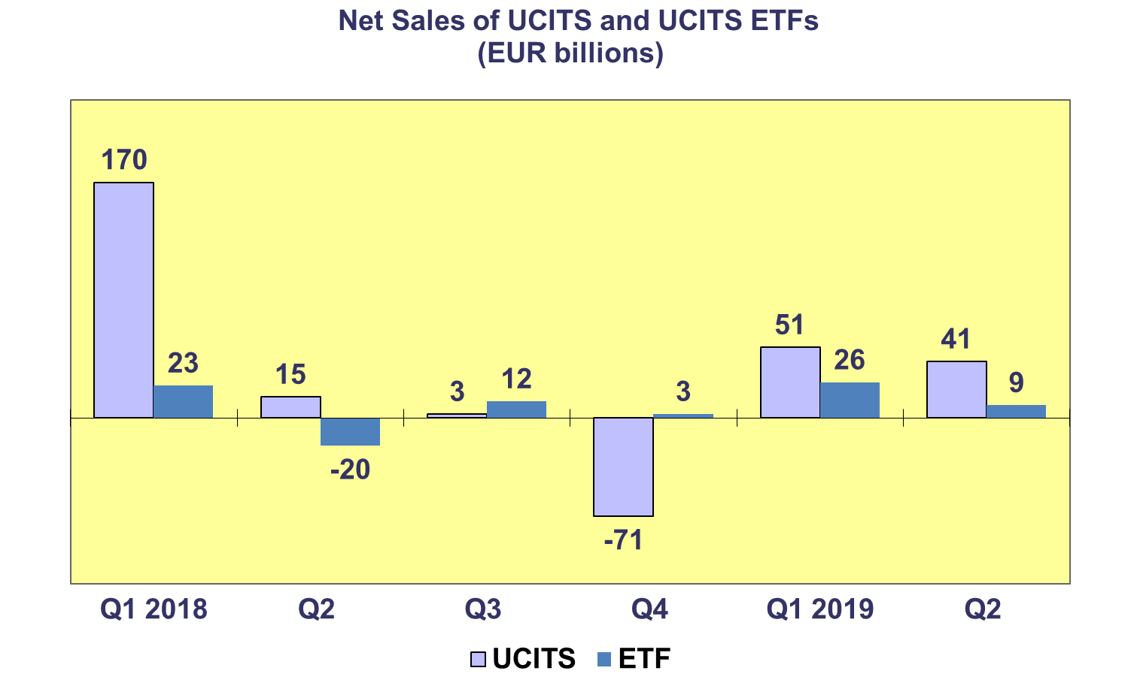

**Trends in the UCITS Market**

***Net Assets and Number of Funds by Investment Type***

**UCITS net assets increased by 1.4% in Q2 2019 to reach EUR 10,144 billion. Since the end of 2018, net assets of UCITS grew by 9.3%.**

Net assets of guaranteed funds increased 9.3% to reach EUR 7 billion in Q2 2019. Bond funds increased by 4.1% to reach EUR 2,836 billion. Multi-asset funds and equity funds grew 1.4% and 0.7% to reach EUR 1,867 billion and EUR 3,881 billion, respectively. Other funds and money market funds experienced net asset decreases of 3.0% and 1.4%, respectively.

The number of UCITS funds increased from 33,570 at end Q1 2019 to 33,720 at end Q2 2019.



**Trends in the UCITS Market**

***Net Assets by Country of Domiciliation***

**Twenty-four domiciles recorded net asset growth in Q2 2019, with net assets of UCITS reaching EUR 10,144 billion.**

Among the major domiciles, Ireland recorded the largest net asset growth (2.9%), followed by Germany (2.4%) and Luxembourg (1.1%). Net decreases of assets were registered in France (1.1%) and the UK (0.2%)

Most countries in Western Europe recorded increases in net assets, with the largest increase in Switzerland (3.8%), followed by Netherlands (2.6%) and Austria (1.3%). Net asset growth was seen in all Nordic countries, with a solid increase in Sweden (3.3%), followed by Denmark (3.1%), Finland (1.5%) and Norway (1.4%). In Southern Europe, the highest net asset growth was recorded in Greece (11.2%), followed by Cyprus (3.3%) and Malta (2.3%). In Central and Eastern Europe, strong increases in net assets were recorded in Czech Republic (5.4%), Romania (5%), Croatia (4.3%) and Bulgaria (3.3%).



**Trends in the AIF Market**

***Net Sales by Investment Type***

**AIFs recorded net inflows of EUR 48 billion in Q2 2019, up from EUR 28 billion in Q1. So far in 2019, AIFs attracted net sales of EUR 76 billion, compared to EUR 65 billion in the first half of 2018.**

Long-term AIFs recorded net sales of EUR 46 billion, down from EUR 50 billion in Q1 2019. Equity funds registered net inflows of EUR 0.4 billion in Q2 2019, compared to net outflows of EUR 11 billion in Q1 2019. Net inflows of bond funds amounted to EUR 5 billion in Q2 2019, compared to EUR 3 billion in the previous quarter. Multi-asset funds recorded net inflows of EUR 11 billion in Q2 2019, up from EUR 6 billion in Q1 2019. Net sales of other funds decreased from EUR 46 billion in Q1 2019 to EUR 23 billion in Q2 2019.

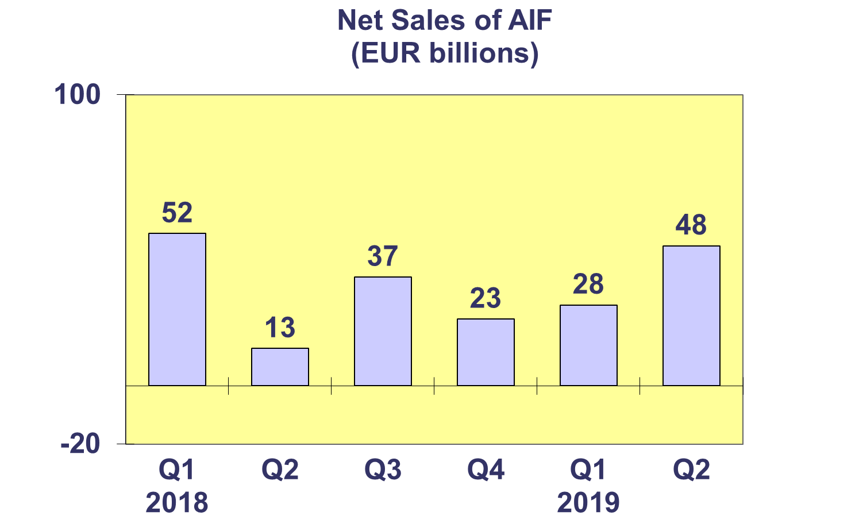

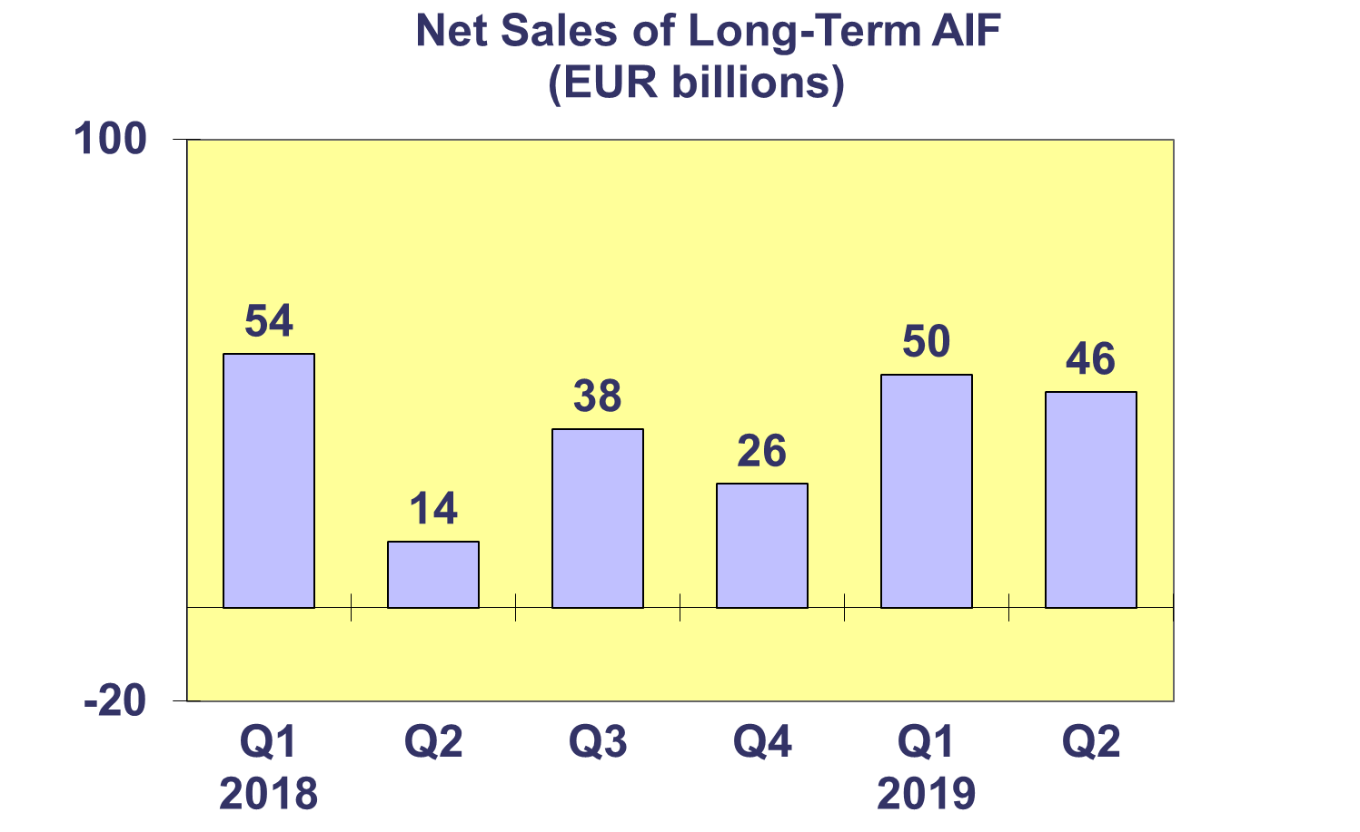

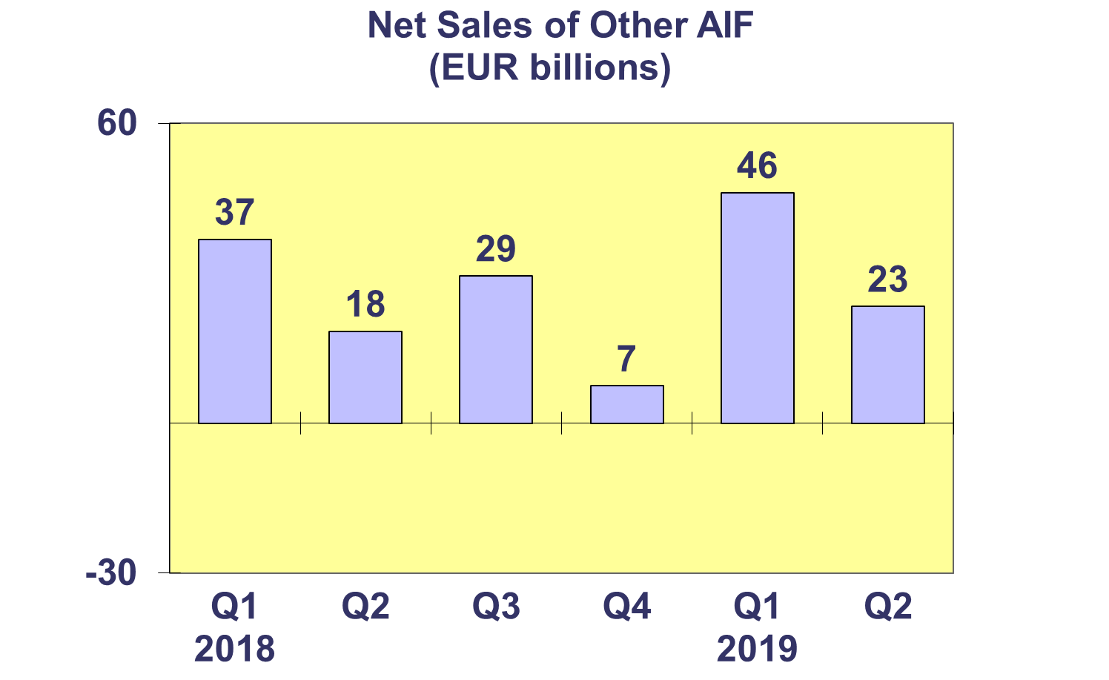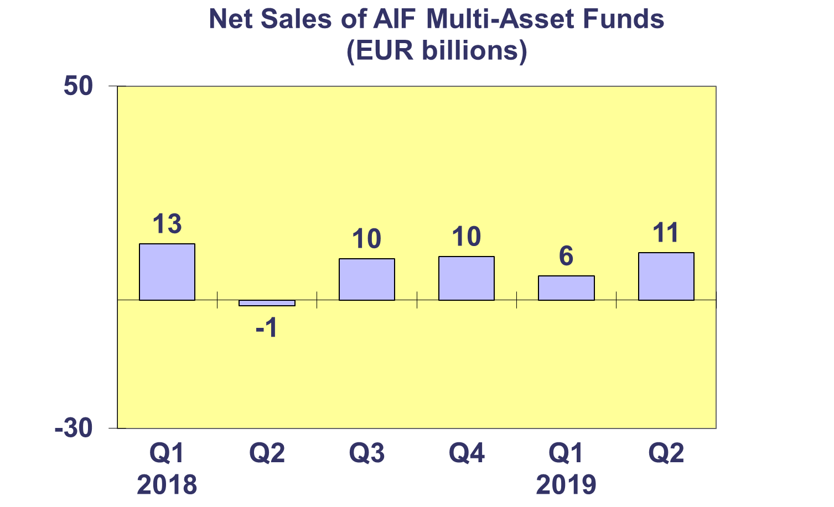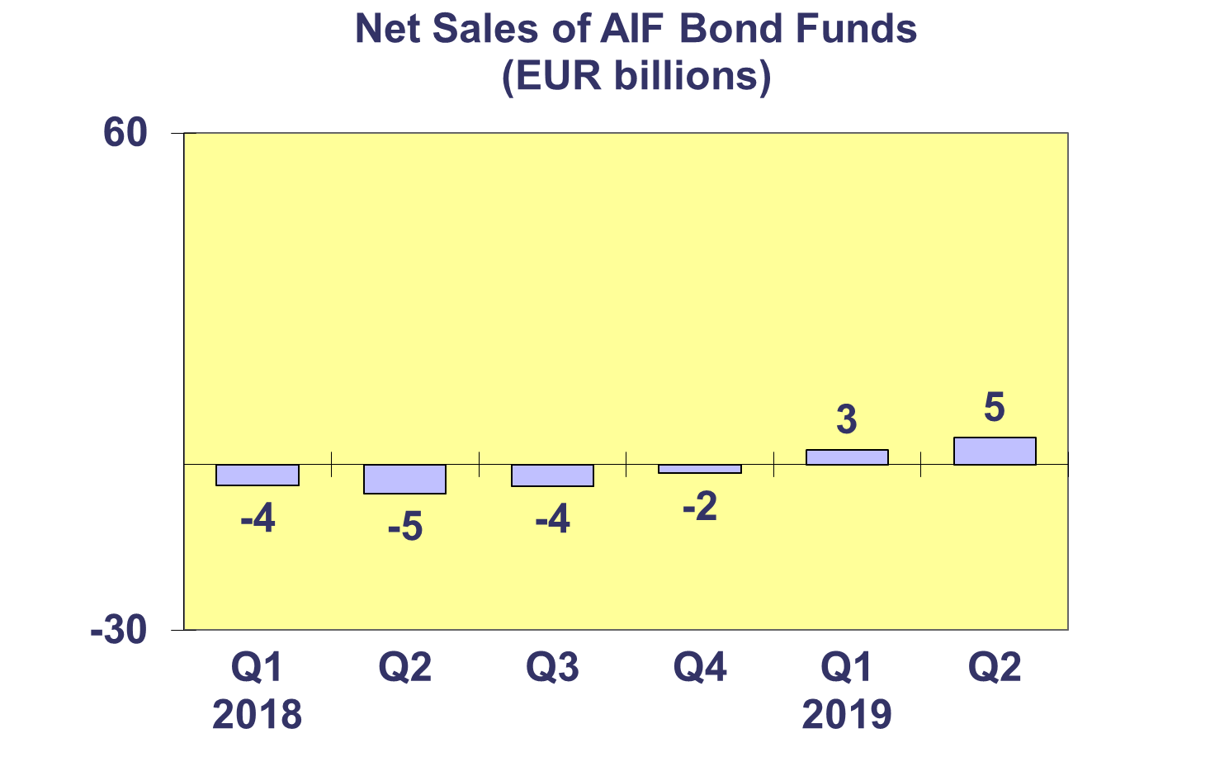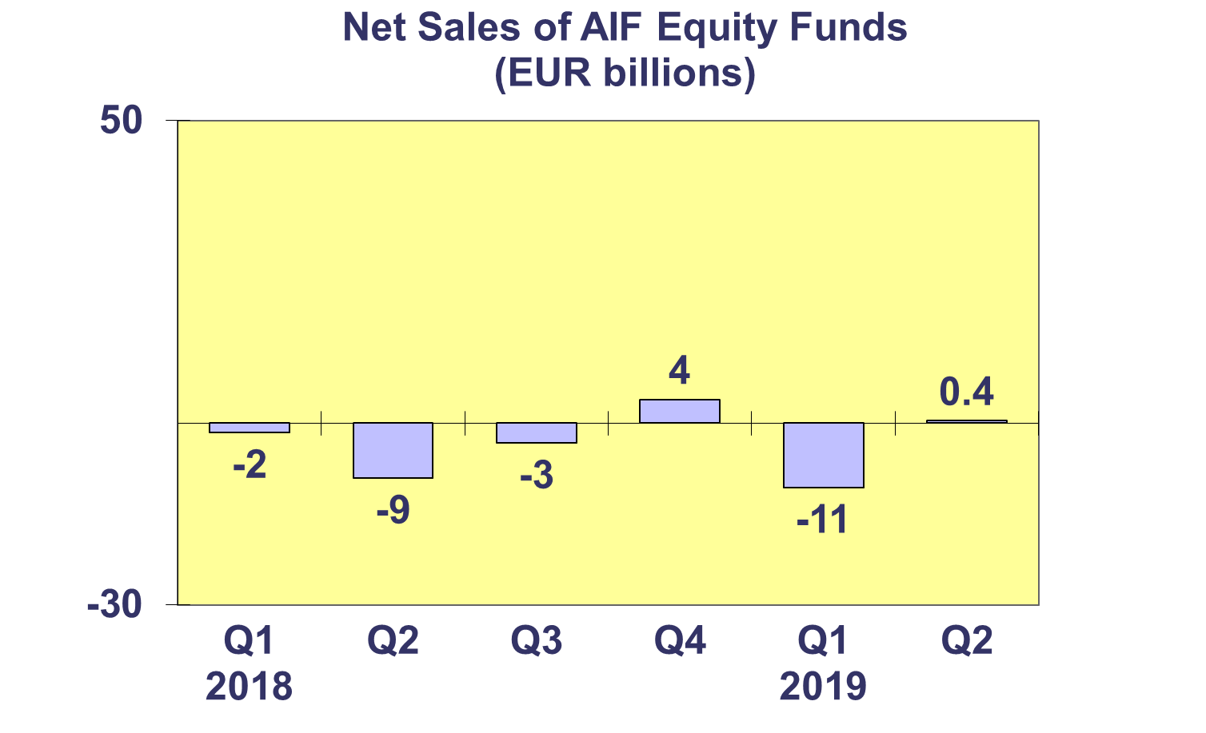**Trends in the AIF Market**

***Net Sales by Country of Domiciliation and Investment Type***

**Seventeen countries experienced positive net sales of AIFs in Q2 2019, with six countries recording net inflows higher than EUR 1 billion.**

Net inflows above EUR 1 billion were registered in Germany (EUR 16 billion), Luxembourg (EUR 14.2 billion), Ireland (EUR 7.2 billion), France (EUR 5.4 billion), Switzerland (EUR 4.2 billion) and Denmark (EUR 1 billion).

All categories of AIFs registered net inflows this quarter, with the largest inflows recorded in other funds (EUR 24 billion), due to strong sales in Ireland (EUR 6.6 billion), Luxembourg (EUR 5.8 billion) and Germany (EUR 5.3 billion).

**Trends in the AIF Market**

***Net Assets and Number of Funds by Investment Type***

**Net assets of AIFs increased by 2.2% in Q2 2019 to reach EUR 6,396 billion.**

All AIF categories recorded an increase in net assets in Q2 2019. Money market funds recorded the largest asset growth (3.5%), followed by bond funds (2.9%), other AIFs (2.4%), multi-asset funds (2.0%), guaranteed/ protected funds (1.8%), equity funds (1.6%) and real estate funds (1.1%).

There were 28,818 Alternative Investment Funds at end Q2 2019, compared to 28,607 at end Q1 2019 and 28,594 at end Q4 2018.



**Trends in the AIF Market**

***Net Sales and Assets of Institutional AIFs***

**Net assets of institutional AIFs, which are AIFs reserved for institutional investors, increased by 2.8% to EUR 3,280 billion at end Q2 2019.**

Net assets of ‘other’ institutional funds increased by 4.9% to finish the quarter at EUR 488 billion. Institutional bond funds grew 3.1% to EUR 612 billion. Institutional equity and multi-asset funds increased by 2.7% and 2.6% to reach EUR 252 billion and EUR 1,088 billion, respectively. Institutional real estate fund increased by 2.2% to reach EUR 236 billion. Money market funds experienced a decrease of 1.3%, with their net assets dropping to 10 billion at end Q2 2019.

Institutional AIFs recorded net sales of EUR 36 billion in Q2 2019, lower than in Q1 2019 (EUR 56 billion) but higher than in Q4 2018 (EUR 31 billion).



**Trends in the AIF Market**

***Net Assets by Country of Domiciliation***

**Net assets of AIFs increased 2.2% compared to end Q1 2019 and 8.9% compared to end 2018. Twenty domiciles recorded AIF net asset growth in Q2 2019.**

The five largest AIF domiciles all recorded net asset growth in Q2 2019, with the largest net growth in Germany (3.2%), followed by Luxembourg (2.7%), France (2.2%), the Netherlands (2.0%) and Ireland (1.5%).

Elsewhere in Europe, net assets grew strongly in the Czech Republic (7.5%), Romania (7.4%), Switzerland (6.1%), Cyprus (6.0%) and Slovakia (5.8%).



**Trends in the European Investment Fund Industry**

***Net Sales by Investment Type***

**UCITS and AIFs recorded net sales of EUR 89 billion during Q2 2019, compared to EUR 79 billion in Q1 2019. During the first half of 2019, European investment funds attracted net sales of EUR 168 billion.**

Equity funds registered net outflows of EUR 32 billion in Q2 2019, compared to net outflows of EUR 38 billion in the previous quarter. Bond funds recorded net inflows of EUR 83 billion in Q2, slightly up from EUR 82 billion in Q1 2019. Net sales of multi-asset funds totalled EUR 13 billion in Q2 2019, up from EUR 7 billion in the previous quarter. Money market funds experienced net inflows of EUR 6 billion, compared to net outflows of EUR 11 billion in Q1 2019. Net sales of other funds (including real estate, guaranteed/protected funds and other funds which do not fit any of the categories below or for which information is not available) totalled EUR 19 billion, down from EUR 39 billion in Q1 2019.

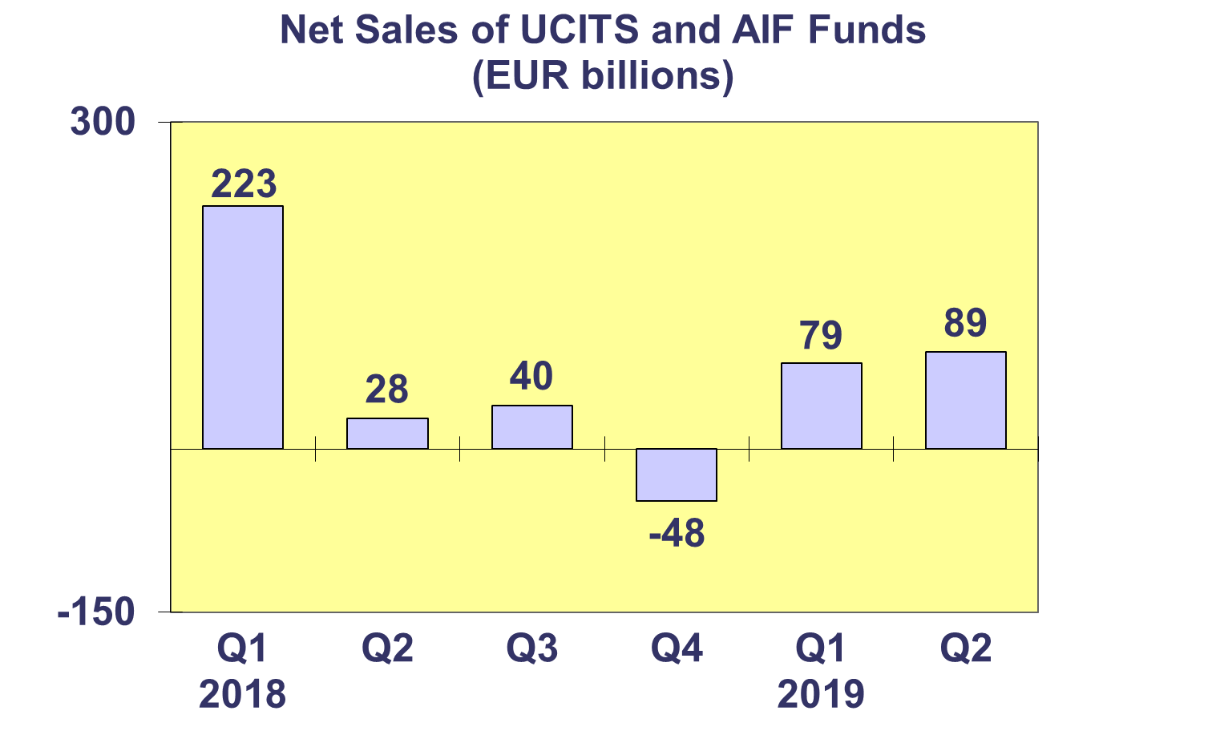

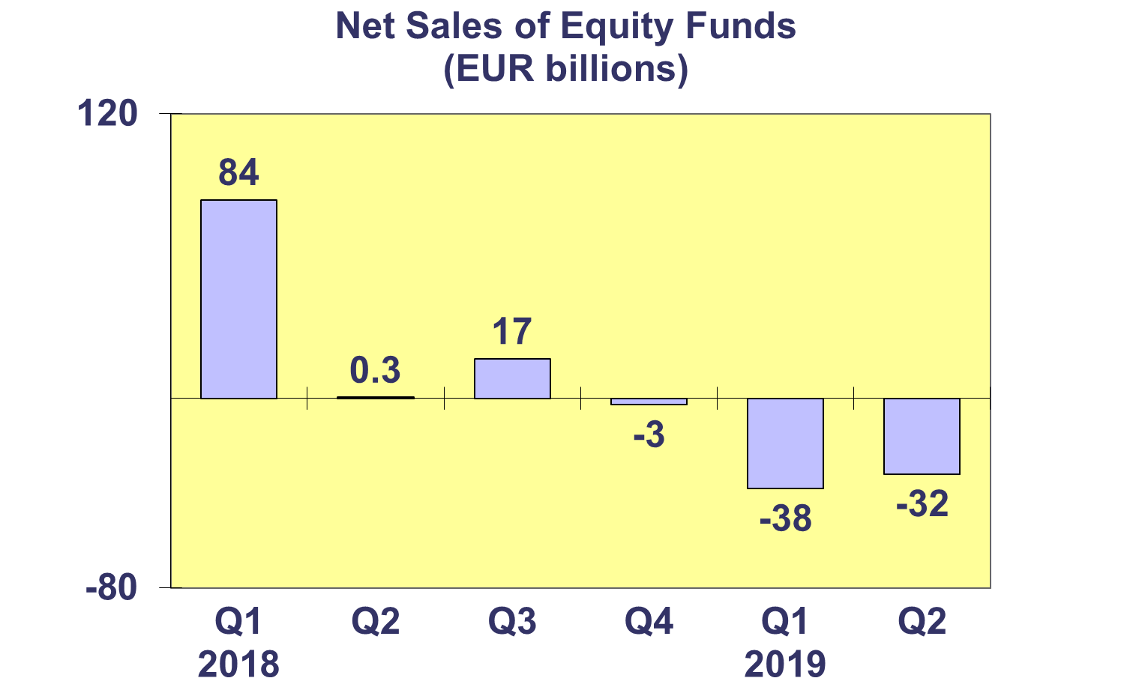

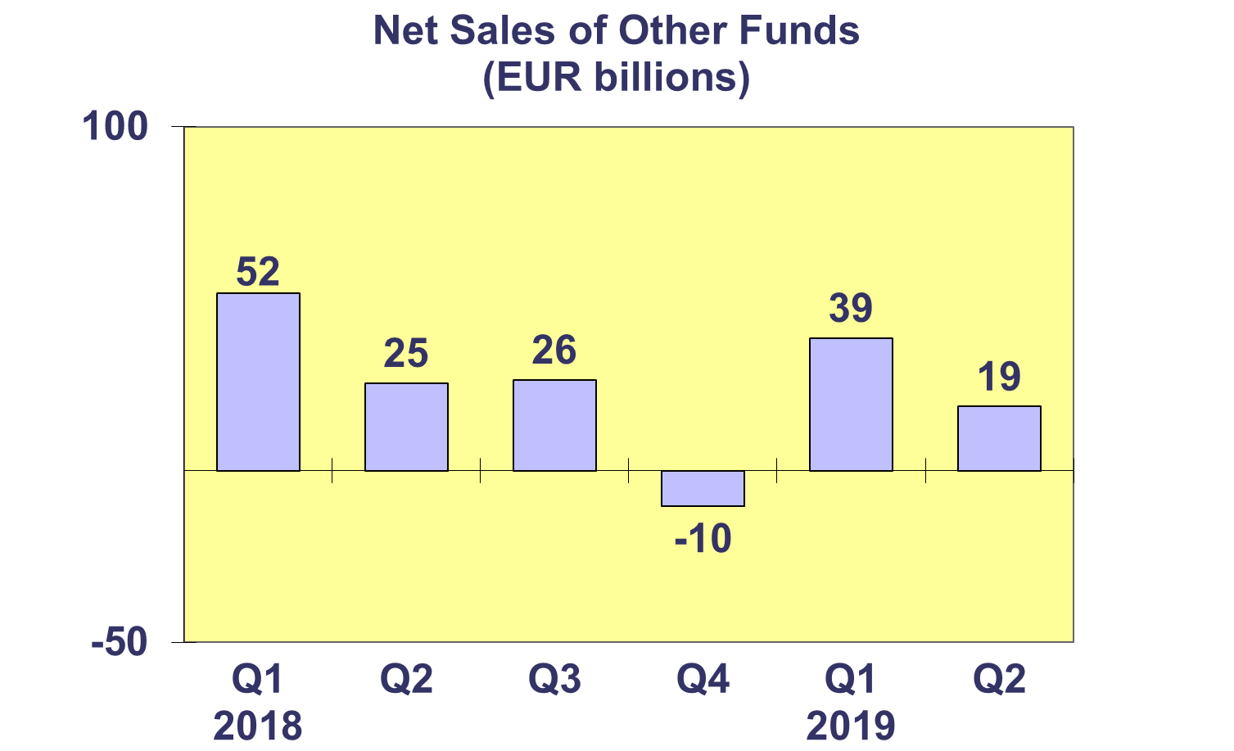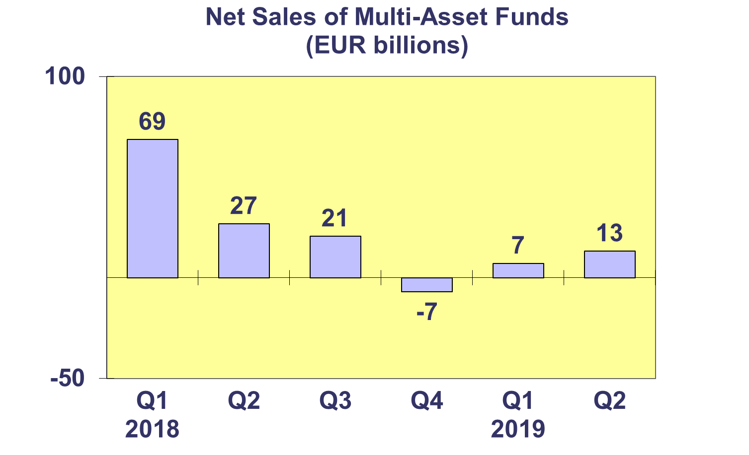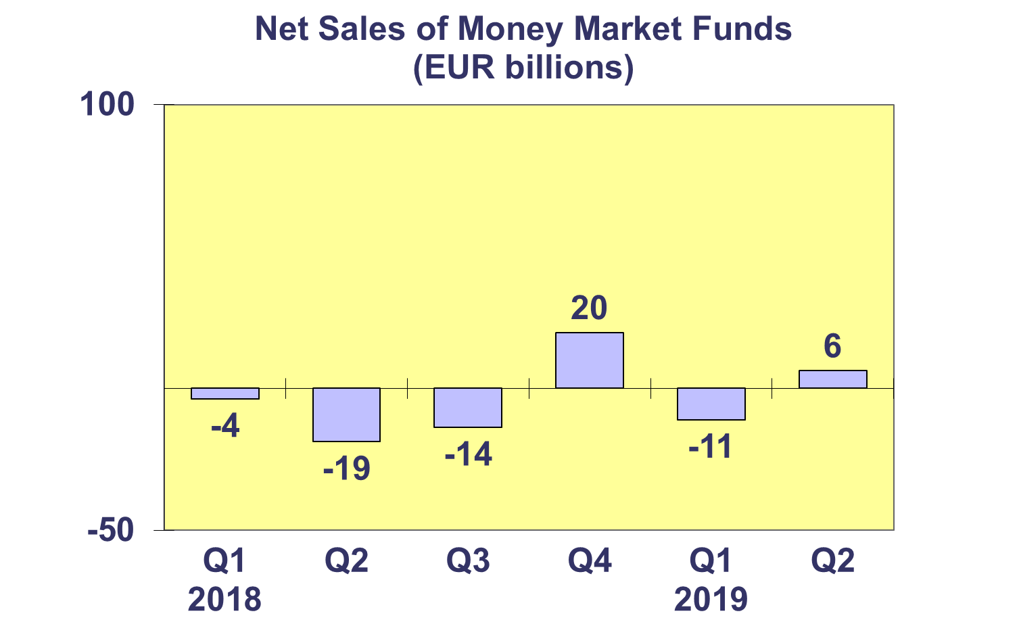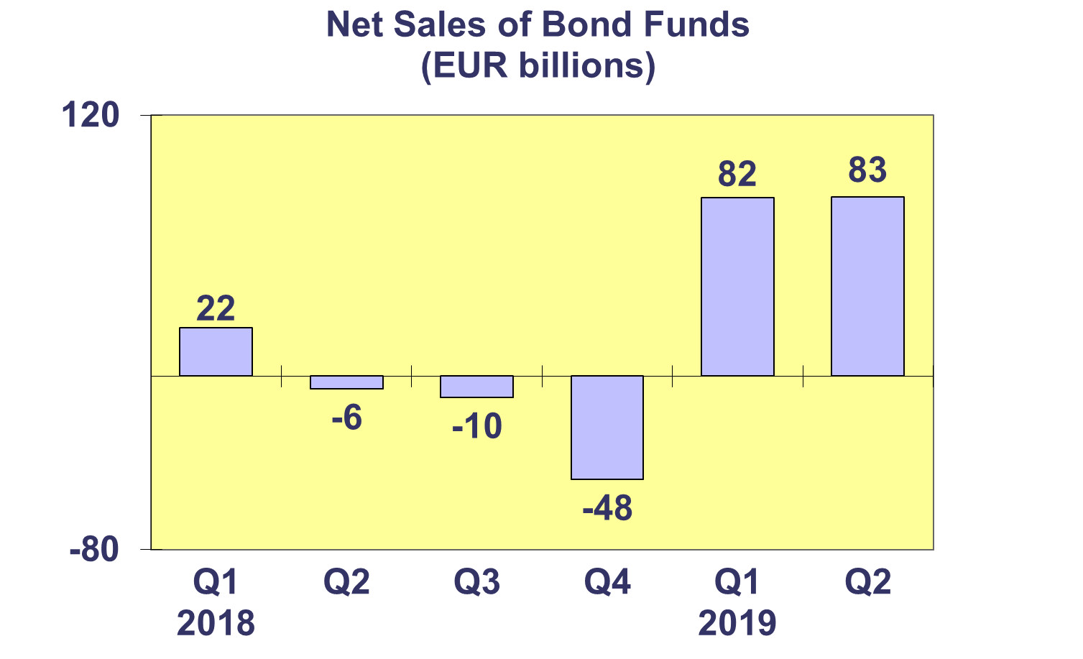**Trends in the European Investment Fund Industry**

***Net Assets by Country of Domiciliation***

**Total net assets of the European investment increased to EUR 16,540 billion at end Q2 2019, representing a net asset growth of 1.7% since Q1 2019 and 9.1% since end 2018.**

In Q2 2019, twenty-six countries recorded growth in their total net assets of investment funds.

With EUR 10,144 billion invested in UCITS, this segment accounted for 61.3% of total European investment fund assets at end Q2 2019, with the remaining 38.7% (equivalent to EUR 6,396 billion) coming from AIFs.



**Trends in the European Investment Fund Industry**

***Number of Funds by Country of Domiciliation***

**In Q2 2019, the total number of UCITS and Alternative Investment Funds (AIFs) increased by 0.6% to 62,538.**

At the end of Q2 2019, UCITS accounted for 33,720 funds or 53.9% of the European investment fund market, while AIFs accounted for 28,818 funds, or 46.1% of the market.

