Quarterly Statistical Release

September 2017 N° 70

This release and other statistical
releases are available on Efama’s
website (www.efama.org)

Trends in the European Investment Fund Industry

in the Second Quarter of 2017

This report was prepared by Alex Carroll, Bernard Delbecque and Thomas Tilley

EFAMA
The European Fund and Asset Management Association

Rue Montoyer 47 - B-1000 BRUXELLES - Tel. 32-2-513.39.69 Fax: 32-2-513.26.43 - e-mail: info@efama.org

Trends in the UCITS Market

Net Sales by Investment Type

UCITS recorded net inflows of EUR 174 billion during Q2 2017, compared to EUR 202 billion in the first quarter of 2017. In the first half of 2017, UCITS funds have attracted EUR 377 billion in net new money, compared to EUR 271 billion recorded in 2016.

Long-term UCITS recorded net sales of EUR 188 billion in Q2 2017, up from EUR 152 billion in Q1 2017. Net sales of equity funds amounted to EUR 35 billion, compared to EUR 29 billion in Q1 2017. Net sales of multi-asset funds increased from EUR 38 billion in Q1 to EUR 54 billion in Q2 2017. Net sales of bond increased from EUR 75 billion in Q1 to EUR 93 billion in Q2 2017. Net sales of money market fund saw a reversal in net flows, decreasing from net inflows of EUR 51 billion in Q1 to net outflows of EUR 13 billion in Q2 2017.
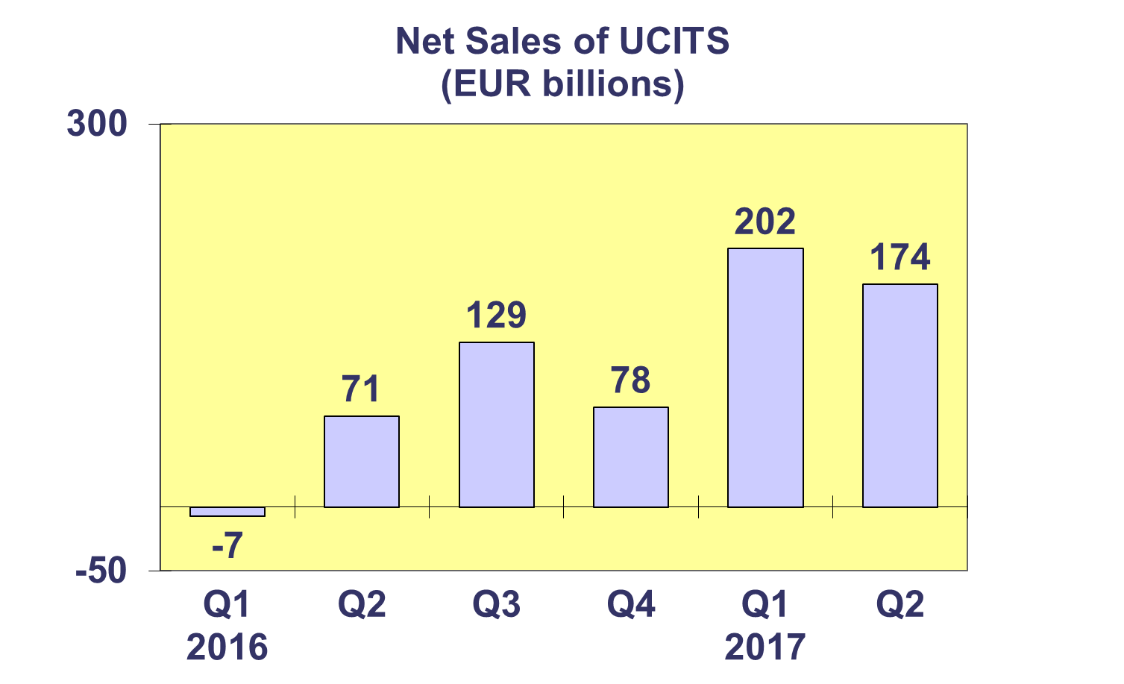
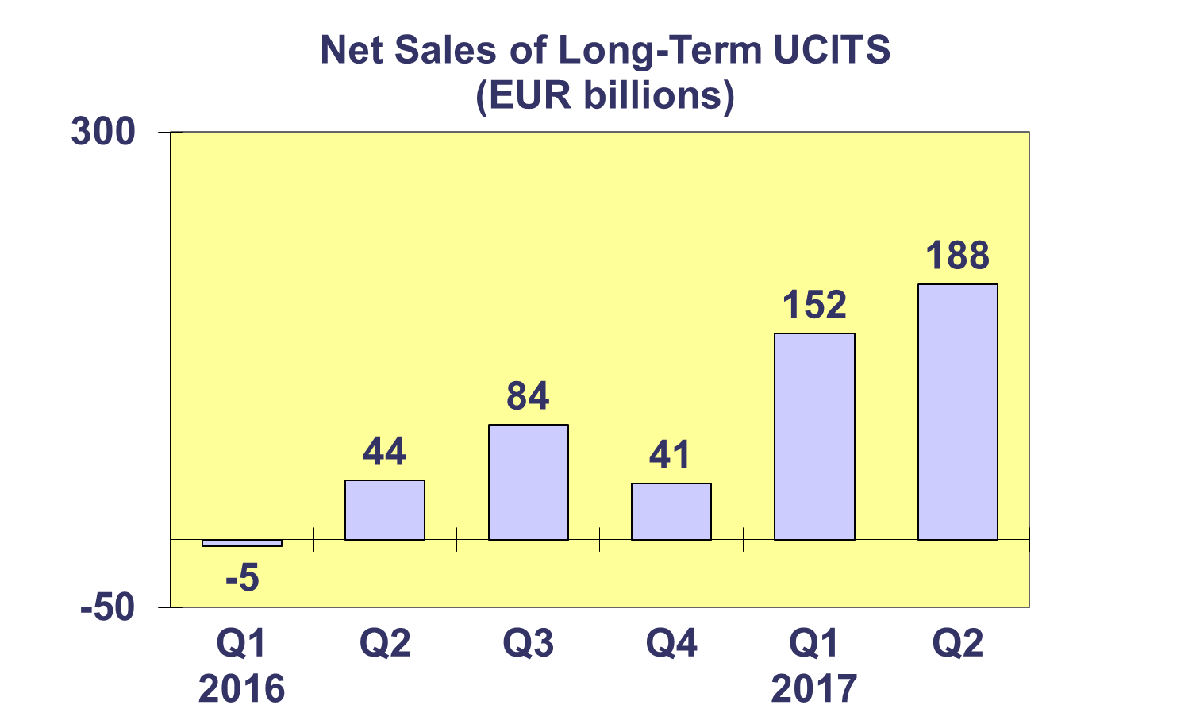

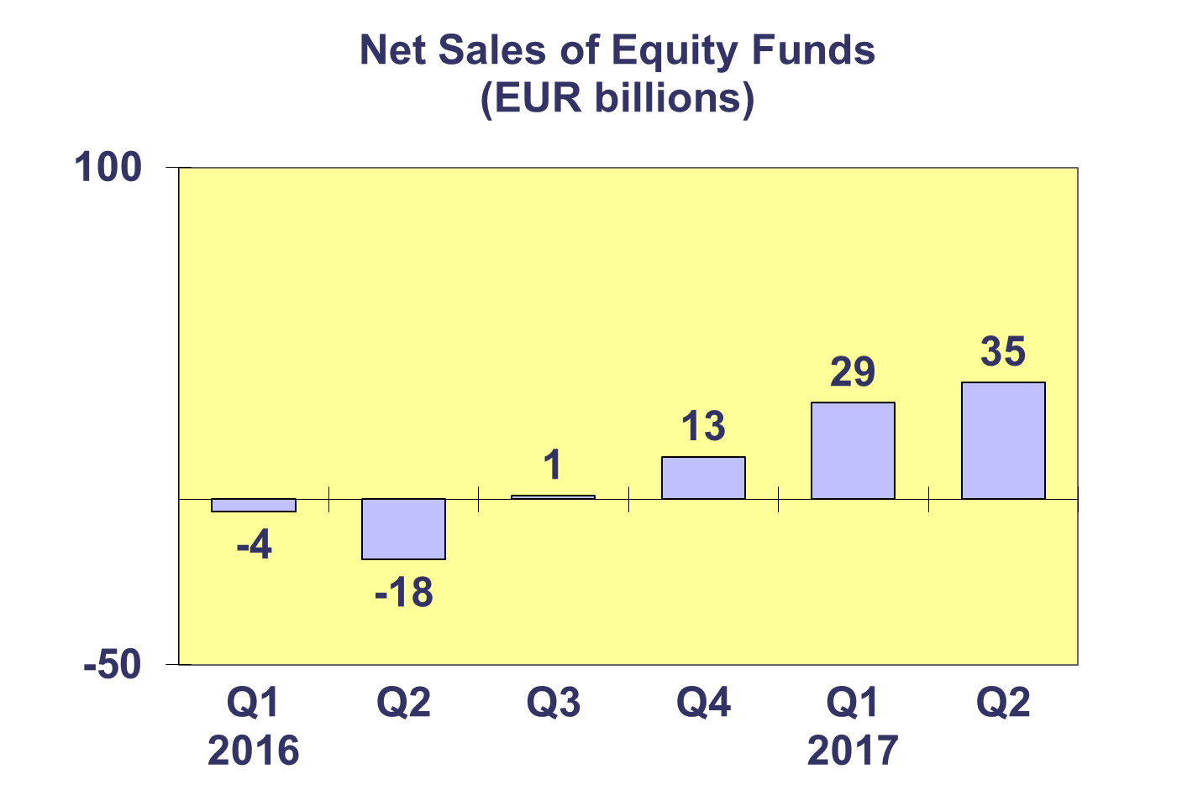
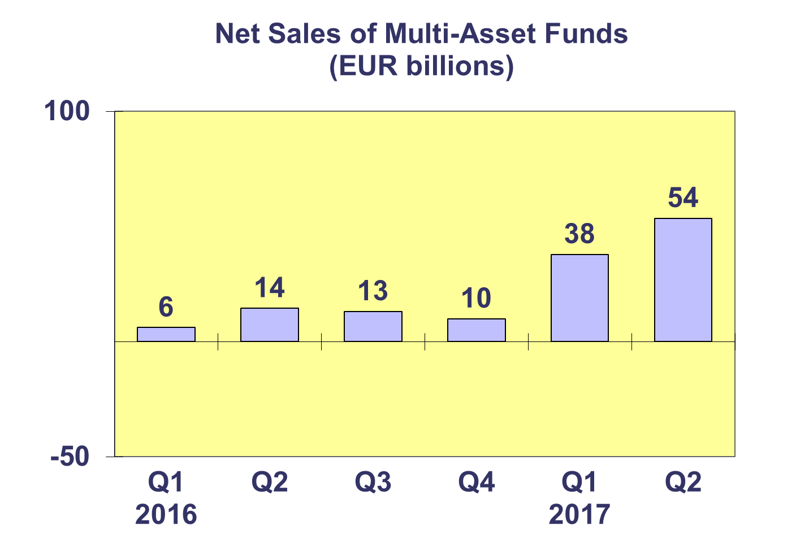

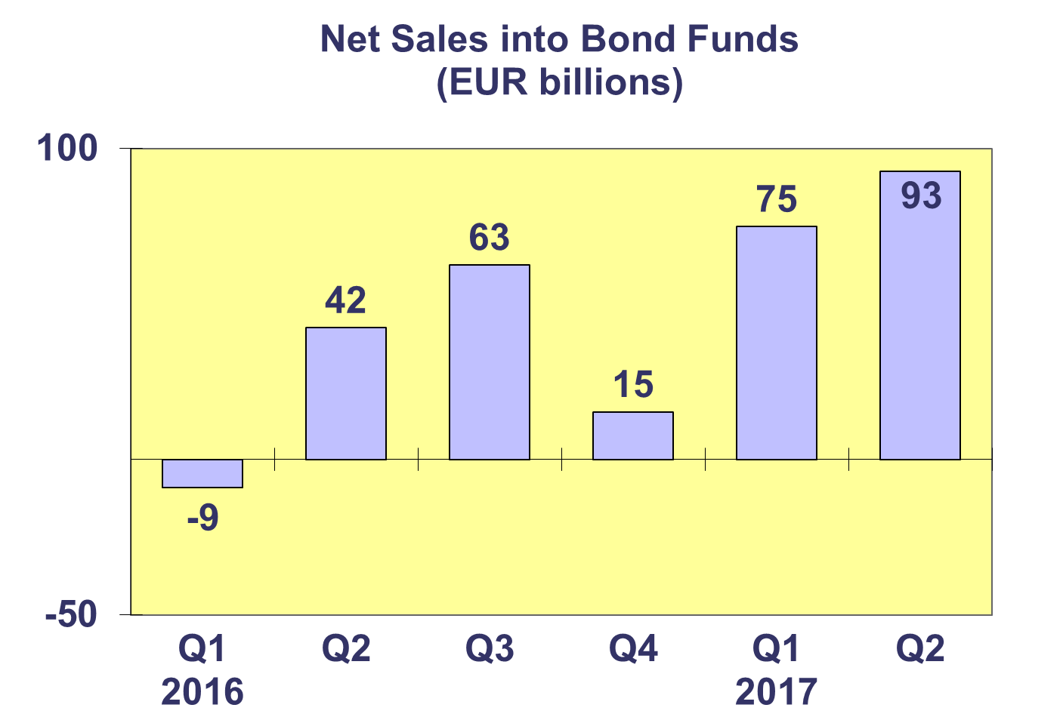
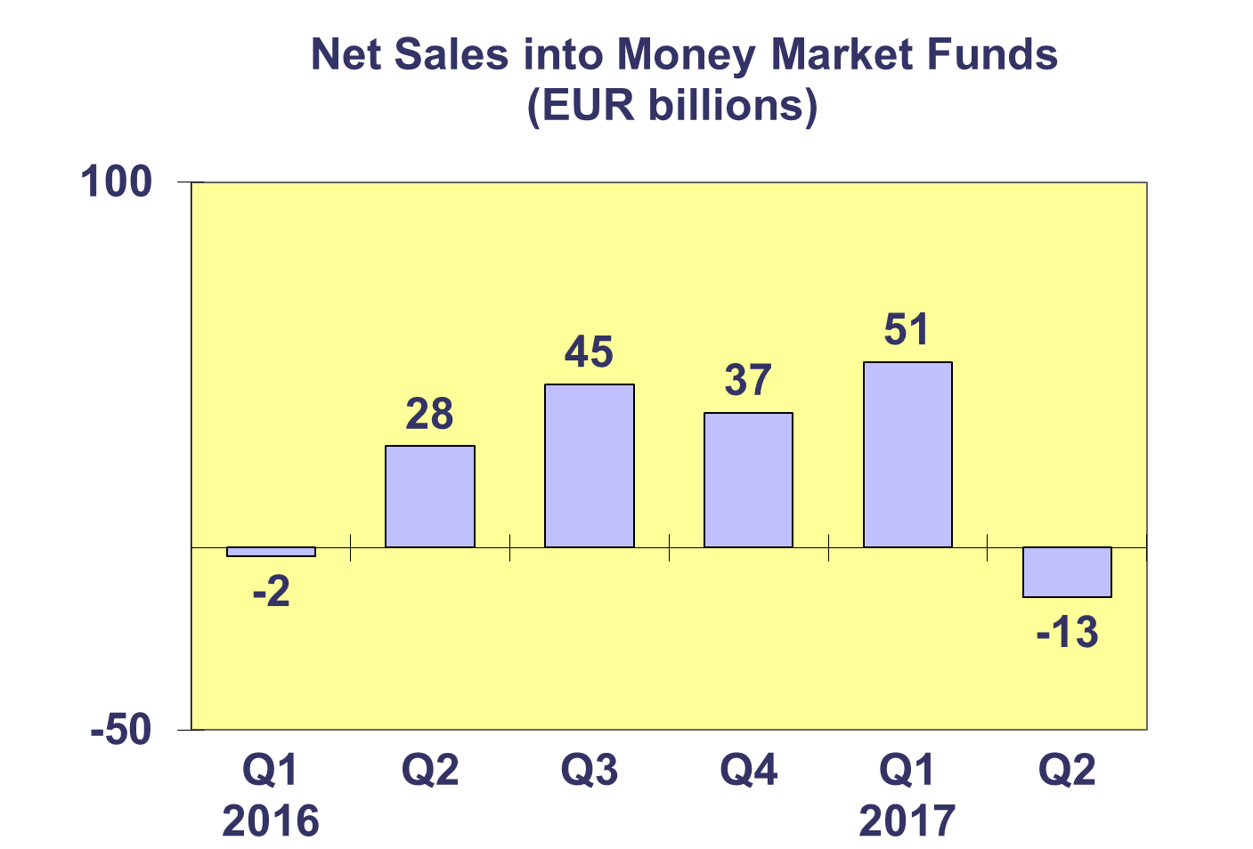

Trends in the UCITS Market
Net Sales by Country of Domiciliation and Investment Type

Twenty-four countries registered net inflows into UCITS in the second quarter of 2017, with ten countries recording net inflows above EUR 1 billion.

The largest net inflows into UCITS were recorded in Luxembourg (EUR 70 billion), closely followed by Ireland (EUR 68 billion), thanks to strong net inflows into bond funds, as well as equity funds in Ireland and multi-asset funds in Luxembourg. The United Kingdom registered EUR 14 billion, followed by Spain (EUR 7 billion) and Switzerland (EUR 7 billion). The largest net outflows in Q2 2017 were recorded in France (EUR 12 billion), primarily due to end-of-quarter withdrawals from money market funds.

So far in 2017, bond funds and multi-asset funds have attracted the largest net sales with EUR 168 billion and EUR 92 billion, respectively.

Trends in the UCITS Market
Net Sales and Net Assets of ETF by Country of Domiciliation

Net sales of UCITS ETF amounted to EUR 20 billion in Q2 2017, down from EUR 24 billion in the first quarter. UCITS ETF have attracted net sales of EUR 43.6 billion so far this year, compared to EUR 44 billion in 2016.

UCITS ETF domiciled in Ireland registered the largest net inflows during the quarter (EUR 15.5 billion) reflecting the size of their ETF market, followed by France (EUR 4 billion) and Germany (EUR 0.5 billion). The largest net outflows were seen in the Netherlands (EUR -0.1 billion). Looking at cumulative year-to-date net sales, Ireland has so far attracted the largest net inflows (EUR 33 billion) whereas the Netherlands has experienced the largest net outflows from ETF funds (EUR 0.3 billion).
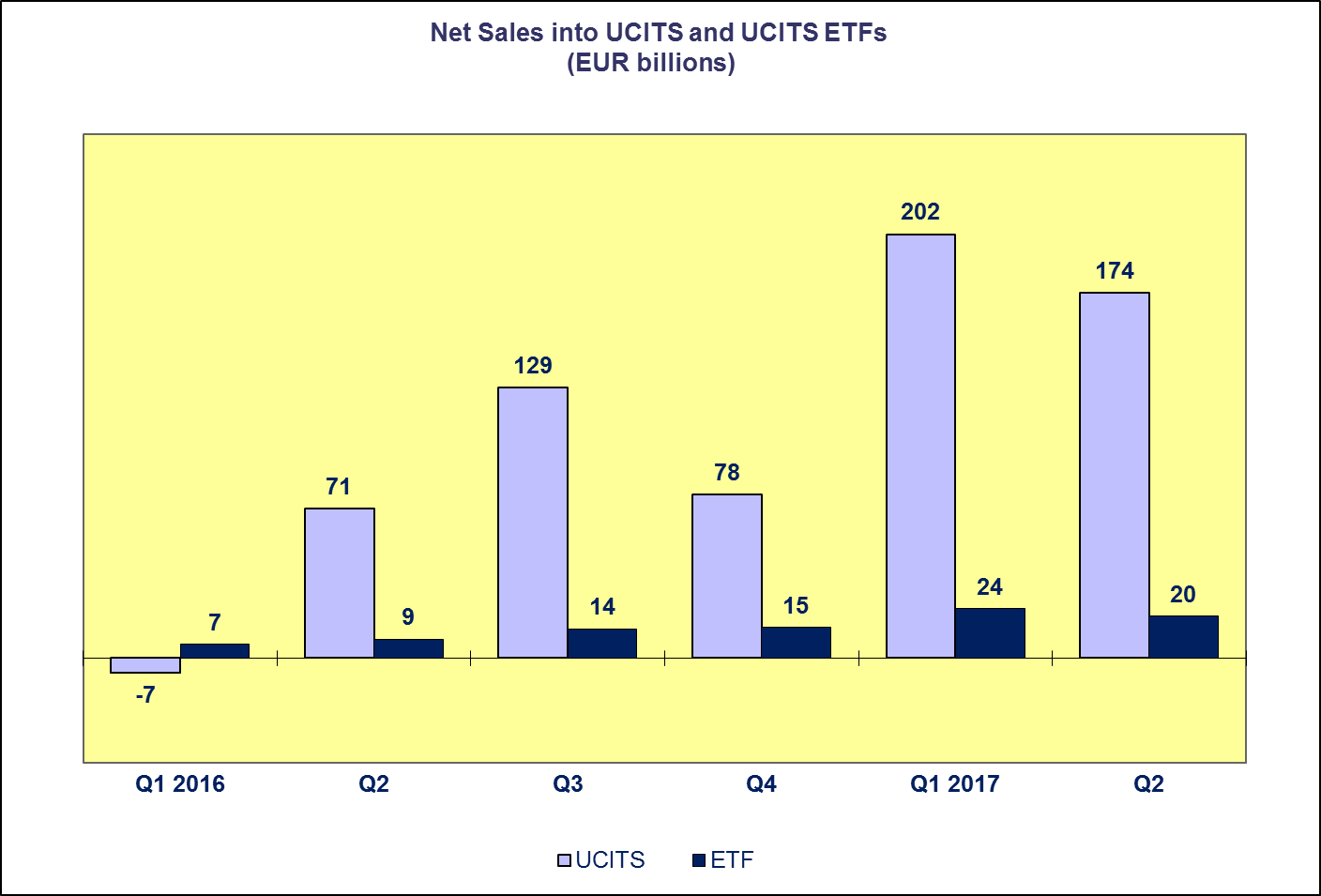

Trends in the UCITS Market

Net Assets by Investment Type

UCITS net assets increased by 0.6% in Q2 2017 to reach EUR 9,171 billion. As of Q2 2017, net assets of UCITS have increased 5.9% since end 2016.

All categories of UCITS funds experienced an increase in net assets in Q2 2017, with the exception of guaranteed funds and money market funds which experienced net asset decreases of 5.7% and 3.7%, respectively. Net assets of multi-asset funds and “other” UCITS funds both increased 2.3% to reach EUR 1,605 billion and EUR 409 billion, respectively. Bond funds increased 2.1% to EUR 2,492 billion, and equity funds increased 0.2% to EUR 3,474 billion.

The number of UCITS funds increased from 30,987 at end Q1 2017 to 31,281 at end Q2 2017.

Trends in the UCITS Market
Net Assets by Country of Domiciliation

Twenty-two domiciles recorded net asset growth at end Q2 2017, with net assets of UCITS reaching EUR 9,171 billion.

In Western Europe, Germany recorded the largest net asset growth (2.0%), followed by Ireland (1.5%) and Luxembourg (0.9%). The largest net asset decreases were seen in the Netherlands (1.9%). Strong net asset growth was seen in every Southern European domicile, with the largest growth seen in Malta (9%), followed by Greece (7.9%), Cyprus (7.0%), Spain (3.6%), Portugal (3%) and Italy (2.2%). In the Nordic countries, the largest net asset increases were registered in Denmark (2.3%) with the largest decreases in Norway (0.5%). In Central and Eastern Europe, the largest increases in net assets were recorded in Hungary with 9.3% and the Czech Republic (6.6%), with the largest decrease in Slovenia (1.4%).

Trends in the AIF Market

Net Sales by Investment Type

AIF recorded net inflows of EUR 70 billion in Q2 2017, up from EUR 62 billion in Q1. So far in 2017, AIF have garnered net sales of EUR 132 billion in net sales, compared to EUR 187 billion in 2016.

Long-term AIF recorded net sales of EUR 75 billion, up from EUR 61 billion in Q1 2017. Net sales of equity funds increased from EUR 6 billion in the first quarter to EUR 7 billion in the second. Net sales of multi-asset funds increased slightly from EUR 13 billion in Q1 to EUR 14 billion in Q2 2017. Net sales of bond funds amounted to EUR 10 billion at the end of the quarter, slightly lower than the previous quarter (EUR 12 billion). Net sales of other funds increased from EUR 35 billion in Q1 2017 to EUR 39 billion in Q2.
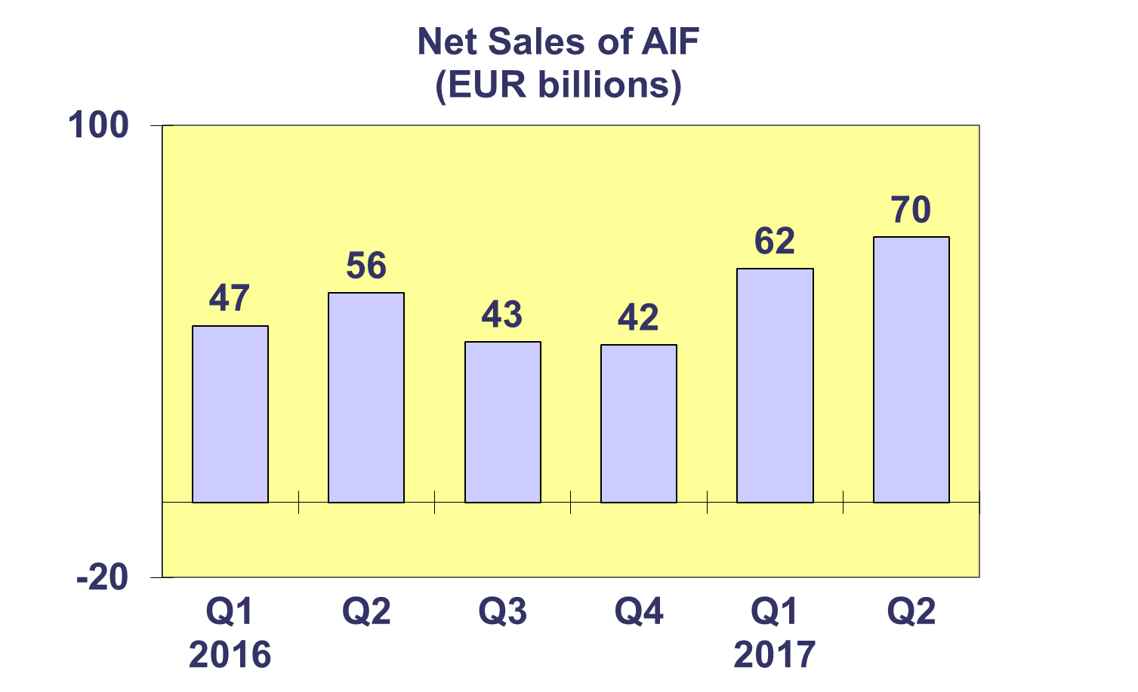
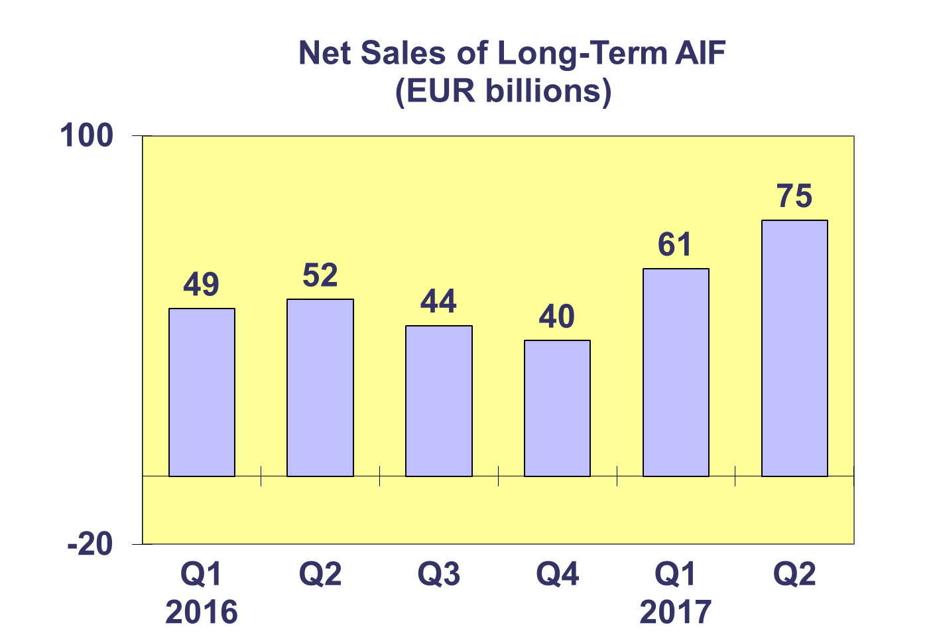

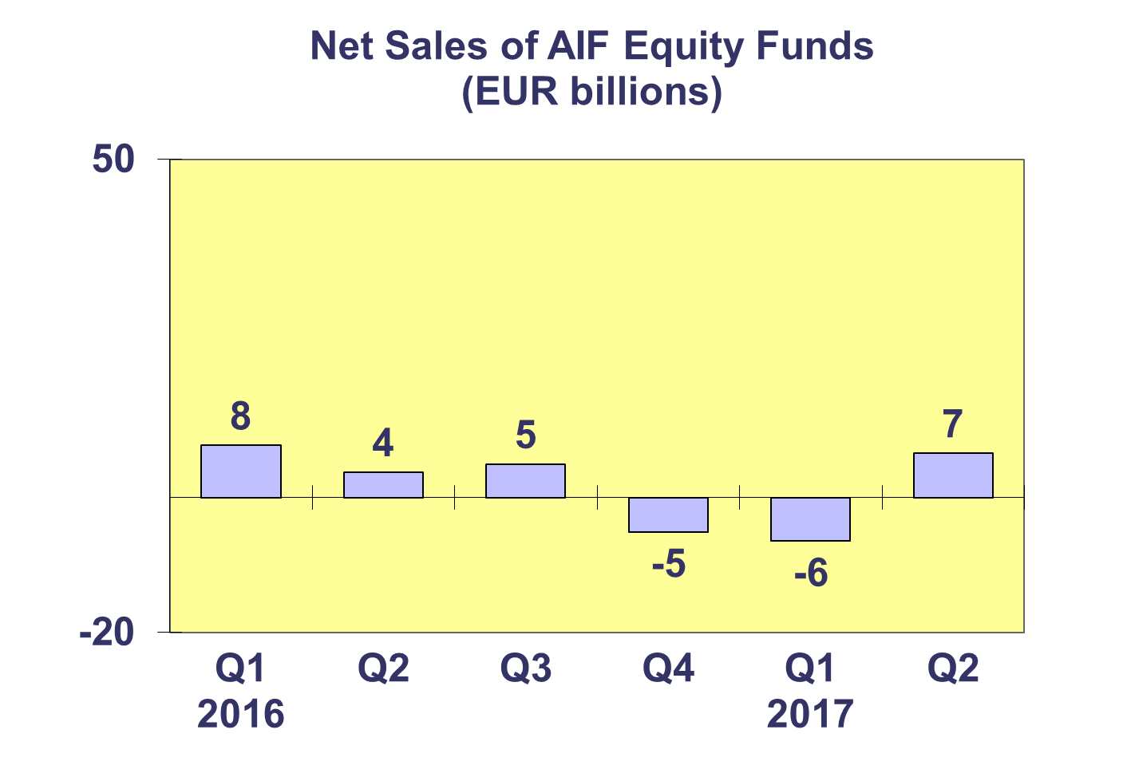
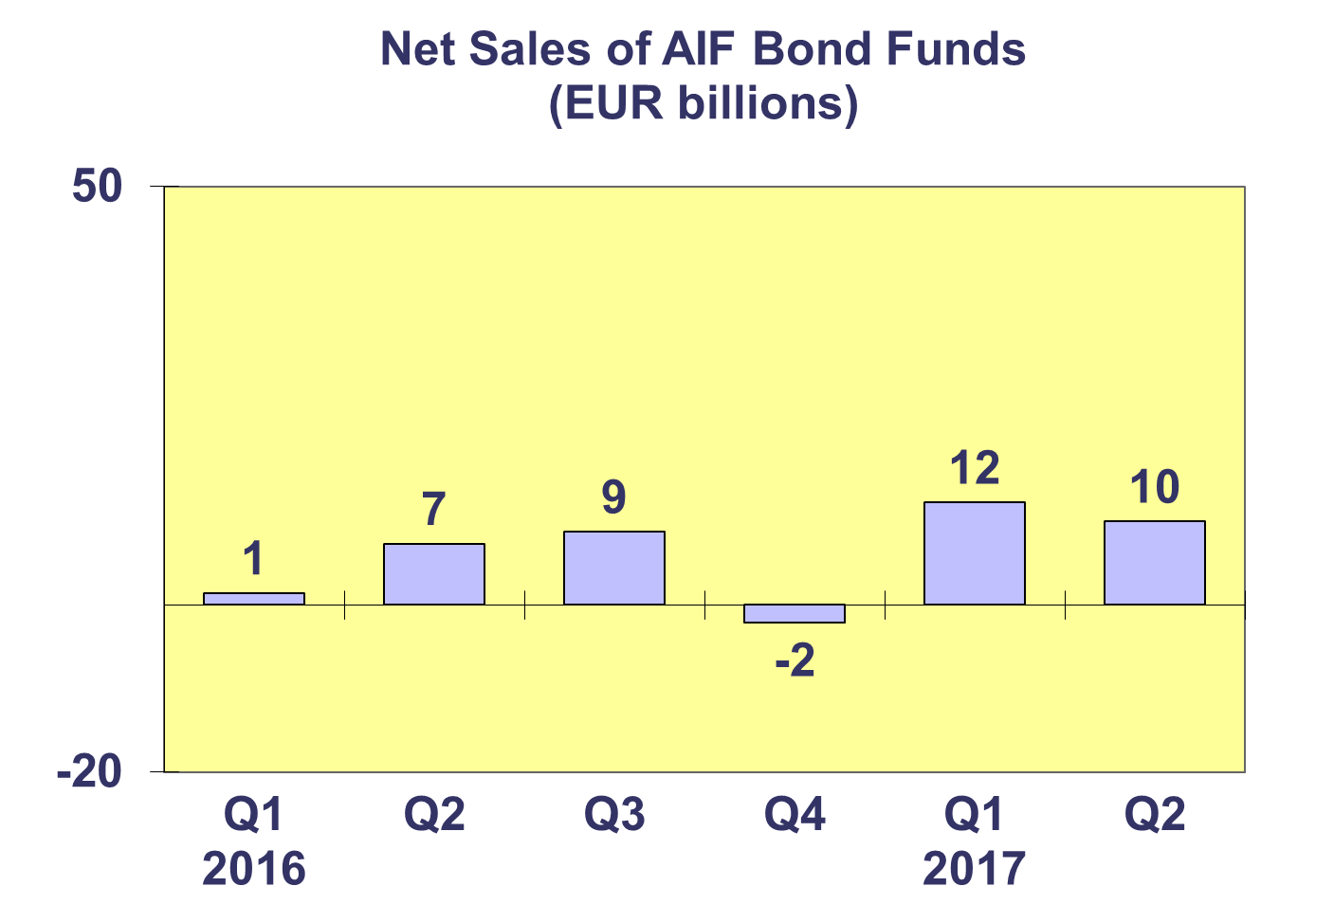
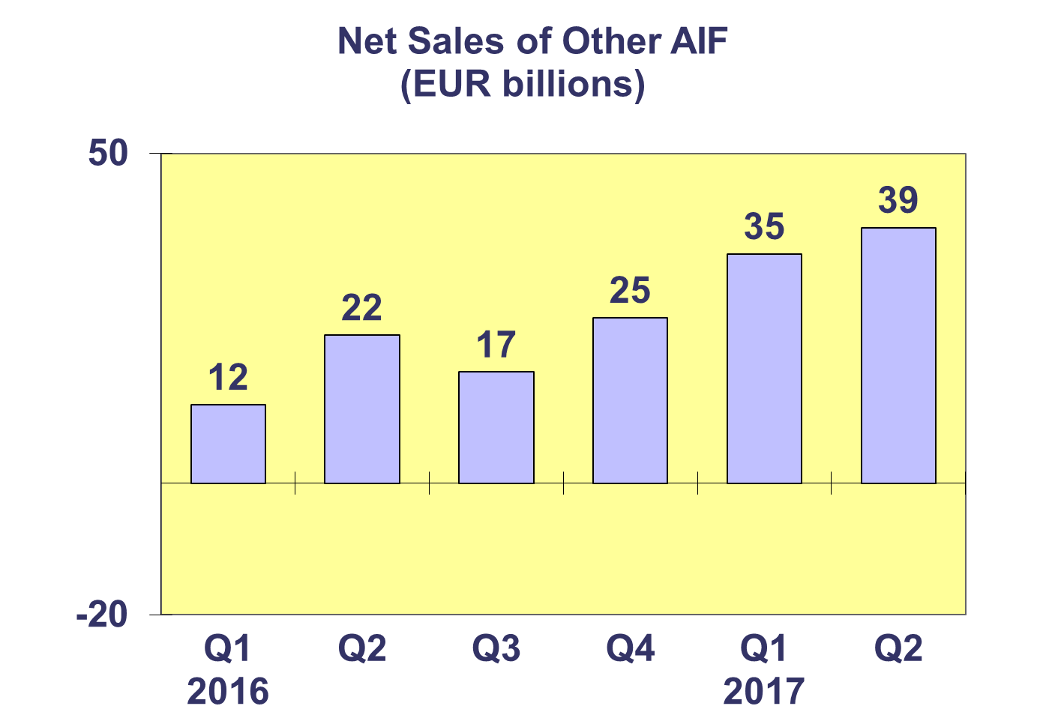
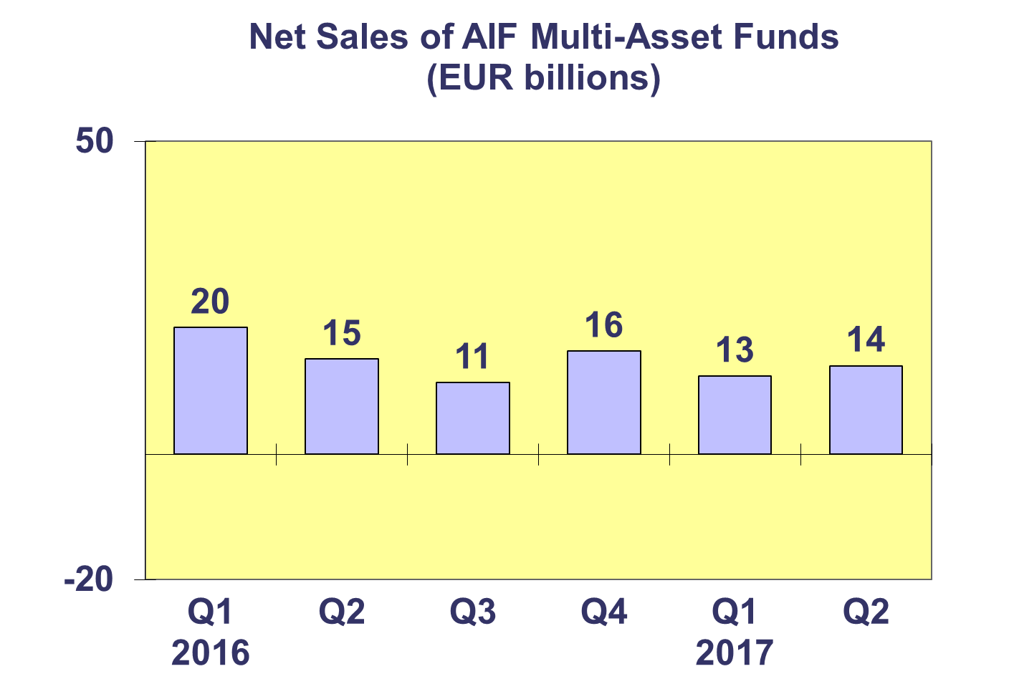

Trends in the AIF Market
Net Sales by Country of Domiciliation and Investment Type

Nineteen countries experienced net inflows into AIF in Q2 2017, with six countries recording net inflows higher than EUR 1 billion.

Net inflows above EUR 1 billion were registered in Ireland (EUR 22 billion), Germany (EUR 18 billion), Netherlands (EUR 16 billion), Luxembourg (EUR 7 billion), Denmark (EUR 4 billion) and the United Kingdom (EUR 3 billion). The largest net outflows during the quarter were registered in France (EUR 1 billion).

All categories of long-term AIF funds registered net inflows during Q2 2017, while money market funds registered net outflows (EUR 5 billion).

Trends in the AIF Market
Net Assets by Investment Type

Net assets of AIF increased by 0.6% in the second quarter to reach EUR 5,723 billion.

In Q2 2017, real estate funds recorded the largest asset growth (0.9%), followed by bond funds (0.4%) and equity funds (0.1%). Large decreases in net assets were seen in money market funds (7%) and smaller decreases in guaranteed/protected funds (0.9%) and multi-asset funds (0.6%). Net assets of other AIF, which include Other AIF funds grew 2.3 percent.

There were 28,322 AIF funds at end Q2 2017, compared to 28,239 at end Q1 2017 and 27,934 at end Q4 2016.

Trends in the AIF Market
Net Sales and Assets of Institutional AIF

Net assets of institutional AIF, which are AIF reserved for institutional investors, increased 2.3% to EUR 2,749 billion at end Q2 2017.

Net assets of institutional equity funds increased 0.7% to finish the quarter at EUR 224 billion. Net assets of institutional multi-asset funds increased by 0.4% to reach EUR 998 billion. Net assets of institutional bond funds remained stable at EUR 572 billion, and real estate fund net assets increased 3.6% to EUR 173 billion. Other institutional funds experienced net asset growth of 5.8% to reach EUR 309 billion at end Q2 2017.

Institutional AIF recorded net sales of EUR 46 billion in Q2 2017, higher than both Q1 2017 (EUR 38 billion) and Q4 2016 (EUR 45 billion).

Trends in the AIF Market
Net Assets by Country of Domiciliation

At end Q2 2017, net assets of AIF increased 0.6% compared to Q1 2017 and 4.3% compared to end 2016.

Of the largest AIF domiciles, the largest net asset growth was seen in Germany (1.5%), followed by Luxembourg (1.1%), the Netherlands (0.8%), and Ireland (0.2%). Elsewhere in Europe, net assets grew strongly in the Czech Republic (12.1%), Cyprus (6.3%), Croatia (4.3%) and Bulgaria (3.6%).

Trends in the European Investment Fund Industry

Net Sales by Investment Type

UCITS and AIF recorded net sales of EUR 245 billion during Q2 2017, compared to EUR 264 billion in Q1. So far this year, European investment funds have attracted net sales of EUR 509 billion, higher than total net sales in 216 (EUR 458 billion).

Net sales of equity funds increased to EUR 42 billion in Q2 2017 compared to EUR 23 billion in the previous quarter. Net sales of bond funds increased from EUR 87 billion in Q1 to EUR 103 billion in Q2 2017. Net sales of multi-asset funds totalled EUR 68 billion in Q2 2017, up from EUR 50 billion in the previous quarter. Money market funds experienced net outflows amounting to EUR 18 billion, compared to net inflows of EUR 52 billion in the first quarter of 2017. Net sales of other funds (including real estate, guaranteed/protected funds and other funds which do not fit any of the categories below or for which information is not available) totalled EUR 51 billion, slightly less than EUR 52 billion during the previous quarter.
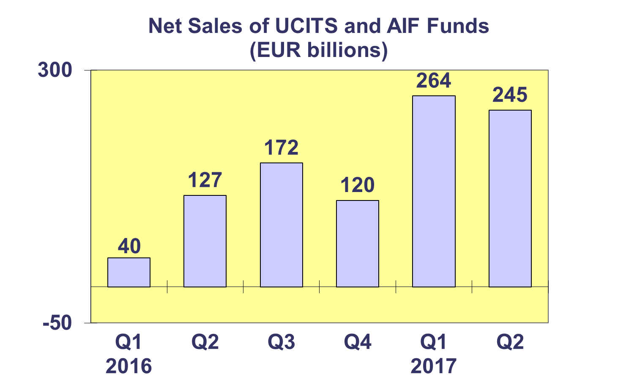
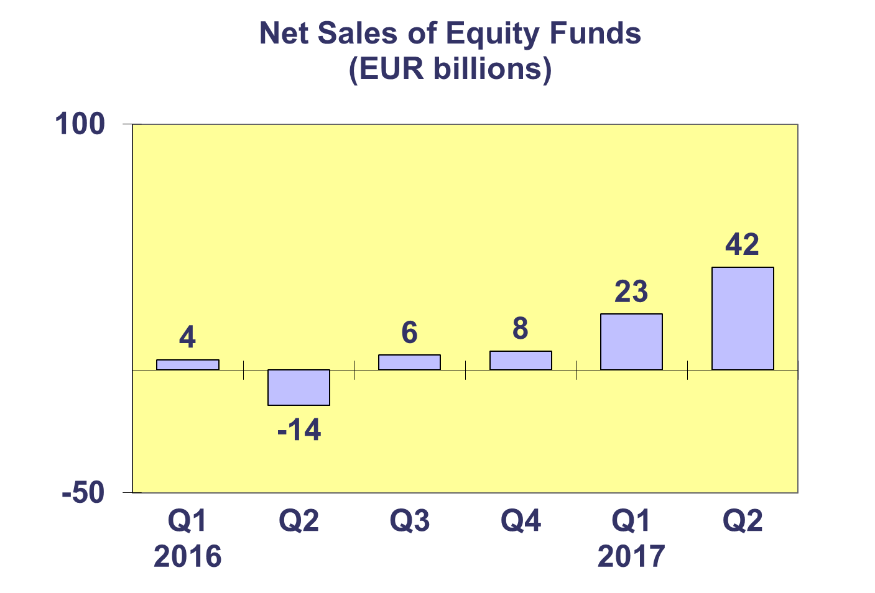
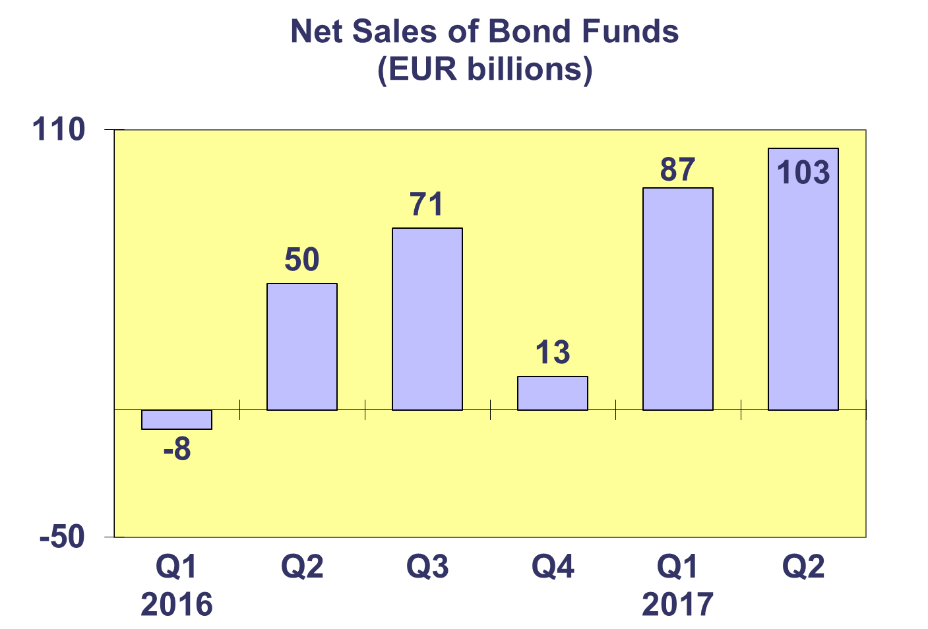
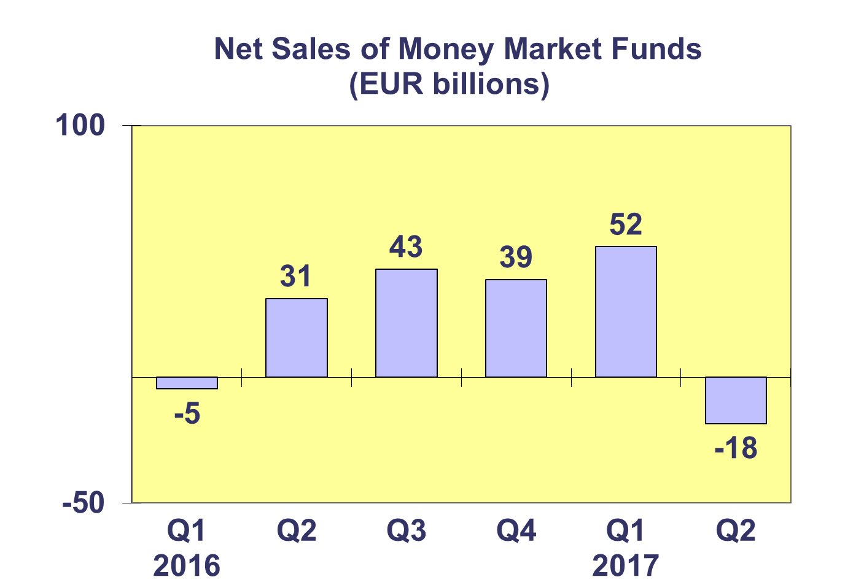
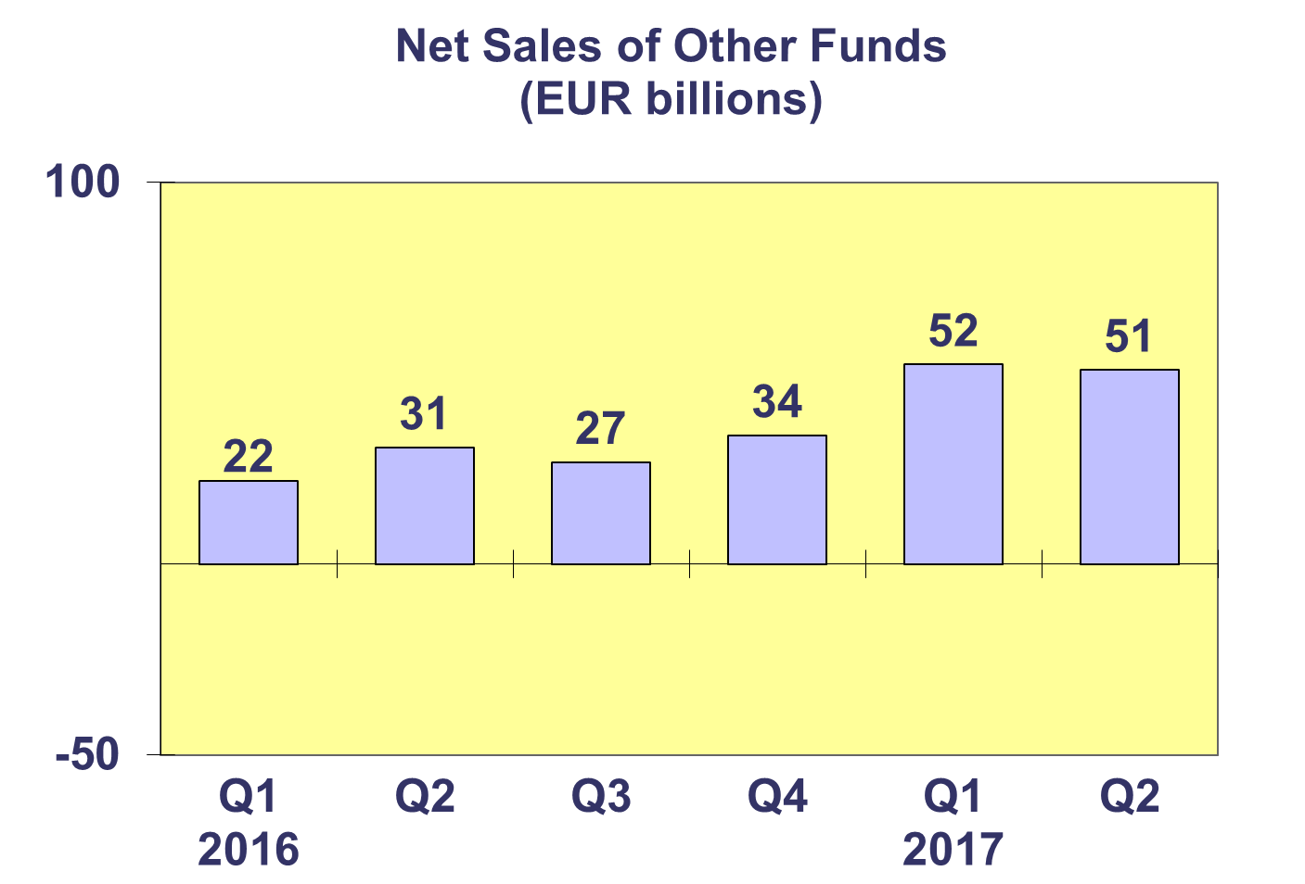

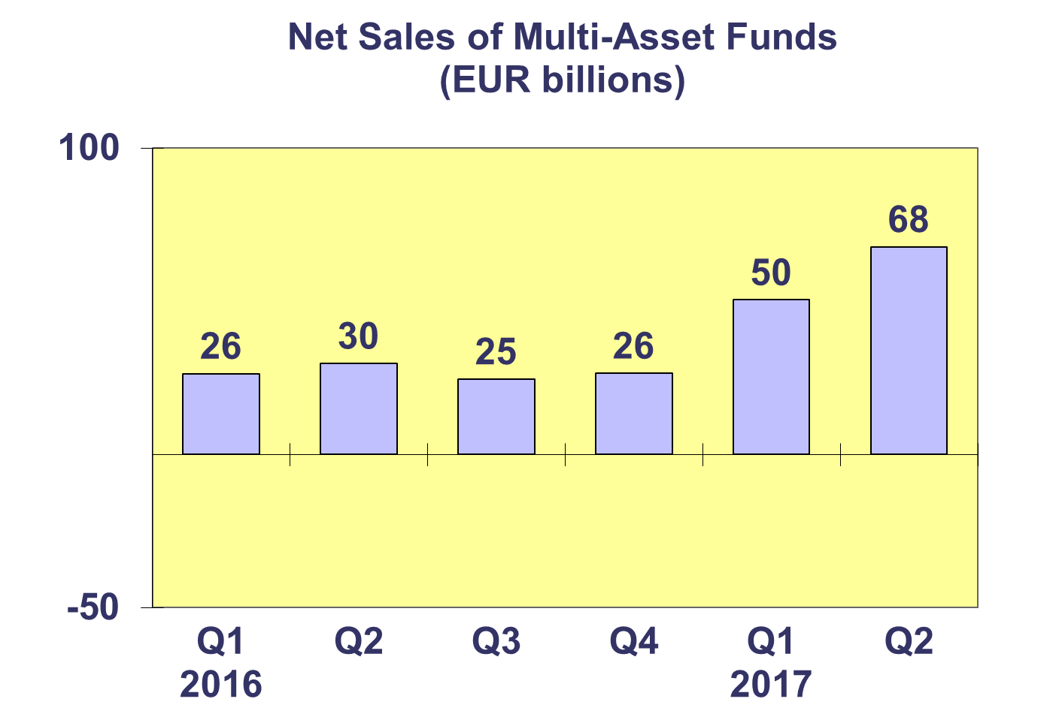
Trends in the European Investment Fund Industry
Net Assets by Country of Domiciliation

Total net assets of the European investment increased to EUR 14,894 billion at end Q2 2017, representing net asset growth of 0.6% since Q2 2017 and 5.3% since end 2016.

With EUR 9,171 billion invested in UCITS, this segment accounted for 61.6% of total European investment fund assets at end Q2 2017, with the remaining 38.4% (equivalent to EUR 5,723 billion) coming from AIF.

Trends in the European Investment Fund Industry
Number of Funds by Country of Domiciliation

In Q2 2017, the total number of UCITS and AIF funds increased by 0.6% to 59,603.

At the end of the second quarter of 2017, UCITS accounted for 31,281 funds or 52.5% of the European investment fund market, while AIF accounted for 28,322 funds, or 47.5% of the market.

Please note that this data does not include net sales of UCITS ETF domiciled in Luxembourg.

