|  |
| --- |
| ***Quarterly Statistical Release*** |

**June 2018, N° 73**

***This release and other statistical***

***releases are available on Efama’s***

***website (***[***www.efama.org***](http://www.efama.org)***)***

***Trends in the European Investment Fund Industry***

***in the First Quarter of 2018***

|  |
| --- |
| **This report was prepared by Bernard Delbecque and Thomas Tilley**  **EFAMA**  **The European Fund and Asset Management Association**  **Rue Montoyer 47 - B-1000 BRUXELLES - Tel. 32-2-513.39.69 Fax: 32-2-513.26.43 - e-mail: info@efama.org** |

**Trends in the UCITS Market**

***Net Sales by Investment Type***

**UCITS recorded net inflows of EUR 171 billion in Q1 2018, of which EUR 126 billion were recorded in January.**

Long-term UCITS recorded net inflows of EUR 173 billion in Q1 2018, exactly the same amount as in Q4 2017. Net sales of equity funds amounted to EUR 85 billion, up from EUR 56 billion in Q4 2017. Net sales of bond funds decreased significantly from EUR 75 billion in Q4 2017 to EUR 27 billion in Q1 2018. Net sales of multi-asset funds increased from EUR 54 billion in Q4 2017 to EUR 58 billion in Q1 2018. Net sales of money market funds recorded net outflows of EUR 2 billion in Q1 2018, compared to net outflows of EUR 3 billion in Q4 2017.

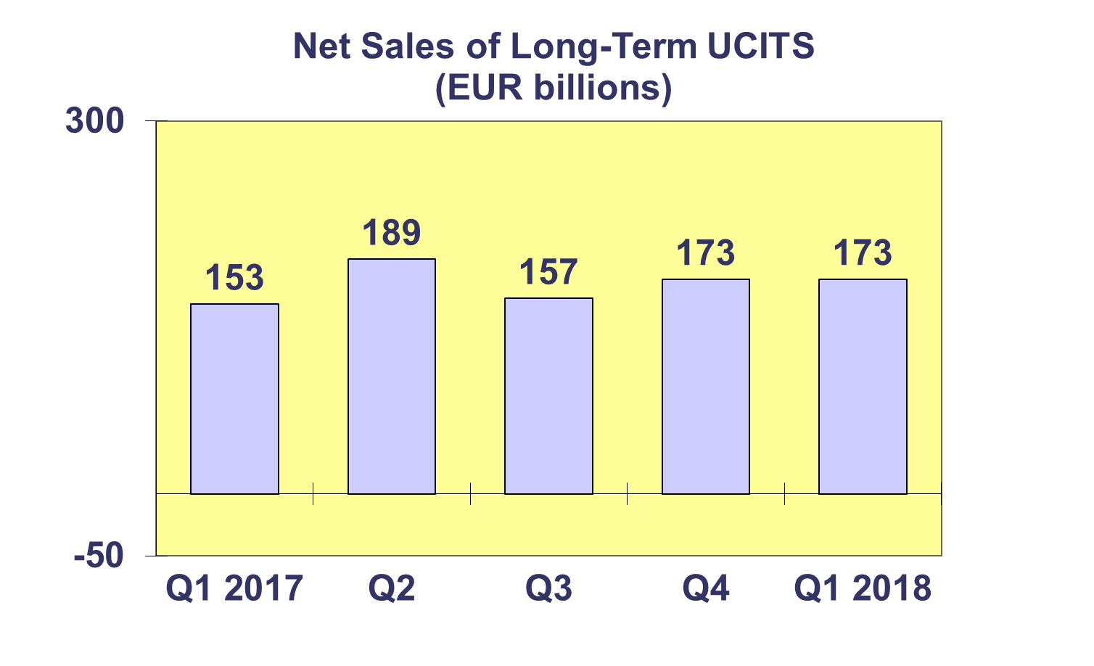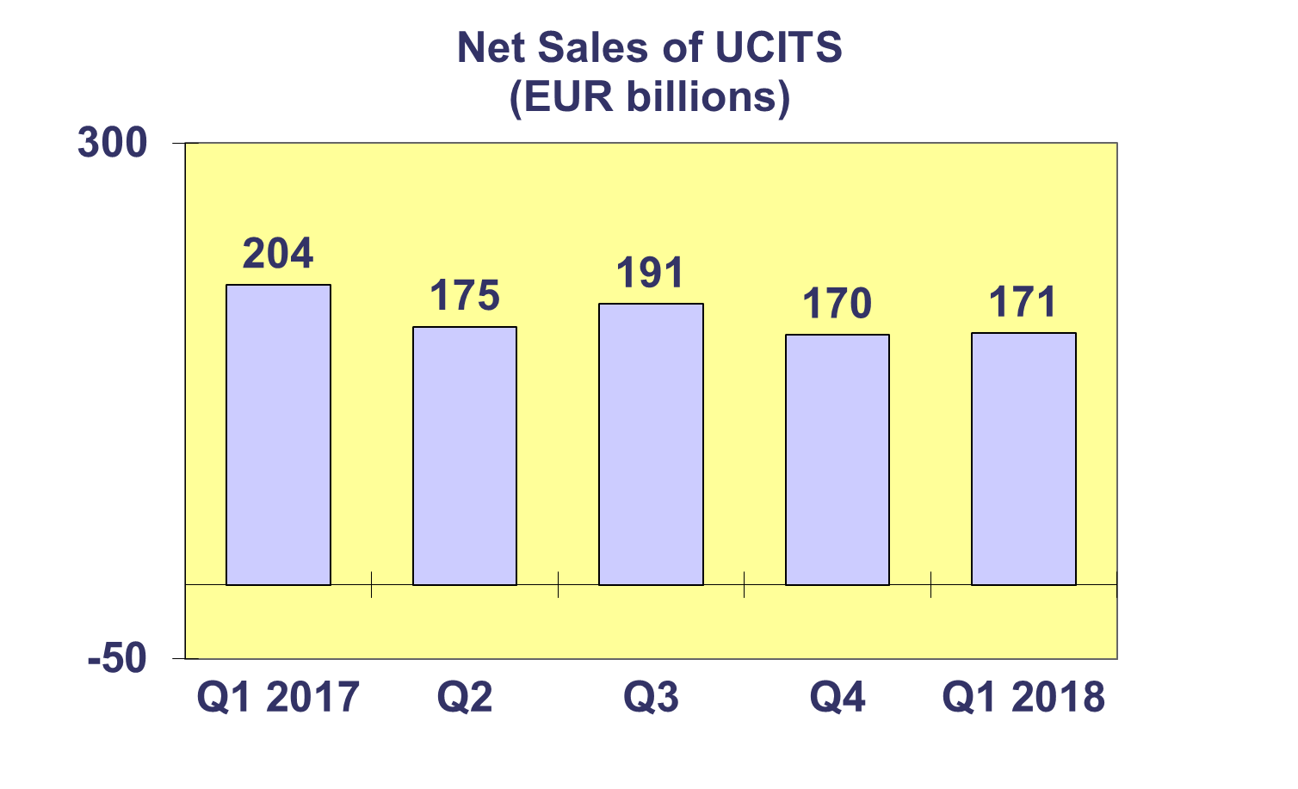

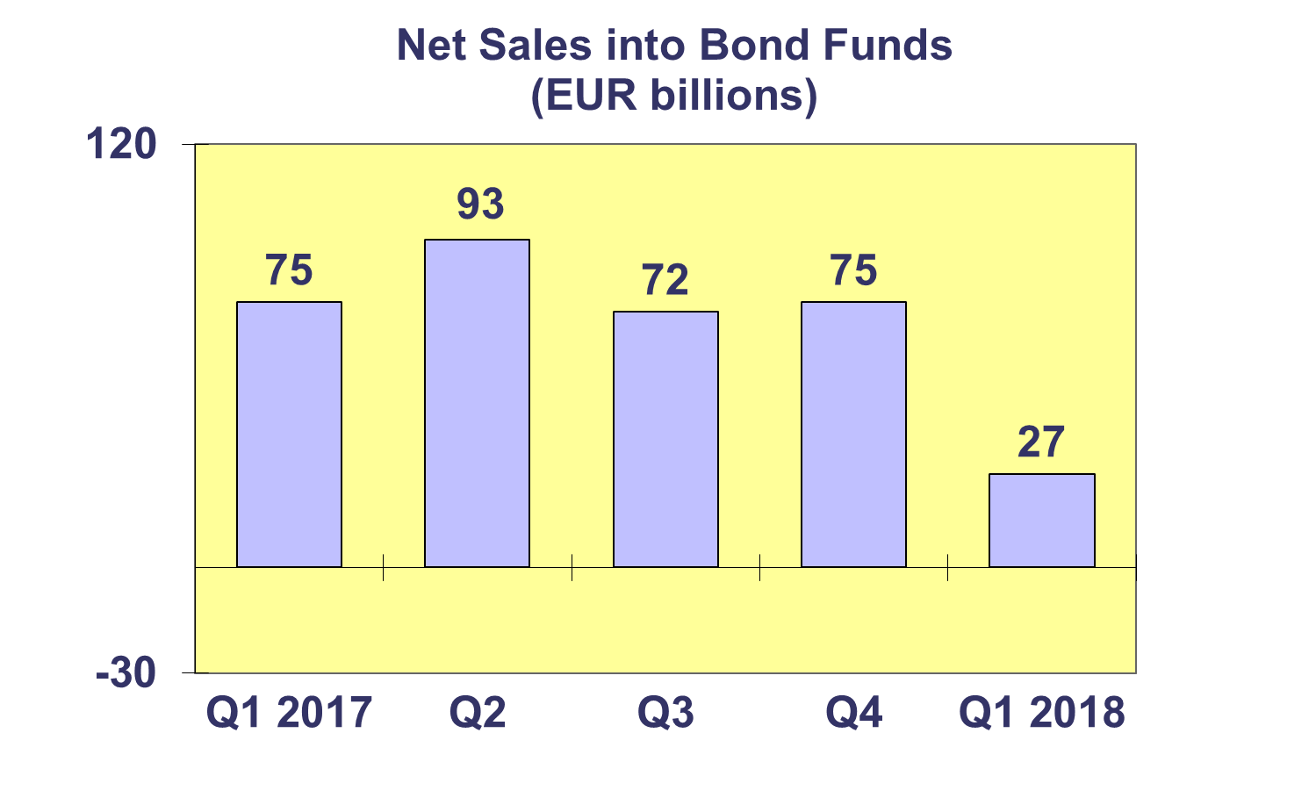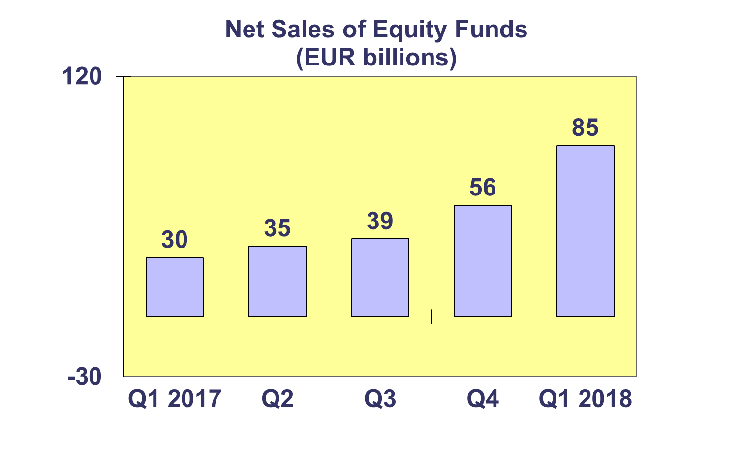

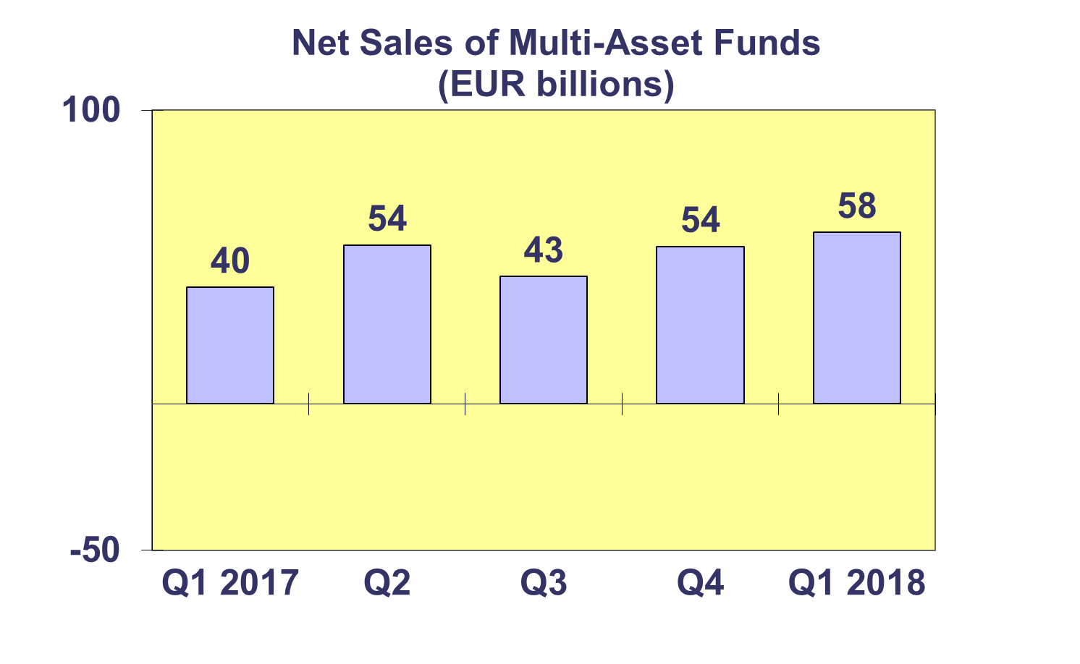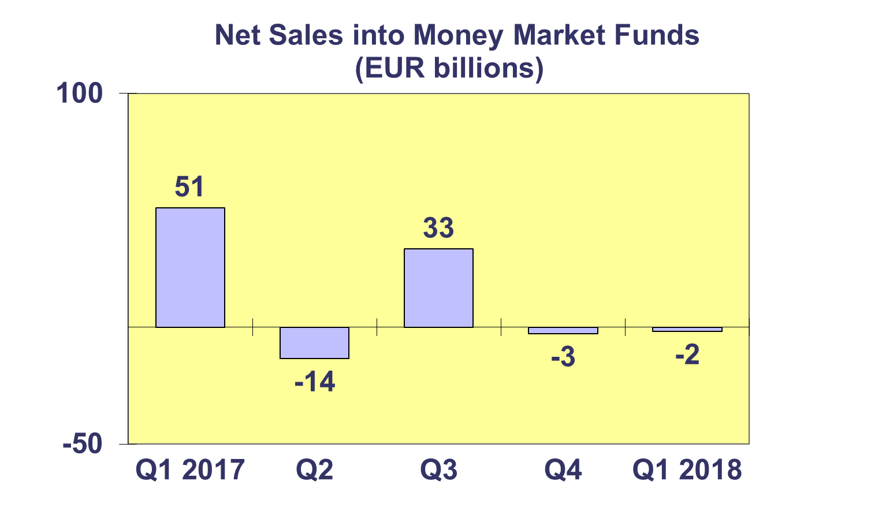**Trends in the UCITS Market**

***Net Sales by Country of Domiciliation and Investment Type***

**Twenty-six countries registered net inflows into UCITS in Q1 2018, with nine countries recording net inflows above EUR 1 billion.**

In Q1 2018, the five domiciles with the largest net sales were Luxembourg (EUR 67.9 billion), followed by France (EUR 32.9 billion), Ireland (EUR 28.4 billion), Spain (EUR 10.1 billion), and Switzerland (EUR 9.4 billion).

Strong net inflows into UCITS funds were also seen in United Kingdom (EUR 7.3 billion), Germany (EUR 5.3 billion), Denmark (EUR 3.5 billon) and Italy (EUR 3 billion).



**Trends in the UCITS Market**

***Net Sales and Net Assets of ETF by Country of Domiciliation***

**Net sales of UCITS ETF reached EUR 23 billion in Q1 2018, up from EUR 9 billion in Q4 2017. Net sales of UCITS ETF in Q1 2018 amounted to 13.5% of the total net sales of UCITS.**

Of the largest UCITS ETF domiciles, Luxembourg registered the largest inflows (EUR 22.4 billion). Ireland attracted EUR 12.4 billion in net inflows and Germany EUR 1.6 billion. France, on the other hand, recorded net outflows of EUR 13.5 billion.



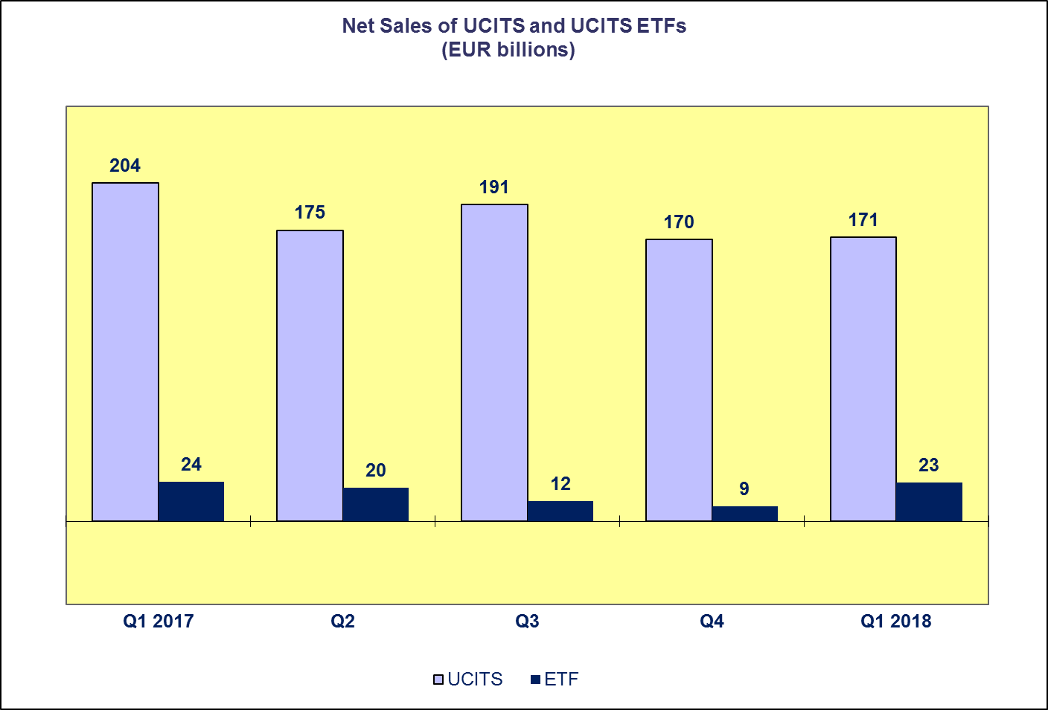**Trends in the UCITS Market**

***Net Assets by Investment Type***

**UCITS net assets decreased by 0.6 percent in Q1 2018, to total EUR 9,669 billion at end March 2018. The decline in net assets reflected falls in stock and bond prices, which had a stronger impact than the robust sales volume.**

Of the major fund categories, only multi-asset funds recorded an increase in net assets in Q1 2018 (0.5%). The other types of funds registered decreases in net assets. Guaranteed/protected funds recorded the largest decrease in net assets (6.5%), followed by equity funds (1.4%), money market funds (0.7%) and bond funds (0.2%).

The number of UCITS funds increased from 32,026 at end 2017 to 32,343 at end Q1 2018.



**Trends in the UCITS Market**

***Net Assets by Country of Domiciliation***

**Net assets of UCITS amounted to EUR 9,669 billion at end March 2018. The vast majority of domiciles recorded a decrease in net assets in Q1 2018.**

Among the larger domiciles, UCITS assets fell in United Kingdom (2.8%), Germany (0.8%), Luxembourg (0.4%) and Ireland (0.3%). France was the only major domicile to record an increase in UCITS assets in Q1 2018 (0.7%).

The other countries in Western Europe also recorded decreases in net assets, whereas UCITS assets in most of the countries in Southern Europe increased. In the Nordic countries, Norway was the only country to register a net asset increase (2.8%). In Central and Eastern Europe, the largest increases in net assets were recorded in Czech Republic (1.3%) and Poland (1.2%).



**Trends in the AIF Market**

***Net Sales by Investment Type***

**AIFs recorded net inflows of EUR 51 billion in Q1 2018, up from EUR 19 billion in the last quarter of 2017.**

Long-term AIFs recorded net inflows of EUR 53 billion, up from net inflows of EUR 20 billion in Q4 2017. Equity funds saw a reversal in flows, from net inflows of EUR 13 billion in Q4 2017 to net outflows of EUR 2 billion in Q1 2018. Net outflows from bond funds continued, albeit at a slower rate: EUR 4 billion compared to EUR 37 billion in Q4 2017. Net sales of multi-asset funds increased from EUR 10 billion in Q4 2017 to EUR 13 billion in Q1 2018, whereas net sales of other funds increased from EUR 26 billion to 37 billion.

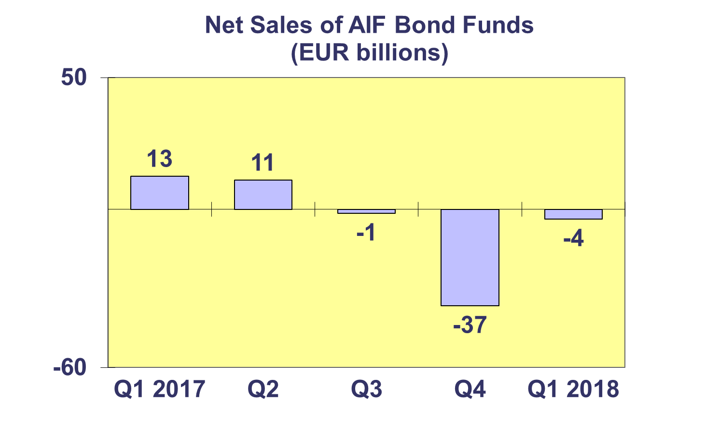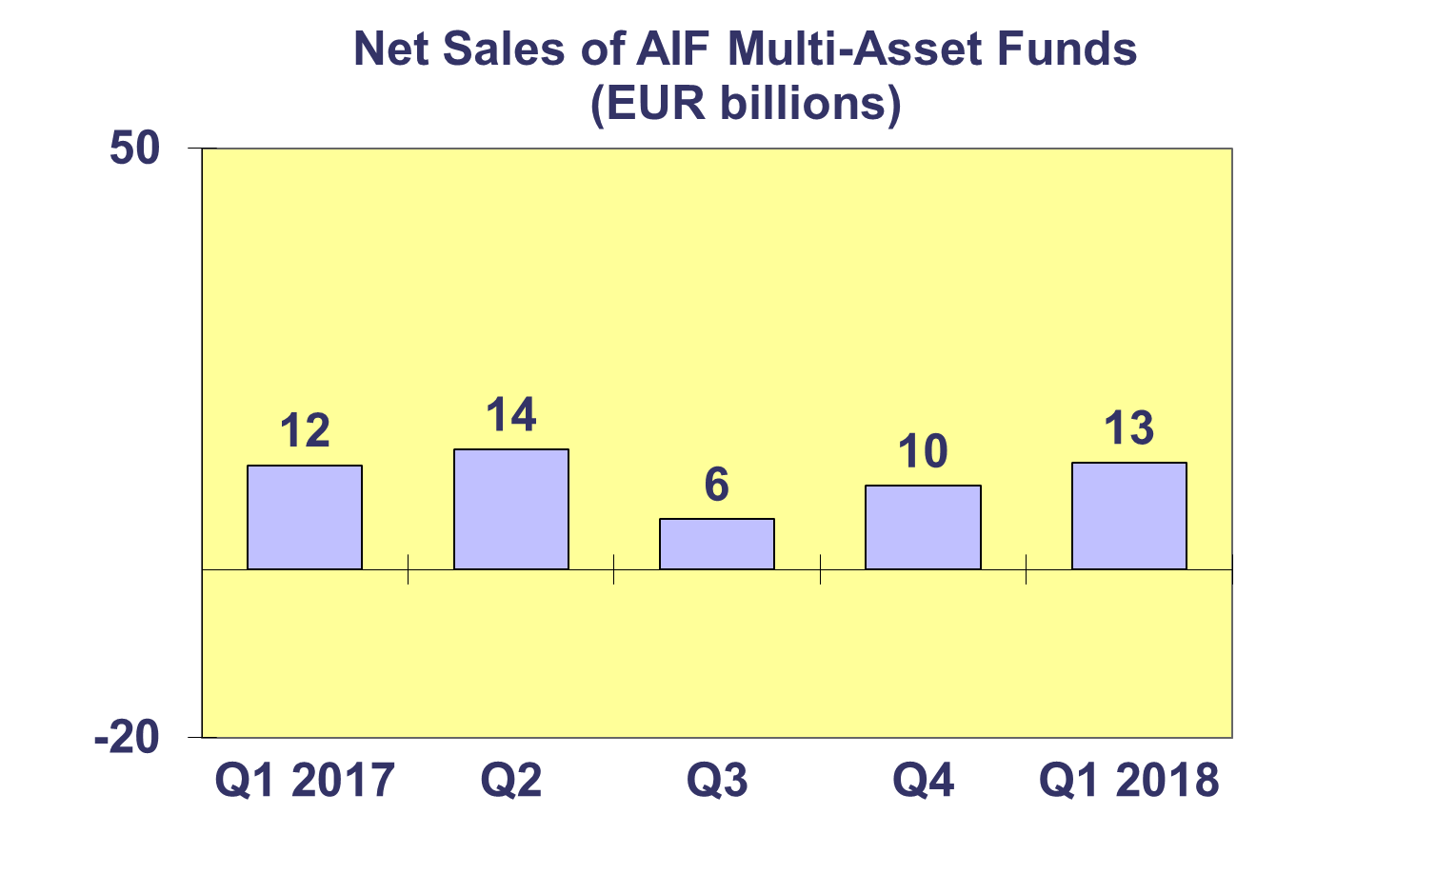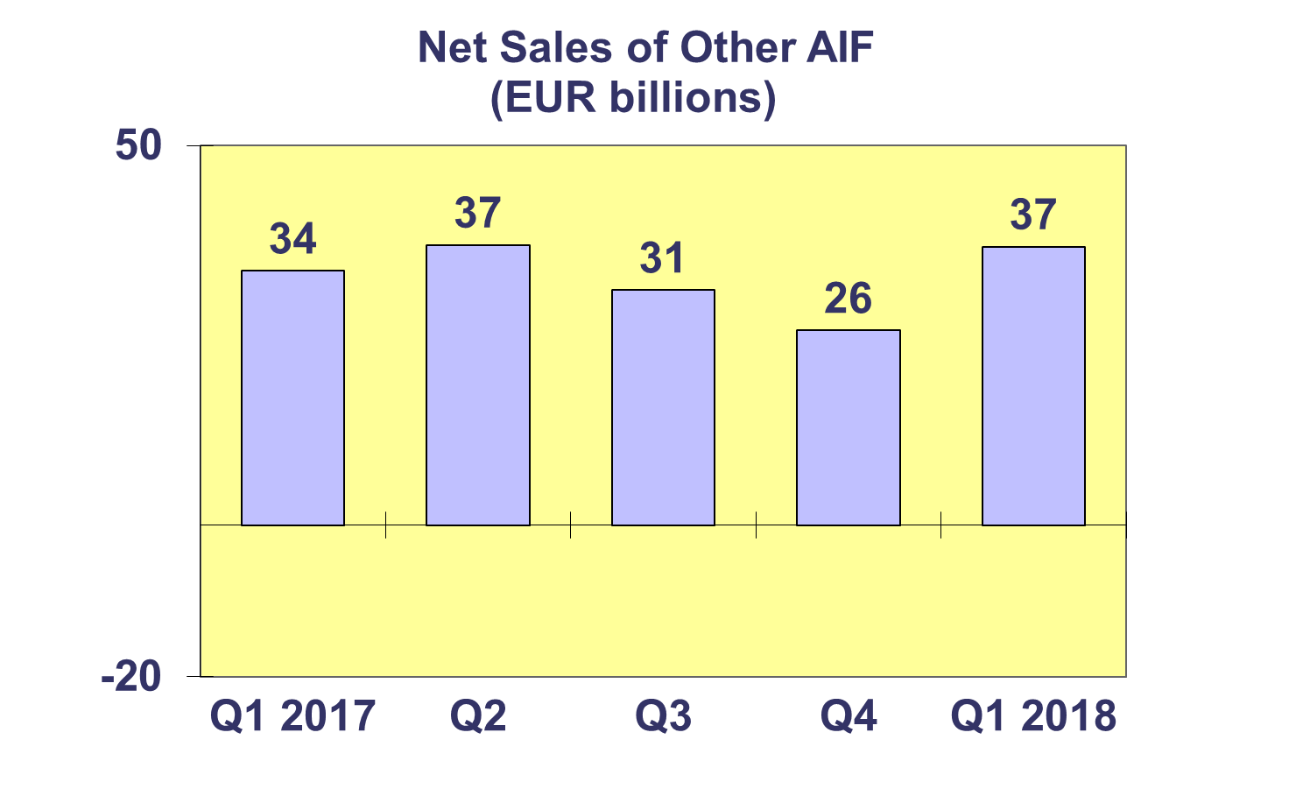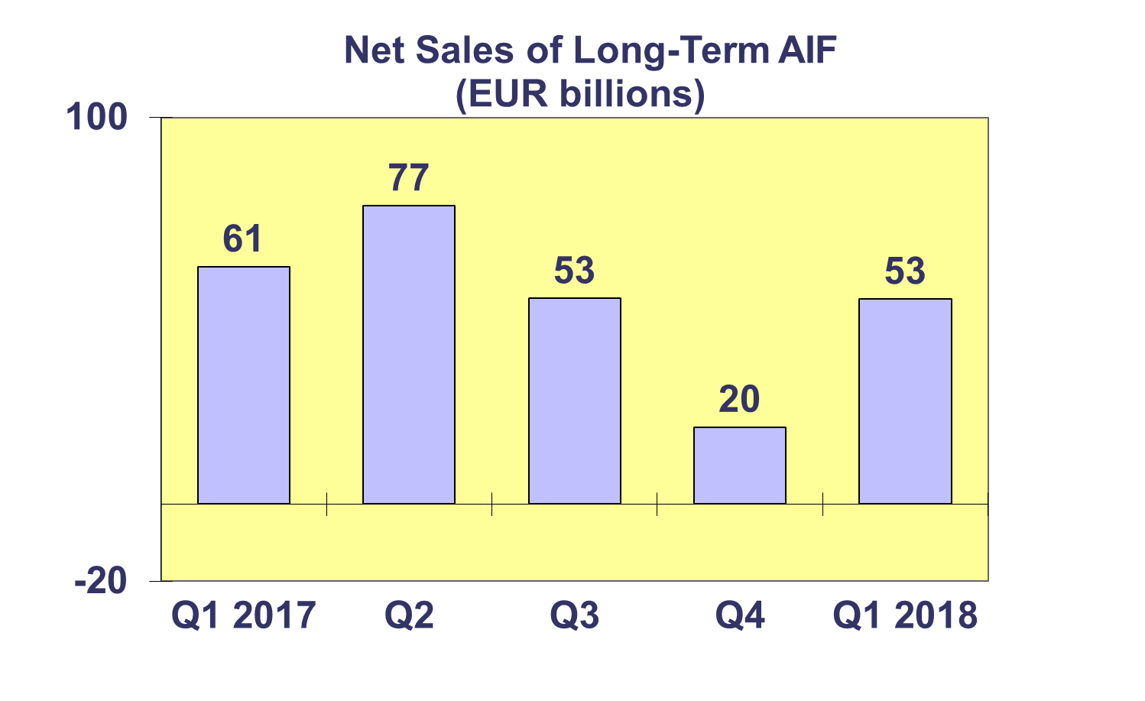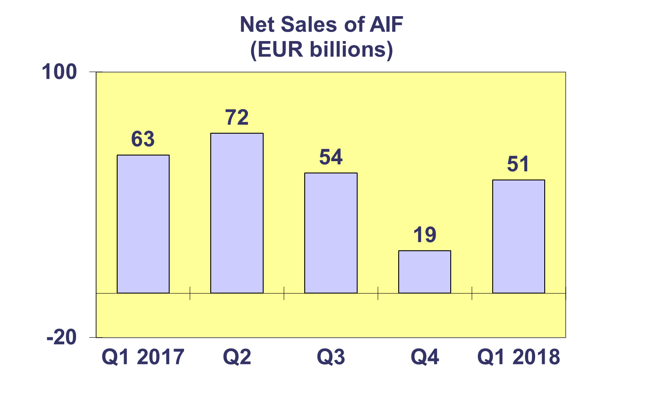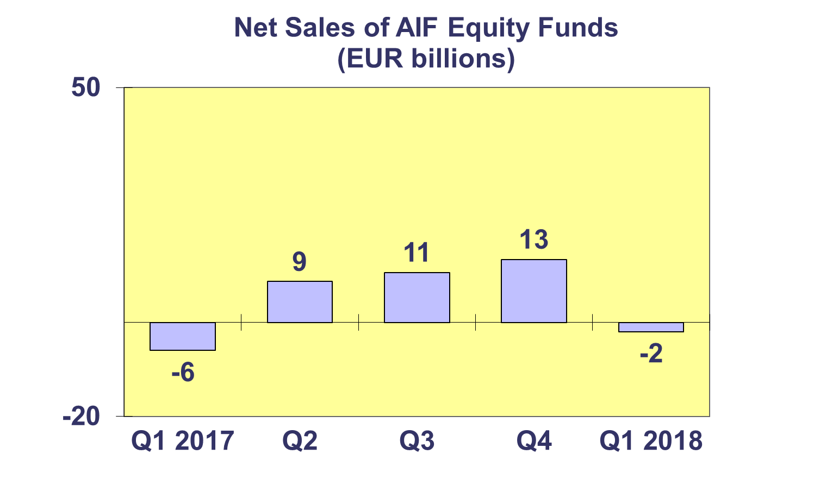**Trends in the AIF Market**

***Net Sales by Country of Domiciliation and Investment Type***

**Net sales of AIFs totaled EUR 51 billion in Q1 2018, compared to EUR 19 billion in Q4 2017.**

In Q1 2018, net sales above EUR 1 billion were registered in Germany (EUR 26.7 billion), Ireland (25.5 billion), Luxembourg (EUR 8.7 billion), the United Kingdom (EUR 2.6 billion), Switzerland (EUR 1.2 billion), and Cyprus (EUR 1 billion).

**Trends in the AIF Market**

***Net Assets by Investment Type***

**Net assets of AIFs decreased by 0.4 percent to reach EUR 5,872 billion at end March 2018.**

In Q1 2018, only “other” AIF and real estate funds recorded asset growth, 1.6% and 1.4%, respectively. Decreases in net assets were recorded in guaranteed/protected funds (3.3%), equity funds (3.2%), money market funds (3.1%), multi asset funds (1.3%) and bond funds (1.3%).

There were 28,437 AIF funds at end March 2018, compared to 28,153 at end 2017.



**Trends in the AIF Market**

***Net Sales and Assets of Institutional AIFs***

**Net assets of institutional AIFs, which are AIFs reserved for institutional investors, increased by 1.1% to EUR 2,891 billion at end Q1 2018.**

Net assets of institutional real estate funds increased by 2.9% to EUR 189 billion, followed by “other” institutional funds (2.8% to EUR 359 billion). The other categories of institutional AIFs experienced a decrease in net assets. Money market funds decreased by 4.8% to EUR 10 billion, followed by equity funds (2.4%, to EUR 235 billion), bond funds (0.4% to EUR 568 billion) and multi-asset funds (0.1% to EUR 1,014 billion).

Institutional AIFs recorded net sales of EUR 57 billion in Q1 2018, up from EUR 39 billion in the last quarter of 2017.



**Trends in the AIF Market**

***Net Assets by Country of Domiciliation***

**Net assets of AIFs decreased 0.4 percent in Q1 2018. Decreases in net assets were observed in 17 domiciles, whereas 9 domiciles saw an increase in net assets.**

Among the larger AIF domiciles, the largest net asset growth in Q1 2018 was seen in Ireland (4.6%), followed by Luxembourg (0.4%). Net assets of AIFs domiciled in Netherlands decreased by 2.4%, followed by France and the United Kingdom (1.1%). Elsewhere in Europe, net assets grew strongly in Cyprus (33.2%), Czech Republic (5.8%), Poland (3.2%) and Greece (2.7%).



**Trends in the European Investment Fund Industry**

***Net Sales by Investment Type***

**The combined net sales of UCITS and AIFs recorded net inflows of EUR 222 billion in Q1 2018, compared to EUR 189 billion in the last quarter of 2017.**

Equity funds saw an increase in net inflows, from EUR 69 billion in Q4 2017 to EUR 84 billion in Q1 2018. Net sales of bond funds decreased from EUR 39 billion to EUR 23 billion. Net sales of multi-asset funds totalled EUR 71 billion in Q1 2018, up from EUR 64 billion in the previous quarter. Net sales of money market funds experienced net outflows of EUR 4 billion, compared to net outflows of EUR 3 billion in the last quarter of 2017. Net sales of other funds (including real estate and other funds which do not fit any of the other categories for which information is not available) totalled EUR 48 billion, up from EUR 21 billion in the last quarter of 2017.

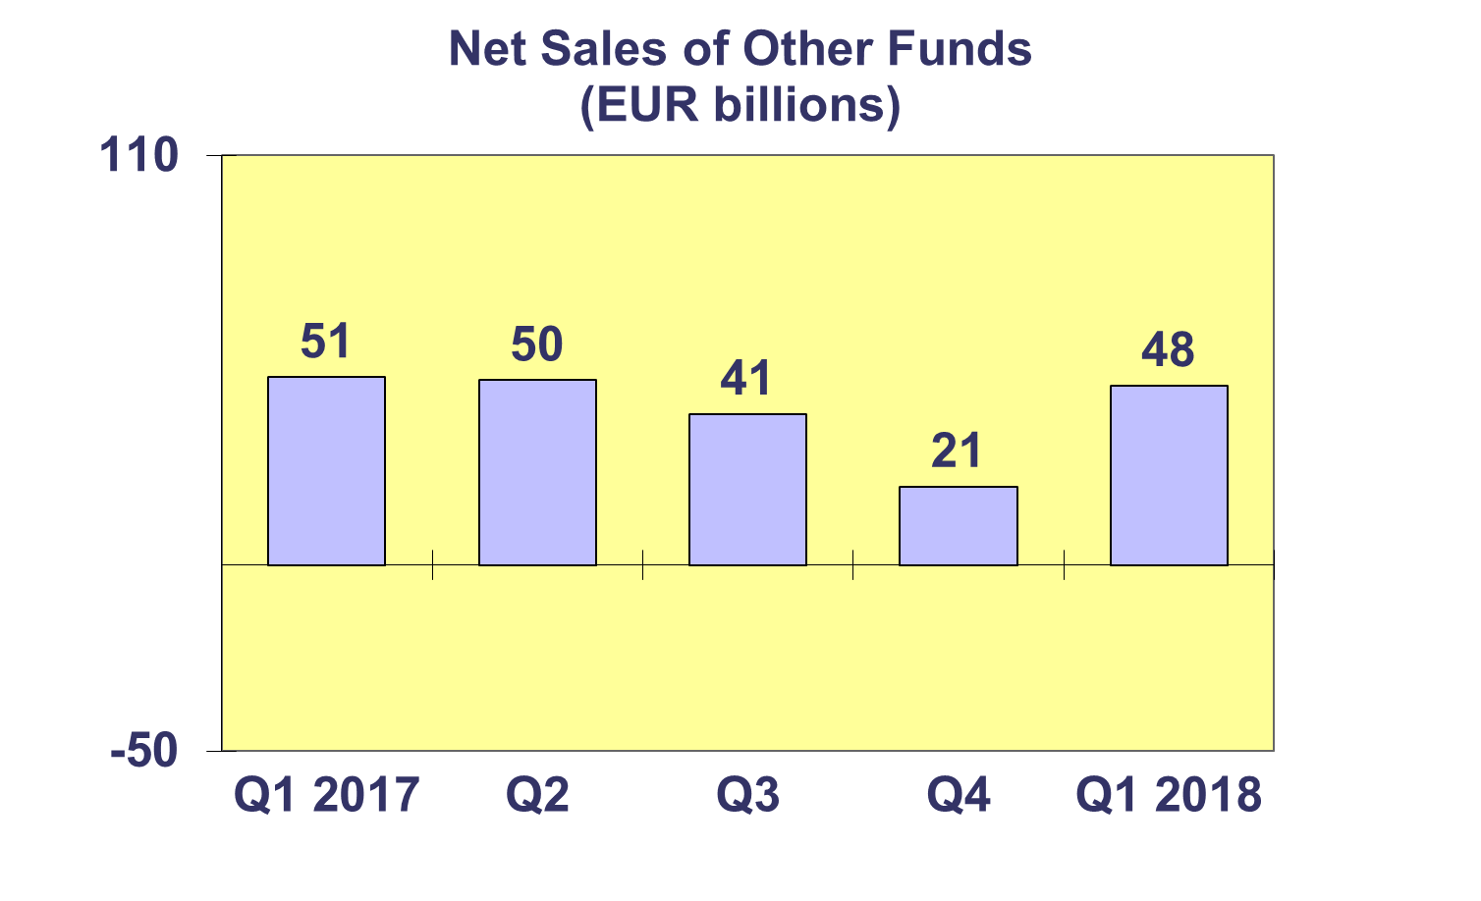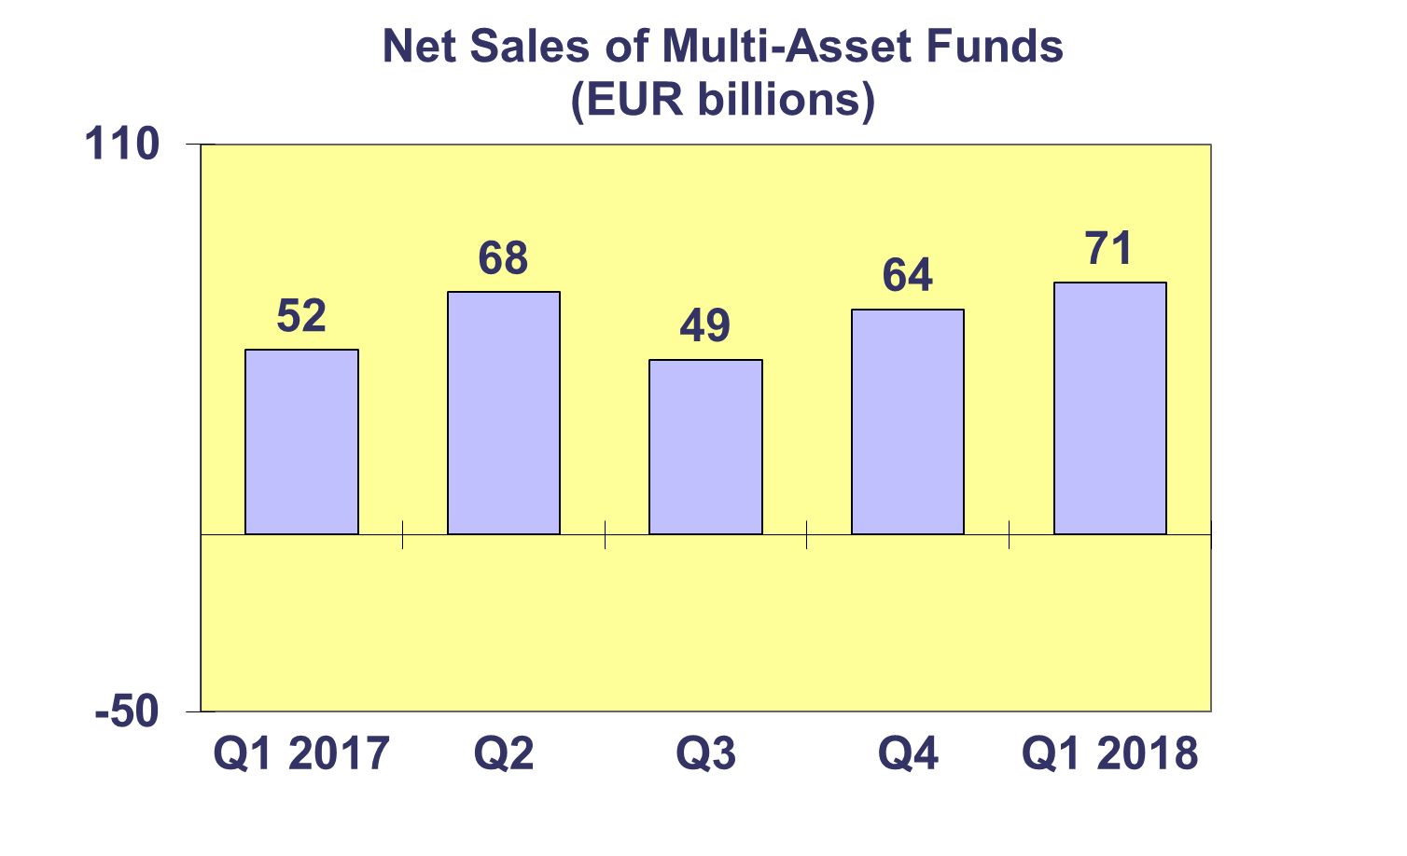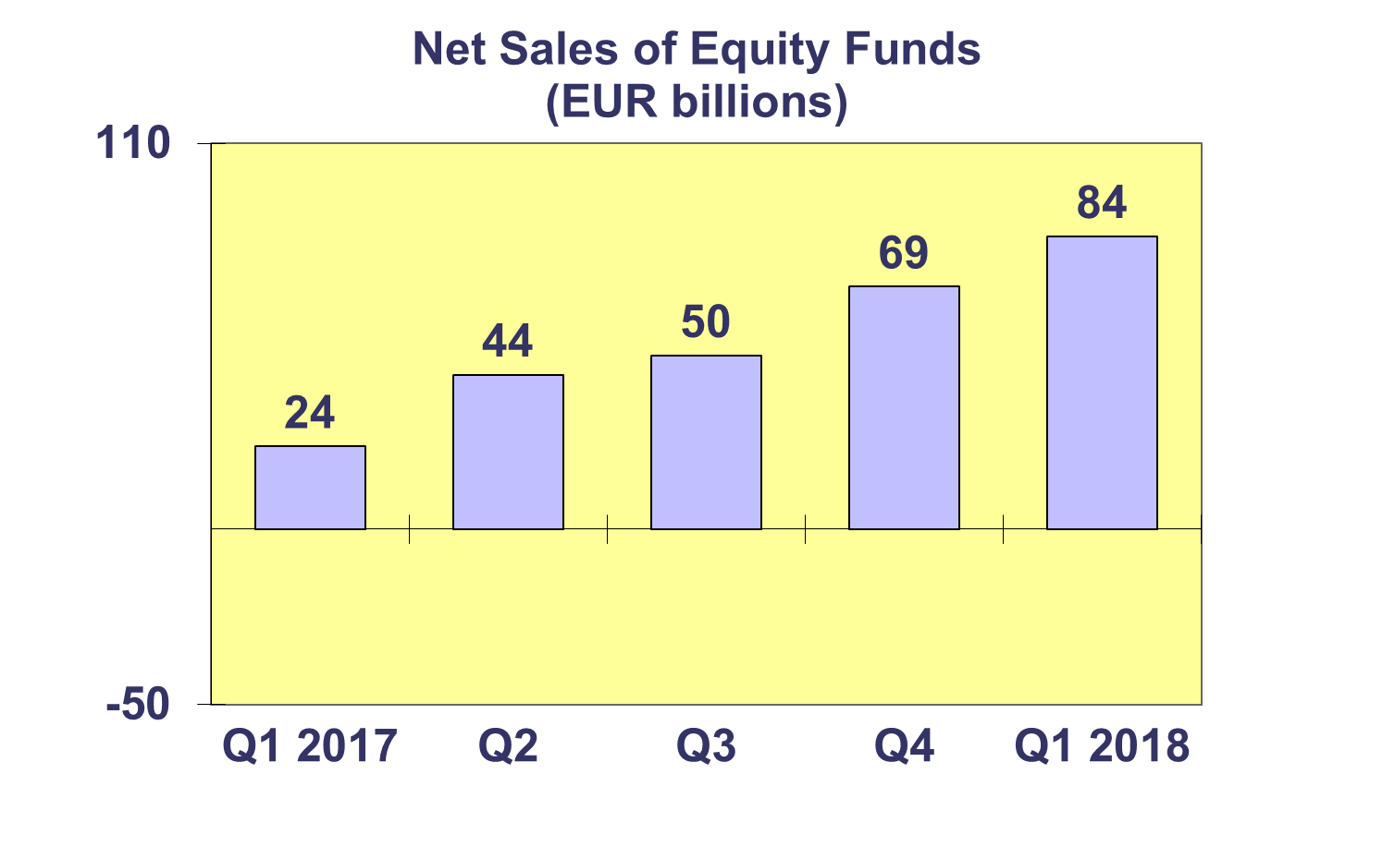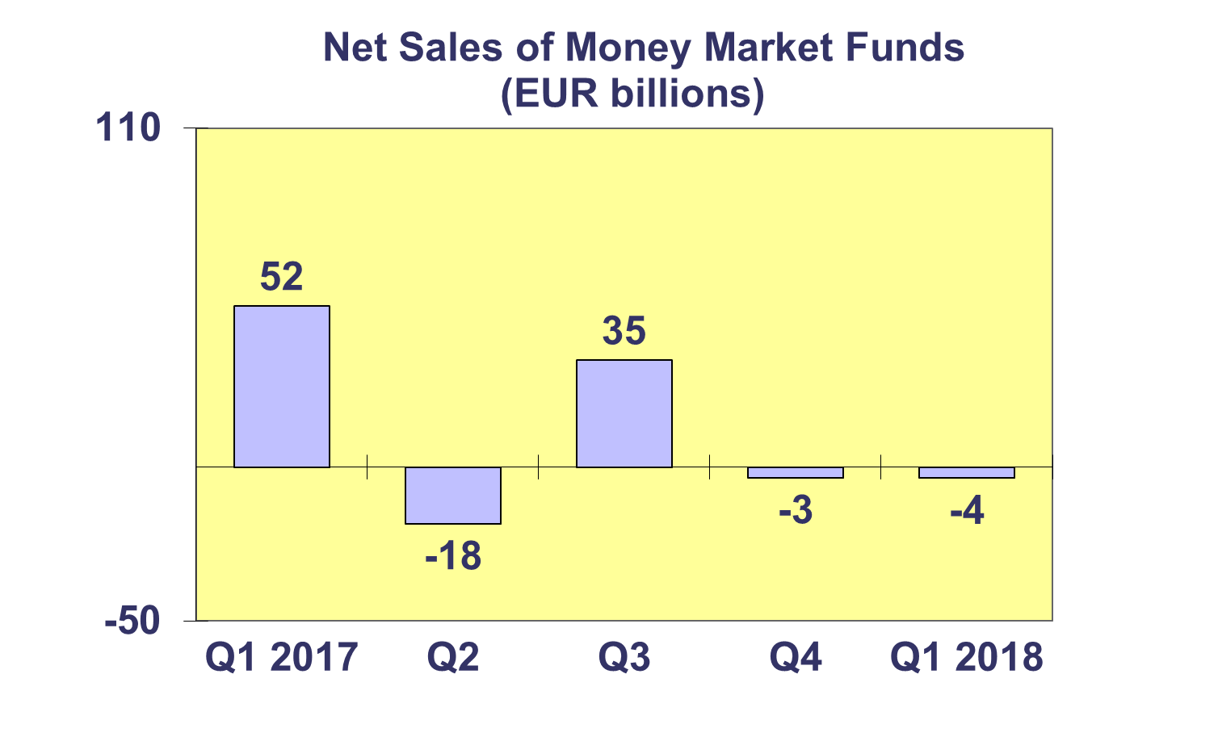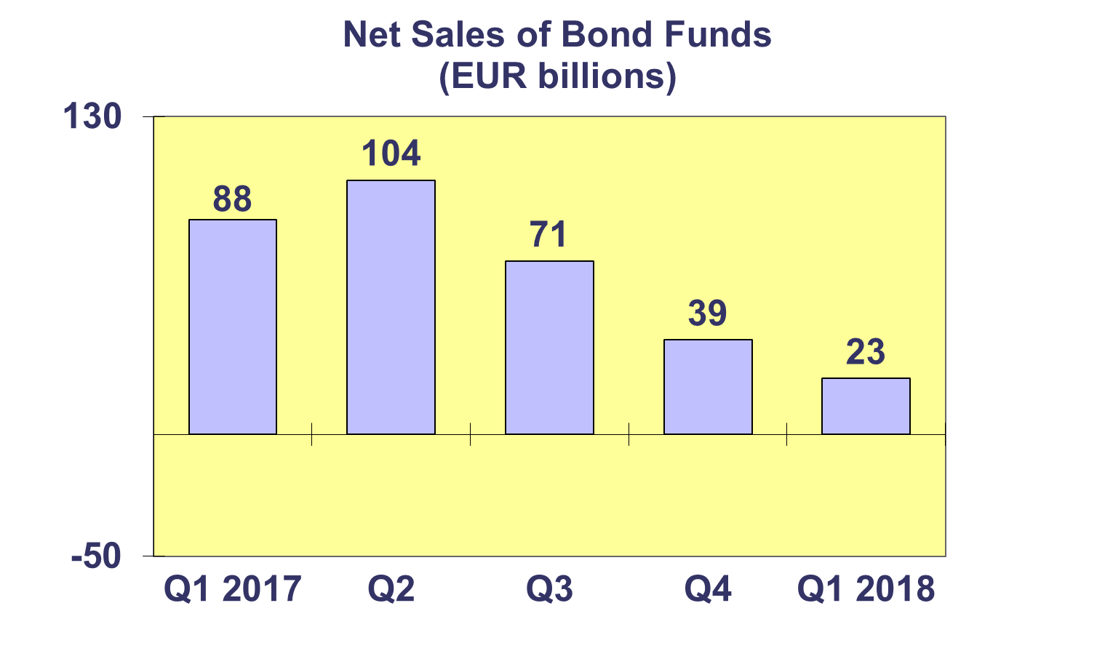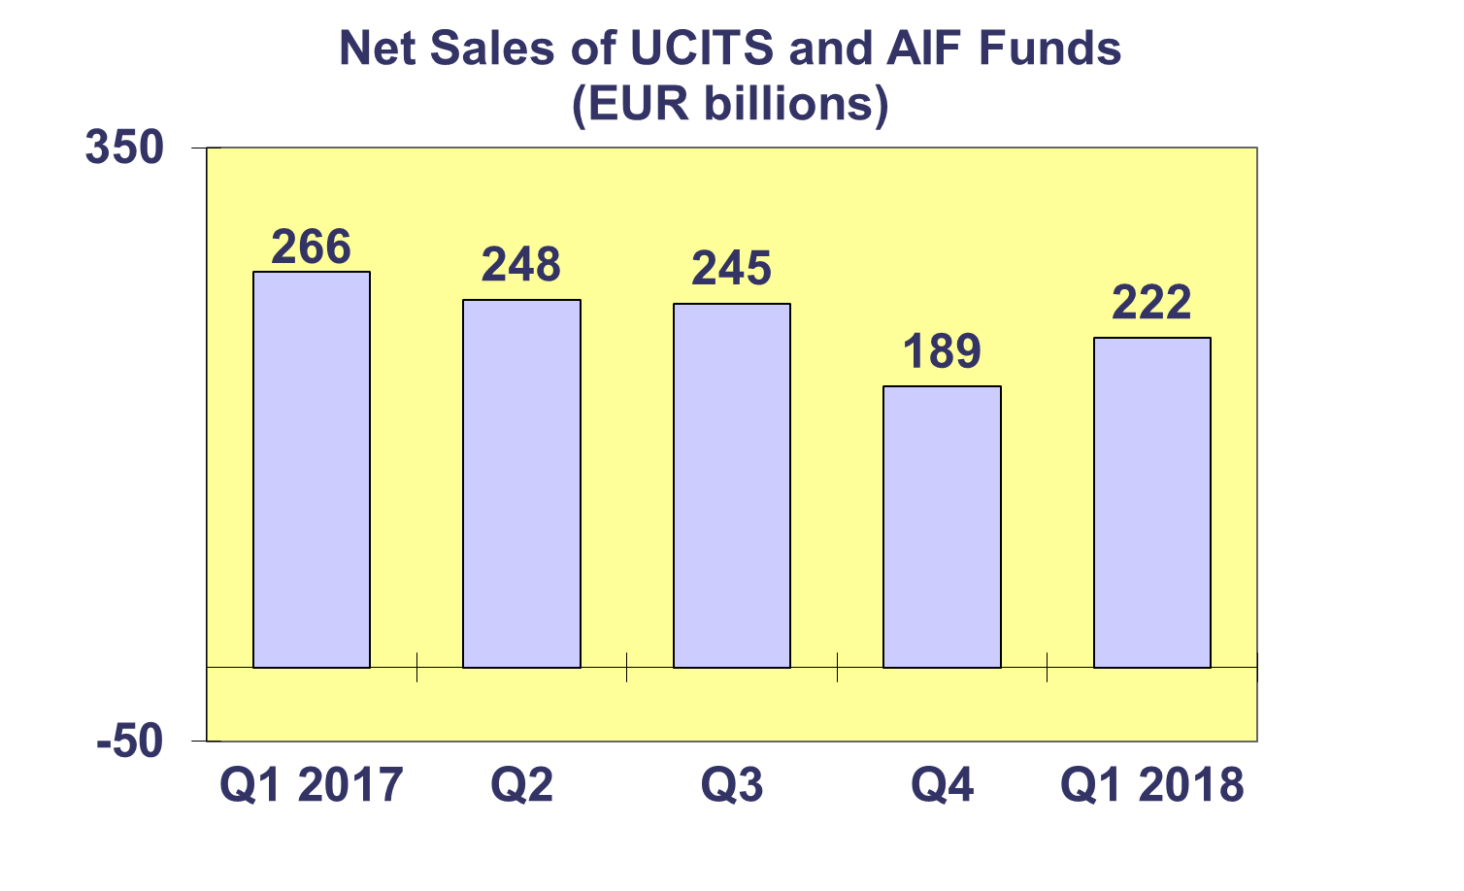**Trends in the European Investment Fund Industry**

***Net Assets by Country of Domiciliation***

**Total net assets of European investment funds decreased by 0.5% to EUR 15,541 billion at end Q1 2018.**

With EUR 9,669 billion invested in UCITS, this segment accounted for 62.2% of total European investment fund assets at end Q1 2018, with the remaining 37.8% (or EUR 5,872 billion) coming from AIF.



**Trends in the European Investment Fund Industry**

***Number of Funds by Country of Domiciliation***

**In Q1 2018, the total number of UCITS funds and AIFs increased by 1%, up to 60,780 funds.**

At the end of the first quarter of 2018, UCITS accounted for 32,343 funds or 53.2% of the total number of European funds, while AIF accounted for 28,437 funds (46.8%).

