Quarterly Statistical Release

May 2016, N° 65

This release and other statistical
releases are available on Efama’s
website (www.efama.org)

Trends in the European Investment Fund Industry

in the First Quarter of 2016

This report was prepared by Bernard Delbecque, Alessandro Sciamarelli and Alex Carroll

EFAMA
The European Fund and Asset Management Association

Rue Montoyer 47 - B-1000 BRUXELLES - Tel. 32-2-513.39.69 Fax: 32-2-513.26.43 - e-mail: info@efama.org

Trends in the UCITS Market

Net Sales by Investment Type

UCITS recorded net outflows of EUR 6.5 billion during Q1 2016, compared to net inflows of EUR 122 billion in the last quarter of 2015.

Long-term UCITS recorded net outflows of EUR 4 billion in Q1 2016, against net inflows of EUR 83 billion in Q4 2015. Equity funds experienced net outflows of EUR 3 billion, against net inflows of EUR 57 billion in the previous quarter. Net sales of bond funds continued to record net outflows in Q1 2016 (EUR 9 billion, the same as in Q4 2015). Net sales of multi-asset funds slowed down in Q1 2016 as they recorded net inflows of EUR 6 billion from EUR 31 billion in the previous quarter. Money market funds experienced net outflows of EUR 2 billion, compared to net inflows of EUR 39 billion in Q4 2015.

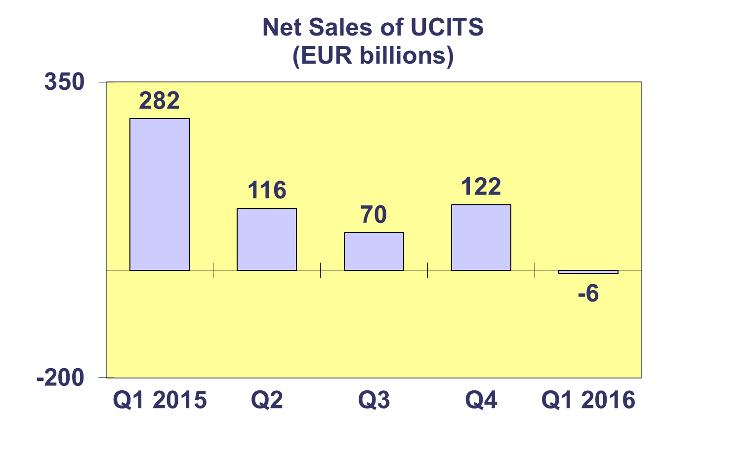
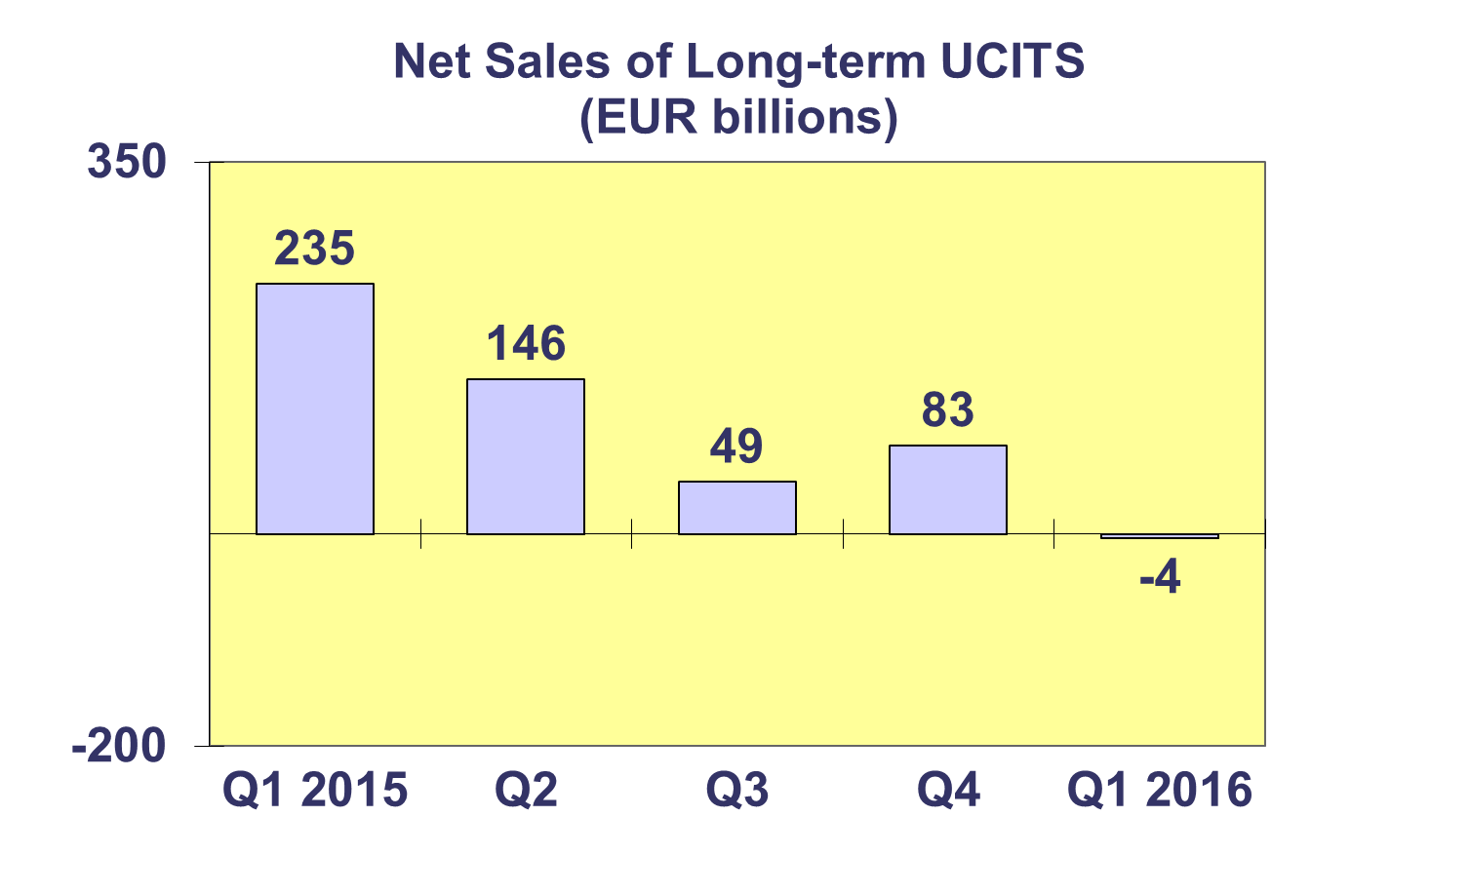
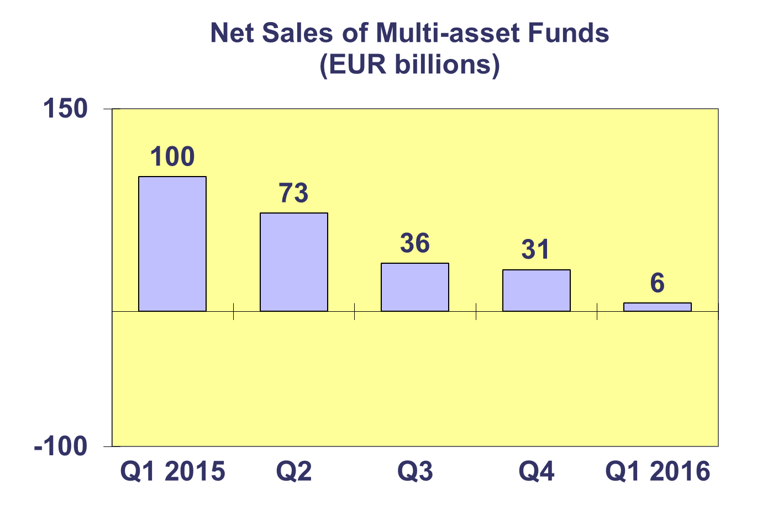
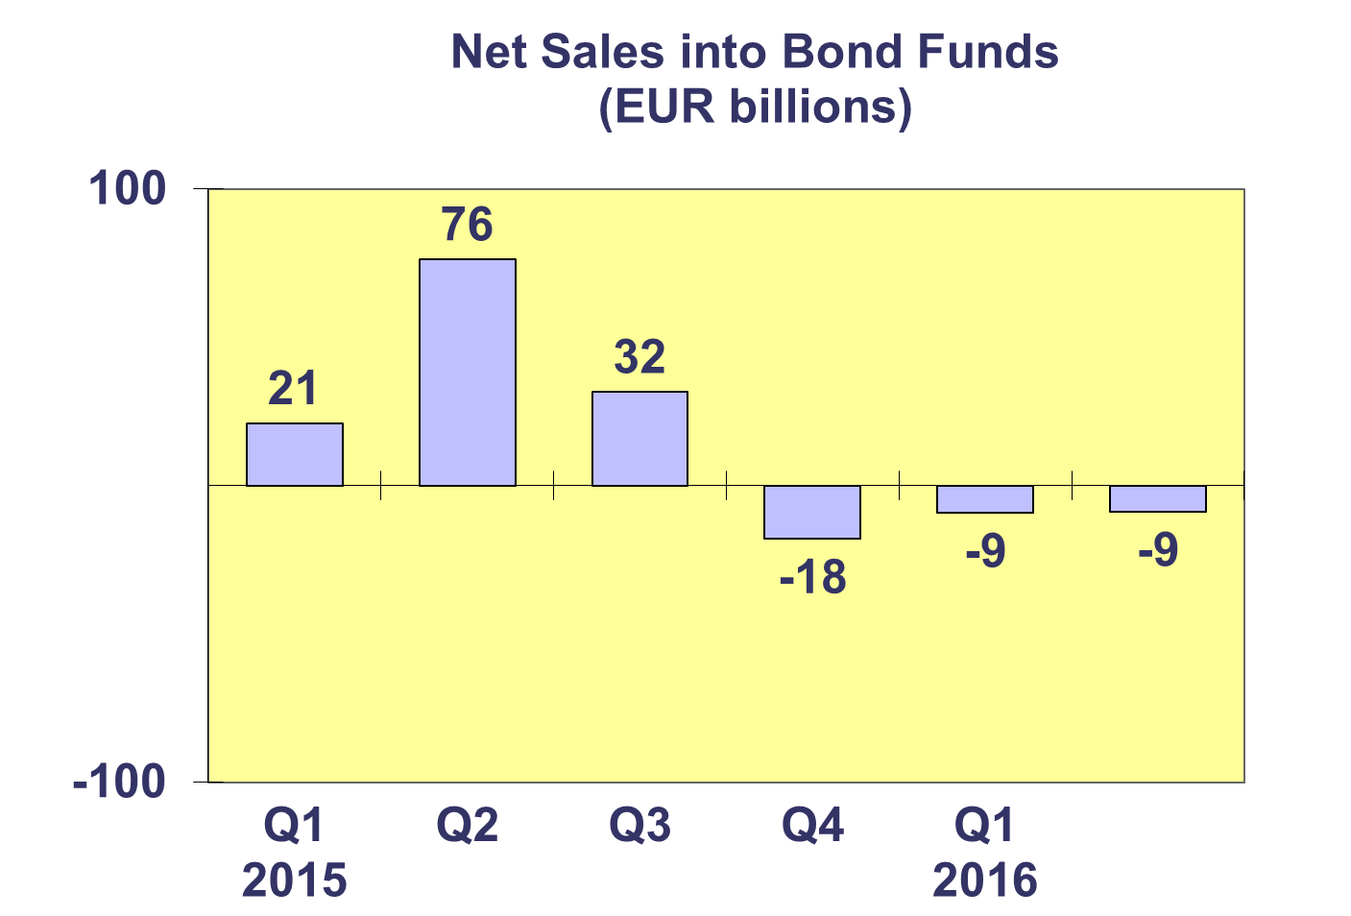
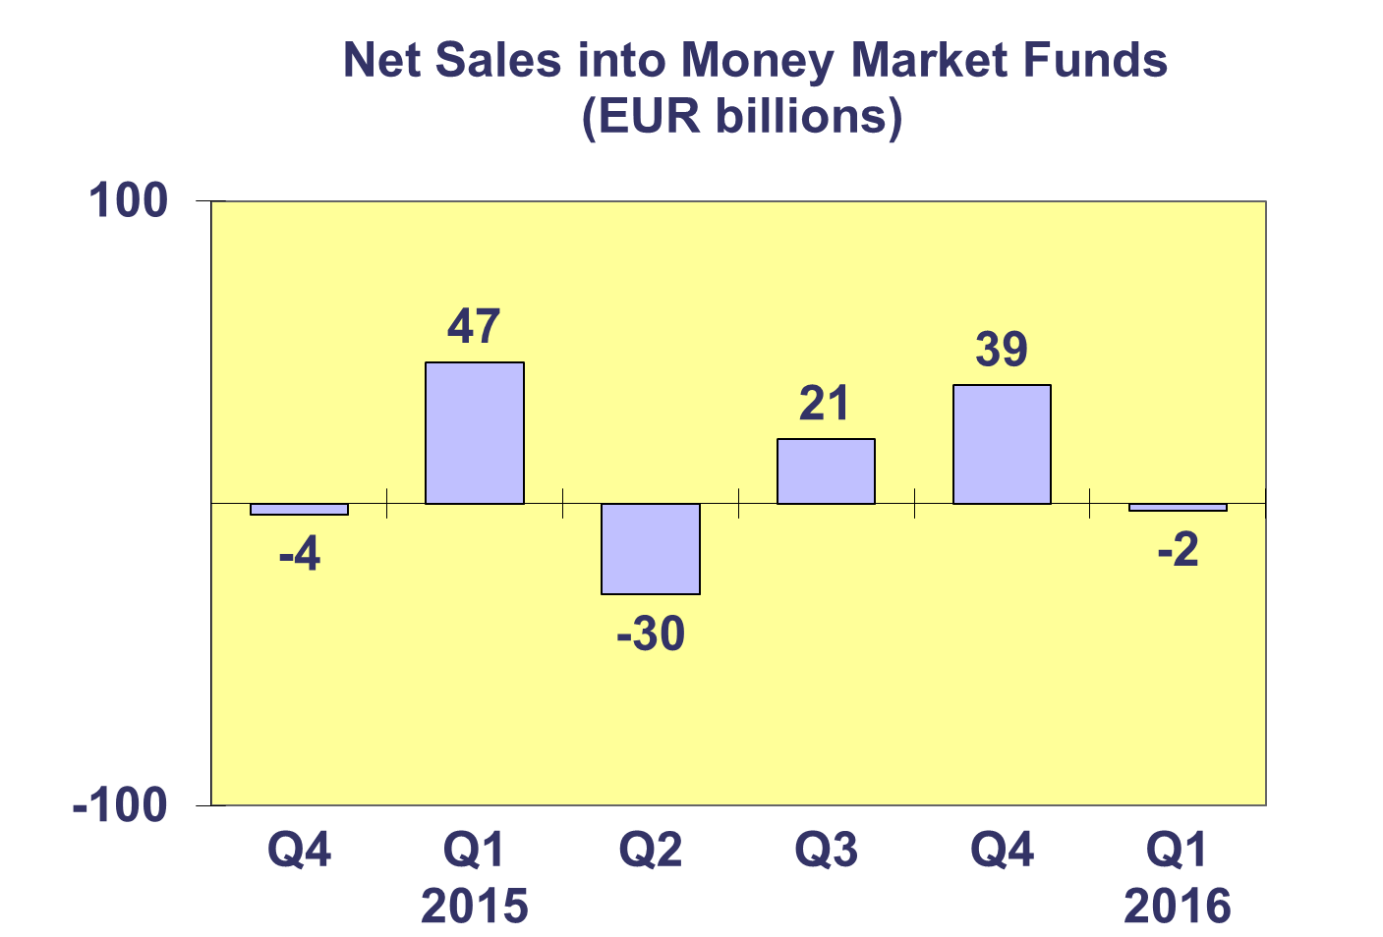
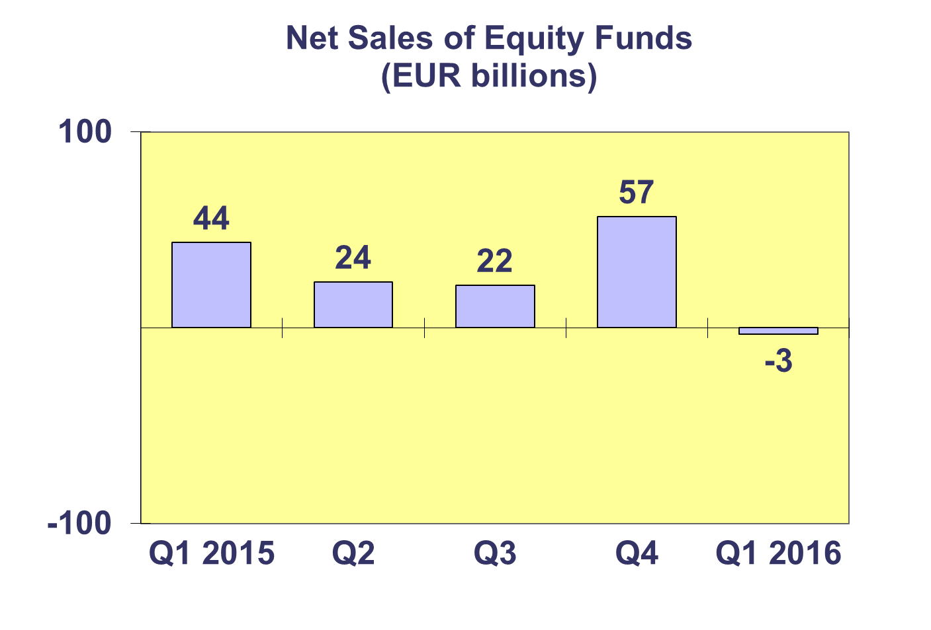

Trends in the UCITS Market
Net Sales by Country of Domiciliation

Ten countries registered net inflows in the first quarter of 2016, with four countries recording net inflows above EUR 1 billion.

Among major domiciles, France attracted net sales of UCITS worth EUR 15.6 billion in Q1 2016, thanks to strong net inflows into money market funds (EUR 19.1 billion). Luxembourg experienced net outflows of EUR 21.8 billion, reflecting outflows from bond funds and money market funds. Ireland recorded net outflows of EUR 2 billion, mainly as a result of net outflows from money market funds (EUR 9.2 billion). The UK also experienced net outflows of EUR 1 billion. Germany attracted net inflows of EUR 2.5 billion.

In the Nordic countries, Norway and Denmark experienced net inflows (EUR 1.8 billion and EUR 233 million, respectively), while Sweden and Finland recorded net outflows of EUR 532 million and EUR 561 million. In Southern Europe, all countries recorded net outflows, albeit of relatively small size. In the rest of Europe, it is worth highlighting that Switzerland recorded net inflows of EUR 5.5 billion and that net sales of UCITS were positive in all central European countries, except in Poland, Slovakia and Slovenia.

Trends in the UCITS Market

Net Assets by Investment Type

UCITS net assets decreased by 3.4% in Q1 2016 to reach EUR 7,929 billion at the end of March.

All UCITS categories experienced a fall in net assets in Q1 2016. Net assets of equity funds fell by 7% to EUR 2,879 billion. Multi-asset fund assets dropped by 2.7% to EUR 1,377 billion. Bond fund net assets decreased by 1.3% to EUR 2,127 billion. Money market fund assets went down by 3.5% to EUR 1,072 billion, whereas guaranteed/protected fund net assets fell by 6.7% to EUR 14 billion. Net assets of other UCITS funds went up by 11.2% and reached EUR 461 billion at end March.

The number of UCITS funds slightly increased from 30,036 at end 2015 to 30,145 in Q1 2016.

Trends in the UCITS Market
Net Assets by Country of Domiciliation

The vast majority of countries recorded negative quarterly growth rates in net assets during Q1 2016.

Among major domiciles, no countries recorded positive quarterly growth in net assets of UCITS in Q1 2016. The UK, Ireland, Luxembourg, Germany and France saw UCITS assets fall by 7.3%, 4.1%, 3.4%, 2.9% and 0.7%, respectively.

All Nordic countries experienced a decrease in net UCITS assets, albeit at moderate rates, with the only exception of Norway which recorded an increase of 1.3%. On the other hand, Denmark, Finland and Sweden all recorded drops in net UCITS assets by -0.9%, -2.2% and -2.9% respectively.

Southern countries all recorded falls in net UCITS assets: in Greece net assets went down by 6%, in Portugal by 4.5%, in Spain by 2% and in Italy by 1.8%.

Across Europe, positive growth in net assets was essentially recorded in Eastern European countries, i.e. Hungary (11.2%). Croatia (3.1%), Czech Republic (1.6%), Romania (1.4%) and Bulgaria (0.7%), with the exceptions of Slovenia (-4%), Slovakia (-1.2%) and Poland (-0.6%).

Trends in the AIF Market
Net Sales by Country of Domiciliation and Investment Type

Net sales of AIF totaled EUR 43.4 billion in Q1 2016, compared to 48.4 billion in Q4 2015.

All AIF fund categories recorded positive net inflows during Q1 2016, with the exceptions of money market funds and bond funds. Multi-asset funds recorded remarkable quarterly net inflows of 20.3 billion.

Thirteen countries experienced net inflows into AIF in Q1 2016, with five countries recording net inflows higher than EUR 1 billion (France, Germany, Luxembourg, Netherlands and Switzerland). In the largest domiciles, the highest net inflows were observed in Germany (EUR 28.2 billion), Luxembourg (EUR 6.4 billion) and Netherlands (EUR 6.4 billion). France experienced net inflows of 1.6 billion, while Ireland recorded net inflows of 334 million. Net inflows above 1 billion were also recorded in Switzerland (EUR 1.6 billion). In Spain AIF attracted 675 million of net sales while net outflows were experienced in Italy (EUR 325 million) and Portugal (EUR 75 million). Sweden and Finland both recorded net inflows in Q1 2016 amounting to EUR 98 million and EUR 190 million, respectively. Net inflows into AIF were also registered in Poland, Austria and the Czech Republic, amounting to EUR 335 million, EUR 120 million and EUR 52 million respectively.

Trends in the AIF Market
Net Assets by Investment Type

Net assets of AIF fell by 0.1% in Q1 2016 to reach EUR 5,110 billion at end March.

Net assets of bond funds increased by 2.1% to EUR 988 billion, and real estate fund assets increased by 1.1% to EUR 524 billion. Net assets of multi-asset funds increased by 0.3% to EUR 1,305 billion.

On the other hand, equity fund net assets decreased by 3.7% in Q1 2016 to EUR 590 billion, whereas money market fund net assets dropped by 3.5% down to EUR 85 billion. Net assets of guaranteed/protected funds fell by 5.4% compared to Q4 2015 to EUR 50 billion. Other AIF, which include AIF funds for which no breakdown according to the underlying fund categories is available, recorded a modest decrease in net assets of 0.4% to stand at EUR 1,568 billion at end Q1 2016.

The number of AIF funds was 27,648 in Q1 2016 and remained almost unchanged compared to Q4 2015 (27,649).

Trends in the AIF Market
Net Sales and Assets of Institutional AIF

Net assets of institutional AIF, which are AIF reserved for institutional investors, increased by 0.7% in Q1 2016 to stand at EUR 2,438 billion at end March 2016.

Net assets of institutional equity funds fell by 2.4% in Q1 2016, down to EUR 194 billion. Net assets of institutional money market funds decreased by 1.5%, down to 9 EUR billion. Institutional multi-asset fund net assets rose by 1.9% to reach EUR 921 billion. Net assets of institutional bond funds increased by 3.2% to EUR 544 billion, whereas real estate fund net assets increased by 3.4% to EUR 147 billion. Other institutional funds experienced a net asset quarterly growth of 1.3% and reached EUR 243 billion at end Q1 2016.

Institutional AIF recorded net sales of EUR 31.7 billion in Q1 2016.

Trends in the AIF Market
Net Assets by Country of Domiciliation

Net assets of AIF decreased by 0.1% during the first quarter of 2016, to reach EUR 5,110 billion at end March 2016.

Among the large domiciles of AIF, Germany and the Netherlands recorded asset increases of 2.9% and 0.9% respectively. On the other hand, AIFs domiciled in France, Luxembourg and Ireland saw their assets fall by 1.2%, 2.0% and 1.9%, respectively.

Elsewhere, AIF assets increased in only three countries: Turkey (4.2%), Poland (2.4%) and Austria (0.2%). The sharpest falls were recorded in Croatia (22.9%) and Sweden (7.3%), while most other countries recorded moderate drops in net assets.

Trends in the European Investment Fund Industry
Net Assets by Country of Domiciliation

The combined assets of the investment fund market in Europe, i.e. the market for UCITS and AIF, decreased by 2.1% in Q1 2016 to EUR 13,039 billion.

With EUR 7,929 billion invested in UCITS, this segment accounted for 61% of total European investment fund assets at end Q1 2016, with the remaining 39% (equivalent to EUR 5,110 billion) coming from AIF.

Trends in the European Investment Fund Industry
Number of Funds by Country of Domiciliation

In Q1 2016, the total number of funds of the European investment fund market, i.e. the market for UCITS and AIF, slightly increased by 0.2% to 57,793.

At the end of the first quarter of 2016, UCITS accounted for 30,145 funds or 52.2% of the European investment fund market, while AIF accounted for 27,648 funds, or 47.8% of the market.

