***This release and additional tables***

***of international statistics are***

***available on efama’s website***

***(***[***www.efama.org***](http://www.fefsi.org)***).***

## Worldwide Regulated Open-ended Fund Assets and Flows

**Trends in the Fourth Quarter of 2018**

Brussels, 27 March 2019 **–** Worldwide regulated open-ended fund assets decreased 5.7 percent to EUR 43.99 trillion at the end of the fourth quarter of 2018.[1] Worldwide net cash flow to all funds amounted to EUR 120 billion in the fourth quarter, compared to EUR 169 billion in the third quarter of 2018.

The information presented in this report was compiled by EFAMA and the Investment Company Institute (ICI) on behalf of the International Investment Funds Association (IIFA), an organization of national investment fund associations. Statistics from 47 countries are included in this report.

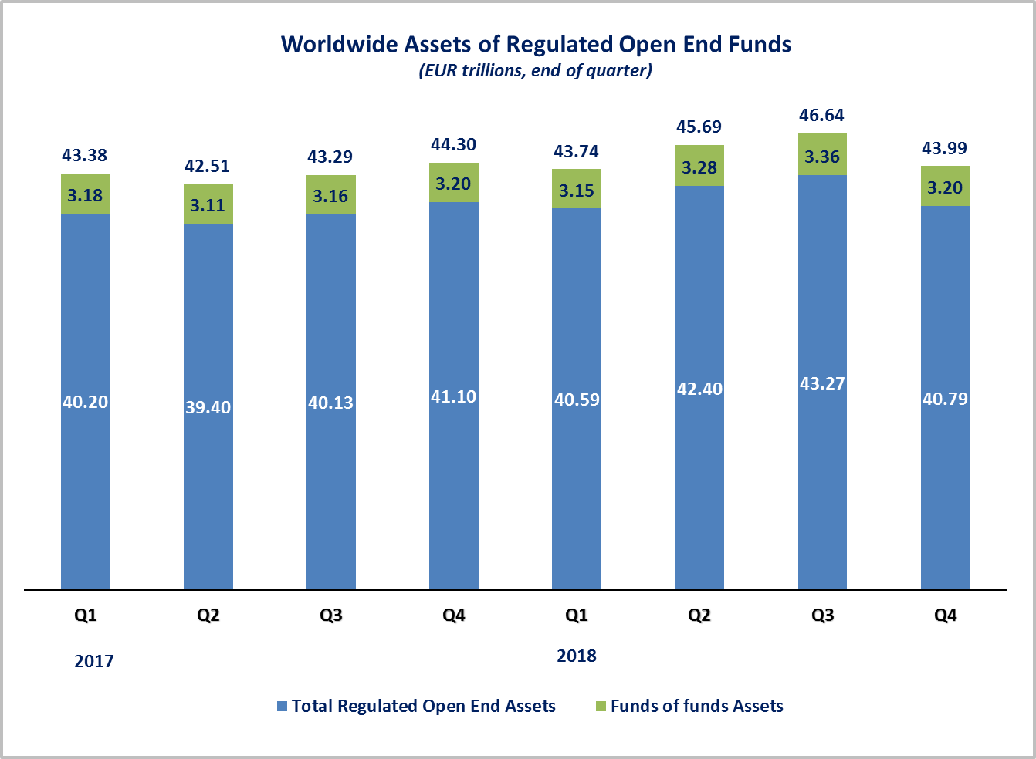

Measured in U.S. dollars, worldwide investment fund net assets decreased to USD 50.4 trillion at the end of 2018. This represented a decrease of 6.8 percent, compared to a drop of 5.7 percent on a euro-denominated basis. The following two graphs compare the net asset growth in the fourth quarter of 2018 in the seven largest countries/regions.

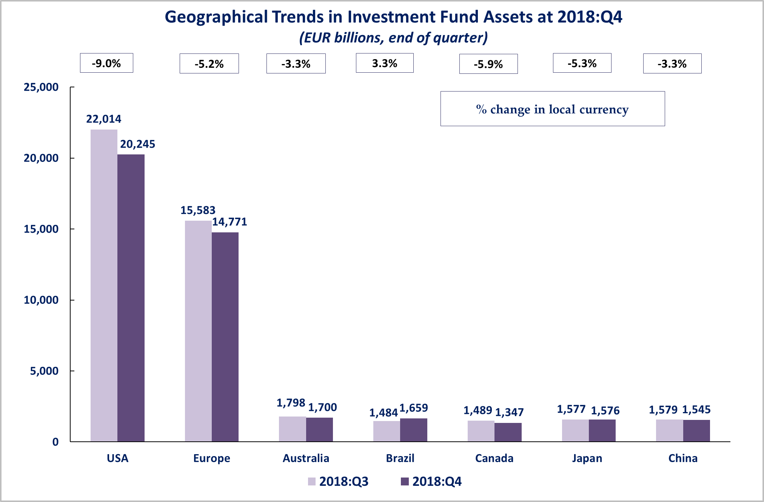



On a euro-denominated basis, equity fund net assets decreased by 11.4 percent to EUR 17.6 trillion at the end of 2018. Bond funds net assets remained more or less stable at EUR 9.3 trillion. Balanced/mixed fund assets decreased by 6.1 percent to EUR 7.6 trillion. Net assets of money market funds and real estate funds registered increases (2.7% and 2.8%, respectively).



At the end of 2018, 40.1 percent of worldwide regulated open-ended fund net assets were held in equity funds. The net asset share of bond funds was 21.1 percent and the net asset share of balanced/mixed funds was 17.2 percent. Money market fund net assets represented 12.1 percent of the worldwide total.

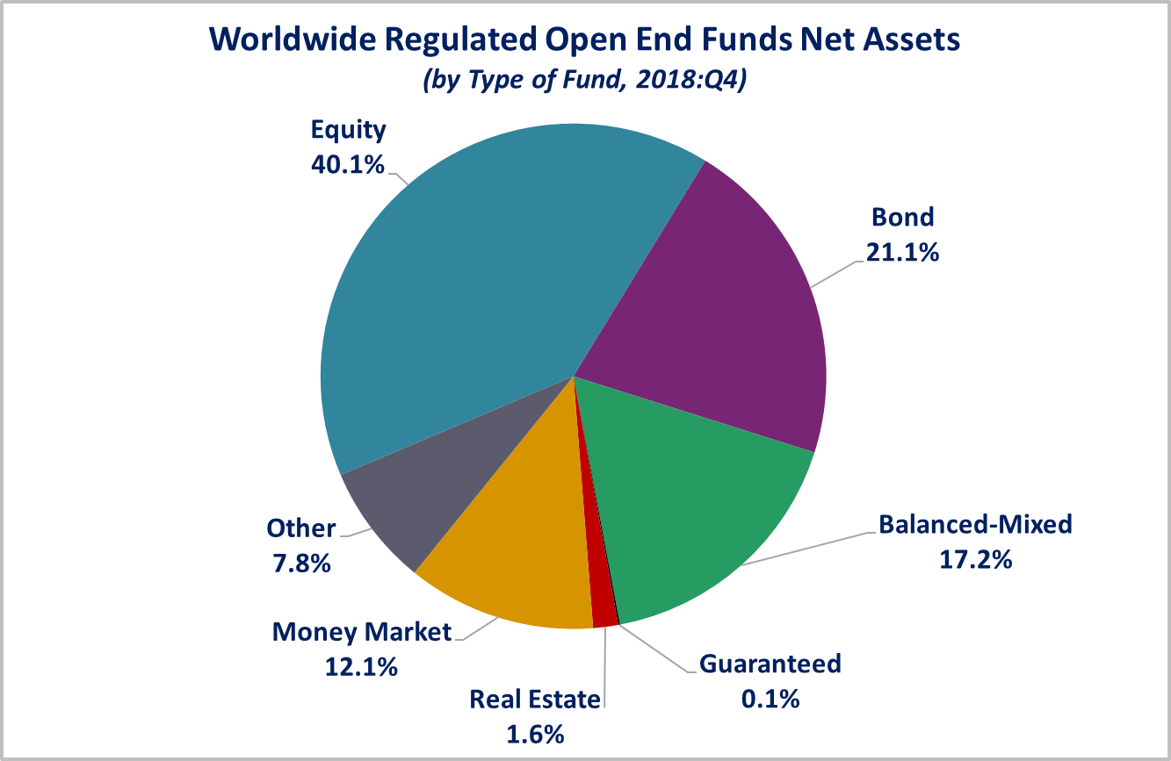

Looking at the worldwide distribution of investment fund net assets at end 2018, the United States and Europe held the largest shares in the world market, with 46 percent and 33.6 percent, respectively. Australia (3.9%), Brazil (3.8%), Japan (3.6%), China (3.5%), Canada (3.1%), Rep. of Korea (1%), India (0.6%) and South Africa (0.4%) follow in this ranking.

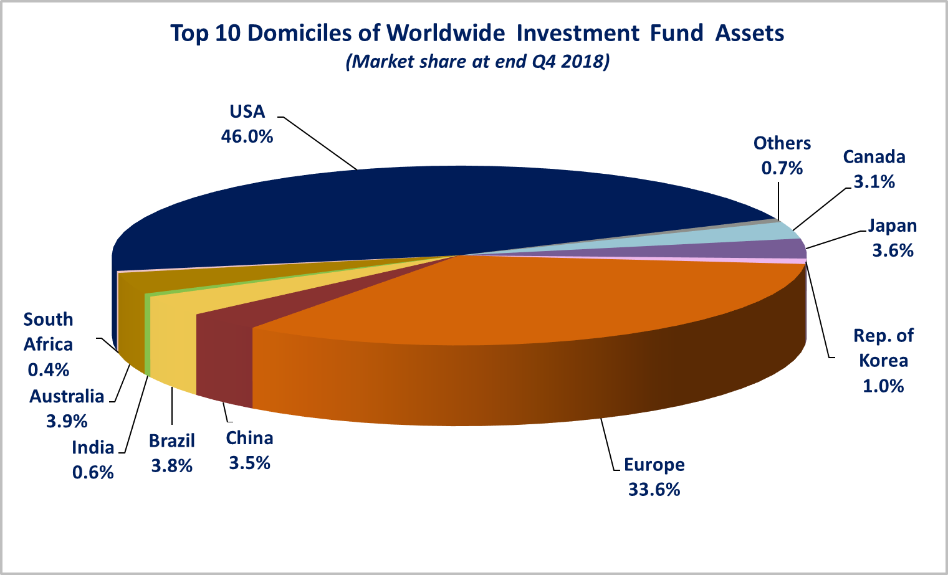

Overall, five European countries ranked among the top ten largest fund domiciles: Luxembourg (with 9.2 percent of worldwide investment fund assets), Ireland (5.5%), Germany (4.6%), France (4.1%), and the United Kingdom (3.5%).

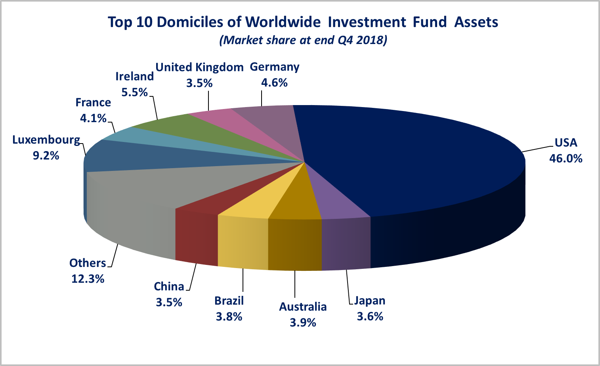

Net sales of regulated worldwide open-ended funds amounted to EUR 120 billion in the fourth quarter of 2018, compared to EUR 169 billion in the third quarter. Long-term funds recorded net sales of EUR 48 billion, down from EUR 215 billion in the third quarter. Globally, equity funds recorded net sales of EUR 99 billion, compared to EUR 83 billion in the third quarter of 2018. Bond funds recorded net outflows of EUR 57 billion, compared to net inflows of EUR 78 billion in the previous quarter. Balanced/mixed funds worldwide registered net outflows of EUR 7 billion, compared to net inflows of EUR 19 billion in the third quarter 2018. Money market funds recorded net inflows of EUR 71 billion, compared to net outflows of EUR 46 billion in the third quarter of 2018.

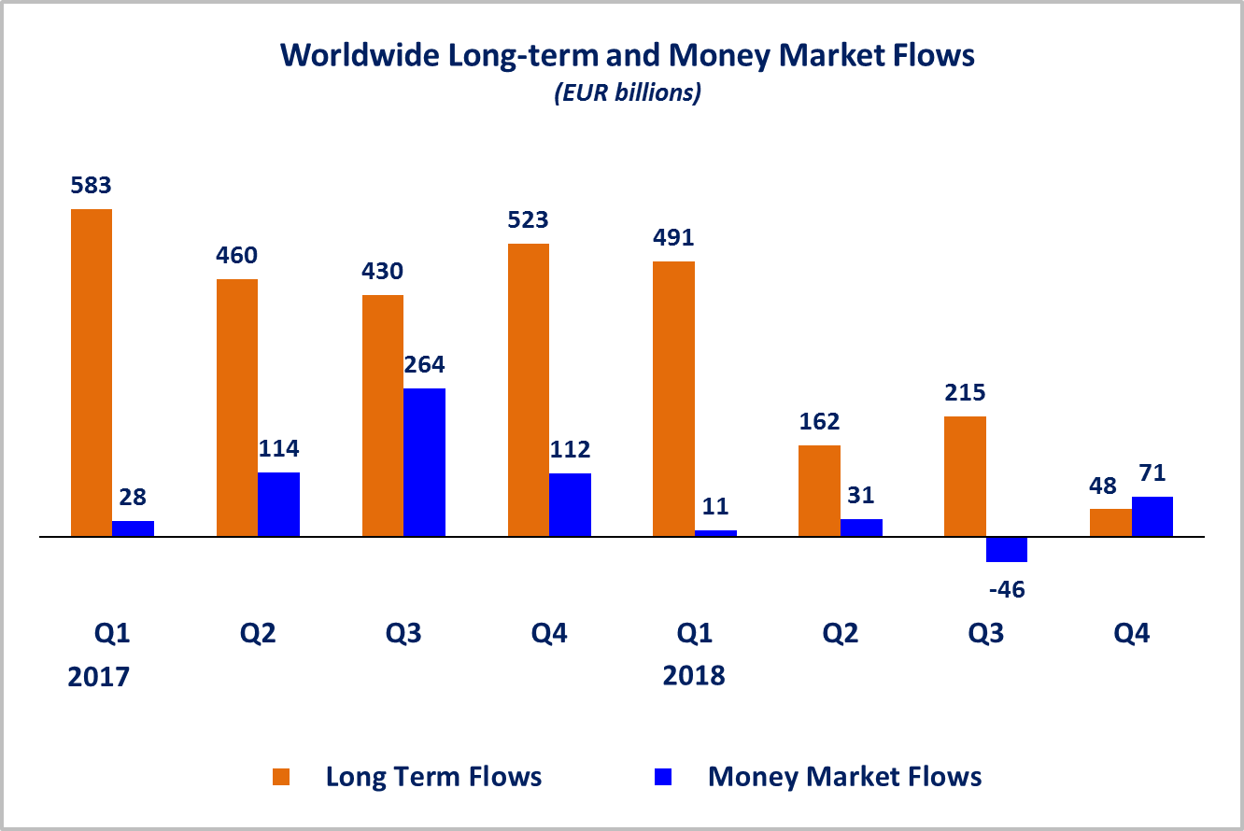

Net sales of regulated open-ended funds reached EUR 114 billion in the United States, EUR 39 billion in Japan, and EUR 25 billion in Canada. Net outflows were recorded in Europe (EUR 40 billion) and the emerging markets (EUR 34 billion, of which net outflows of EUR 40 billion in China).

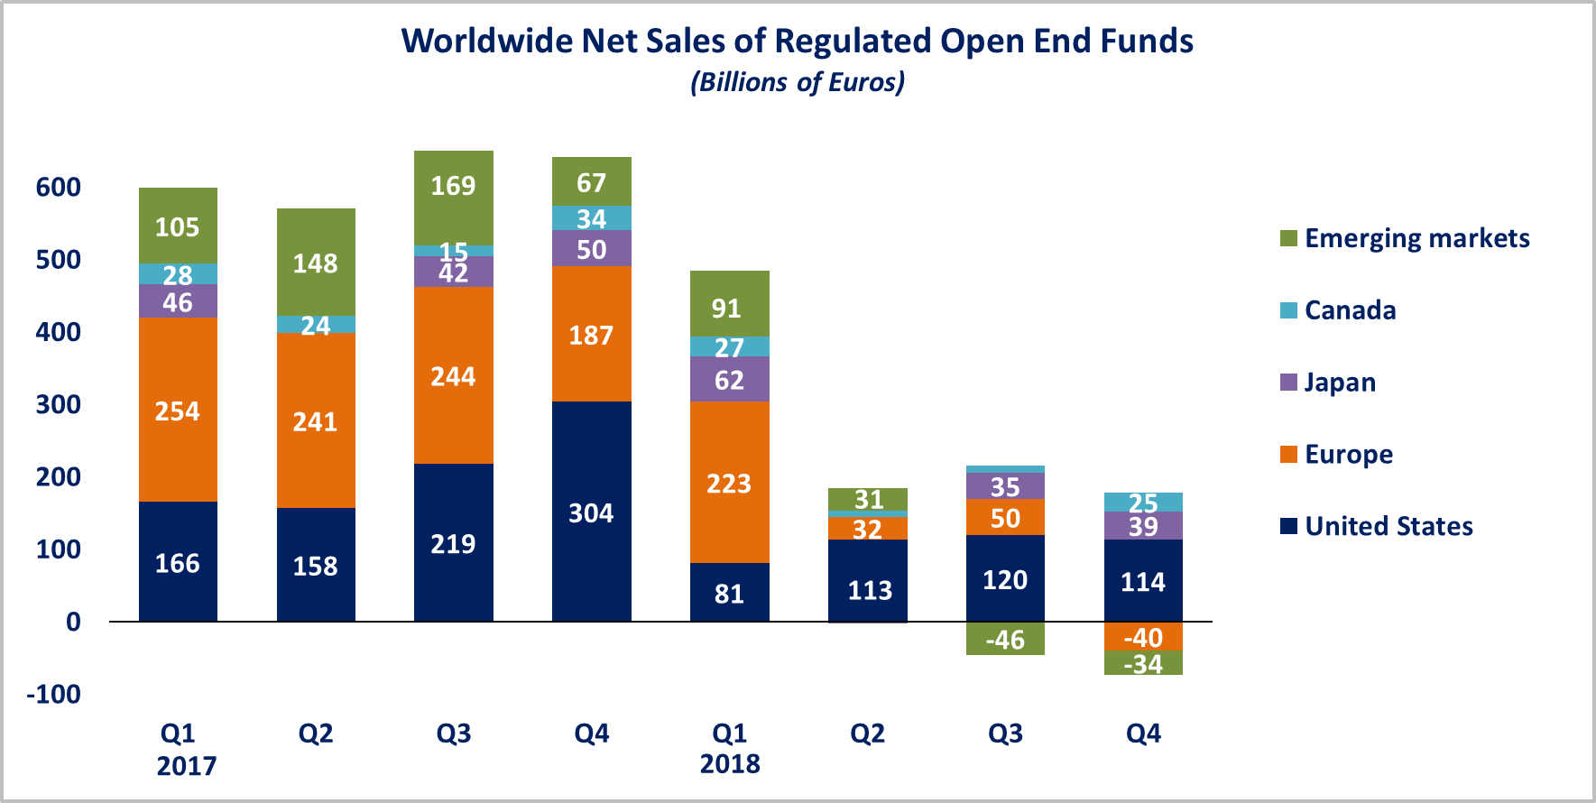

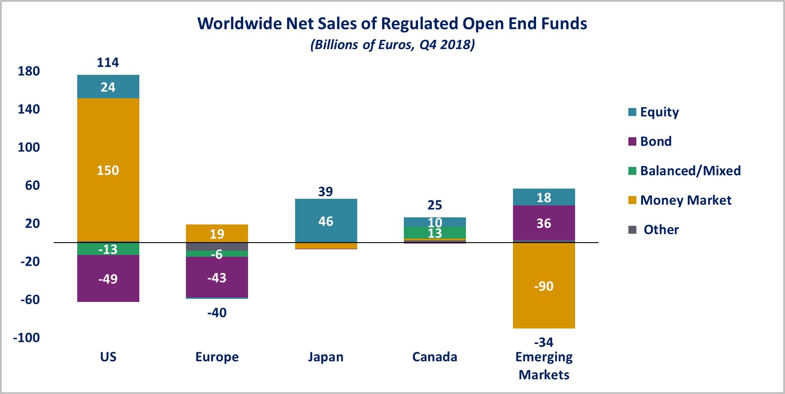

In Europe, long-term funds registered net outflows of EUR 60 billion, compared to net inflows of EUR 65 billion in the third quarter of 2018. Equity funds recorded net outflows of EUR 1 billion, compared to net inflows of EUR 20 billion in the previous quarter. Bond funds continued to record net outflows of EUR 43 billion, compared to EUR 3 billion in the previous quarter. Balanced/mixed funds registered net outflows of EUR 6 billion, compared to net inflows of EUR 21 billion in the third quarter of 2018. Money market funds recorded net inflows of EUR 19 billion, compared to net outflows of EUR 14 billion in the previous quarter.

In the United States, long-term open-ended funds recorded net outflows of EUR 36 billion in the last quarter of 2018, compared to net inflows of EUR 85 billion in the third quarter. Equity funds increased from EUR 18 billion in the third quarter of 2018 to EUR 24 billion in the fourth quarter. Bond funds recorded net outflows of EUR 49 billion, compared to net inflows of EUR 78 billion in the previous quarter. Balanced/mixed funds continued to record net outflows of EUR 13 billion, compared to EUR 8 billion in the third quarter of 2018. Money market funds recorded net inflows of EUR 150 billion, up from EUR 35 billion in the previous quarter.

**Regional Summary Table by Type of Fund, Q4 2018**



1. All data presented in this report include funds of funds, exchange-traded funds and institutional funds.