***This release and additional tables***

***of international statistics are***

***available on efama’s website***

***(***[***www.efama.org***](http://www.fefsi.org)***).***

## Worldwide Regulated Open-ended Fund Assets and Flows

**Trends in the Third Quarter of 2019**

Brussels, December 19, 2019 **–** Worldwide regulated open-ended fund assets increased by 4.8 percent to EUR 51.2 trillion in the third quarter of 2019.[1] Worldwide net cash flow to all funds amounted to EUR 622 billion, compared to EUR 315 billion in the second quarter of 2019.

The information presented in this report was compiled by EFAMA and the Investment Company Institute (ICI) on behalf of the International Investment Funds Association (IIFA), an organization of national investment fund associations. Statistics from 47 countries are included in this report.

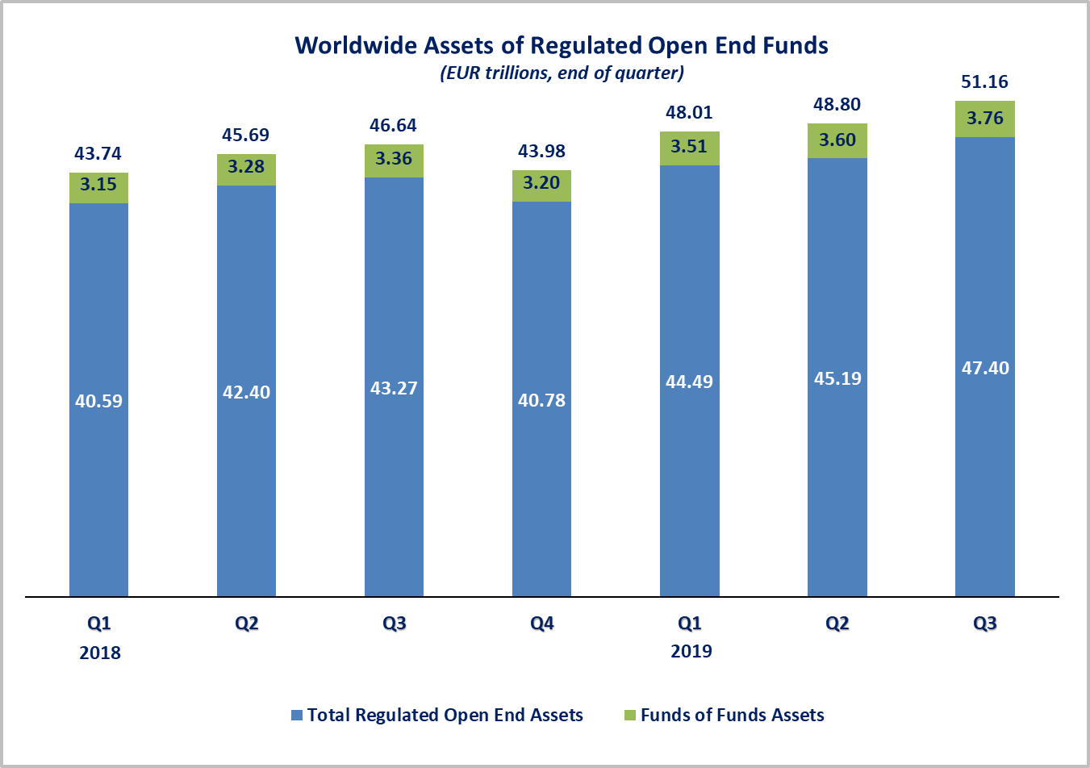

Measured in U.S. dollars, worldwide investment fund net assets increased to USD 55.7 trillion at the end of Q3 2019. This represented an increase of 0.3 percent. The following two graphs compare the net asset growth in the seven largest countries/regions.

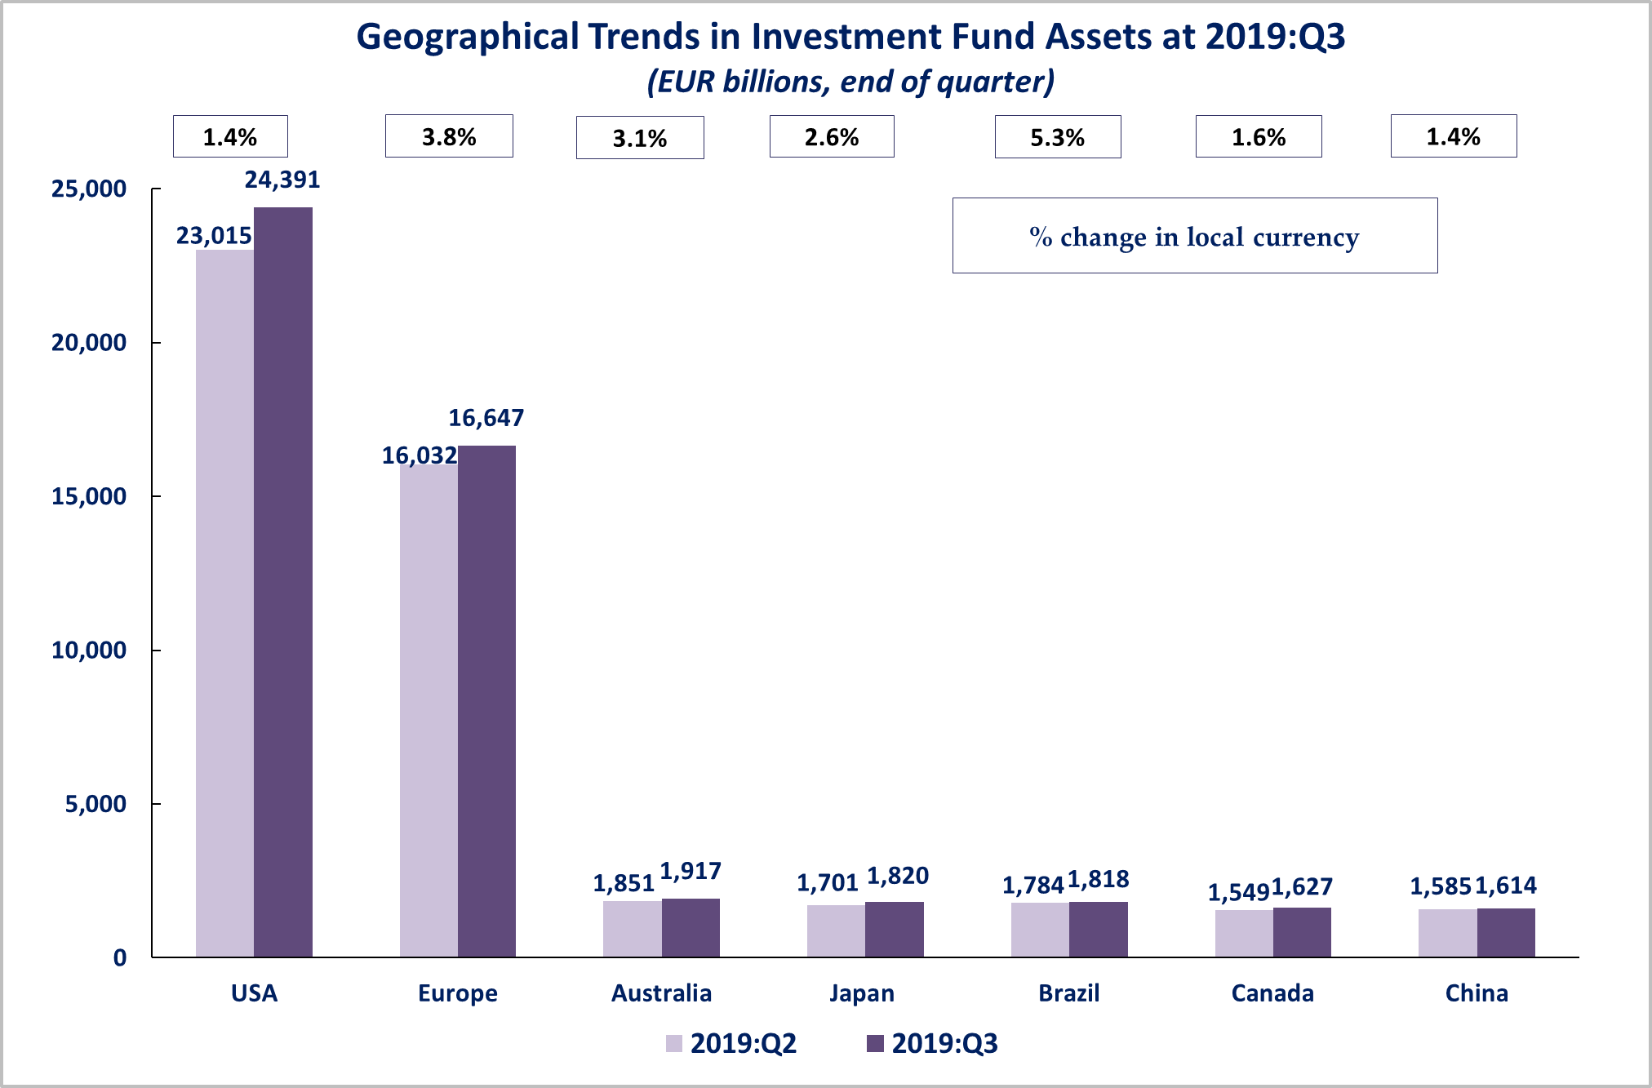



On a euro-denominated basis, worldwide equity fund assets increased by 4.2 percent to EUR 21.1 trillion at the end of the third quarter of 2019. Bond fund assets increased by 6.9 percent to EUR 10.9 trillion. Balanced/mixed fund assets increased by 5.8 percent to EUR 8.8 trillion. Money market fund assets increased by 7.6 percent to 6.1 trillion at the end of Q3 2019.



At the end of Q3 2019, 41.3 percent of worldwide regulated open-ended fund net assets were held in equity funds. The asset share of bond funds was 21.4 percent and the asset share of balanced/mixed funds was 17.3 percent. Money market fund assets represented 11.9 percent of the worldwide total.

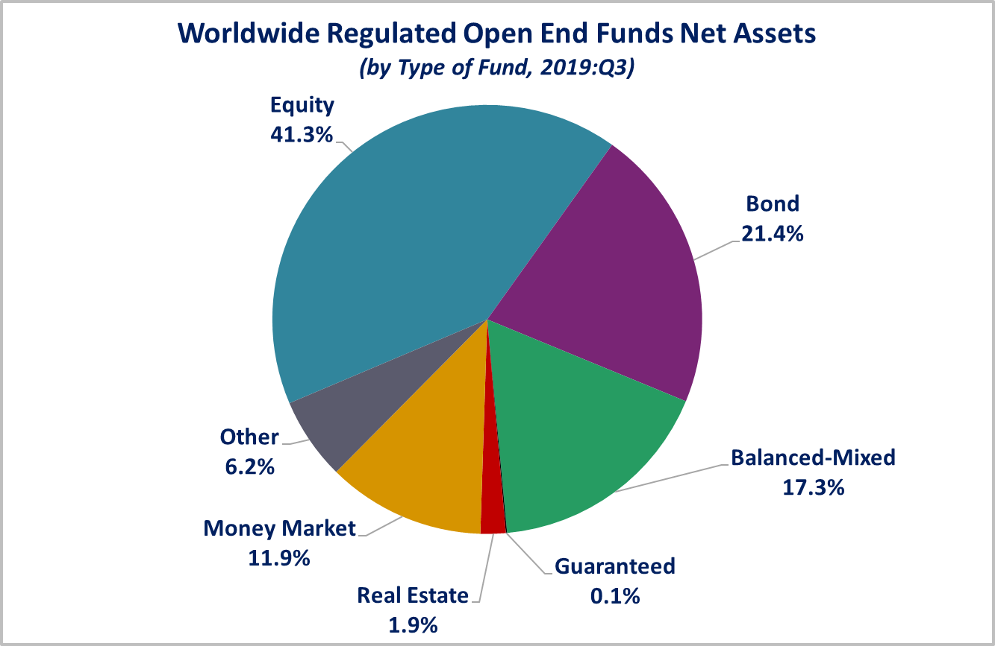

Looking at the worldwide distribution of investment fund net assets at end Q3 2019, the United States and Europe held the largest shares in the world market, with 47.7 percent and 32.5 percent, respectively. Australia (3.7%), Japan (3.6%), Brazil (3.6%), Canada (3.2%), China (3.2%), Rep. of Korea (1%), India (0.6%) and South Africa (0.3%) follow in this ranking.

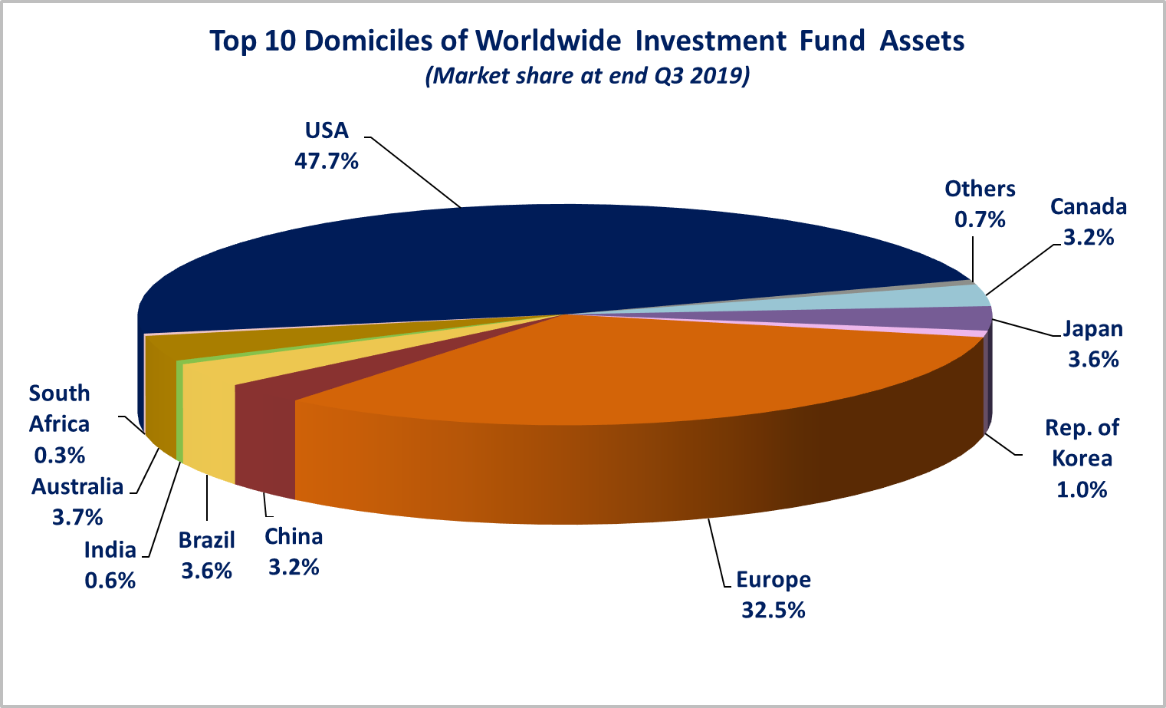

Overall, five European countries ranked among the top ten largest fund domiciles: Luxembourg (with 8.9 percent of worldwide investment fund assets), Ireland (5.7%), Germany (4.5%), France (3.8%), and the United Kingdom (3.2%).

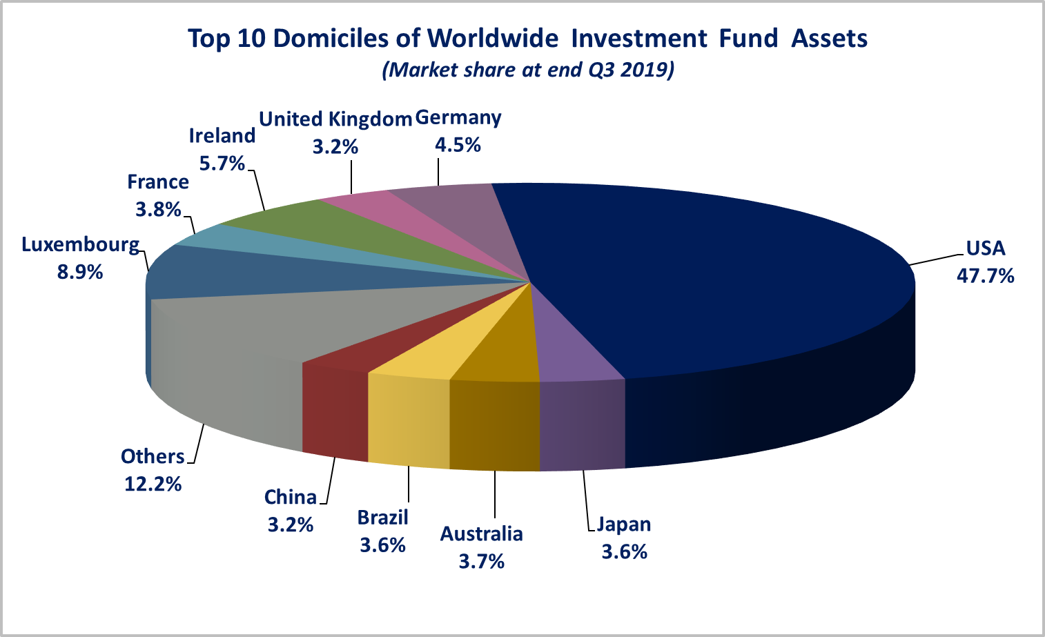Worldwide net sales of regulated open-ended funds increased to EUR 622 billion in the third quarter of 2019, from EUR 315 billion in Q2 2019. Long-term funds recorded net sales of EUR 342 billion, up from EUR 251 billion in the previous quarter. Globally, bond funds recorded net sales of EUR 245 billion, up from EUR 210 billion in the previous quarter. Net inflows into balanced/mixed funds worldwide totalled EUR 50 billion, up from EUR 23 billion in Q2 2019. Net sales of money market funds increased from EUR 64 billion in the second quarter of 2019 to EUR 280 billion in Q3 2019. Equity funds recorded net inflows of EUR 0.4 billion, compared to net outflows of EUR 36 billion in Q2 2019.

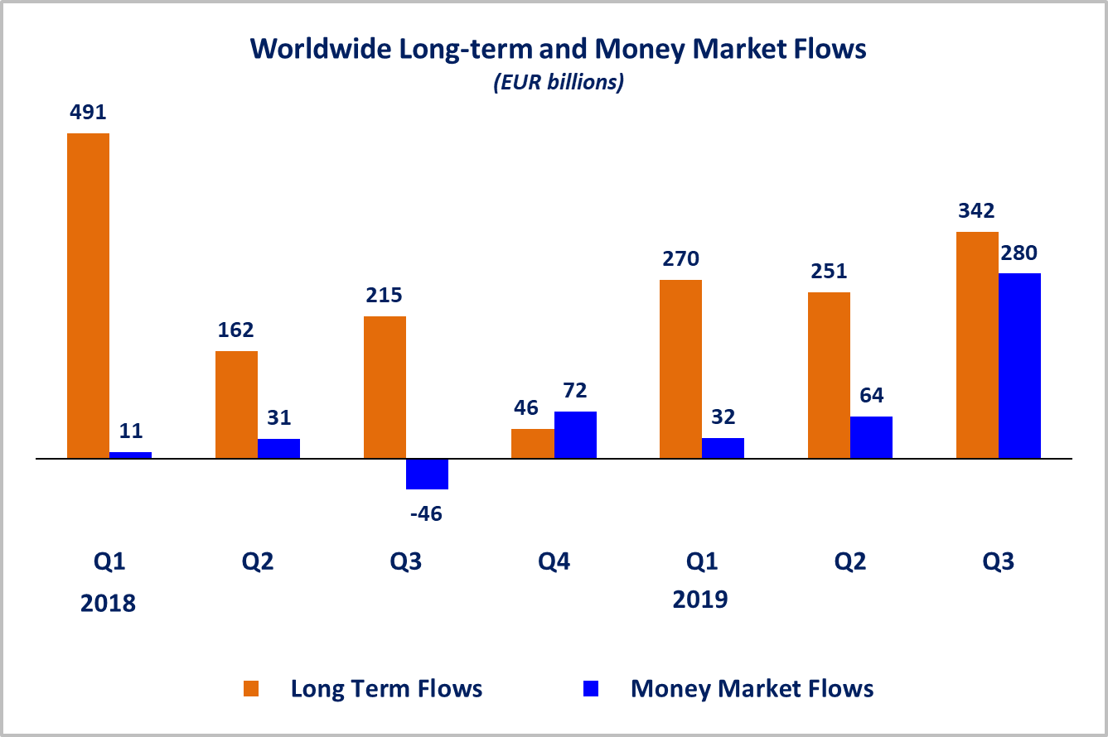Net sales of regulated open-ended funds reached EUR 303 billion in the United States, EUR 191 billion in Europe, EUR 65 billion in the other advanced economies[2] (of which net inflows of EUR 32 billion in Japan, EUR 13 billion in Canada, and EUR 10 billion in Korea). Emerging markets[3] recorded net inflows of EUR 63 billion (of which net inflows of EUR 36 billion in China and EUR 17 billion in Brazil). All regions experienced an increase in net sales compared to Q2 2019.

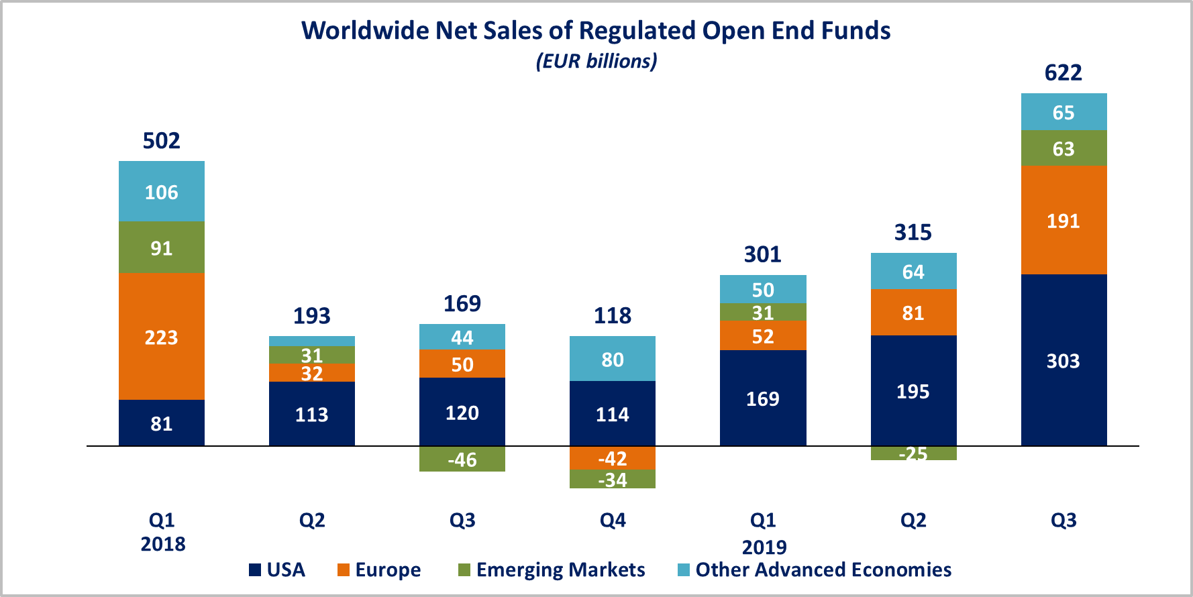

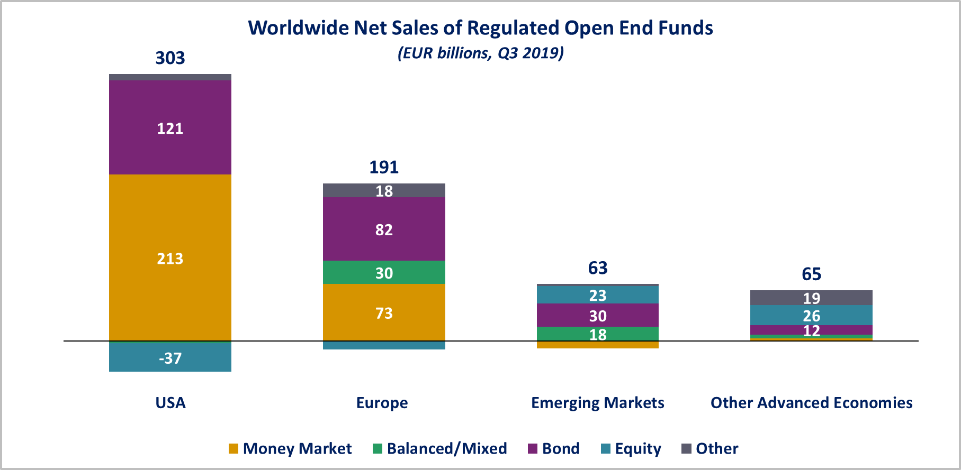

In Europe, long-term funds attracted net sales of EUR 118 billion, up from EUR 75 billion in the second quarter of 2019. Equity funds recorded net outflows of EUR 11 billion, compared to net outflows of EUR 33 billion in Q2 2019. Bond funds recorded net inflows of EUR 82 billion, compared to net inflows of EUR 81 billion in the previous quarter. Net inflows into balanced/mixed funds amounted to EUR 30 billion, up from EUR 14 billion in Q2 2019. Money market funds recorded net inflows of EUR 73 billion, compared to net inflows of EUR 6 billion in the second quarter of 2019.

In the United States, long-term open-ended funds recorded net sales of EUR 89 billion, up from EUR 88 billion in Q2 2019. Equity funds recorded net outflows of EUR 37 billion, compared to net outflows of EUR 28 billion in the previous quarter. Net sales of bond funds increased from EUR 118 billion in Q2 2019 to EUR 121 billion in Q3 2019. Balanced/mixed funds registered net outflows of EUR 3 billion, compared to net outflows of EUR 1 billion in the second quarter of 2019. Net sales of money market funds amounted to EUR 213 billion, compared to EUR 107 billion in the previous quarter.

**Regional Summary Table by Type of Fund, Q3 2019**



1. All data presented in this report include funds of funds, exchange-traded funds and institutional funds.
2. Other advanced economies are countries thus defined by the International Monetary Fund, based on criteria such as per capita income level and the degree of integration into the global financial system, excluding the US and the countries included in the Europe aggregate. Data is not available for all advanced economies. Other advanced economies include Australia, Canada, Japan, Korea, New Zealand and Chinese Taipei (Taiwan).
3. Emerging markets are countries thus defined by the International Monetary Fund . Data is not available for all emerging markets. The following countries are included: Argentina, Brazil, Chile, China, Costa Rica, India, Mexico, Pakistan, the Philippines, South Africa and Trinidad & Tobago.