This release and additional tables
of international statistics are
available on efama’s website
(www.efama.org).

Worldwide Regulated Open-ended Fund Assets and Flows
Trends in the Third Quarter of 2017

Brussels, December 21, 2017 – Worldwide regulated open-ended fund assets increased 1.8 percent to EUR 43.28 trillion in the third quarter of 2017. Worldwide net cash flow to all funds amounted to EUR 694 billion, compared to EUR 574 billion in the second quarter of 2017.

The information presented in this report was compiled by EFAMA and the Investment Company Institute (ICI) on behalf of the International Investment Funds Association (IIFA), an organization of national investment fund associations. Statistics from 47 countries are included in this report.

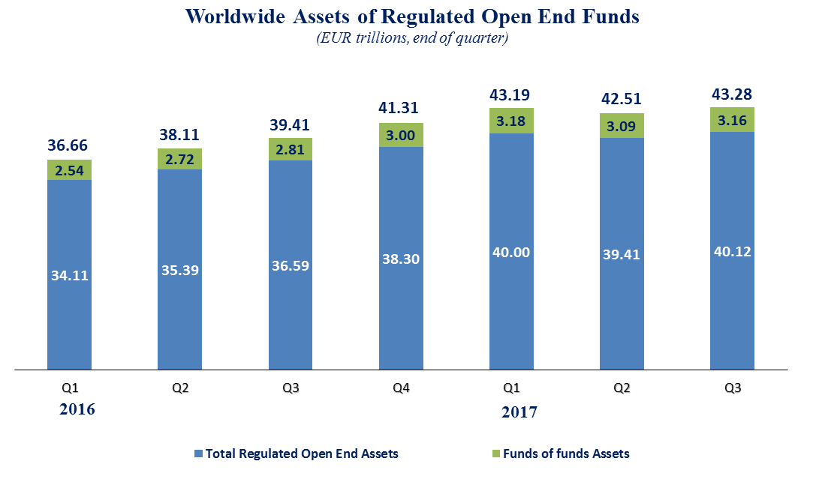

Measured in U.S. dollars, worldwide investment fund net assets increased to USD 51.10 trillion at the end of Q3 2017. This represented an increase of 5.3 percent, compared to an increase of 1.8 percent on a euro-denominated basis. The following two graphs compare the net asset growth in the six largest countries/regions.

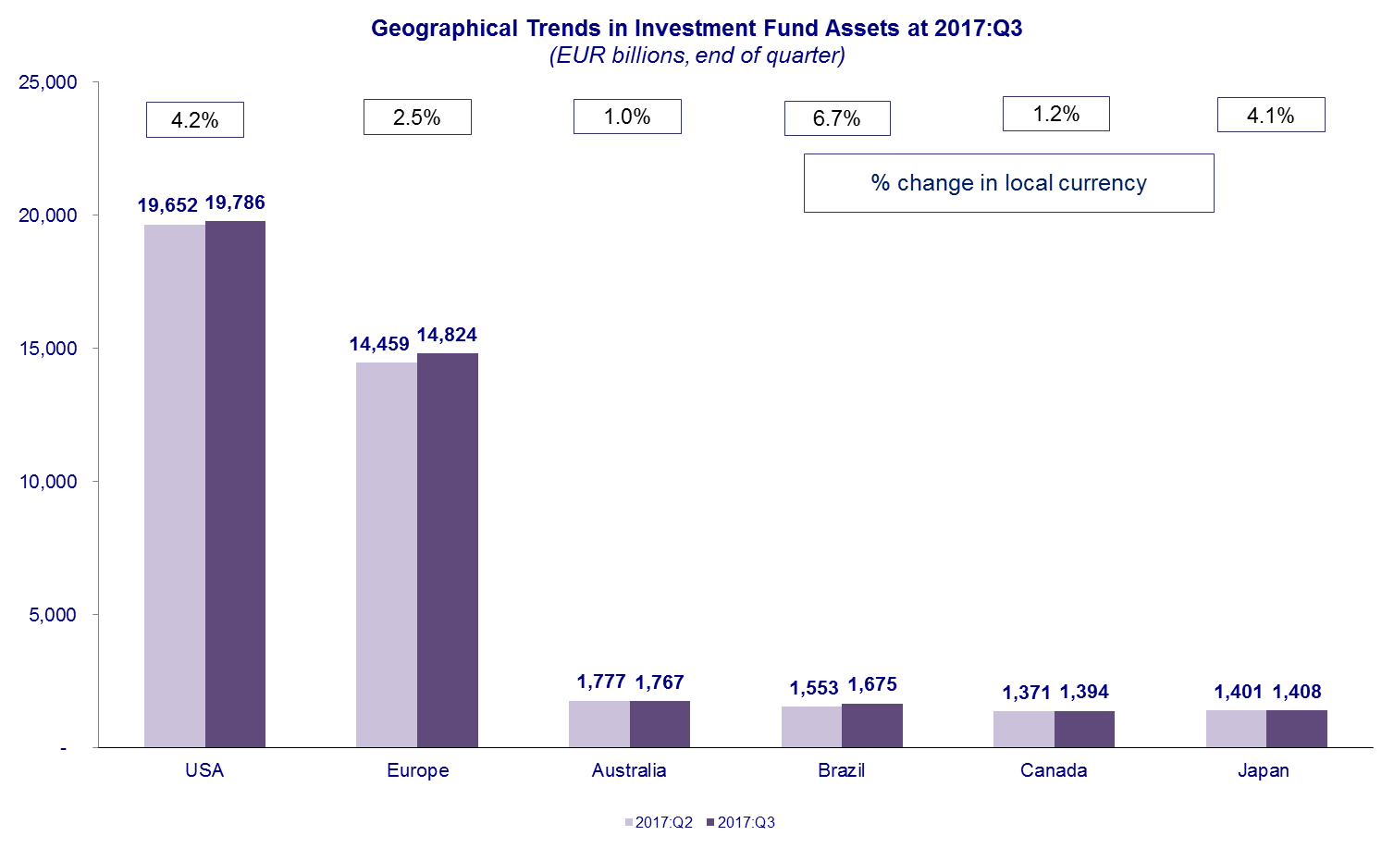

On a euro-denominated basis, equity fund net assets increased 1.7 percent to EUR 17.7 trillion at the end of Q3 2017. Bond funds net assets increased 1.2 percent to EUR 9.1 trillion. Balanced/mixed fund assets increased 1.4 percent to EUR 9.1 trillion, and money market fund assets increased 3.7 percent to EUR 4.8 trillion.

At the end of Q3 2017, 41 percent of worldwide regulated open-ended fund net assets were held in equity funds. The net asset share of bond funds was 21 percent and the net asset share of balanced/mixed funds was 18 percent. Money market fund net assets represented 11 percent of the worldwide total.

Worldwide Regulated Open End Funds Net Assets
by Type of Fund, 2017:Q3
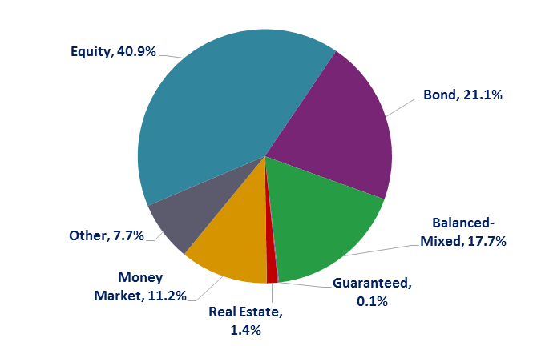

Looking at the worldwide distribution of investment fund net assets at end Q3 2017, the United States and Europe held the largest shares in the world market, with 45.7 percent and 34.2 percent, respectively. Australia (4.1%), Brazil (3.9%), Japan (3.3%), Canada (3.2%), China (3.1%), Rep. of Korea (0.9%), India (0.6%) and South Africa (0.4%) follow in this ranking.

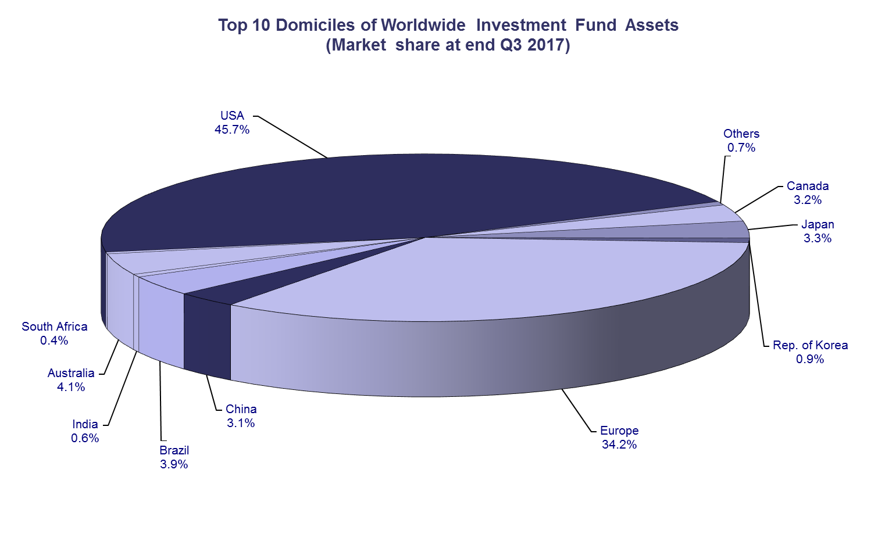

Overall, five European countries ranked among the top ten largest fund domiciles: Luxembourg (with 9.3 percent of worldwide investment fund assets), Ireland (5.3%), Germany (4.6%), France (4.5%), and the United Kingdom (3.7%).
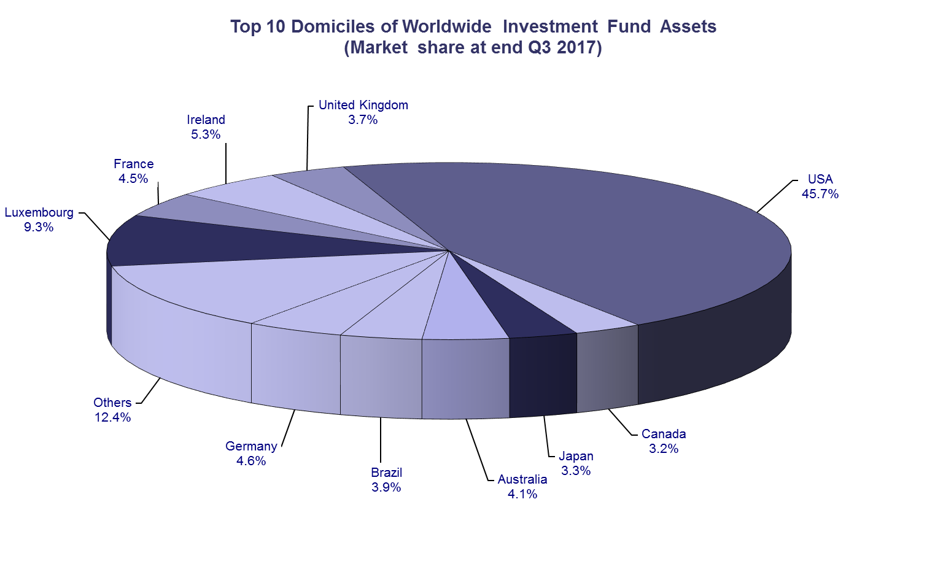
Net sales of regulated worldwide open-ended funds amounted to EUR 694 billion in the third quarter of 2017, compared to EUR 574 billion in the second quarter. Long-term funds recorded net sales of EUR 430 billion, down from EUR 460 billion in the previous quarter. Globally, equity funds recorded net sales of EUR 121 billion, compared to EUR 113 billion in Q2 2017. Bond funds recorded net sales of EUR 193 billion, compared to EUR 200 billion in the previous quarter. Net sales into balanced/mixed funds worldwide totalled EUR 65 billion, down from EUR 82 billion in the second quarter. Finally, net flows of money market funds equalled EUR 264 billion, up from EUR 114 billion in the previous quarter.
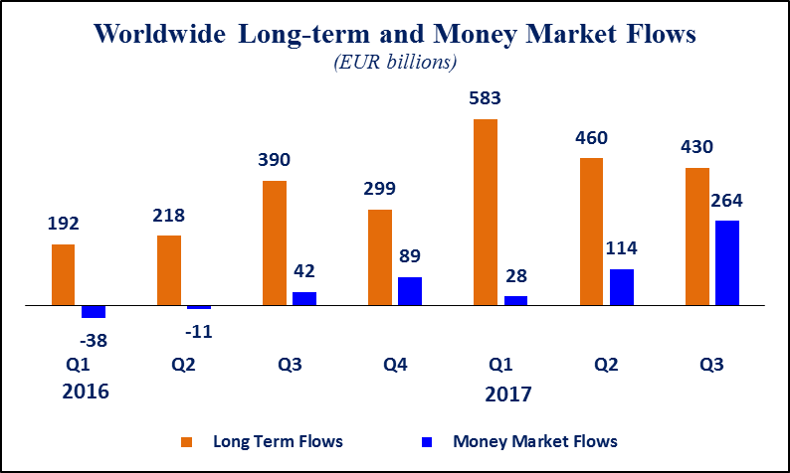
Net sales of regulated open-ended funds reached EUR 244 billion in Europe, EUR 219 billion in the United States, EUR 169 billion in emerging markets, EUR 42 billion in Japan, and EUR 15 billion in Canada. Europe, the United States, Japan and the emerging markets all experienced an increase in net sales compared to Q2 2017, whereas Canada experienced a decrease in net sales.

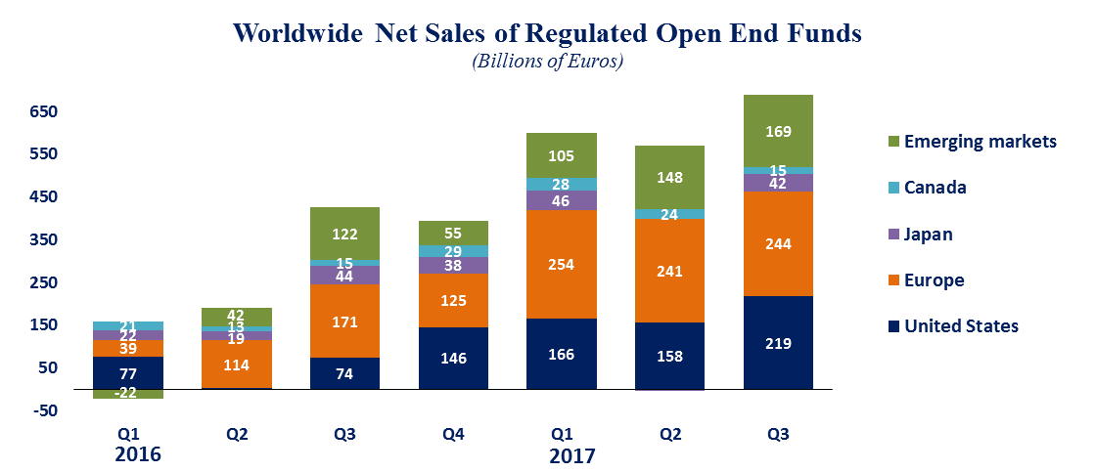

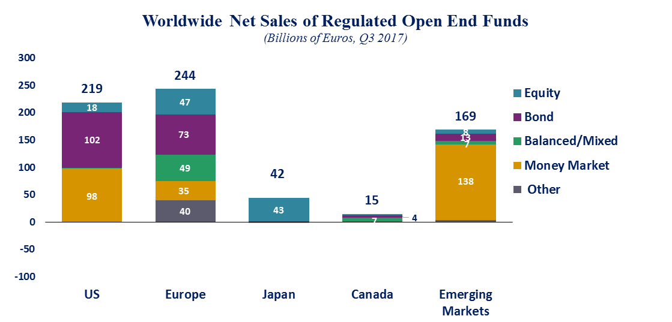

In Europe, long-term funds attracted net sales of EUR 209 billion, down from EUR 259 billion in the second quarter of 2017. Equity funds recorded net sales of EUR 47 billion, compared to EUR 40 billion in the previous quarter. Bond funds recorded net sales of EUR 73 billion, compared to EUR 102 billion in the previous quarter. Net sales into balanced/mixed funds amounted to EUR 49 billion, down from EUR 65 billion in Q2 2017. Money market funds recorded net inflows of EUR 35 billion, compared to net outflows of EUR 18 billion in the previous quarter.

In the United States, long-term open-ended funds recorded net sales of EUR 121 billion, compared to EUR 186 billion in the second quarter of 2017. Equity funds recorded net sales of EUR 18 billion, compared to EUR 71 billion in Q2 2017. Bond funds decreased from EUR 107 billion in Q2 2017 to EUR 102 billion in Q3 2017. Net sales of balanced/mixed funds amounted to EUR 1 billion, compared to EUR 6 billion in the second quarter of 2017. Money market funds posted net inflows of EUR 98 billion, compared to net outflows of EUR 29 billion in the previous quarter.

Regional Summary Table by Type of Fund, Q3 2017

Note: Includes funds-of-funds, ETFs and institutional funds in the totals and underlying categories. All funds are open-ended (i.e. redeemable), substantively-regulated and domiciled in the reporting country. New Zealand and Trinidad and Tobago include home and foreign domiciled funds.

All data presented in this report include funds of funds, exchange-traded funds and institutional funds.

