***This release and additional tables***

***of international statistics are***

***available on efama’s website***

***(***[***www.efama.org***](http://www.fefsi.org)***).***

## Worldwide Regulated Open-ended Fund Assets and Flows

**Trends in the Second Quarter of 2018**

Brussels, September 28, 2018 **–** Worldwide regulated open-ended fund assets increased by 4.4 percent to EUR 45.65 trillion in the second quarter of 2018.[1] Worldwide net cash flow to all funds amounted to EUR 190 billion, compared to EUR 502 billion in the first quarter of 2018.

The information presented in this report was compiled by EFAMA and the Investment Company Institute (ICI) on behalf of the International Investment Funds Association (IIFA), an organization of national investment fund associations. Statistics from 47 countries are included in this report.

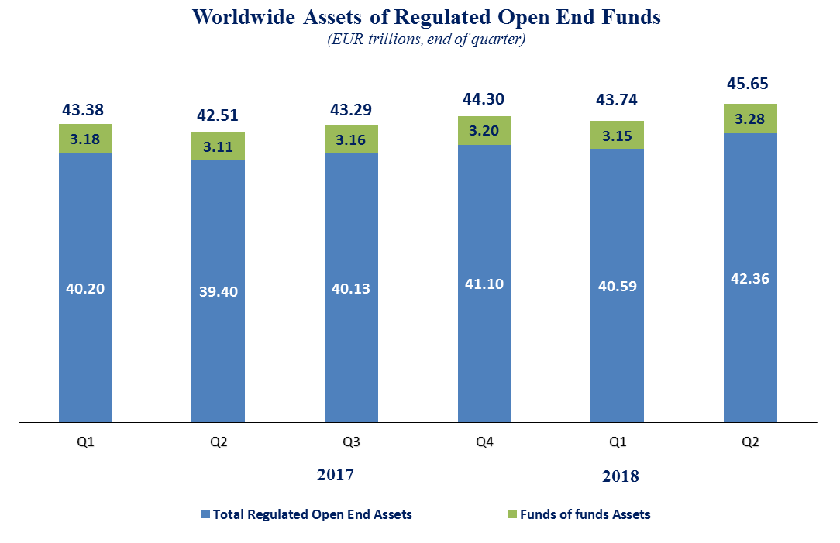

Measured in U.S. dollars, worldwide investment fund net assets decreased to USD 53.2 trillion at the second quarter of 2018. This represented a decrease of 1.3 percent, which reflected the appreciation of the US dollar. The following two graphs compare the net asset growth in the seven largest countries/regions.

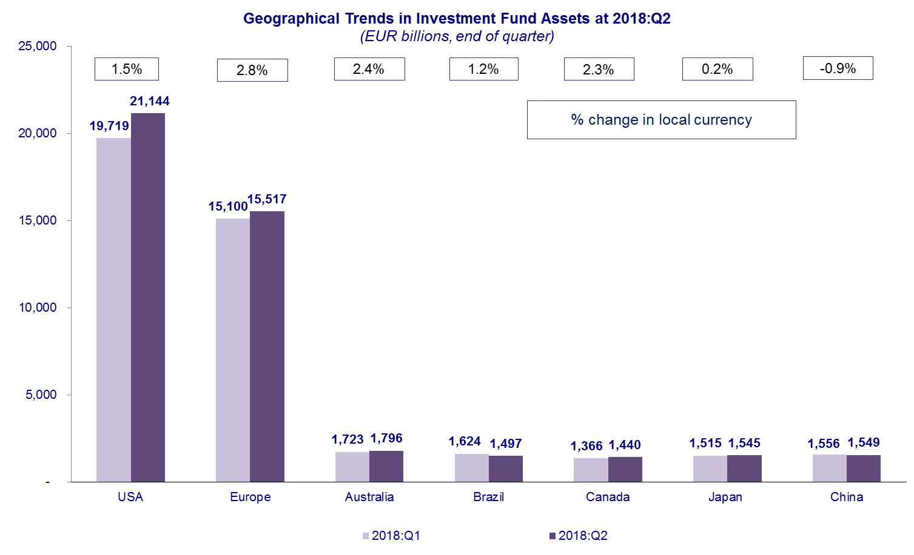



On a euro-denominated basis, worldwide equity fund assets increased by 6.5 percent to EUR 19.2 trillion at the second quarter of 2018. Bond fund assets increased by 2.2 percent to EUR 9.2 trillion. Balanced/mixed fund assets increased 2.8 percent to EUR 7.9 trillion. Money market fund assets increased by 3.3 percent to 5.1 trillion at the end of the second quarter of 2018.



At the end of Q2 2018, 42 percent of worldwide regulated open-ended fund net assets were held in equity funds. The asset share of bond funds was 20 percent and the asset share of balanced/mixed funds was 17 percent. Money market fund assets represented 11 percent of the worldwide total.

**Worldwide Regulated Open End Funds Net Assets**

**by Type of Fund, 2018:Q2**

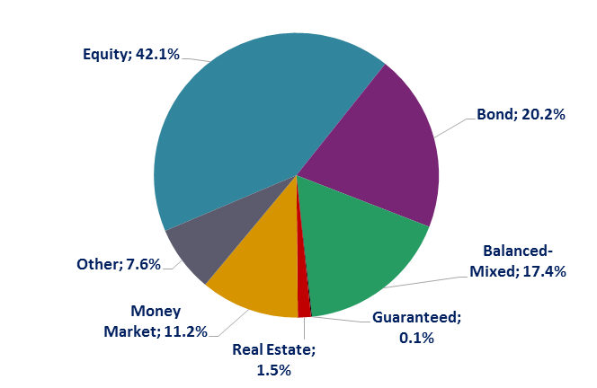

Looking at the worldwide distribution of investment fund net assets at end Q2 2018, the United States and Europe held the largest shares in the world market, with 46.3 percent and 34.0 percent, respectively. Australia (3.9%), China (3.4%), Japan (3.4%), Brazil (3.3%), Canada (3.2%), Rep. of Korea (0.9%), India (0.6%) and South Africa (0.4%) follow in this ranking.

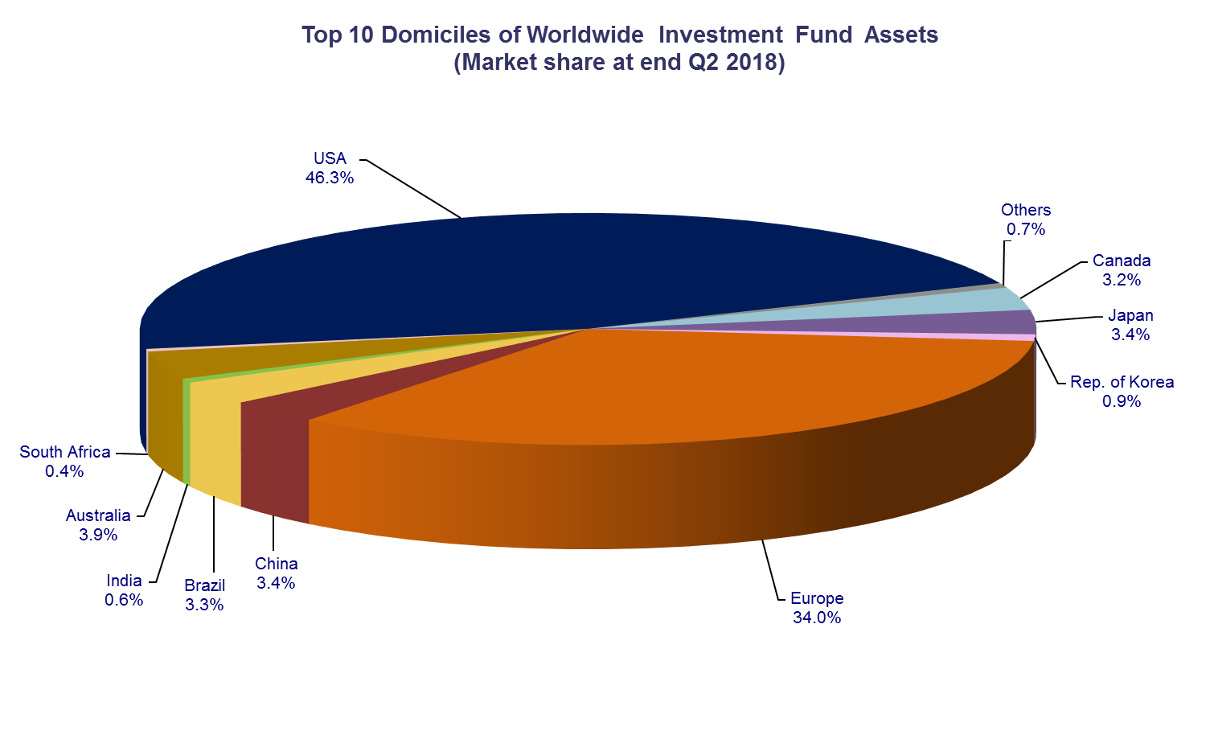

Overall, five European countries ranked among the top ten largest fund domiciles: Luxembourg (with 9.3 percent of worldwide investment fund assets), Ireland (5.4%), Germany (4.5%), France (4.2%), and the United Kingdom (3.9%).

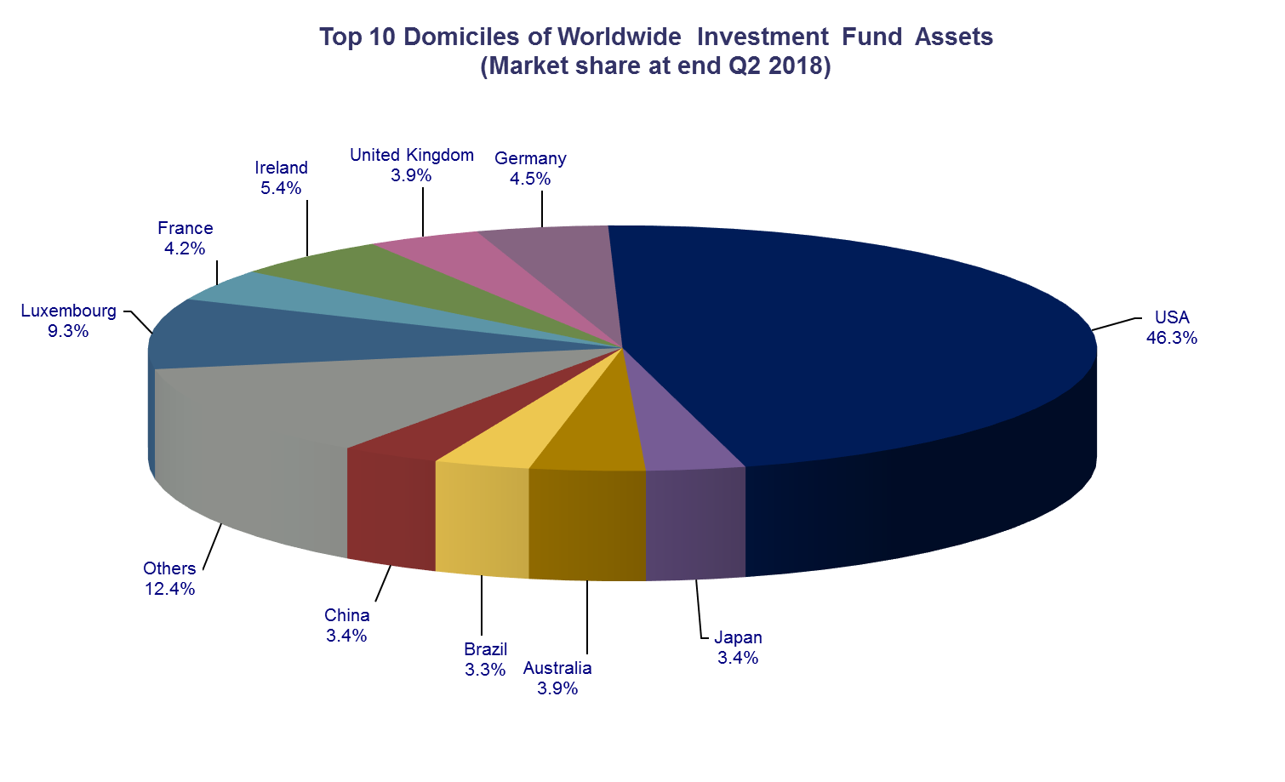

Worldwide net sales of regulated open-ended funds decreased to EUR 190 billion in the second quarter of 2018, from to EUR 502 billion in Q1 2018. Long-term funds recorded net sales of EUR 159 billion, down from EUR 491 billion in the previous quarter. Globally, equity funds recorded net sales of EUR 36 billion, compared to EUR 217 billion in Q1 2018. Bond funds recorded net sales of EUR 60 billion, down from EUR 119 billion in the previous quarter. Net sales into balanced/mixed funds worldwide totalled EUR 23 billion, down from EUR 89 billion in Q1 2018. Finally, net inflows into money market funds increased from EUR 11 billion in the first quarter of 2018 to EUR 31 billion in Q2 2018.

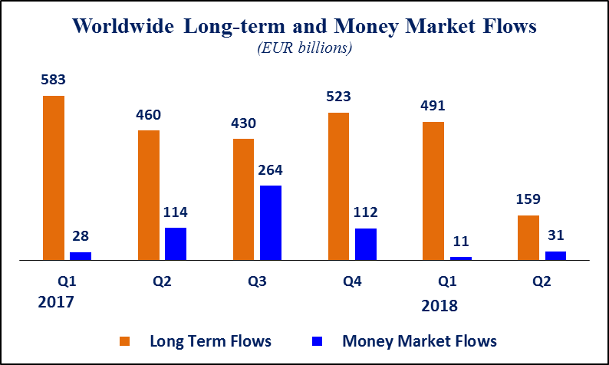Net sales of regulated open-ended funds reached EUR 29 billion in Europe, EUR 113 billion in the United States, EUR 31 billion in emerging markets (of which EUR 16 billion in China and EUR 16 billion in India), EUR 10 billion in Rep. of Korea, and EUR 8 billion in Canada. Japan registered net outflows of EUR 2 billion. Europe, the emerging markets, Japan and Canada all experienced a decrease in net sales compared to Q1 2018, whereas the United States saw an increase in net sales.

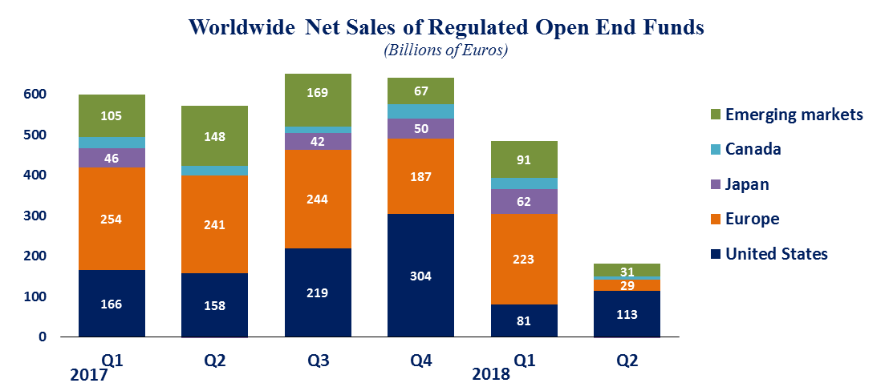

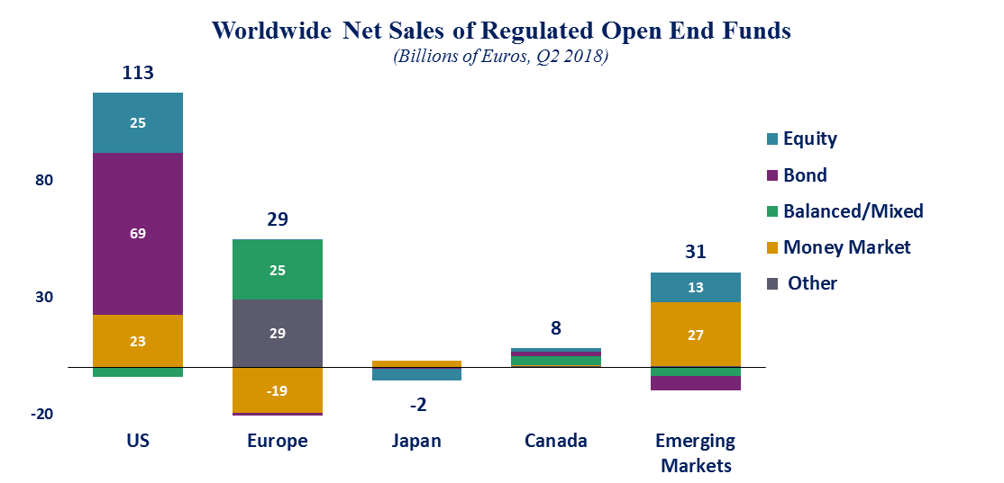

In Europe, long-term funds attracted net sales of EUR 48 billion, down from EUR 227 billion in the first quarter of 2018. Equity funds recorded net sales of EUR 0.5 billion, compared to EUR 85 billion in Q1 2018. Bond funds recorded net outflows of EUR 7 billion, compared to net inflows of EUR 24 billion in Q1 2018. Net inflows into balanced/mixed funds amounted to EUR 25 billion, down from EUR 71 billion in Q1 2018. Money market funds recorded net outflows of EUR 19 billion, compared to net outflows of EUR 4 billion in the first quarter of 2018.

In the United States, long-term open-ended funds recorded net sales of EUR 91 billion, compared to EUR 127 billion in Q1 2018. Equity funds recorded net sales of EUR 25 billion, compared to EUR 36 billion in Q1 2018. Net sales of bond funds decreased from EUR 79 billion in Q1 2018 to EUR 69 billion in Q2 2018. Net sales of balanced/mixed funds registered net outflows of EUR 4 billion, compared to net inflows of EUR 9 billion in the first quarter of 2018. Net sales of money market funds recorded net inflows of EUR 23 billion, compared to net outflows of EUR 46 billion in Q1 2018.

**Regional Summary Table by Type of Fund, Q2 2018**



1. All data presented in this report include funds of funds, exchange-traded funds and institutional funds.