This release and additional tables
of international statistics are
available on efama’s website
(www.efama.org).

Worldwide Regulated Open-ended Fund Assets and Flows
Trends in the Second Quarter of 2017

Brussels, June 27, 2017 – Worldwide regulated open-ended fund assets decreased 2.0 percent to EUR 42.33 trillion in the second quarter of 2017. Worldwide net cash flow to all funds amounted to EUR 574 billion, compared to EUR 611 billion in the first quarter of 2017.

The information presented in this report was compiled by EFAMA and the Investment Company Institute (ICI) on behalf of the International Investment Funds Association (IIFA), an organization of national investment fund associations. Statistics from 47 countries are included in this report.

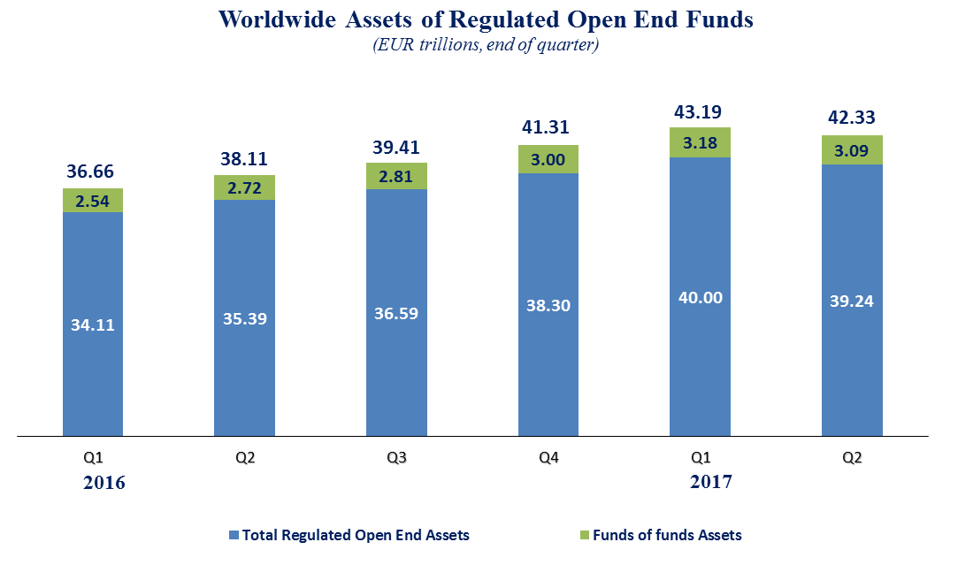

Measured in U.S. dollars, worldwide investment fund net assets increased to USD 48.31 trillion at the end of Q2 2017. This represented an increase of 4.6 percent, compared to a decrease of 2.0 percent on a euro-denominated basis. The following two graphs compare the net asset growth in the six largest countries/regions.

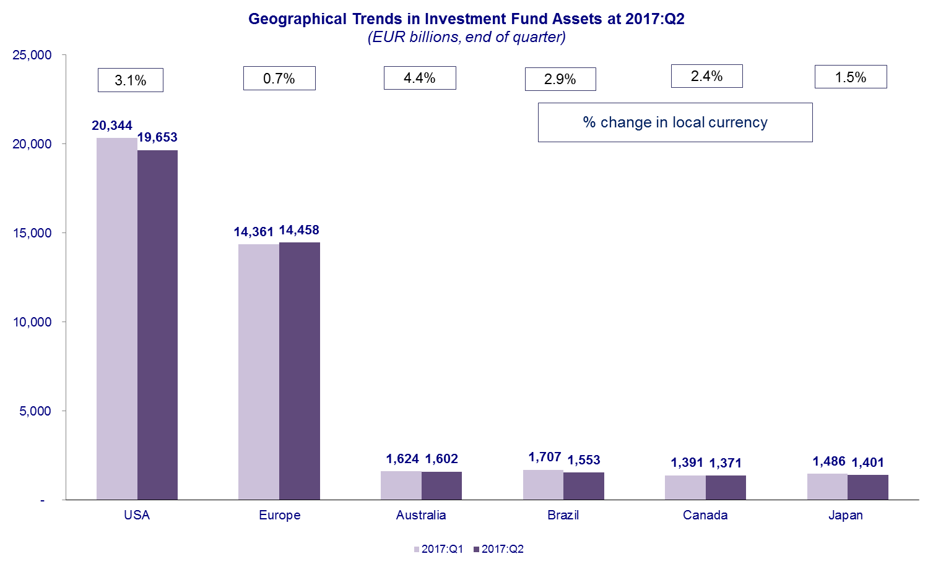

On a euro–denominated basis, equity fund net assets decreased 2.1 percent to EUR 17.2 trillion at the end of Q2 2017. Bond funds net assets decreased 2.3 percent to EUR 9.0 trillion. Balanced/mixed fund assets decreased 2.0 percent to EUR 7.6 trillion, and money market fund assets decreased 3.2 percent to EUR 4.7 trillion.

At the end of Q2 2017, 41 percent of worldwide regulated open-ended fund net assets were held in equity funds. The net asset share of bond funds was 21 percent and the net asset share of balanced/mixed funds was 18 percent. Money market fund net assets represented 11 percent of the worldwide total.

Worldwide Regulated Open End Funds Net Assets
by Type of Fund, 2017:Q2
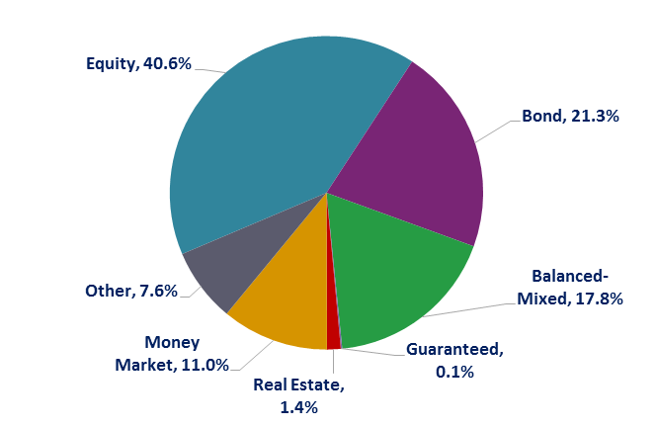

Looking at the worldwide distribution of investment fund net assets at end Q2 2017, the United States and Europe held the largest shares in the world market, with 46.4 percent and 34.2 percent, respectively. Australia (3.8%), Brazil (3.7%), Japan (3.3%), Canada (3.2%), China (2.9%), Rep. of Korea (0.9%), India (0.6%) and South Africa (0.4%) follow in this ranking.
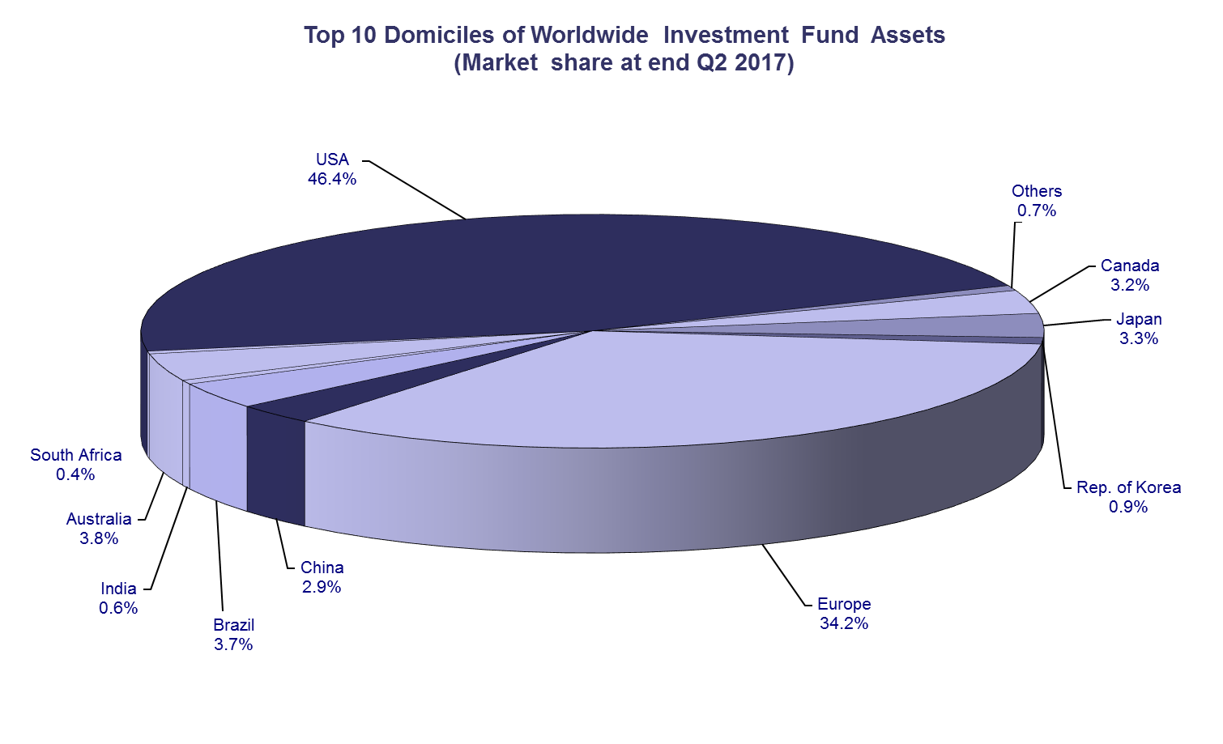

Overall, five European countries ranked among the top ten largest fund domiciles: Luxembourg (with 9.3 percent of worldwide investment fund assets), Ireland (5.3%), Germany (4.6%), France (4.4%), and the United Kingdom (3.6%).
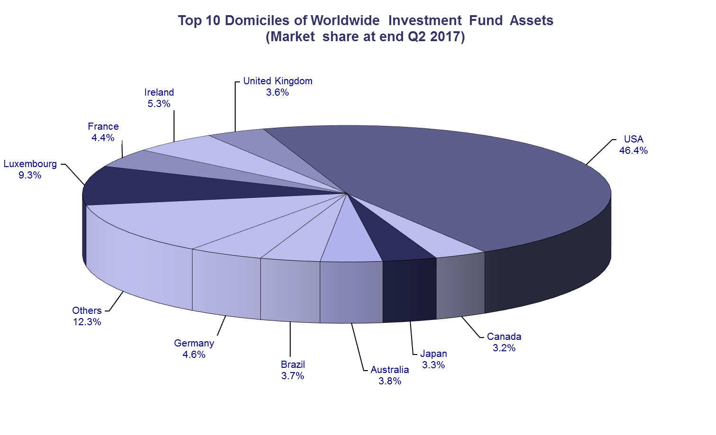
Net sales of regulated worldwide open-ended funds amounted to EUR 574 billion in the second quarter of 2017, compared to EUR 611 billion in the first quarter. Long-term funds recorded net sales of EUR 460 billion, down from EUR 583 billion in the previous quarter. Globally, equity funds recorded net sales of EUR 113 billion, compared to EUR 164 billion in Q1 2017. Bond funds recorded net sales of EUR 200 billion, compared to EUR 254 billion in the previous quarter. Net sales into balanced/mixed funds worldwide totalled EUR 82 billion, down from EUR 102 billion in the first quarter. Finally, net flows of money market funds equalled EUR 114 billion, compared to EUR 28 billion in the previous quarter.
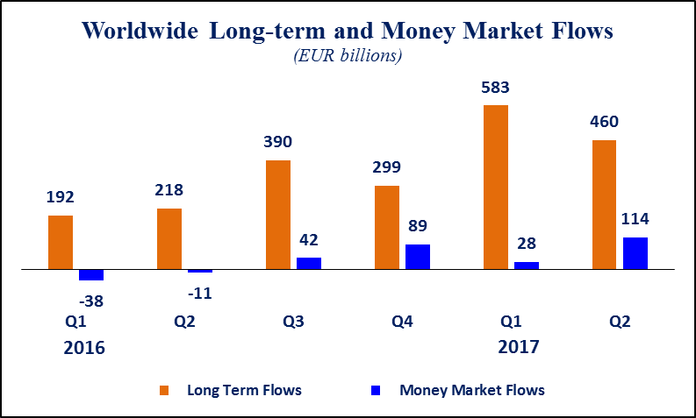
Net sales of regulated open-ended funds reached EUR 241 billion in Europe, EUR 158 billion in the United States, EUR 148 billion in emerging markets, EUR 24 billion in Canada. Japan experienced net outflows of EUR 0.3 billion in Q2 2017. Europe, the United States, Japan and Canada all experienced a decrease in net sales compared to Q1 2017, except for the emerging markets which experienced in increase in net sales thanks to strong inflows into Chinese money market funds (EUR 161 billion).

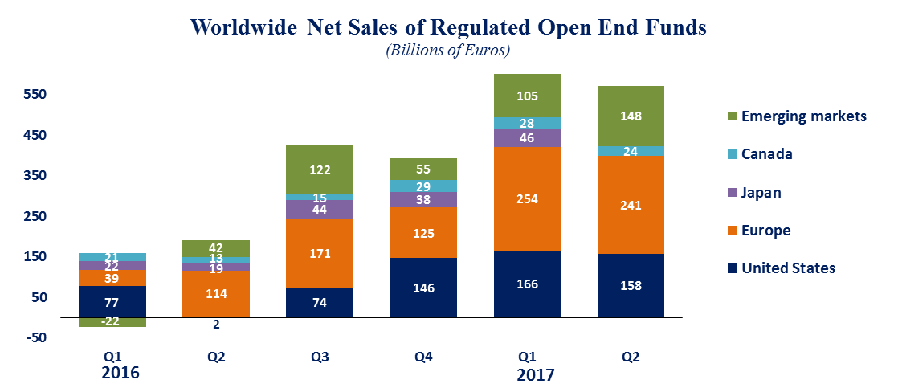

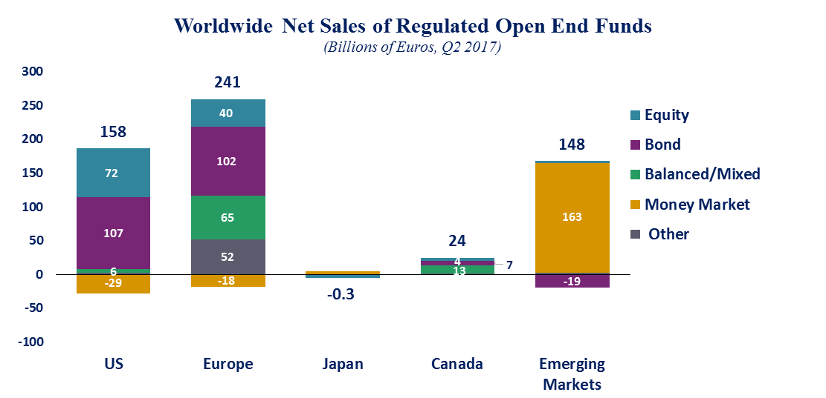

On the European market, long-term funds attracted net sales of EUR 259 billion, up from EUR 202 billion in the first quarter of 2017. Equity funds recorded net sales of EUR 40 billion, compared to EUR 20 billion in the previous quarter. Bond funds recorded net sales of EUR 102 billion, compared to EUR 79 billion in the previous quarter. Net sales into balanced/mixed funds amounted to EUR 65 billion, up from EUR 52 billion in Q1 2017. Money market funds recorded net outflows of EUR 18 billion, compared to net inflows of EUR 52 billion in the previous quarter.

On the US market, long-term open-ended funds recorded net sales of EUR 186 billion, compared to EUR 227 billion in the first quarter of 2017. Equity funds recorded net sales of EUR 72 billion compared to EUR 86 billion in Q1 2017. Bond funds decreased from EUR 122 billion in Q1 2017 to EUR 107 billion in Q2 2017. Net sales of balanced/mixed funds amounted to EUR 6 billion, compared to EUR 18 billion in the first quarter of 2017. Money market funds posted net outflows of EUR 29 billion, compared to net outflows of EUR 61 billion in the previous quarter.

Regional Summary Table by Type of Fund, Q2 2017

Note: Includes funds-of-funds, ETFs and institutional funds in the totals and underlying categories. All funds are open-ended (i.e. redeemable), substantively-regulated and domiciled in the reporting country. New Zealand and Trinidad and Tobago include home and foreign domiciled funds.

All data presented in this report include funds of funds, exchange-traded funds and institutional funds.

