***This release and additional tables***

***of international statistics are***

***available on efama’s website***

***(***[***www.efama.org***](http://www.fefsi.org)***).***

## Worldwide Regulated Open-ended Fund Assets and Flows

**Trends in the First Quarter of 2019**

**Brussels, June 25, 2019 –** Worldwide regulated open-ended fund assets increased by 9.2 percent to EUR 48.02 trillion in Q1 2019.[1] Worldwide net cash flow to all funds amounted to EUR 304 billion, compared to EUR 118 billion in Q4 2018.

The information presented in this report was compiled by EFAMA and the Investment Company Institute (ICI) on behalf of the International Investment Funds Association (IIFA), an organization of national investment fund associations. Statistics from 47 countries are included in this report.

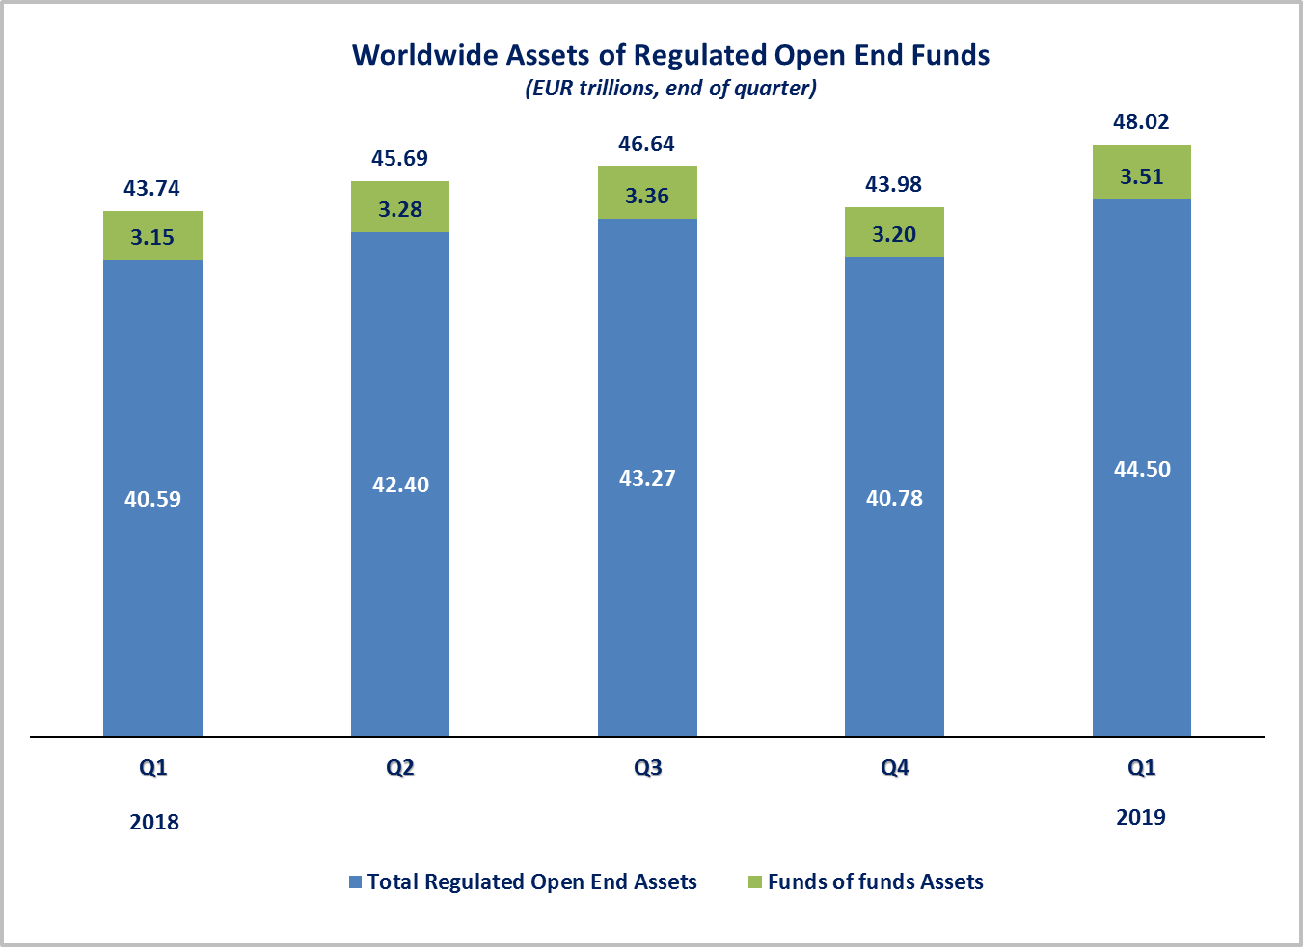

Measured in U.S. dollars, worldwide investment fund net assets increased to USD 53.9 trillion at the end of Q1 2019. This represented an increase of 7.1 percent, compared to an increase of 6.8 percent on a euro-denominated basis. The following two graphs compare the net asset growth in the seven largest countries/regions.

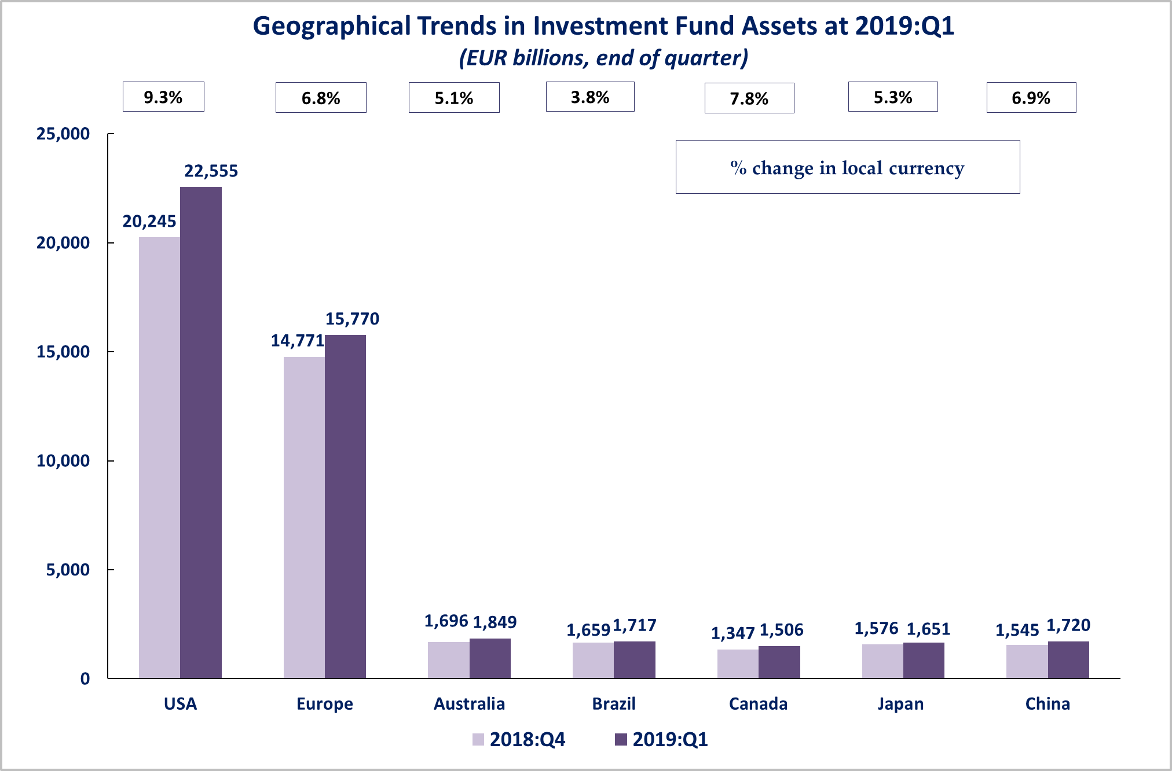



On a euro-denominated basis, all fund categories recorded net asset growth. Equity fund net assets increased 13.1 percent to EUR 20.0 trillion at the end of Q1 2019. Bond funds rose 6.7 percent to EUR 10.0 trillion. Balanced/mixed fund assets amounted to EUR 8.2 trillion, an increase of 8.8 percent. Net assets of money market funds and real estate funds registered increases of 3.2% and 3.6%, respectively.



At the end of Q1 of 2019, 41.5 percent of worldwide regulated open-ended fund net assets were held in equity funds. The net asset share of bond funds was 20.7 percent and the net asset share of balanced/mixed funds was 17.1 percent. Money market fund net assets represented 11.4 percent of the worldwide total.

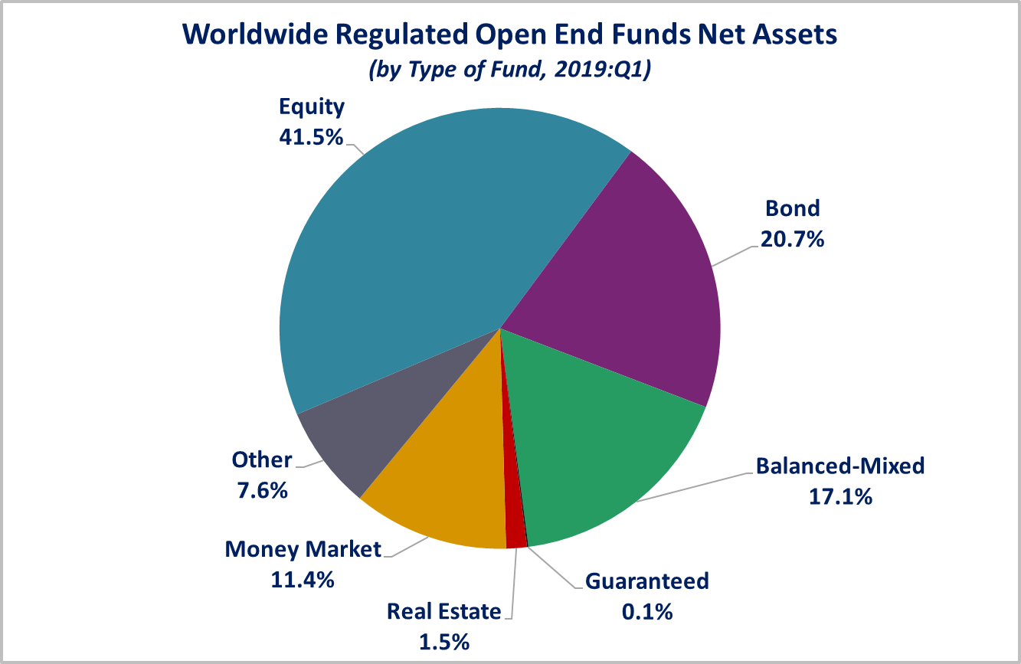

Looking at the worldwide distribution of investment fund net assets at end Q1 2019, the United States and Europe held the largest shares in the world market, with 47.0 percent and 32.8 percent, respectively. Australia (3.9%), Brazil (3.6%), China (3.6%), Japan (3.4%), Canada (3.1%), Rep. of Korea (1.0%), India (0.6%) and South Africa (0.4%) follow in this ranking.

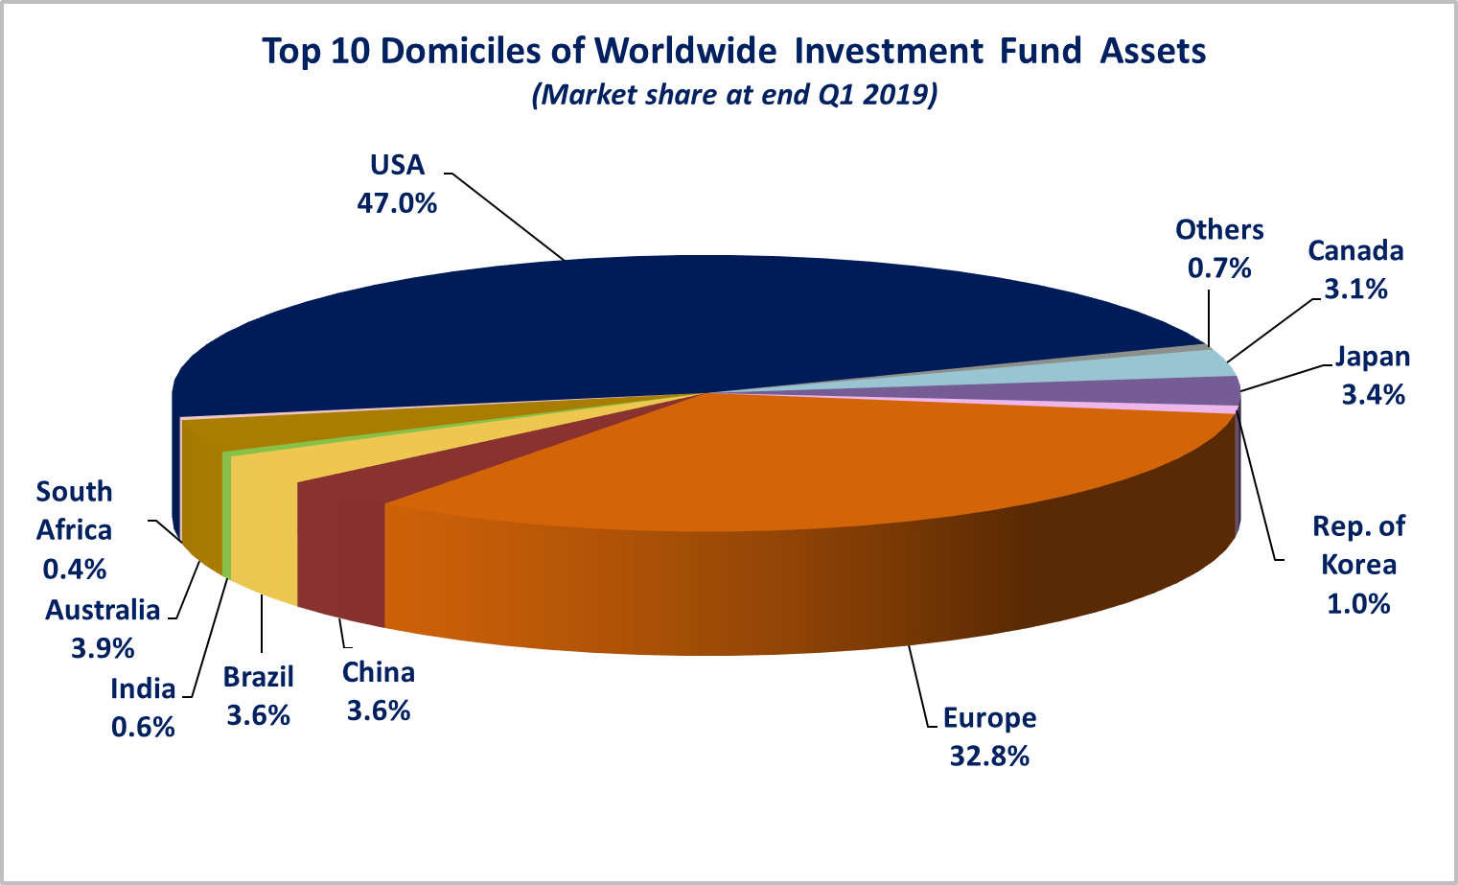

Overall, five European countries ranked among the top ten largest fund domiciles: Luxembourg (with 9.1 percent of worldwide investment fund assets), Ireland (5.5%), Germany (4.5%), France (3.9%), and the United Kingdom (3.4%).

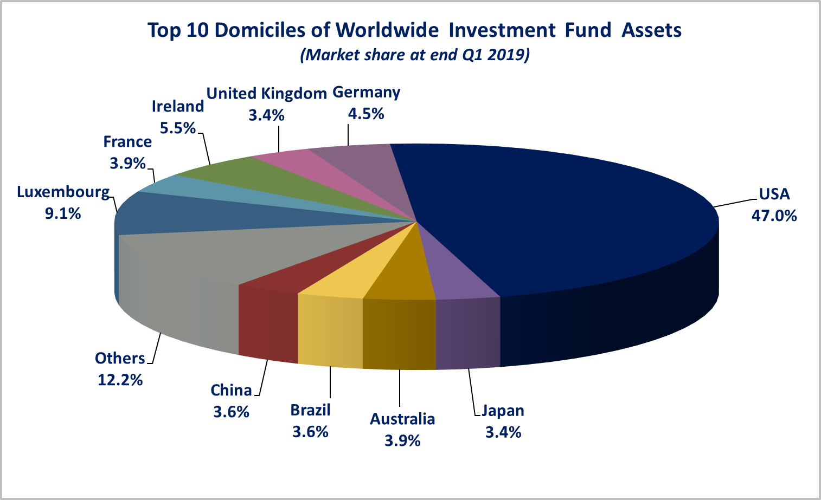

Net sales of regulated worldwide open-ended funds amounted to EUR 304 billion in Q1 2019, compared to EUR 118 billion in Q4 2018. Long-term funds recorded net sales of EUR 271 billion, up from EUR 46 billion in the previous quarter. Worldwide, Bond funds recorded net inflows of EUR 236 billion, compared to net outflows of EUR 59 billion in the previous quarter. Balanced/mixed funds registered net inflows of EUR 23 billion, compared to net outflows of EUR 7 billion in Q4 2018. Net sales of money market funds amounted to EUR 34 billion, down from EUR 72 billion last quarter. Equity funds recorded net outflows of EUR 22 billion, compared to net inflows of EUR 99 billion in Q4 2018.

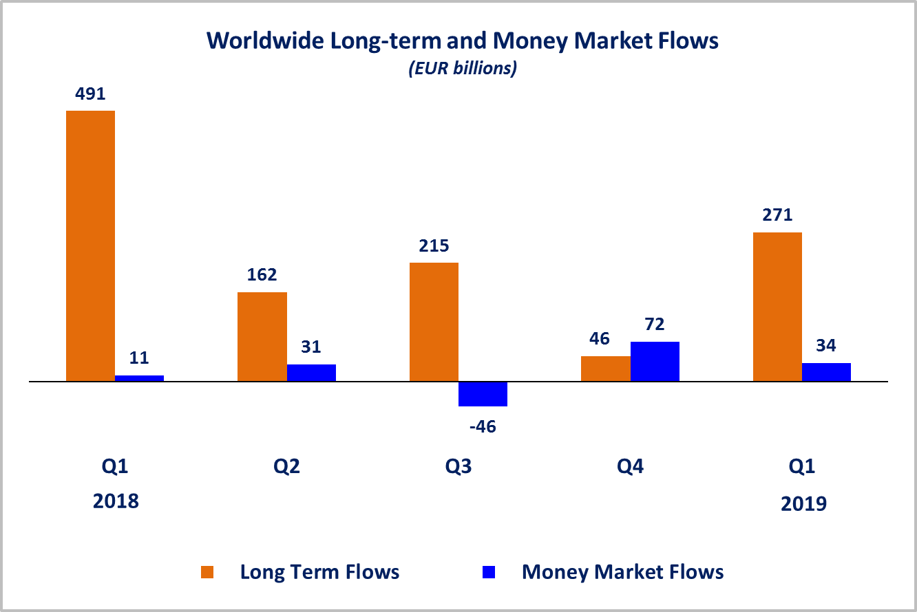Net sales of regulated open-ended funds reached EUR 171 billion in the United States, EUR 52 billion in Europe, EUR 31 billion in the emerging markets[2] (of which EUR 13 billion in Brazil and EUR 12 billion China) and EUR 50 billion in the other advanced economies[3] (of which EUR 19 billion in Korea, EUR 14 billion in Canada and EUR 11 billion in Japan). Most regions experienced an increase in net sales compared to Q4 2018, mostly due to strong sales of bond funds.

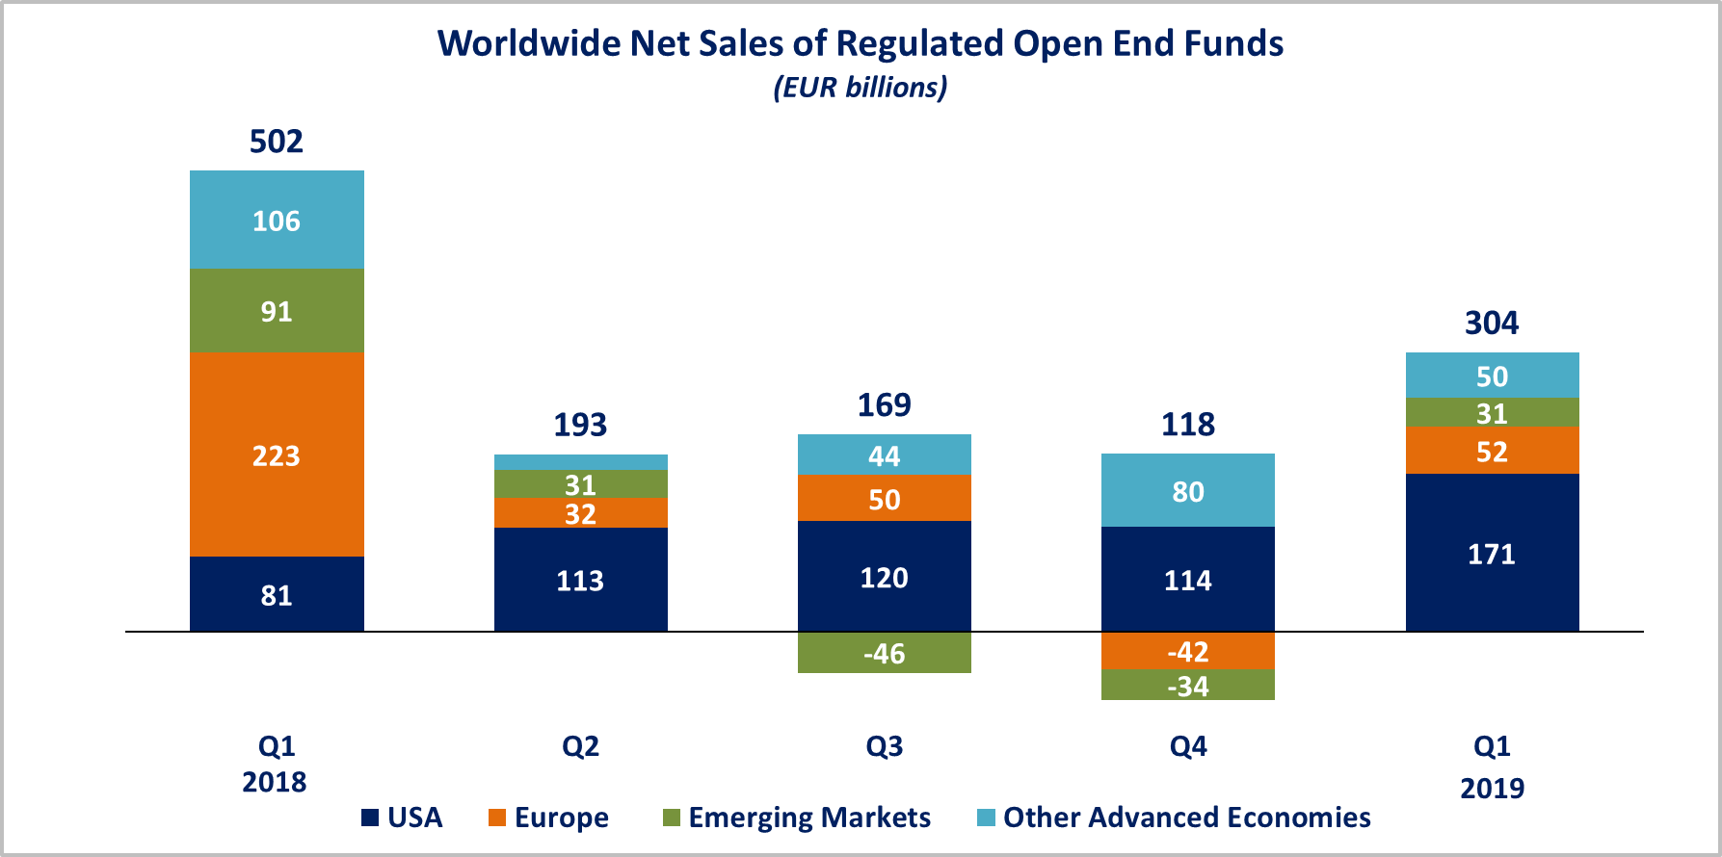

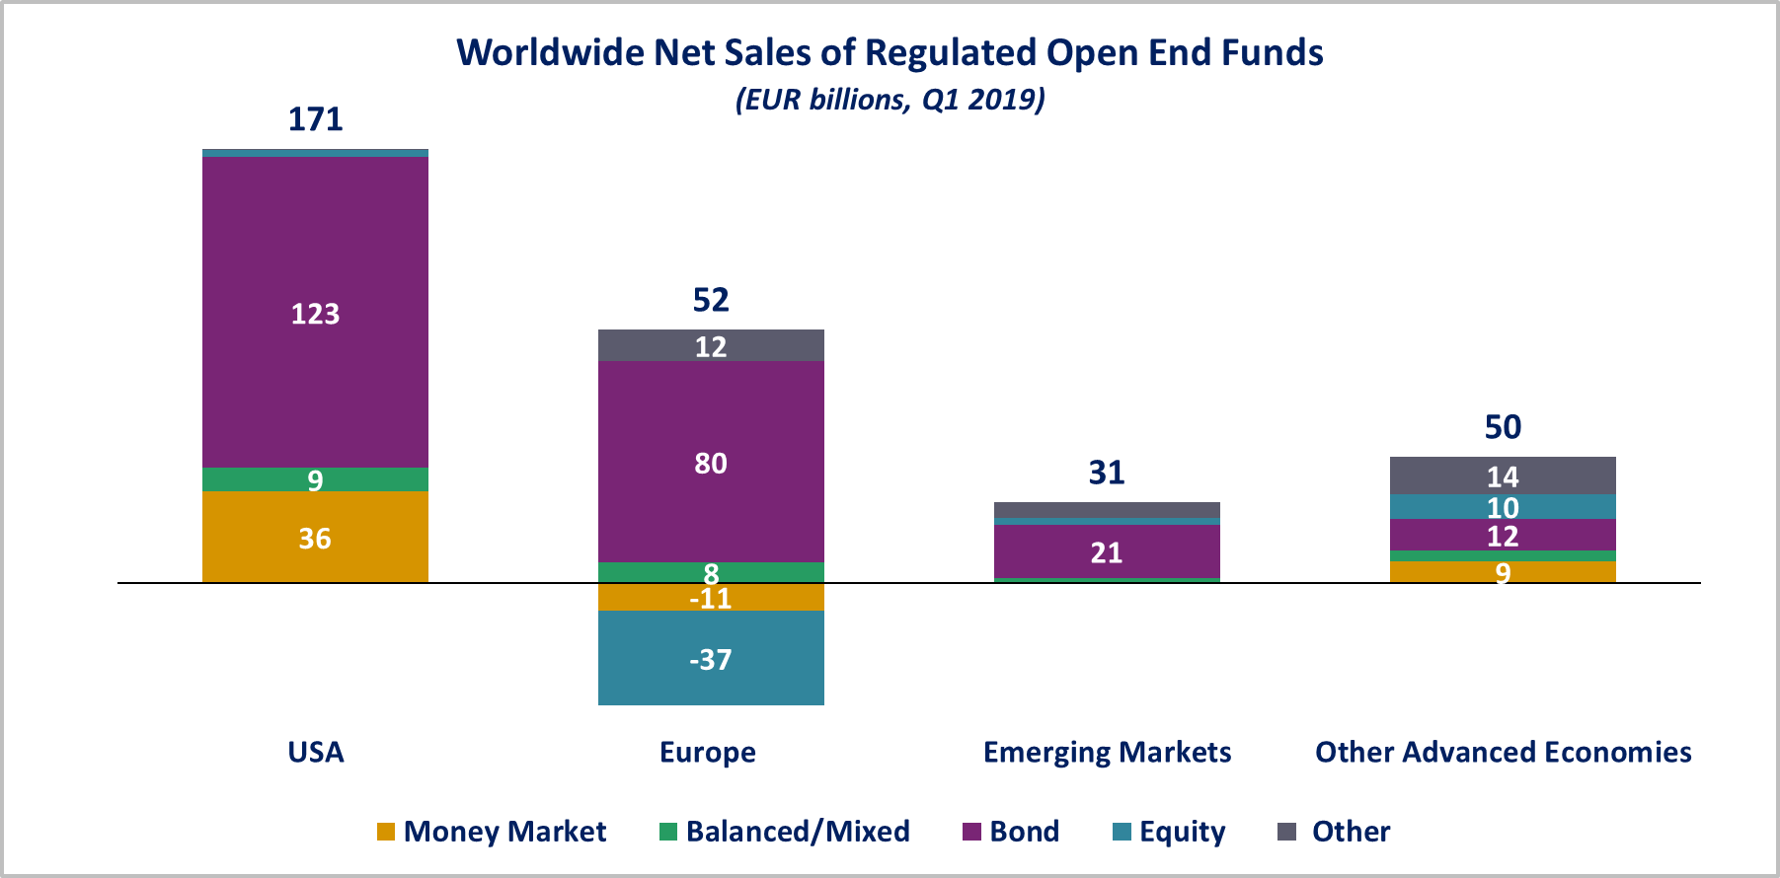

In Europe, long-term funds registered net inflows of EUR 63 billion, compared to net outflows of EUR 62 billion in Q4 2018. Equity funds recorded net outflows of EUR 38 billion, compared to net outflows of EUR 1 billion in the previous quarter. Bond funds recorded net inflows of EUR 80 billion, compared to net outflows of EUR 45 billion in Q4 2018. Balanced/mixed funds registered net inflows of EUR 8 billion, compared to net outflows of EUR 7 billion in the previous quarter. Money market funds recorded net outflows of EUR 11 billion, compared to net inflows of EUR 20 billion in Q4 2018.

In the United States, long-term open-ended funds recorded net inflows of EUR 135 billion in Q1 2019, compared to net outflows of EUR 36 billion in Q4 2018. Net sales of equity funds decreased from EUR 24 billion in Q4 2018 to EUR 3 billion in Q1 2019. Bond funds recorded net inflows of EUR 123 billion, compared to net outflows of EUR 49 billion in the previous quarter. Balanced/mixed funds registered net inflows of EUR 9 billion, compared to net outflows of EUR 13 billion in Q4 2018. Money market funds recorded net sales EUR 36 billion, down from EUR 150 billion in the previous quarter.

**Regional Summary Table by Type of Fund, Q1 2019**



1. All data presented in this report include funds of funds, exchange-traded funds and institutional funds.
2. Emerging markets are countries thus defined by the International Monetary Fund, based on criteria such as per capita income level and the degree of integration into the global financial system. Data is not available for all emerging markets. The following countries are included: Argentina, Brazil, Chile, China, Costa Rica, India, Mexico, Pakistan, the Philippines, South Africa and Trinidad & Tobago.
3. Other advanced economies are countries thus defined by the International Monetary Fund, excluding the US and the countries included in the Europe aggregate. Data is not available for all advanced economies. Other advanced economies include Australia, Canada, Japan, Korea, New Zealand and Chinese Taipei (Taiwan).