***This release and additional tables***

***of international statistics are***

***available on efama’s website***

***(***[***www.efama.org***](http://www.fefsi.org)***).***

## Worldwide Regulated Open-ended Fund Assets and Flows

**Trends in the First Quarter of 2018**

**Brussels, June 21, 2018 –** Worldwide regulated open-ended fund assets decreased by 1.3 percent to EUR 43.74 trillion in the first quarter of 2018.[1] Worldwide net cash flow to all funds amounted to EUR 502 billion, compared to EUR 635 billion in the fourth quarter of 2017.

The information presented in this report was compiled by EFAMA and the Investment Company Institute (ICI) on behalf of the International Investment Funds Association (IIFA), an organization of national investment fund associations. Statistics from 47 countries are included in this report.

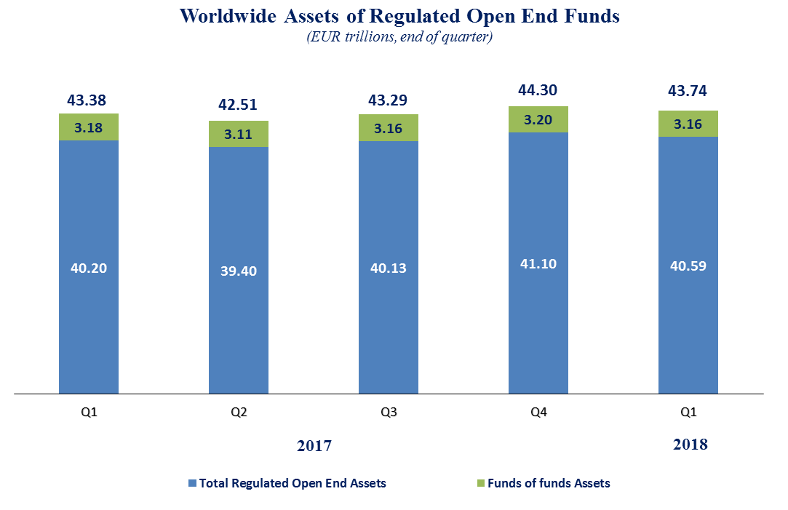

Measured in U.S. dollars, worldwide investment fund net assets increased to USD 53.9 trillion at the first quarter of 2018. This represented an increase of 1.5 percent, compared to a decrease of 1.3 percent on a euro-denominated basis. The following two graphs compare the net asset growth in the six largest countries/regions.

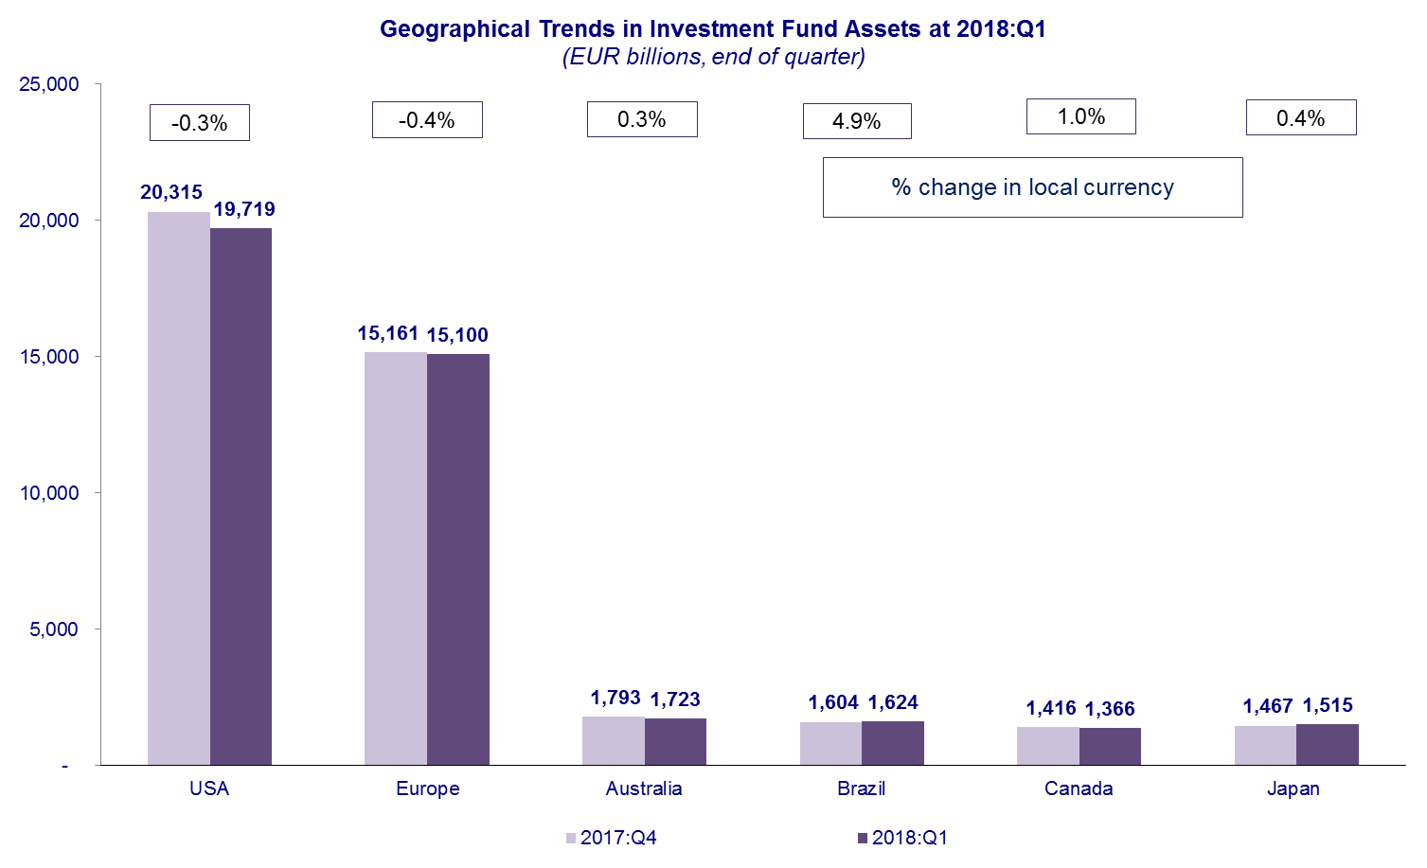



On a euro-denominated basis, equity fund net assets decreased 2.1 percent to EUR 18.0 trillion at the first quarter of 2018. Bond funds decreased slightly to EUR 9.0 trillion. Balanced/mixed fund assets decreased 1.7 percent to EUR 7.7 trillion, and money market fund assets remained stable at EUR 4.9 trillion.



At the first quarter of 2018, 41 percent of worldwide regulated open-ended fund net assets were held in equity funds. The net asset share of bond funds was 21 percent and the net asset share of balanced/mixed funds was 18 percent. Money market fund net assets represented 11 percent of the worldwide total.

**Worldwide Regulated Open End Funds Net Assets**

**by Type of Fund, 2018:Q1**

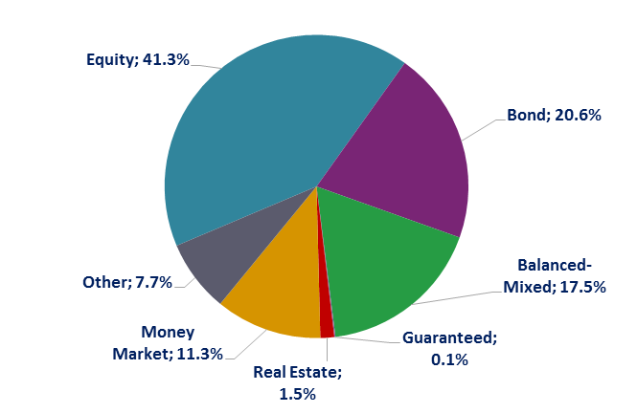

Looking at the worldwide distribution of investment fund net assets at end Q1 2018, the United States and Europe held the largest shares in the world market, with 45.1 percent and 34.5 percent, respectively. Australia (3.9%), Brazil (3.7%), China (3.6%), Japan (3.5%), Canada (3.1%), Rep. of Korea (0.9%), India (0.6%) and South Africa (0.4%) follow in this ranking.

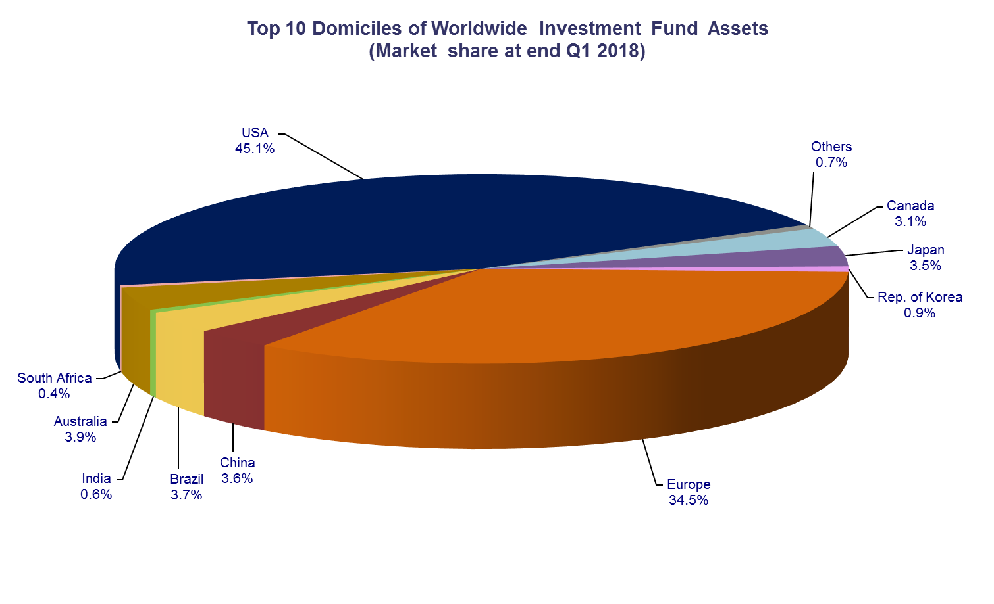

Overall, five European countries ranked among the top ten largest fund domiciles: Luxembourg (with 9.5 percent of worldwide investment fund assets), Ireland (5.5%), Germany (4.6%), France (4.4%), and the United Kingdom (3.7%).

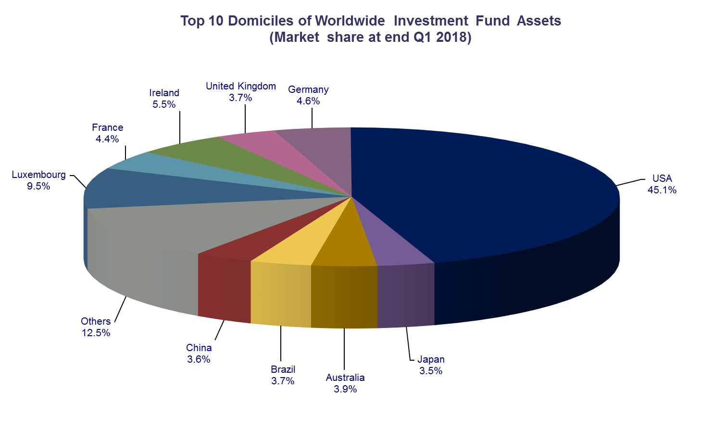

Net sales of regulated worldwide open-ended funds amounted to EUR 502 billion in the first quarter of 2018, compared to EUR 635 billion in the last quarter of 2017. Long-term funds recorded net sales of EUR 490 billion, down from EUR 523 billion in the previous quarter. Globally, equity funds recorded net sales of EUR 217 billion, compared to EUR 245 billion in Q4 2017. Bond funds recorded net sales of EUR 119 billion, down from EUR 138 billion in the previous quarter. Net sales into balanced/mixed funds worldwide totalled EUR 92 billion, down from EUR 112 billion last quarter. Finally, net flows of money market funds fell to EUR 12 billion, from EUR 112 billion in the previous quarter.

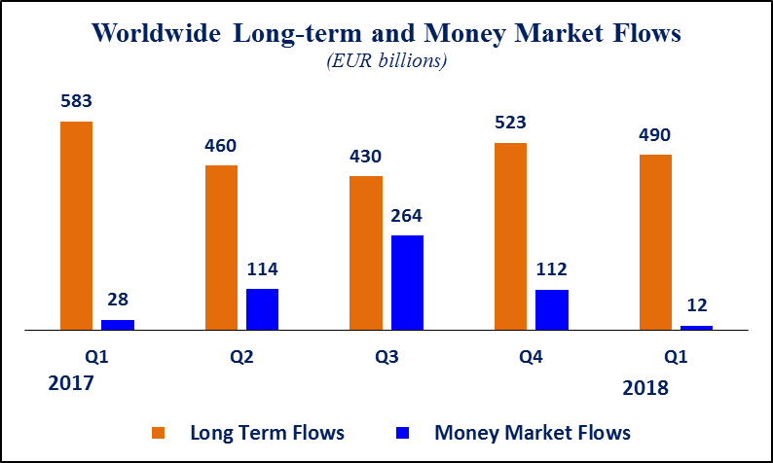Net sales of regulated open-ended funds reached EUR 223 billion in Europe, EUR 81 billion in the United States, EUR 91 billion in emerging markets (of which EUR 62 billion in China), EUR 62 billion in Japan, and EUR 27 billion in Canada. Europe, Japan and emerging markets all experienced an increase in net sales compared to Q4 2017, whereas the United States and Canada registered a decrease in net sales.

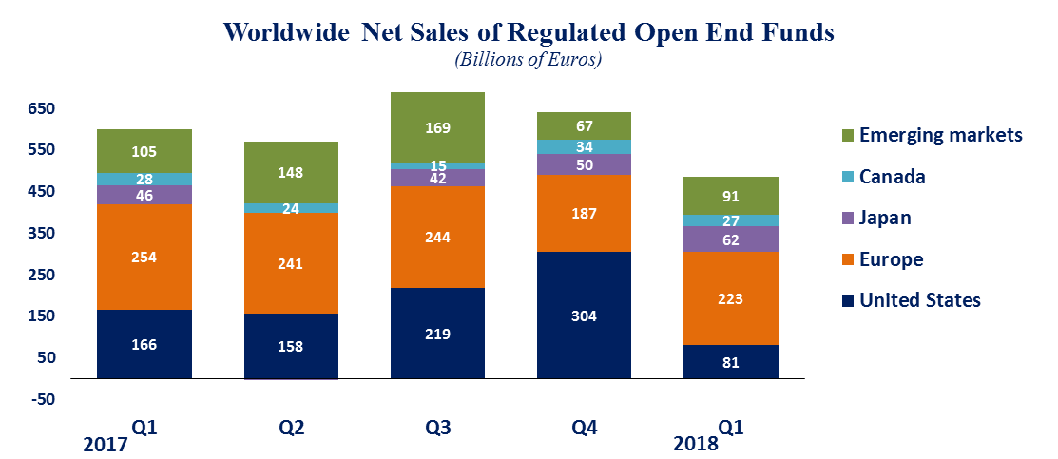

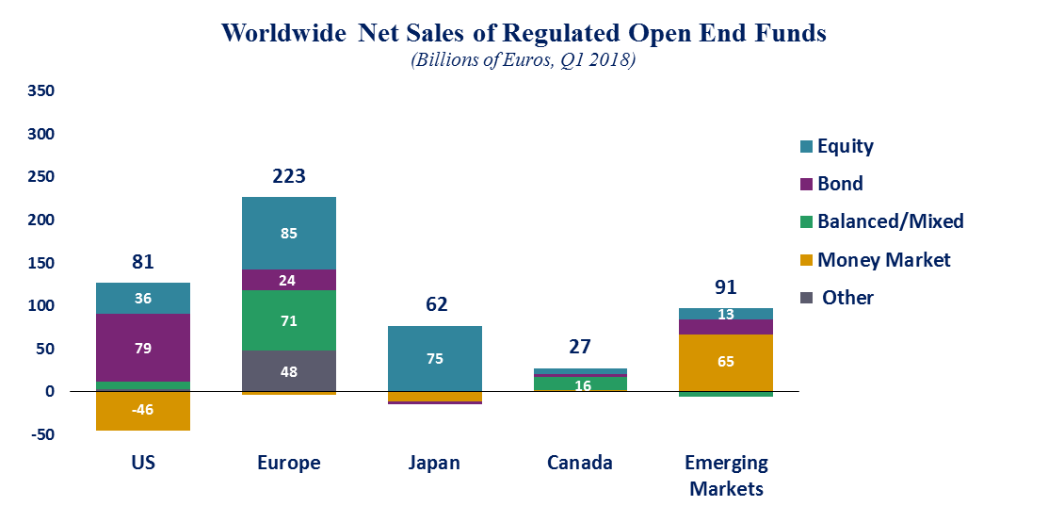

In Europe, long-term funds attracted net sales of EUR 227 billion, up from EUR 190 billion in the fourth quarter of 2017. Equity funds recorded net sales of EUR 85 billion, compared to EUR 69 billion in the previous quarter. Bond funds recorded net sales of EUR 24 billion, compared to EUR 39 billion in in Q4 2017. Net sales into balanced/mixed funds amounted to EUR 71 billion, up from EUR 63 billion in the previous quarter. Money market funds recorded net outflows of EUR 3.6 billion, compared to net outflows of EUR 3.4 billion in the last quarter of 2017.

In the United States, long-term open-ended funds recorded net sales of EUR 127 billion, compared to EUR 220 billion in the fourth quarter of 2017. Equity funds recorded net sales of EUR 36 billion, compared to EUR 98 billion in Q4 2017. Bond funds decreased from EUR 92 billion in Q4 2017 to EUR 79 billion in Q1 2018. Net sales of balanced/mixed funds amounted to EUR 9 billion, down from EUR 32 billion in the last quarter of 2017. Money market funds posted net outflows of EUR 46 billion, compared to net inflows of EUR 84 billion in the previous quarter.

**Regional Summary Table by Type of Fund, Q1 2018**



1. All data presented in this report include funds of funds, exchange-traded funds and institutional funds.