This release and additional tables
of international statistics are
available on efama’s website
(www.efama.org).

Worldwide Regulated Open-ended Fund Assets and Flows
Trends in the First Quarter of 2017

Brussels, June 27, 2017 – Worldwide regulated open-ended fund assets increased 4.6 percent to EUR 43.19 trillion in the first quarter of 2017. Worldwide net cash flow to all funds increased to EUR 605 billion, compared to EUR 388 billion in the fourth quarter of 2016.

The information presented in this report was compiled by EFAMA and the Investment Company Institute (ICI) on behalf of the International Investment Funds Association (IIFA), an organization of national investment fund associations. Statistics from 47 countries are included in this report.

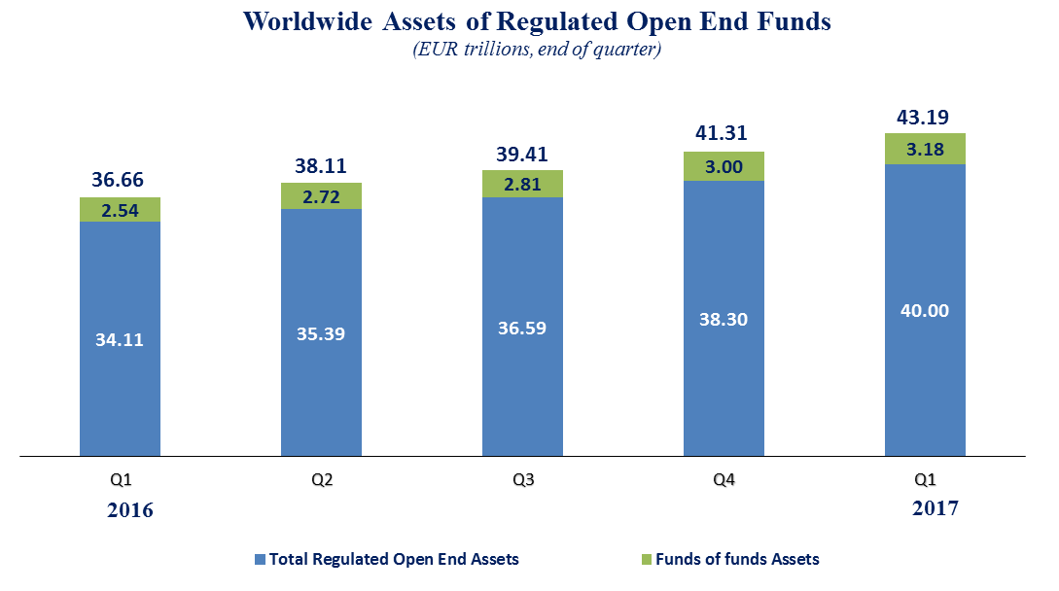

Measured in U.S. dollars, worldwide investment fund net assets reached USD 46.17 trillion at the end of Q1 2017. This represented an increase of 6.0 percent, compared to an increase of 4.6 percent on a euro-denominated basis. The following two graphs compare the net asset growth in the six largest countries/regions.

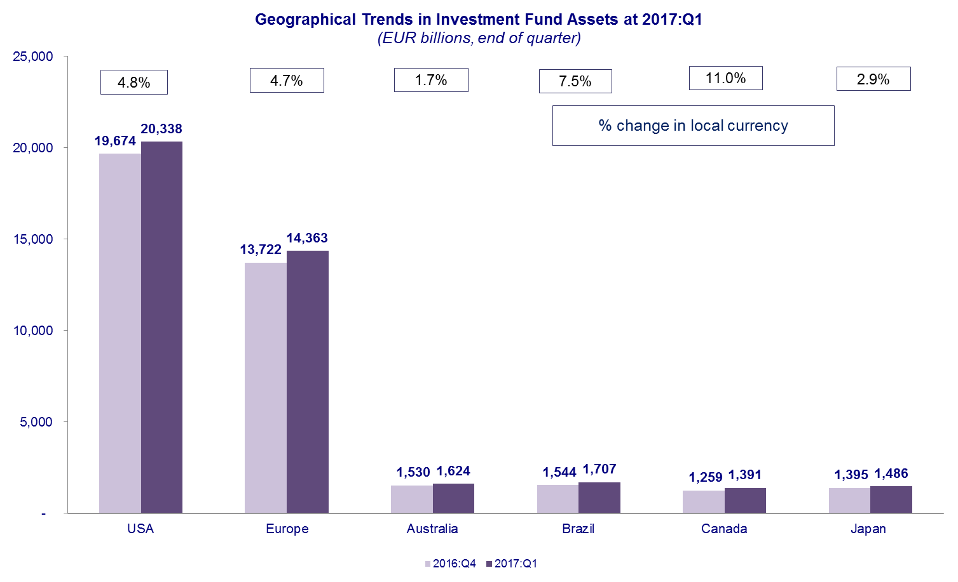

On a euro–denominated basis, equity fund net assets increased 6.8 percent to EUR 17.6 trillion at the end of Q1 2017. Bond funds net assets increased 4.7 percent to EUR 9.3 trillion. Balanced/mixed fund assets increased 4.9 percent to EUR 7.7 trillion, and money market fund assets decreased 1.0 percent to EUR 4.8 trillion.

At the end of Q1 2017, 41 percent of worldwide regulated open-ended fund net assets were held in equity funds. The net asset share of bond funds was 21 percent and the net asset share of balanced/mixed funds was 18 percent. Money market fund net assets represented 11 percent of the worldwide total.

Worldwide Regulated Open End Funds Net Assets
by Type of Fund, 2017:Q1
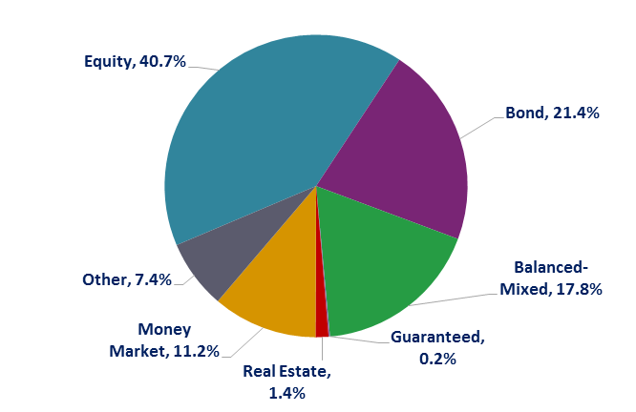

Looking at the worldwide distribution of investment fund net assets at end Q1 2017, the United States and Europe held the largest shares in the world market, with 47.1 percent and 33.3 percent respectively. Brazil (4.0%), Australia (3.8%), Japan (3.4%), Canada (3.2%), China (2.7%), Rep. of Korea (0.9%), India (0.5%) and South Africa (0.4%) follow in this ranking.
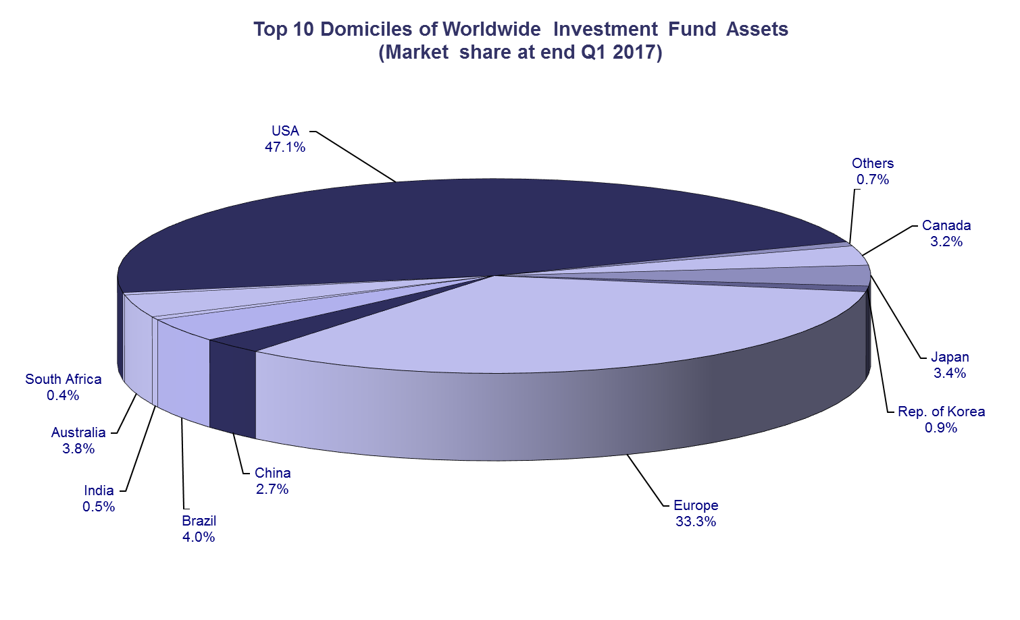

Overall, five European countries ranked among the top ten largest fund domiciles: Luxembourg (with 9.0 percent of worldwide investment fund assets), Ireland (5.1%), Germany (4.5%), France (4.4%), and the United Kingdom (3.6%).
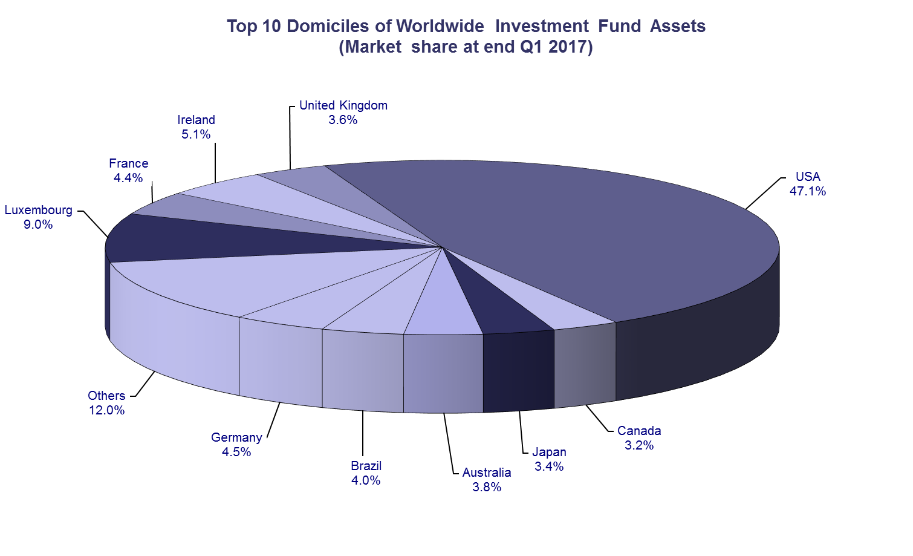
Net sales of regulated worldwide open-ended funds amounted to EUR 605 billion in the first quarter of 2017, compared to EUR 388 billion in the last quarter of 2016. Long-term funds recorded net sales of EUR 578 billion, up from EUR 299 billion in the previous quarter. Globally, equity funds recorded net inflows of EUR 161 billion, compared to EUR 114 billion in Q4 2016. Bond funds recorded net inflows of EUR 252 billion, compared to EUR 88 billion in the previous quarter. Net inflows into balanced/mixed funds worldwide totalled EUR 101 billion, up from EUR 64 billion last quarter. Finally, net flows of money market funds equalled EUR 28 billion, compared to EUR 89 billion in the previous quarter.
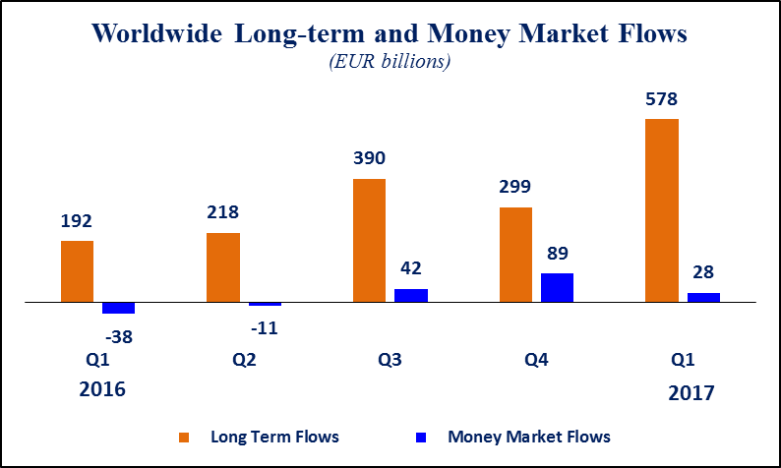
Net sales of regulated open-ended funds reached EUR 254 billion in Europe, EUR 163 billion in the United States, EUR 105 billion in emerging markets, EUR 46 billion in Japan, and EUR 25 billion in Canada. In Q1 2017, increases in net sales were seen in Europe, the US and the emerging markets in large part thanks to strong sales of bond funds.

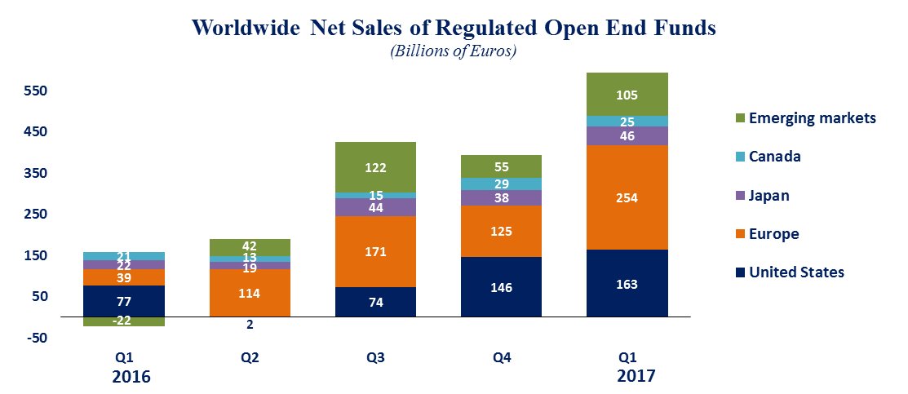

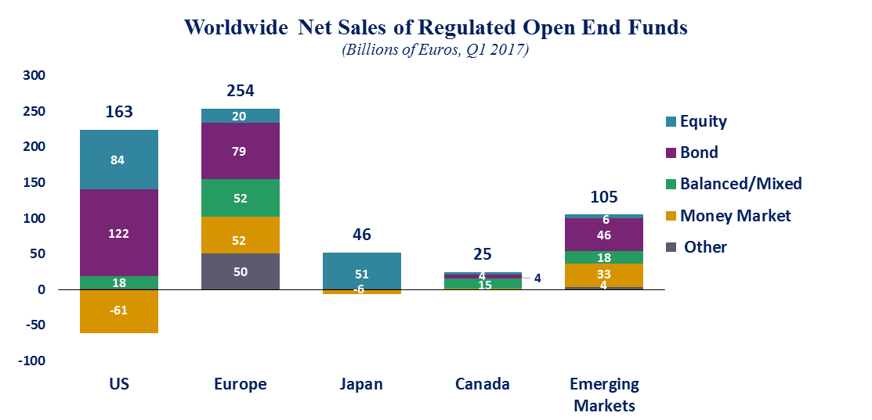

On the European market, long-term funds attracted net inflows of EUR 202 billion, up from EUR 87 billion in the fourth quarter of 2016. Equity funds recorded net sales of EUR 20 billion, compared to net sales of EUR 9 billion in the previous quarter. Bond funds recorded net inflows of EUR 79 billion, compared to EUR 14 billion in the previous quarter. Net inflows into balanced/mixed funds amounted to EUR 52 billion, up from the EUR 33 billion in Q4 2016. Money market funds recorded net flows of EUR 52 billion, compared to EUR 38 billion in the previous quarter.

On the US market, long-term open-ended funds recorded net inflows of EUR 224 billion, compared to EUR 95 billion in the fourth quarter of 2016. Equity funds recorded net sales of EUR 84 billion compared to EUR 77 billion in Q4 2016. Bond funds also experienced a boost in demand, increasing from EUR 21 billion in Q4 2016 to EUR 122 billion in Q4 2016. Net inflows into balanced/mixed funds amounted to EUR 18 billion, compared to EUR 5 billion in the fourth quarter of 2016. Money market funds posted net outflows of EUR 61 billion, compared to net inflows of EUR 51 billion in the previous quarter.

Regional Summary Table by Type of Fund, Q1 2017

Note: Includes funds-of-funds, ETFs and institutional funds in the totals and underlying categories. All funds are open-ended (i.e. redeemable), substantively-regulated and domiciled in the reporting country. New Zealand and Trinidad and Tobago include home and foreign domiciled funds.

All data presented in this report include funds of funds, exchange-traded funds and institutional funds.

