|  |
| --- |
| ***Quarterly Statistical Release*** |

**September 2018 N° 74**

***This release and other statistical***

***releases are available on Efama’s***

***website (***[***www.efama.org***](http://www.efama.org)***)***

***Trends in the European Investment Fund Industry***

***in the Second Quarter of 2018***

|  |
| --- |
| **This report was prepared by Bernard Delbecque and Thomas Tilley**  **EFAMA**  **The European Fund and Asset Management Association**  **Rue Montoyer 47 - B-1000 BRUXELLES - Tel. 32-2-513.39.69 Fax: 32-2-513.26.43 - e-mail: info@efama.org** |

**Trends in the UCITS Market**

***Net Sales by Investment Type***

**UCITS recorded net inflows of EUR 15 billion during Q2 2018, compared to EUR 171 billion in the first quarter of 2018. In the first half of 2018, UCITS funds attracted EUR 186 billion in net new money, compared to EUR 379 billion in first 6 months of 2017.**

Long-term UCITS recorded net sales of EUR 33 billion in Q2 2018, down from EUR 173 billion in Q1 2018. Net sales of equity funds amounted to EUR 10 billion, compared to EUR 85 billion in Q1 2018. Net sales of multi-asset funds decreased from EUR 56 billion in the first quarter of 2018 to EUR 26 billion in Q2 2018. Bond funds shifted from net inflows of EUR 26 billion in Q1 to net outflows of EUR 1 billion in Q2 2018. Net sales of money market fund recorded net outflows of EUR 18 billion in Q2 2018, compared to net outflows of 2 billion in Q1 2018.

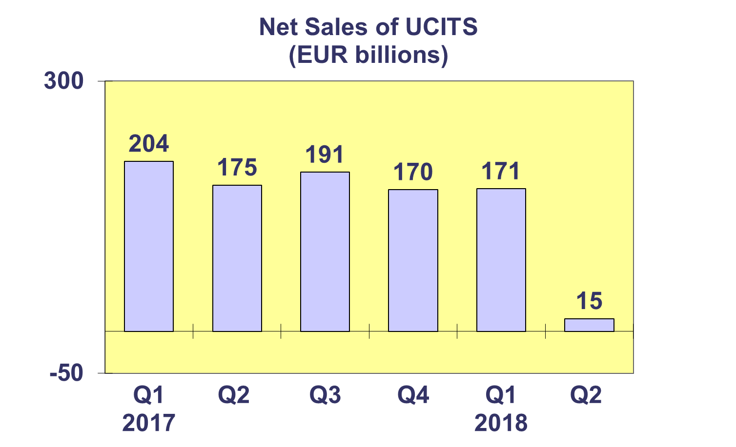

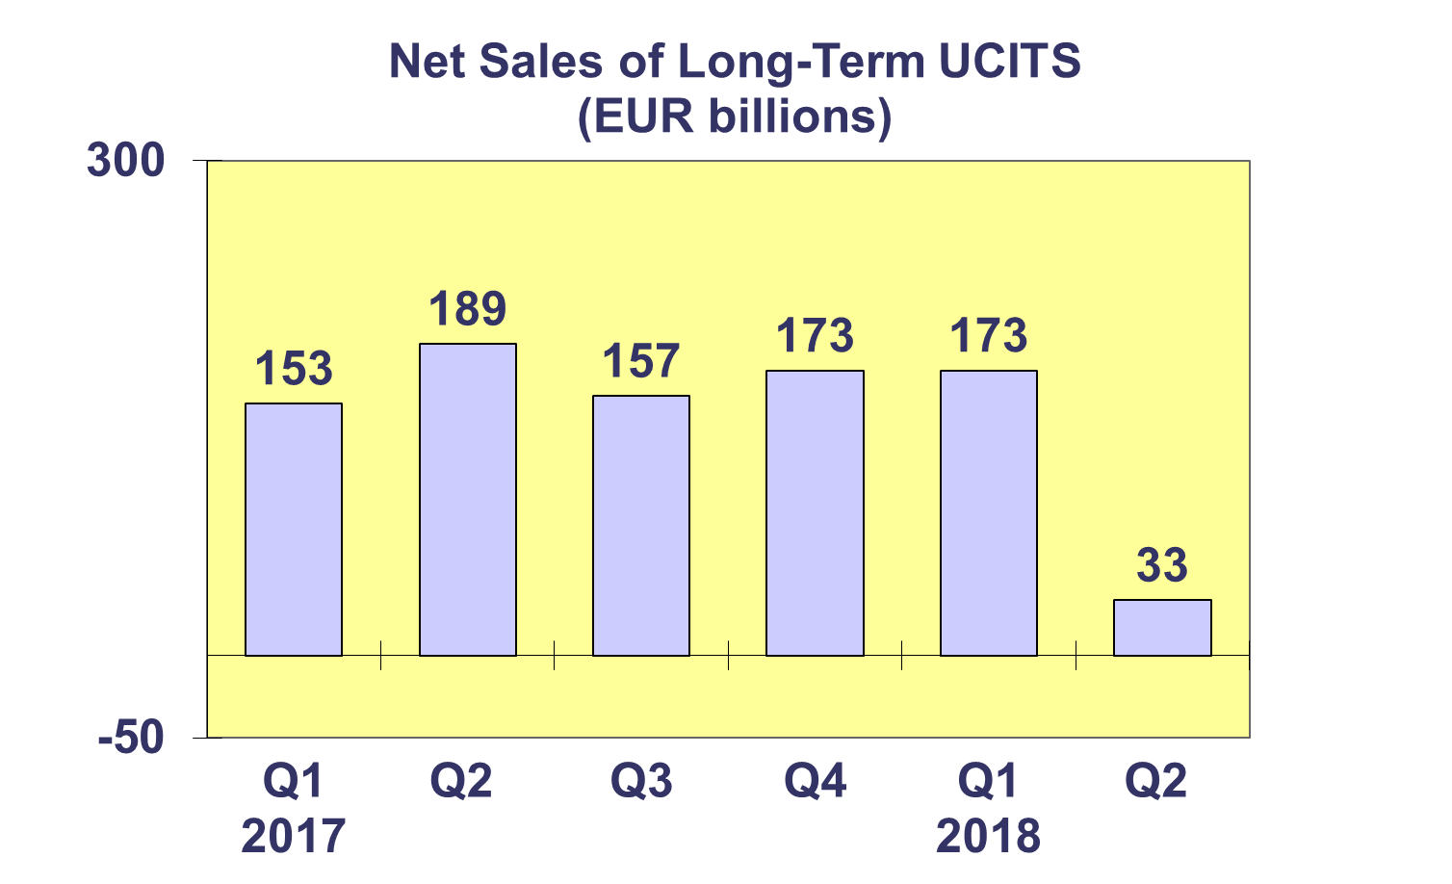

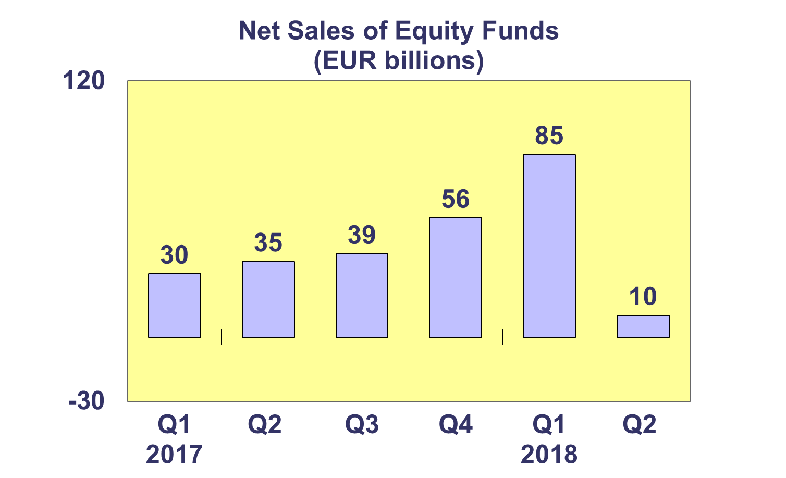

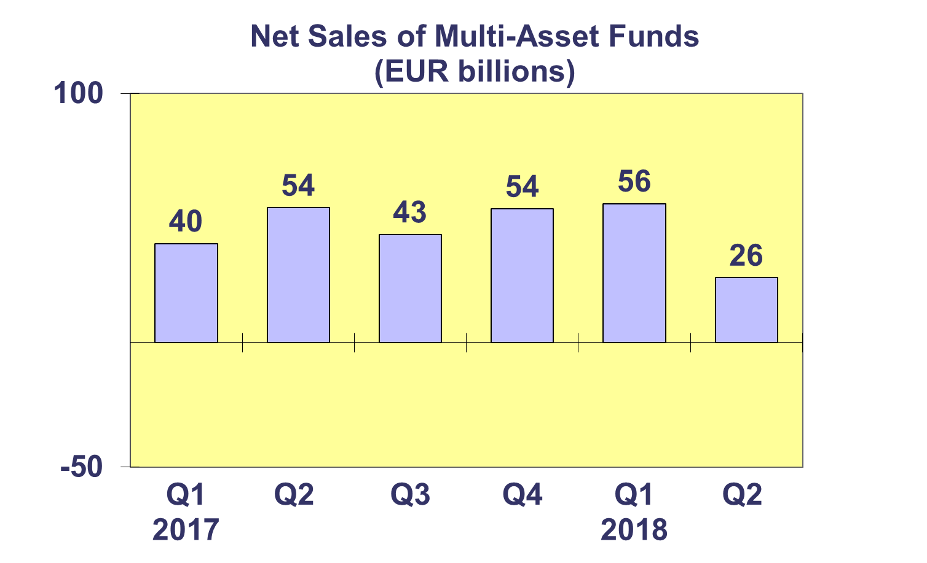

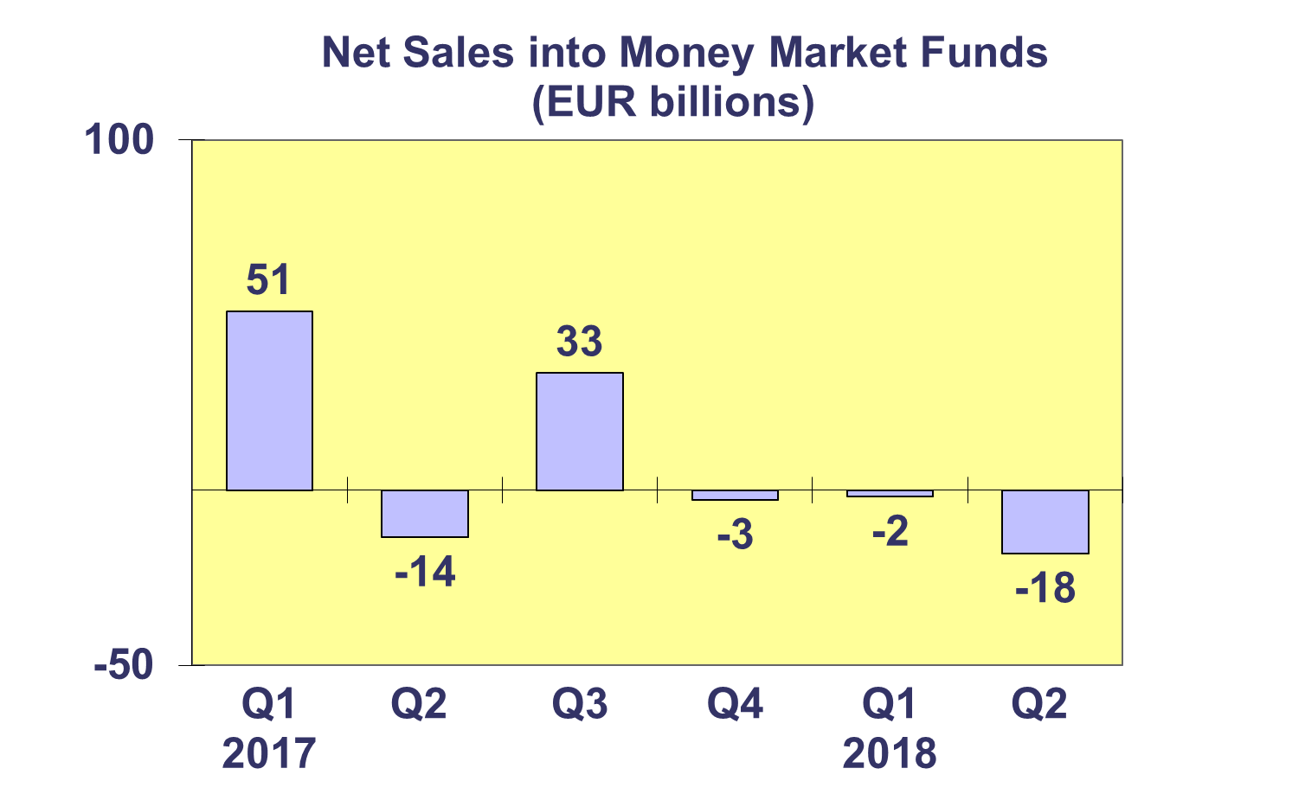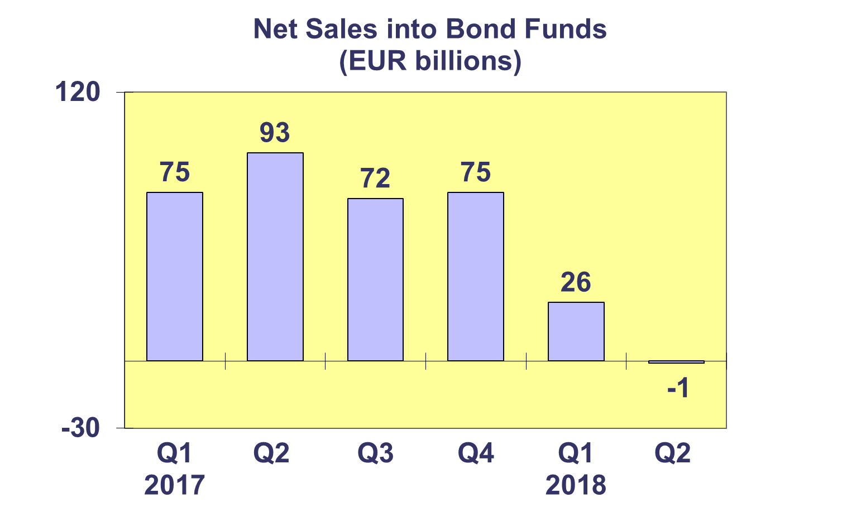**Trends in the UCITS Market**

***Net Sales by Country of Domiciliation and Investment Type***

**Fourteen countries registered net inflows into UCITS in the second quarter of 2018, with seven countries recording net inflows above EUR 1 billion.**

The largest net inflows into UCITS were recorded in Ireland (EUR 17 billion), mainly due to strong inflows into equity funds. Luxembourg took second place (EUR 5 billion), with inflows into equity funds as well as multi-asset funds. Spain registered net sales of EUR 3 billion, followed by Sweden (EUR 2 billion) and Norway (EUR 2 billion). The largest net outflows in Q2 2018 were recorded in France (EUR 9 billion), primarily due to withdrawals from money market funds.

So far in 2018, equity funds and multi-asset funds have attracted largest levels of net sales, EUR 96 billion and EUR 82 billion, respectively.

**Trends in the UCITS Market**

***Net Sales and Net Assets of ETF by Country of Domiciliation***

**Net sales of UCITS ETF registered net outflows of EUR 20 billion in Q2 2018, compared to net inflows of EUR 23 billion in the first quarter of 2018. UCITS ETF attracted net sales of EUR 3 billion so far this year.**

UCITS ETF domiciled in Ireland registered the largest net inflows during the quarter (EUR 5.7 billion). The largest net outflows were seen in France (EUR 23.6 billion). Looking at cumulative year-to-date net sales, Luxembourg has so far attracted the largest net inflows (EUR 23 billion), whereas France has experienced the largest net outflows (EUR 37 billion).



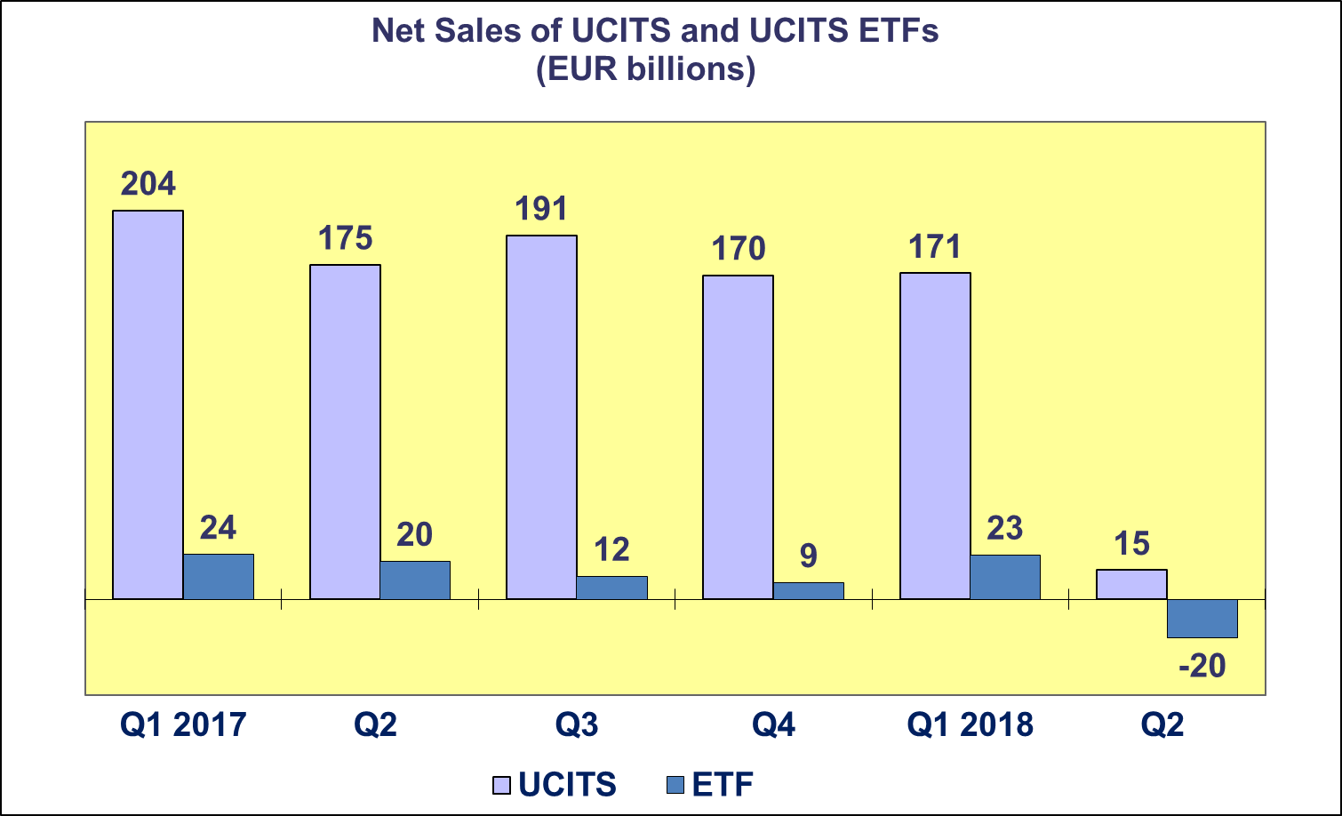

**Trends in the UCITS Market**

***Net Assets and Number of Funds by Investment Type***

**UCITS net assets increased by 1.5% in Q2 2018 to reach EUR 9,824 billion. Since the end of 2017, net assets of UCITS have increased 1%.**

Net assets of equity funds increased by 4.1% to reach EUR 3,833 billion. Multi-asset funds and other funds both grew 0.9% to reach EUR 1,819 billion and EUR 371 billion, respectively. Bond funds, money market funds and guaranteed funds, experienced net asset decreases of 0.6%, 0.4% and 13.2%, respectively.

The number of UCITS funds increased from 32,355 at end Q1 2018 to 32,733 at end Q2 2018.



**Trends in the UCITS Market**

***Net Assets by Country of Domiciliation***

**Sixteen domiciles recorded net asset growth in Q2 2018, with net assets of UCITS reaching EUR 9,824 billion.**

Among the major domiciles, the United Kingdom recorded the largest net asset growth (3.3%), followed by Ireland (2.9%), Germany (2.2%) and Luxembourg (2.0%).

Net asset growth was also seen in all Nordic countries, with the largest net asset increase in Sweden (4.0%), followed by Denmark (2.8%), Norway (2.4%) and Finland (0.8%). In Southern Europe, the largest net asset growth was recorded in Cyprus (13.6%), followed by Malta (2.4%) and Spain (1.9%). In Central and Eastern Europe, increases in net assets were recorded in Slovenia (2.9%), Bulgaria (2.7%) and Croatia (1.5%).



**Trends in the AIF Market**

***Net Sales by Investment Type***

**AIFs recorded net inflows of EUR 12 billion in Q2 2018, down from EUR 52 billion in Q1. So far in 2018, AIFs have garnered net sales of EUR 64 billion, compared to EUR 135 billion in the first half of 2017.**

Long-term AIFs recorded net sales of EUR 14 billion, down from EUR 53 billion in Q1 2018. Equity funds registered net outflows of EUR 10 billion in the second quarter of 2018, compared to net outflows of EUR 2 billion in Q1. Net sales of multi-asset funds reversed in Q2, from inflows of EUR 13 billion in Q1 to outflows of EUR 1 billion. Net outflows of bond funds amounted to EUR 6 billion at the end of the quarter, compared to EUR 4 billion in the previous quarter. Net sales of other funds decreased from EUR 37 billion in Q1 2018 to EUR 21 billion in Q2.

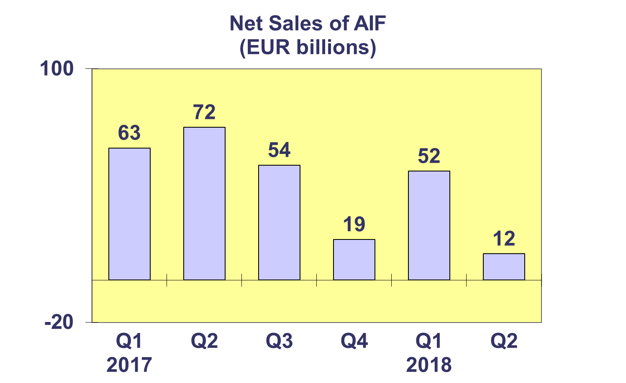

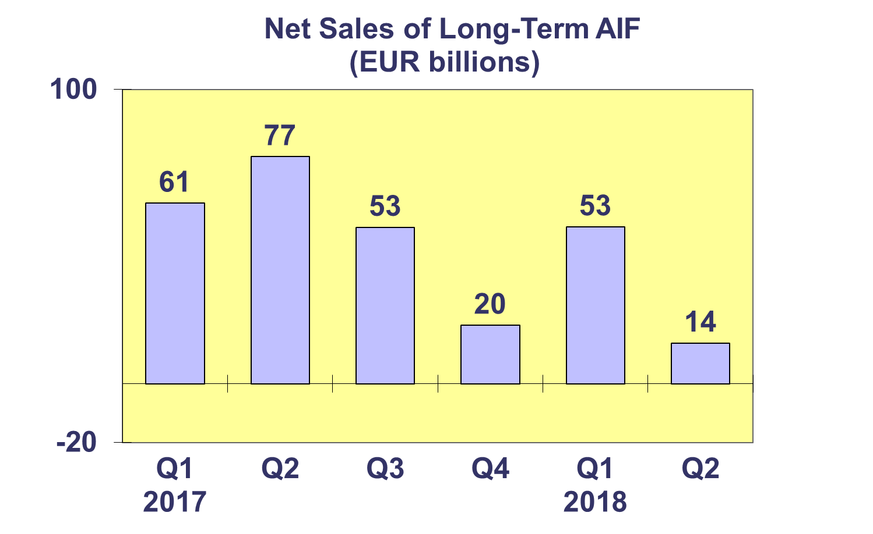

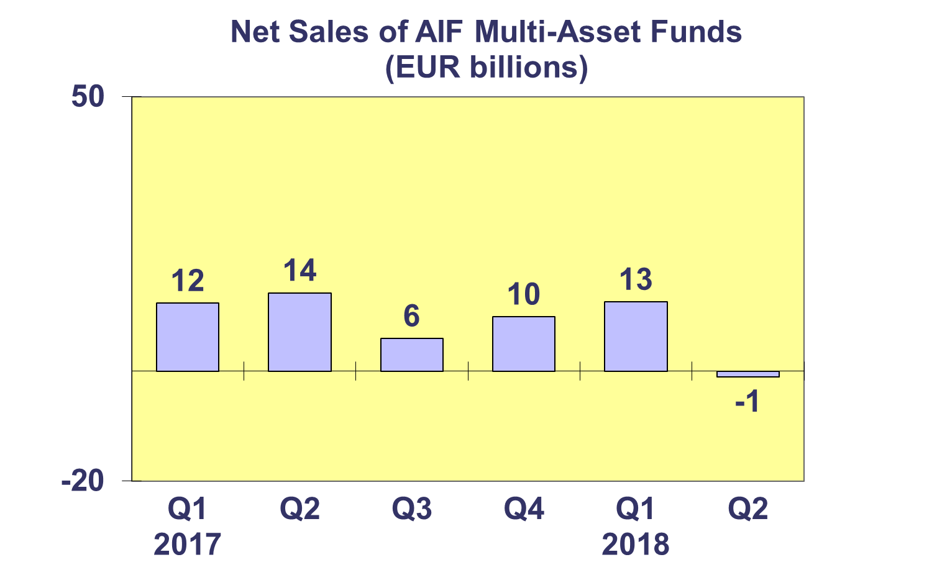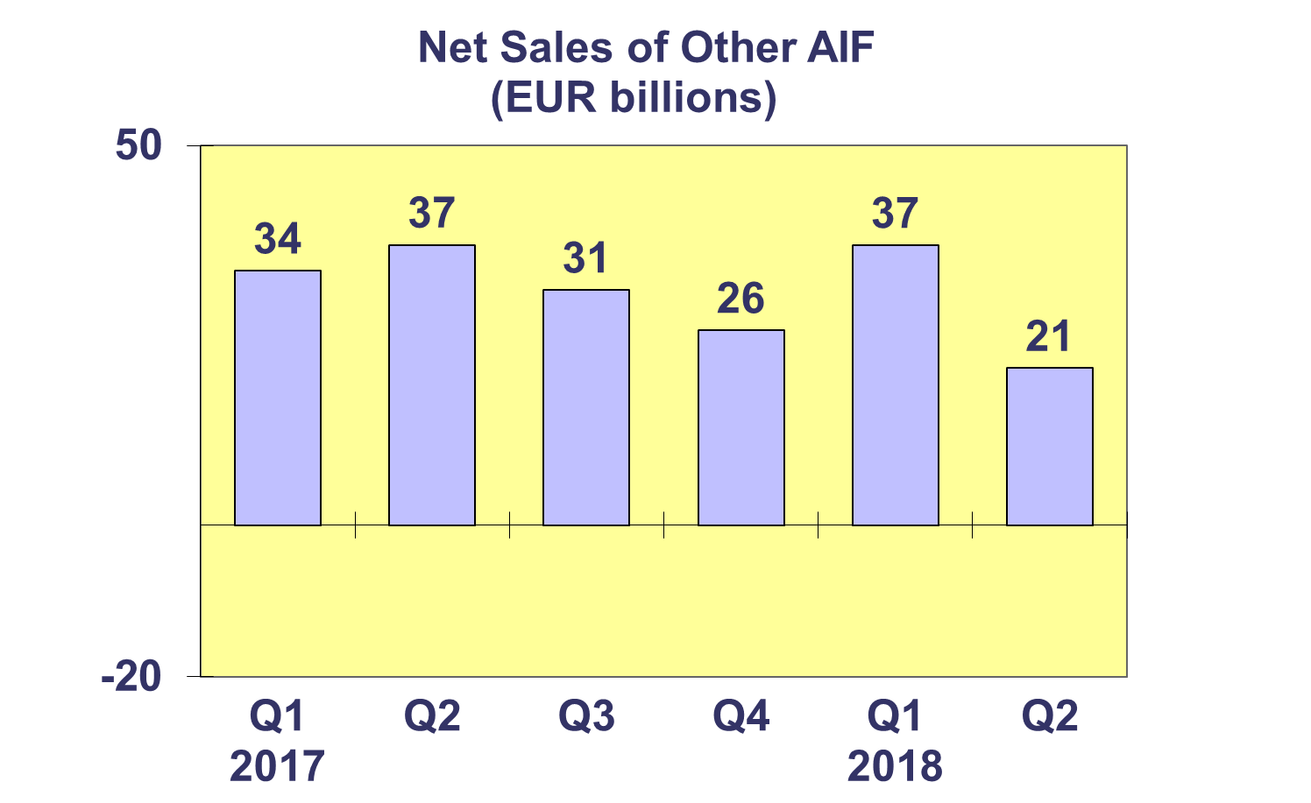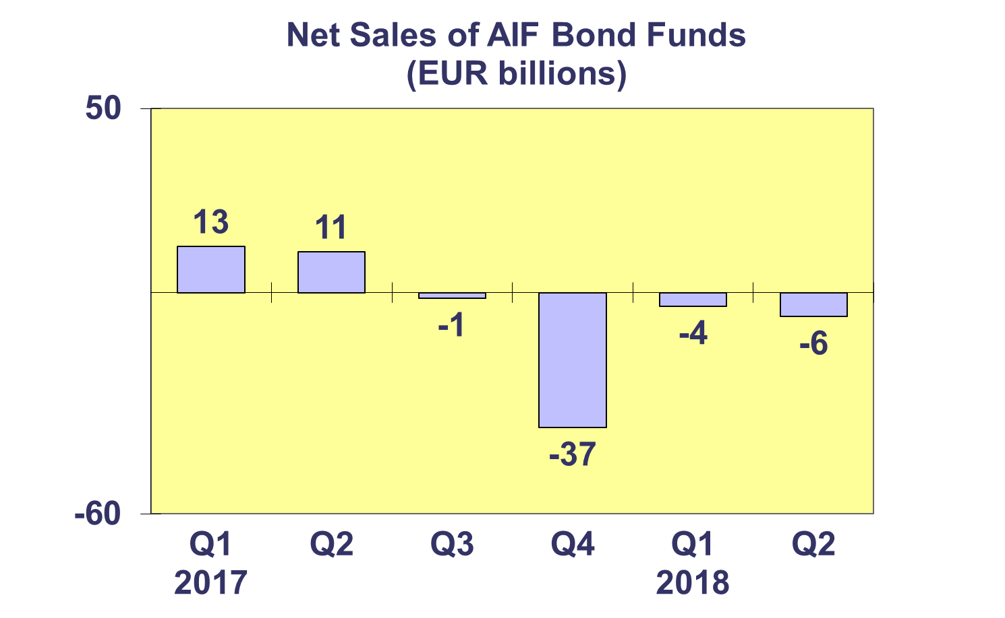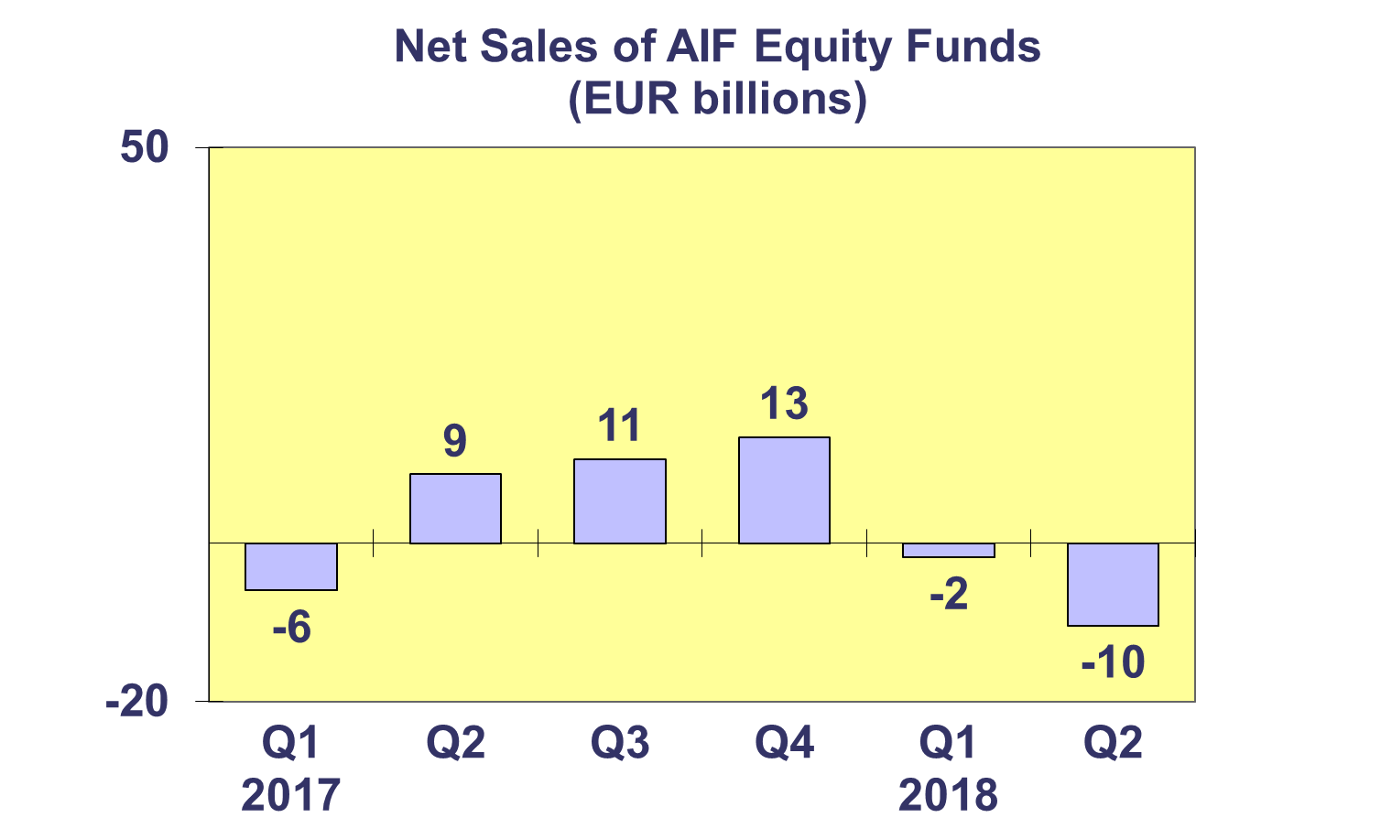**Trends in the AIF Market**

***Net Sales by Country of Domiciliation and Investment Type***

**Fifteen countries experienced net inflows into AIFs in Q2 2018, with three countries recording net inflows higher than EUR 1 billion.**

Net inflows above EUR 1 billion were registered in Germany (EUR 15.0 billion), Luxembourg (EUR 9.7 billion and Ireland (EUR 9.6 billion).

The largest net outflows during the quarter were registered in France (EUR 11.3 billion), followed by the Netherlands (EUR 5.6 billion) and the United Kingdom (EUR 5.4 billion).

Other funds and real estate funds were the only types of AIF to register net inflows this quarter, EUR 21 billion and EUR 11 billion, respectively.

**Trends in the AIF Market**

***Net Assets and Number of Funds by Investment Type***

**Net assets of AIFs increased by 1.6% in the second quarter of 2018 to reach EUR 5,965 billion.**

In Q2 2018, real estate funds recorded the largest asset growth (3.9%), followed by other AIFs (3.1%) and equity funds (2.1%). Decreases in net assets were seen in guaranteed/protected funds (1.2%) and in money market funds (1.0%), with a smaller decrease in bond funds (0.6%).

There were 28,503 Alternative Investment Funds at end Q2 2018, compared to 28,433 at end Q1 2018 and 28,153 at end Q4 2017.



**Trends in the AIF Market**

***Net Sales and Assets of Institutional AIFs***

**Net assets of institutional AIFs, which are AIFs reserved for institutional investors, increased 2.0% to EUR 2,965 billion at end Q2 2018.**

Net assets of institutional real estate fund increased by 5.5% to finish the quarter at EUR 203 billion. Institutional equity funds grew 2.1% to EUR 240 billion and institutional multi-asset funds increased by 0.8% to reach EUR 1,023 billion. Net assets of institutional bond funds increased 0.6% to EUR 571 billion. Money market funds experienced a decrease of 0.6% to reach EUR 10 billion at end Q2 2018.

Institutional AIFs recorded net sales of EUR 29 billion in Q2 2018, lower than both Q1 2018 (EUR 58 billion) and Q4 2017 (EUR 39 billion).



**Trends in the AIF Market**

***Net Assets by Country of Domiciliation***

**Net assets of AIFs increased 1.6% compared to end Q1 2018 and 1.2% compared to end 2017.**

Of the larger AIF domiciles, the largest net asset growth was seen in Ireland (3.1%), followed by Luxembourg (2.9%) and the Netherlands (2.8%).

Elsewhere in Europe, net assets grew strongly in Croatia (10.9%), Cyprus (10.1%), Liechtenstein (5.5%), the Czech Republic (4.6%) and Malta (4.5%).



**Trends in the European Investment Fund Industry**

***Net Sales by Investment Type***

**UCITS and AIFs recorded net sales of EUR 28 billion during Q2 2018, compared to EUR 222 billion in Q1. During the first half of 2018, European investment funds attracted net sales of EUR 250 billion.**

Equity funds registered net outflows of EUR 0.3 billion in Q2 2018, compared to net inflows of EUR 84 billion in the previous quarter. Bond funds recorded net outflows of EUR 7 billion in Q2, compared to net inflows of EUR 22 billion in Q1 2018. Net sales of multi-asset funds totalled EUR 25 billion in Q2 2018, down from EUR 68 billion in the previous quarter. Money market funds experienced net outflows of EUR 19 billion, compared to EUR 4 billion in the first quarter of 2018. Net sales of other funds (including real estate, guaranteed/protected funds and other funds which do not fit any of the categories below or for which information is not available) totalled EUR 30 billion, less than the EUR 51 billion in Q1 2018.

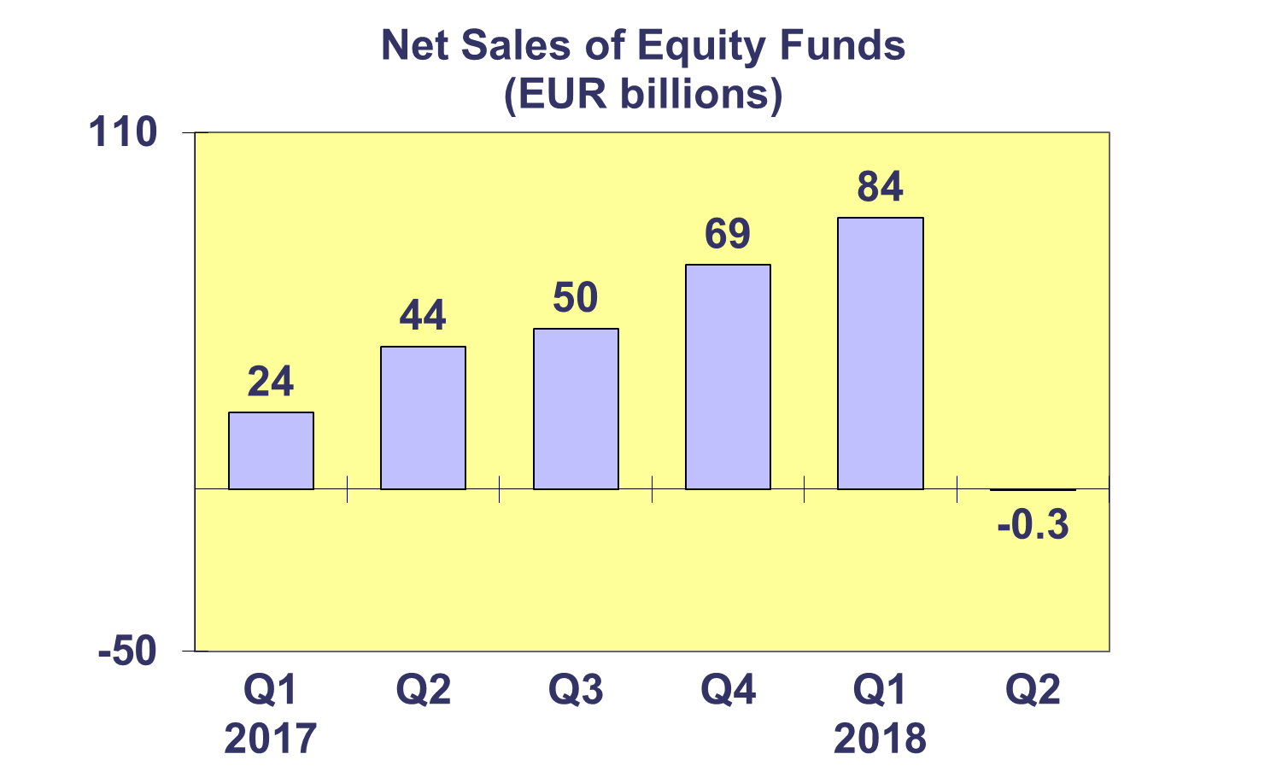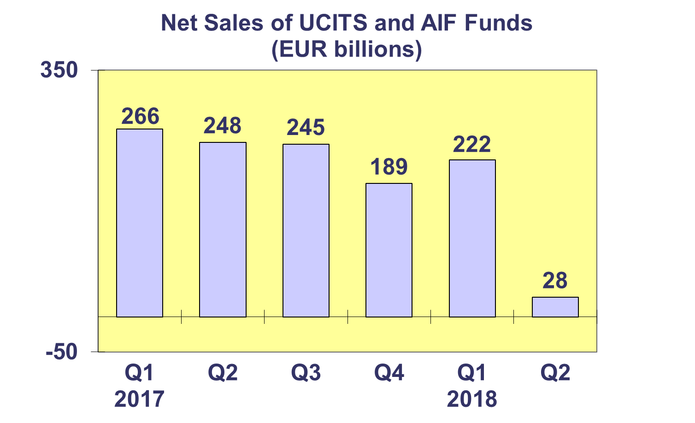

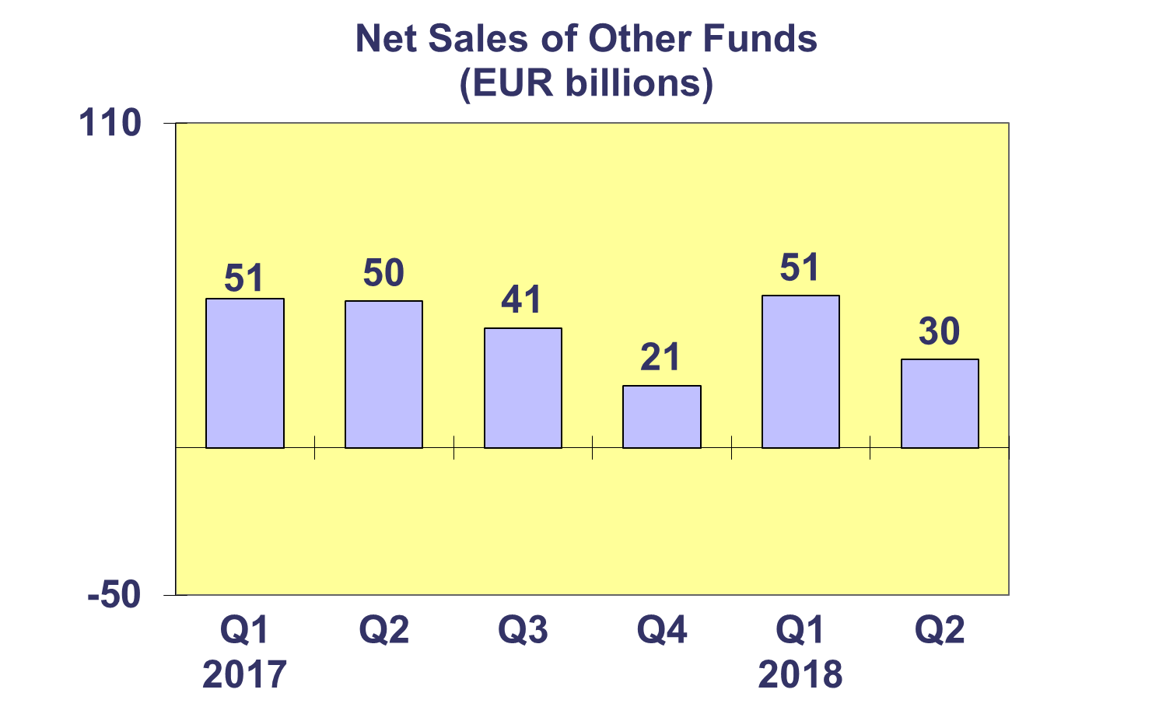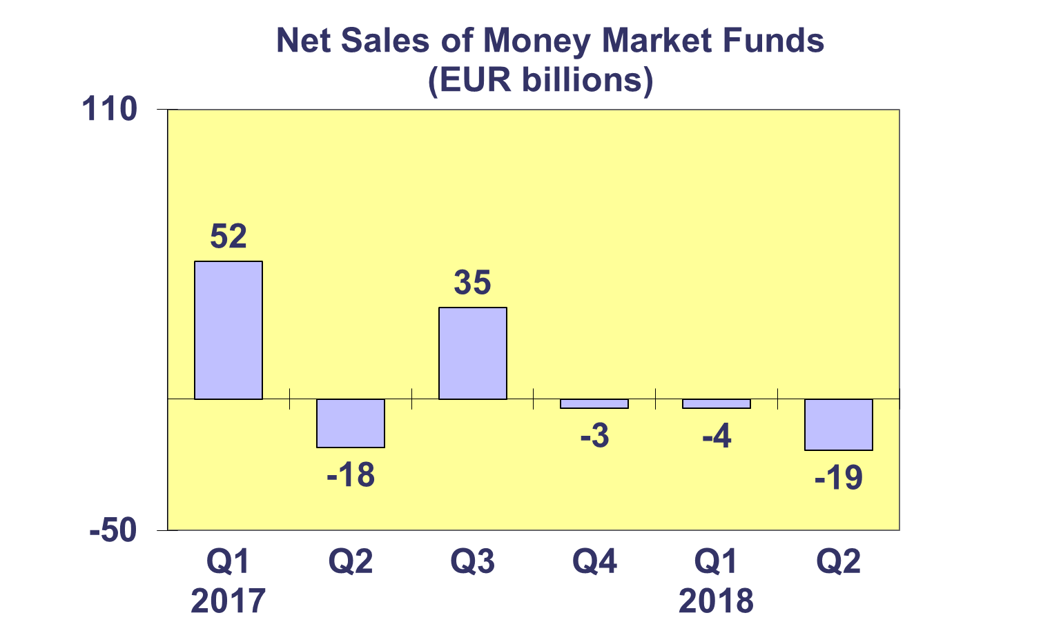**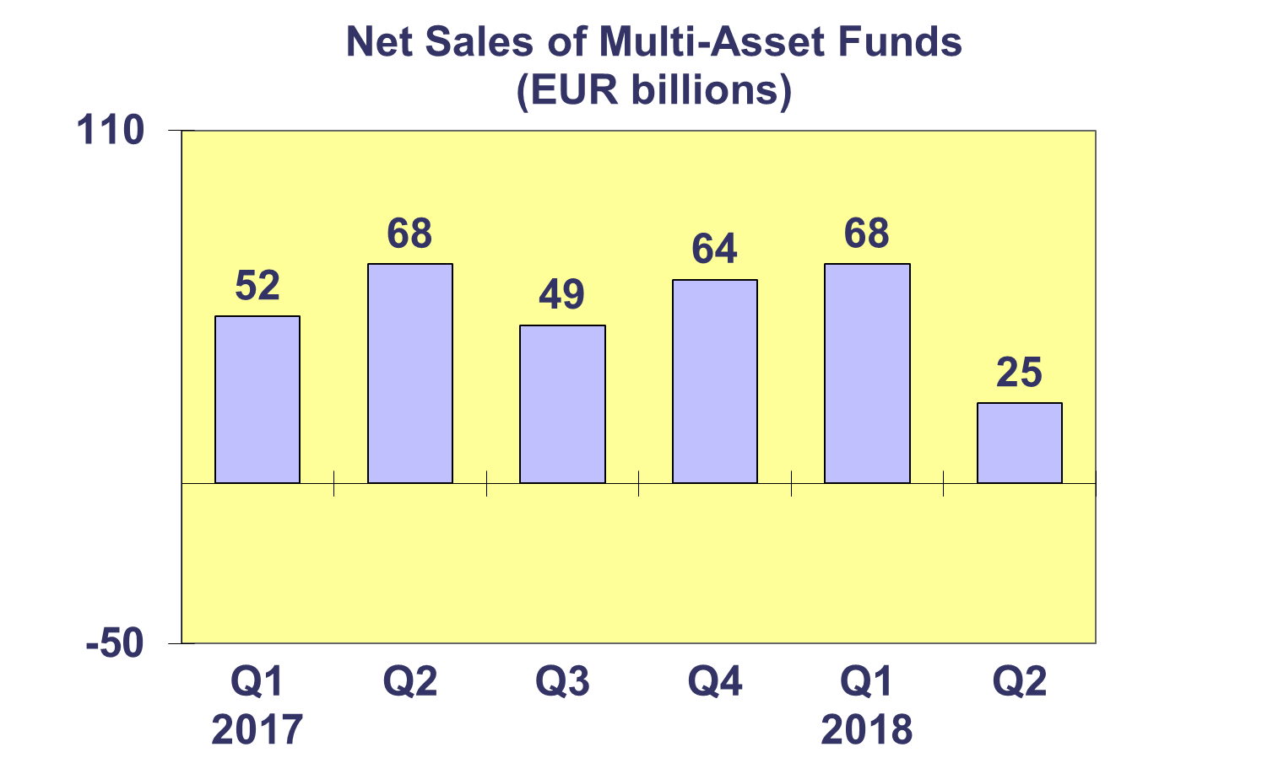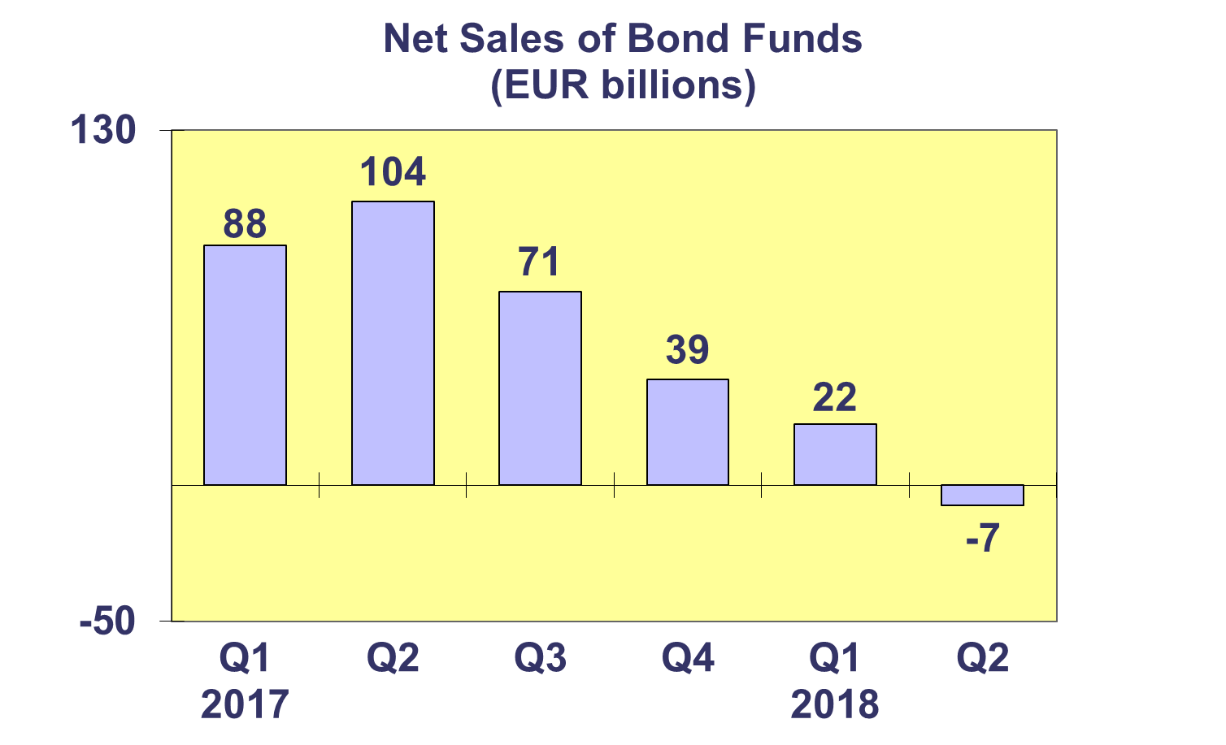Trends in the European Investment Fund Industry**

***Net Assets by Country of Domiciliation***

**Total net assets of the European investment increased to EUR 15,788 billion at end Q2 2018, representing a net asset growth of 1.6% since Q1 2018 and 1.1% since end 2017.**

With EUR 9,824 billion invested in UCITS, this segment accounted for 62.2% of total European investment fund assets at end Q2 2018, with the remaining 37.8% (equivalent to EUR 5,965 billion) coming from AIFs.

**Trends in the European Investment Fund Industry**

***Number of Funds by Country of Domiciliation***

**In Q2 2018, the total number of UCITS and Alternative Investment Funds (AIFs) increased by 0.7% to 61,236.**

At the end of the second quarter of 2018, UCITS accounted for 32,733 funds or 53.5% of the European investment fund market, while AIFs accounted for 28,503 funds, or 46.5% of the market.

