|  |
| --- |
| ***Quarterly Statistical Release*** |

**June 2019, N° 77**

***This release and other statistical***

***releases are available on Efama’s***

***website (***[***www.efama.org***](http://www.efama.org)***)***

***Trends in the European Investment Fund Industry***

***in the First Quarter of 2019***

|  |
| --- |
| **This report was prepared by Bernard Delbecque, Thomas Tilley and Hailin Yang**  **EFAMA**  **The European Fund and Asset Management Association**  **Rue Montoyer 47 - B-1000 BRUXELLES - Tel. 32-2-513.39.69 Fax: 32-2-513.26.43 - e-mail: info@efama.org** |

**Trends in the UCITS Market**

***Net Sales by Investment Type***

**UCITS recorded net inflows of EUR 51 billion in Q1 2019, of which EUR 32 billion were recorded in January.**

Long-term UCITS recorded net inflows of EUR 40 billion in Q1 2019, compared to net outflows of EUR 94 billion in Q4 2018. Equity funds recorded net outflows of EUR 27 billion, compared to net outflows of EUR 7 billion in Q4 2018. Net sales of multi-asset funds turned positive in Q1 2019, with net inflows of EUR 2 billion, compared to net outflows of EUR 17 billion in Q4 2018. Net sales of bond funds recorded net inflows of EUR 79 billion, compared to net outflows of EUR 46 billion in Q4 2018. Net sales of money market funds recorded EUR 11 billion, down from EUR 23 billion in Q4 2018.

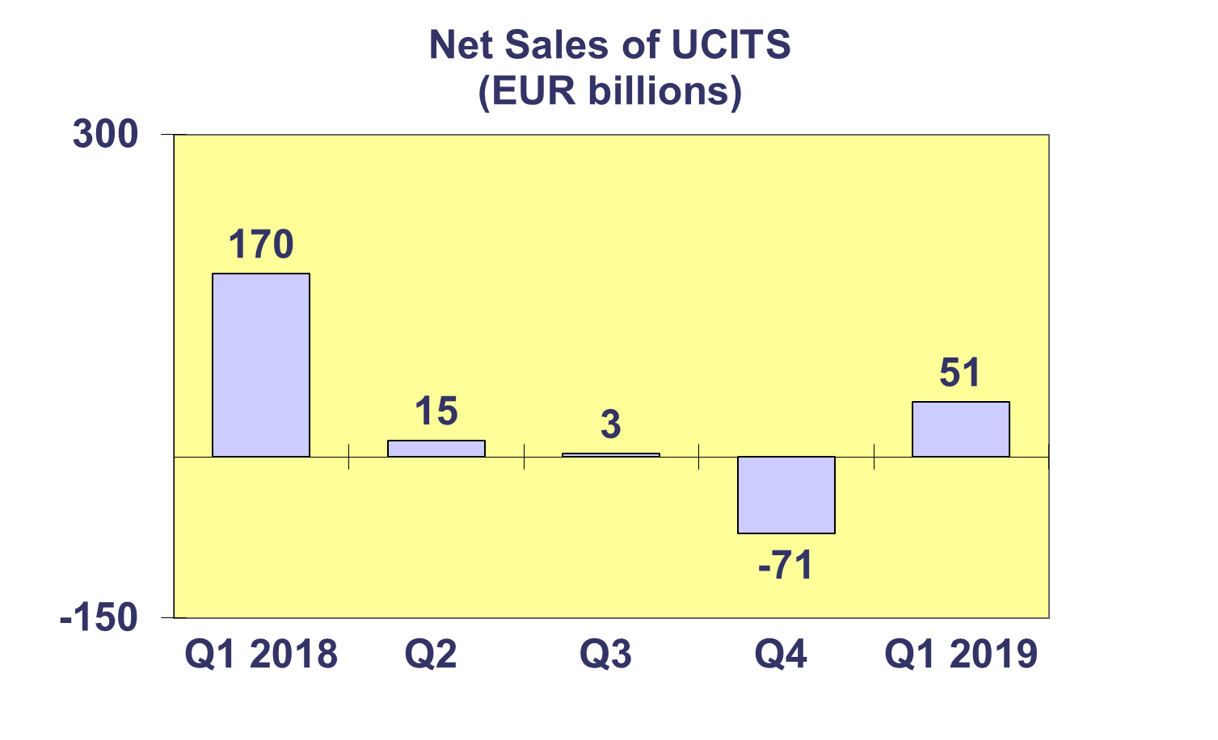

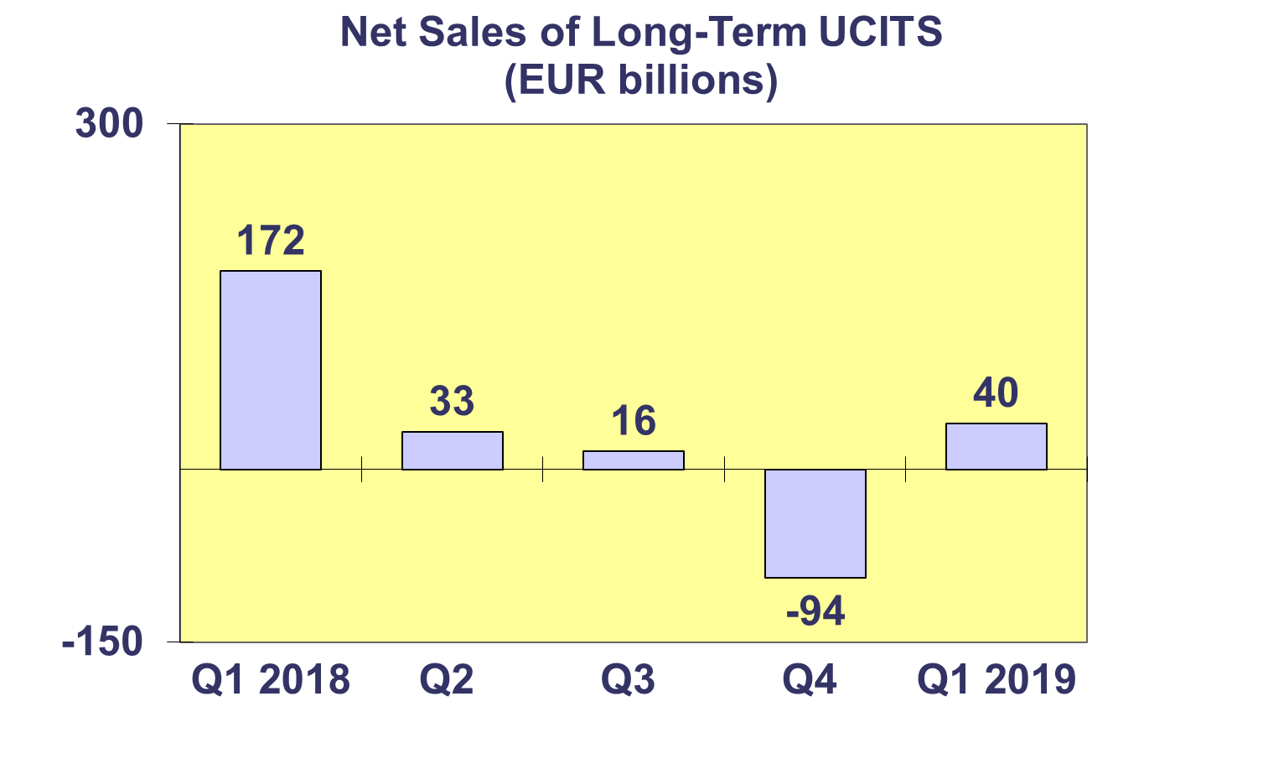

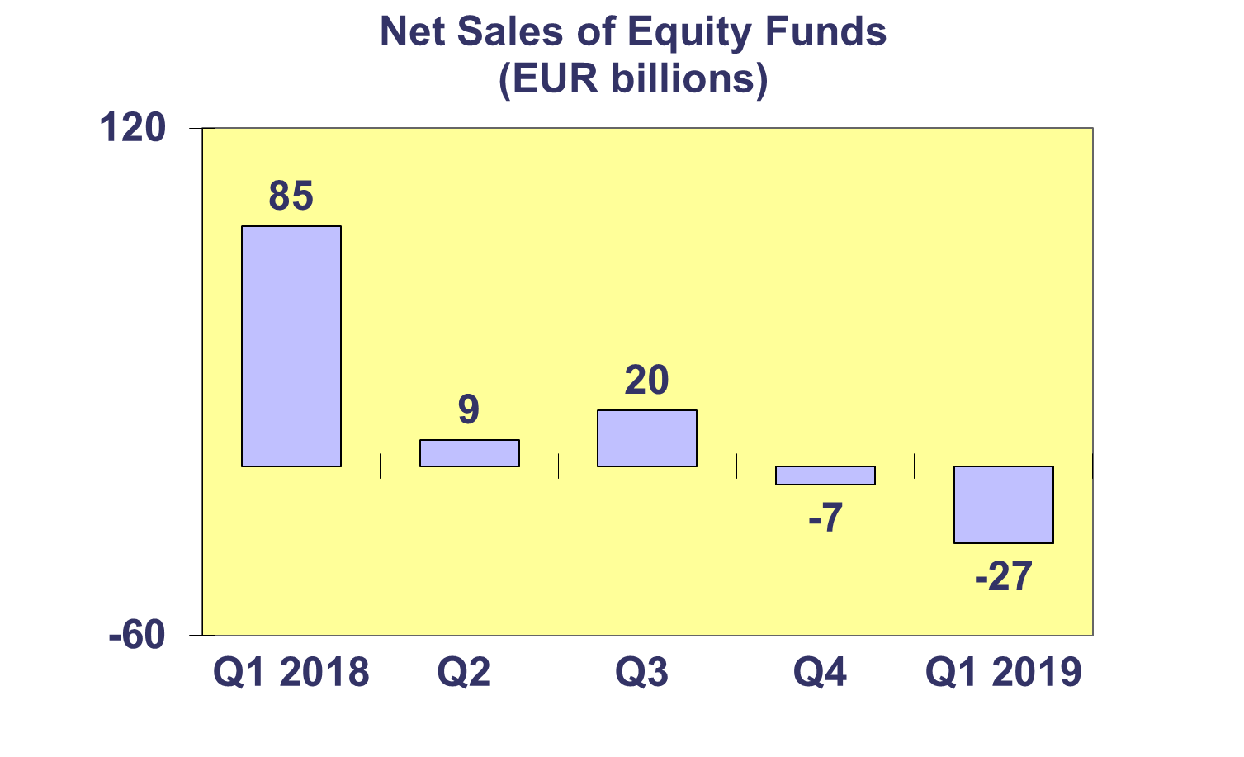

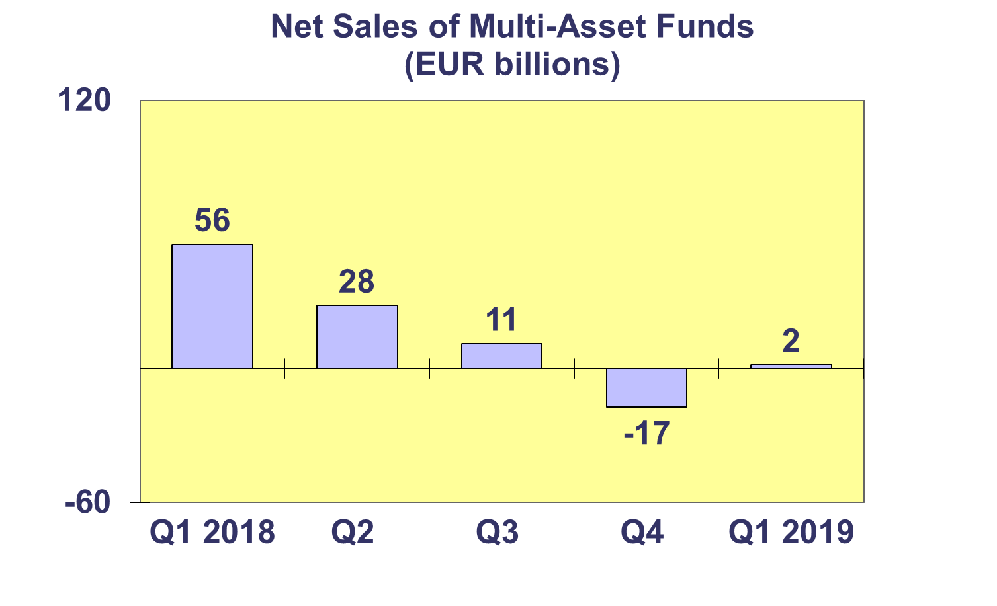

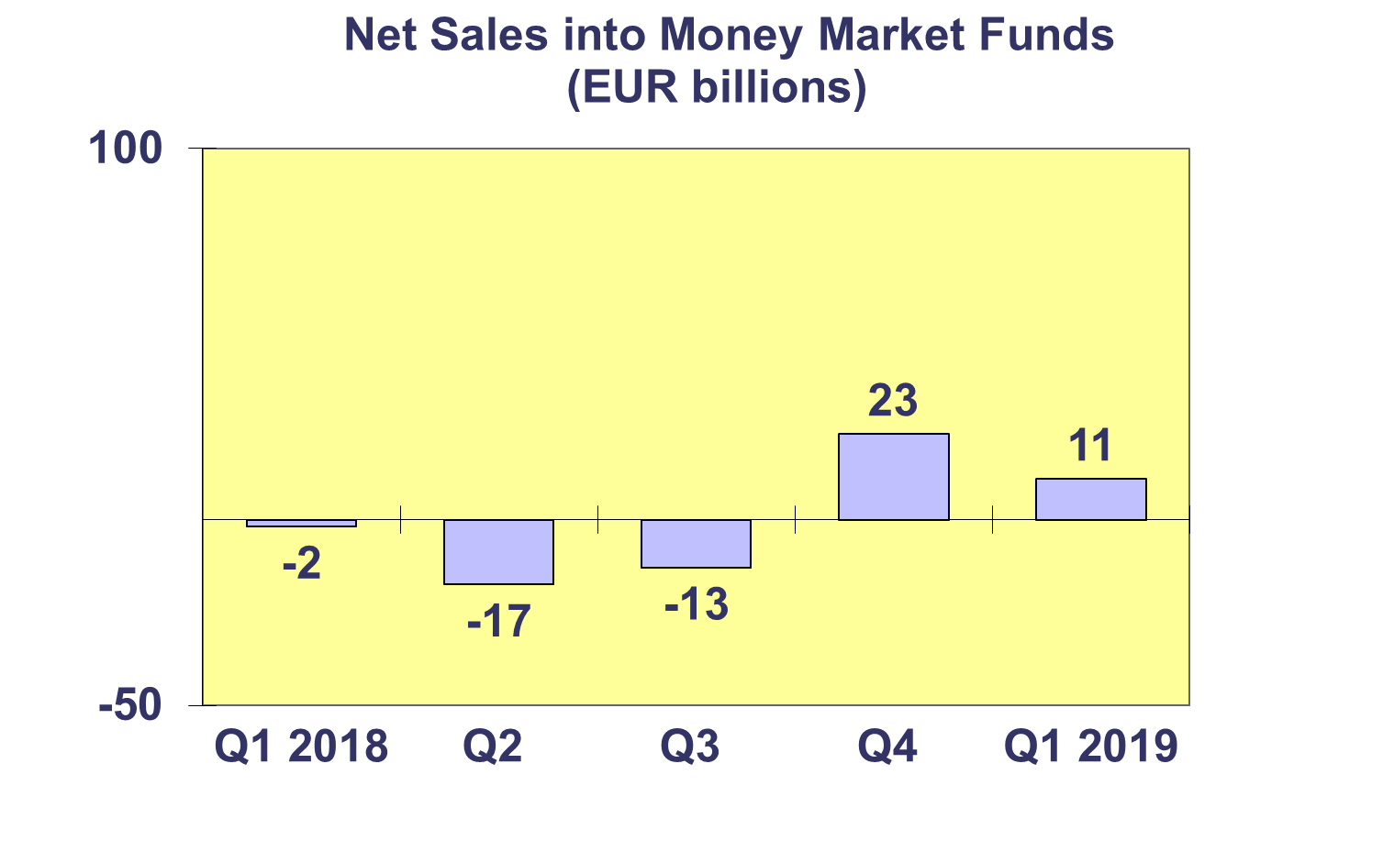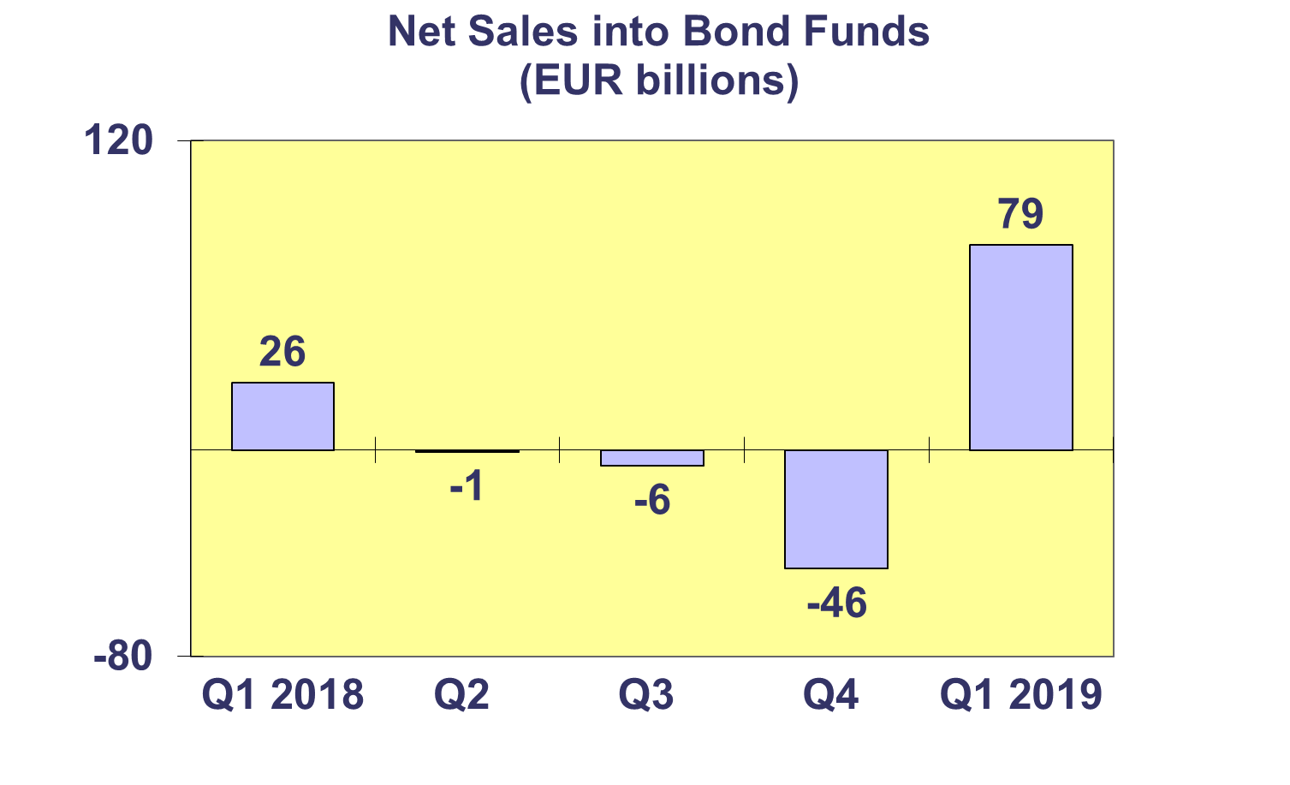**Trends in the UCITS Market**

***Net Sales by Country of Domiciliation and Investment Type***

**Fifteen countries registered net inflows into UCITS in Q1 2019, with eight countries recording net inflows above EUR 1 billion.**

In Q1 2019, the five domiciles with the largest net sales were Ireland (EUR 26.7 billion), followed by France (EUR 20.2 billion), Switzerland (EUR 15.2 billion), Luxembourg (EUR 4.8 billion) and Turkey (EUR 2.6 billion).

The unusually strong inflows in Turkey in Q1 2019 were driven by investors moving into money markets funds in search of a higher-yield alternative to bank deposits.

Flows into money market funds declined or even dropped to zero in several countries, such as Poland, Portugal and Sweden, as a result of the new EU regulation on money market funds (MMF), which introduced more stringent requirements on MMF fund managers. These stricter rules led some MMF managers to transform their MMFs into short-term bond funds in early 2019.



**Trends in the UCITS Market**

***Net Sales and Net Assets of ETF by Country of Domiciliation***

**Net sales of UCITS ETFs reached EUR 26 billion in Q1 2019, up from EUR 3 billion in Q4 2018.**

Of the large UCITS ETF domiciles, Ireland registered the largest inflows (EUR 25.7 billion) followed by Luxembourg (EUR 10.3 billion). France, on the other hand, recorded net outflows of EUR 7.1 billion.



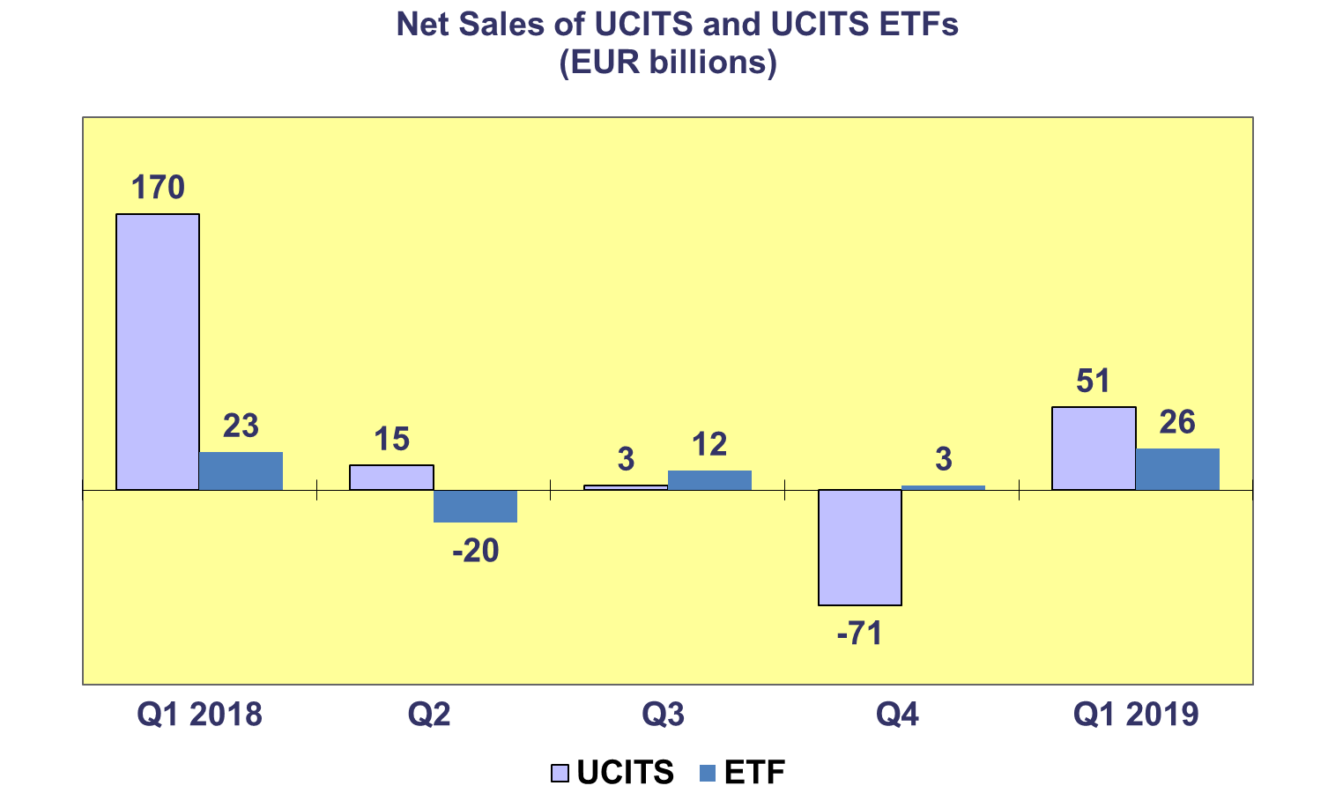



**Trends in the UCITS Market**

***Net Assets and Number of Funds by Investment Type***

**UCITS net assets increased by 7.8 percent in Q1 2019, to total EUR 10,004 billion at end March 2019.**

All categories of UCITS, with the exception of guaranteed funds, experienced an increase in net assets in Q1 2019. Net assets of equity funds increased by 11.7% to reach EUR 3,853 billion at the end of March. Bond funds increased by 7.3% to EUR 2,723 billion, whereas multi-asset funds increased by 6.6% to EUR 1,842 billion. “Other” UCITS funds and money market funds followed in this ranking, increasing 1.2% and 1.0%, respectively.

The number of UCITS funds increased from 33,370 at end 2018 to 33,570 at end Q1 2019.



**Trends in the UCITS Market**

***Net Assets by Country of Domiciliation***

**Net assets of UCITS amounted to EUR 10,004 billion at end Q1 2019, with almost all domiciles recording a growth in net assets.**

All major domiciles recorded net asset growth in the first quarter of 2019. Net assets of UCITS domiciled in Ireland increased by 8.9 percent, followed by Germany (7.9%). Luxembourg and the United Kingdom recorded the same level of growth rate (7.5%). France recorded an asset growth of 6.2 percent.

Other countries in Western Europe also recorded increases in net assets, with the largest increase in the Netherlands (11.6%), followed by Switzerland (11.1%) and Belgium (6.7%). The Nordic countries also experienced solid net asset growth in Q1 2019, with strong growth in Sweden (10.9%), Norway (10.8%) and Denmark (7.1%). In Southern Europe, large net asset growth was seen in Cyprus (8.1%), followed by Malta (7.8%) and Greece (6.9%). In Central and Eastern Europe, large increases in net assets were recorded in Slovenia (9.7%) and the Czech Republic (9.5%).

 **Trends in the AIF Market**

***Net Sales by Investment Type***

**AIFs recorded net inflows of EUR 27 billion in Q1 2019, up from EUR 23 billion in the last quarter of 2018.**

Long-term AIFs recorded net inflows of EUR 49 billion, up from net inflows of EUR 26 billion in Q4 2018. Equity funds registered net outflows of EUR 11 billion, compared to net inflows of 4 billion in Q4 2018. Net sales of multi-asset funds decreased from EUR 10 billion in Q4 2018 to EUR 6 billion in Q1 2019. Bond funds saw a reversal in flows, from net outflows of EUR 2 billion in Q4 2018 to net inflows of EUR 3 billion in Q1 2019. Net sales of other funds registered EUR 46 billion in Q1 2019, up from EUR 7 billion in Q4 2018.

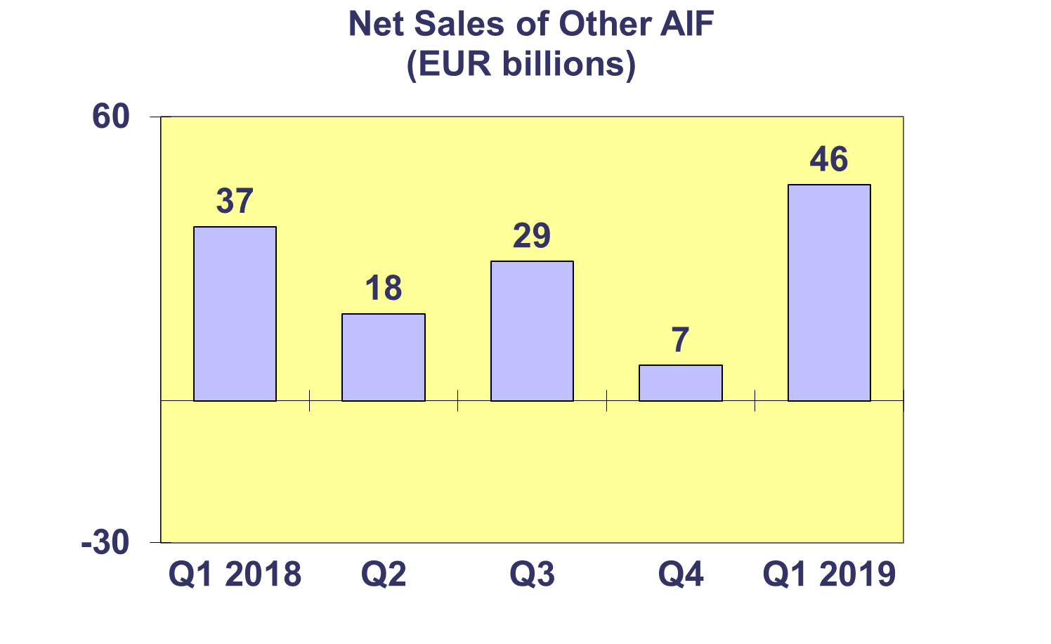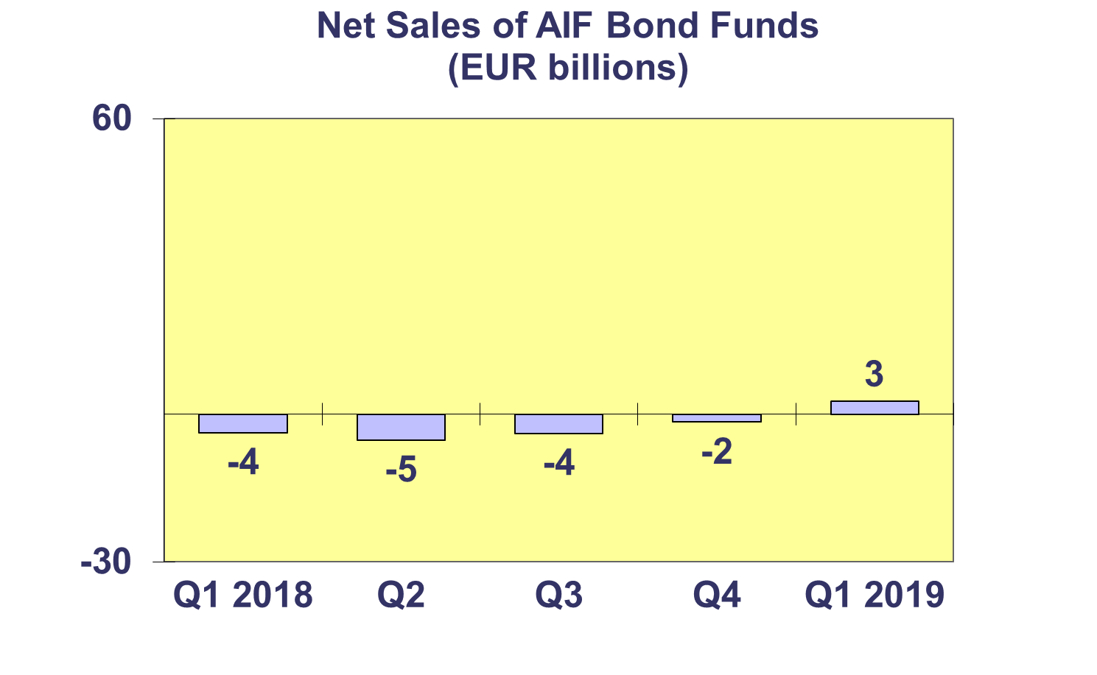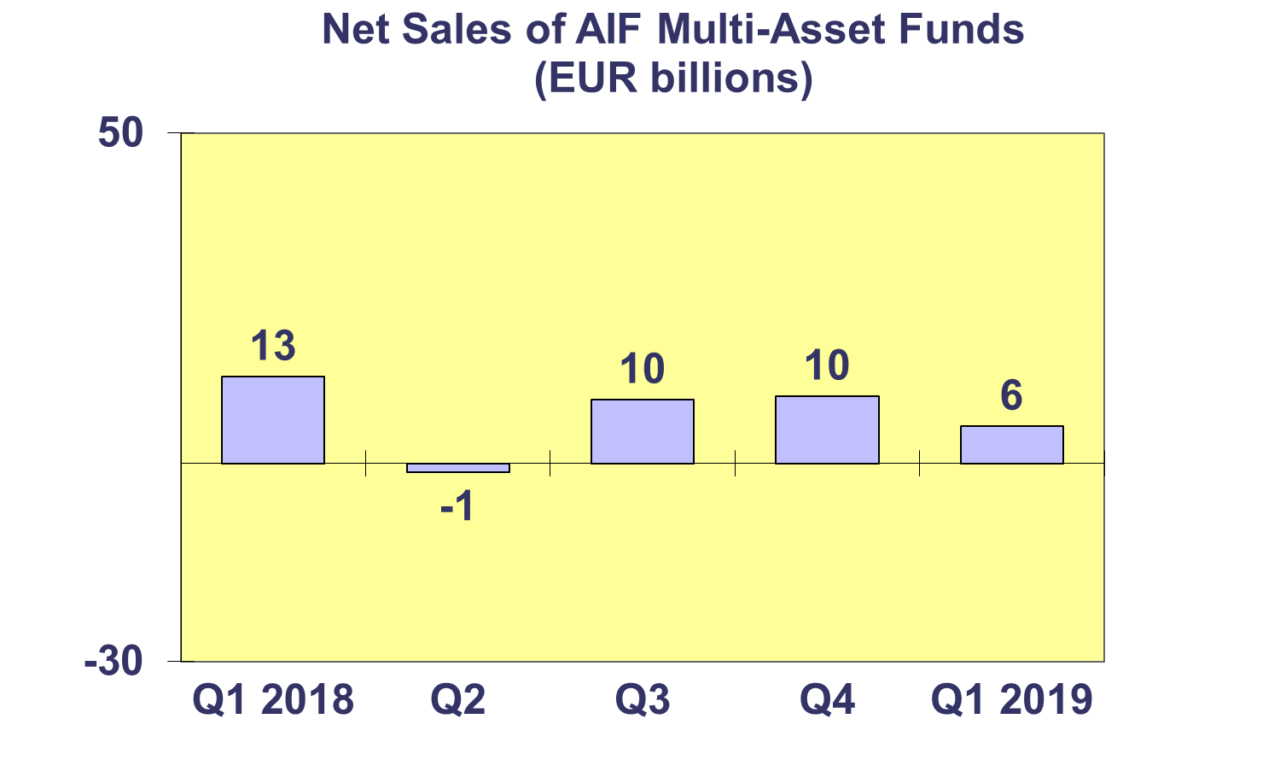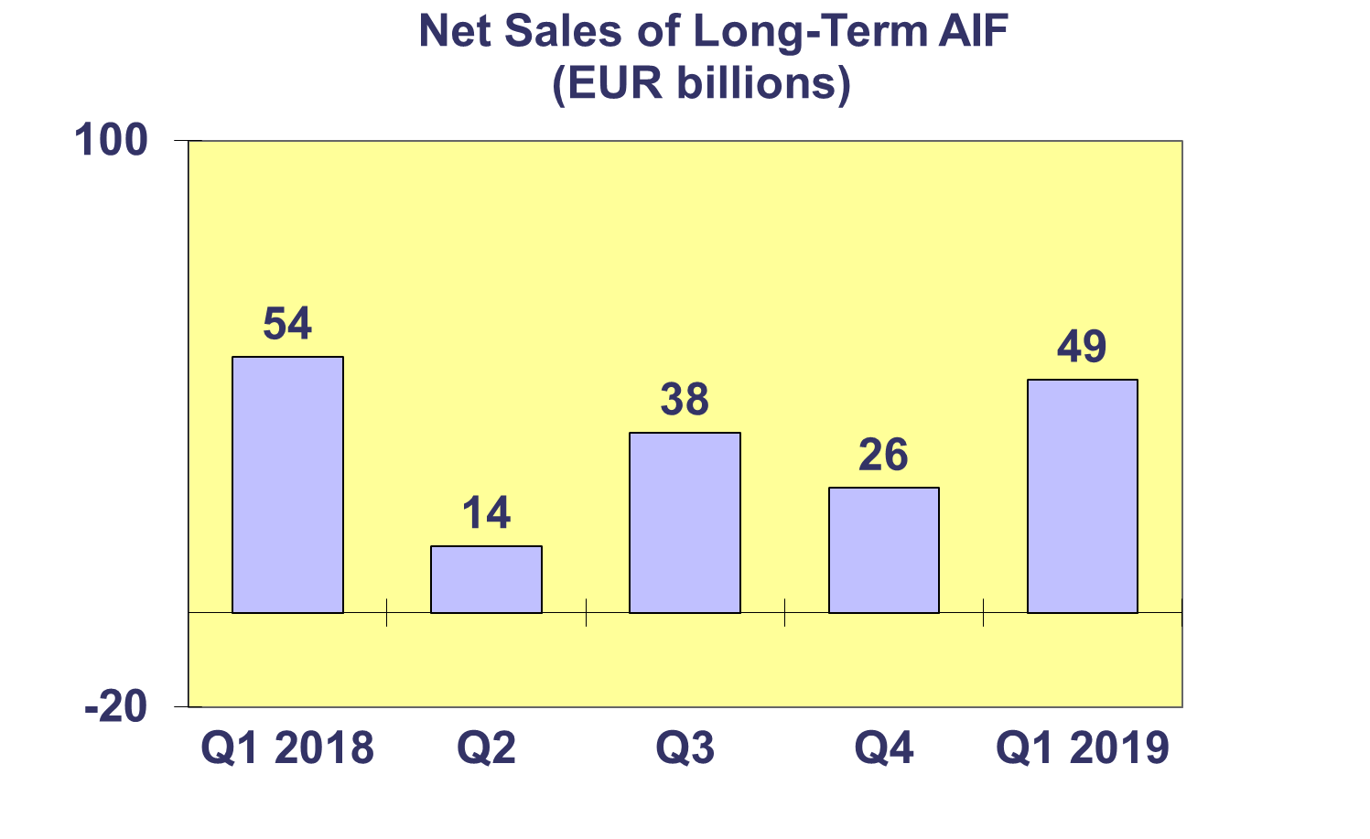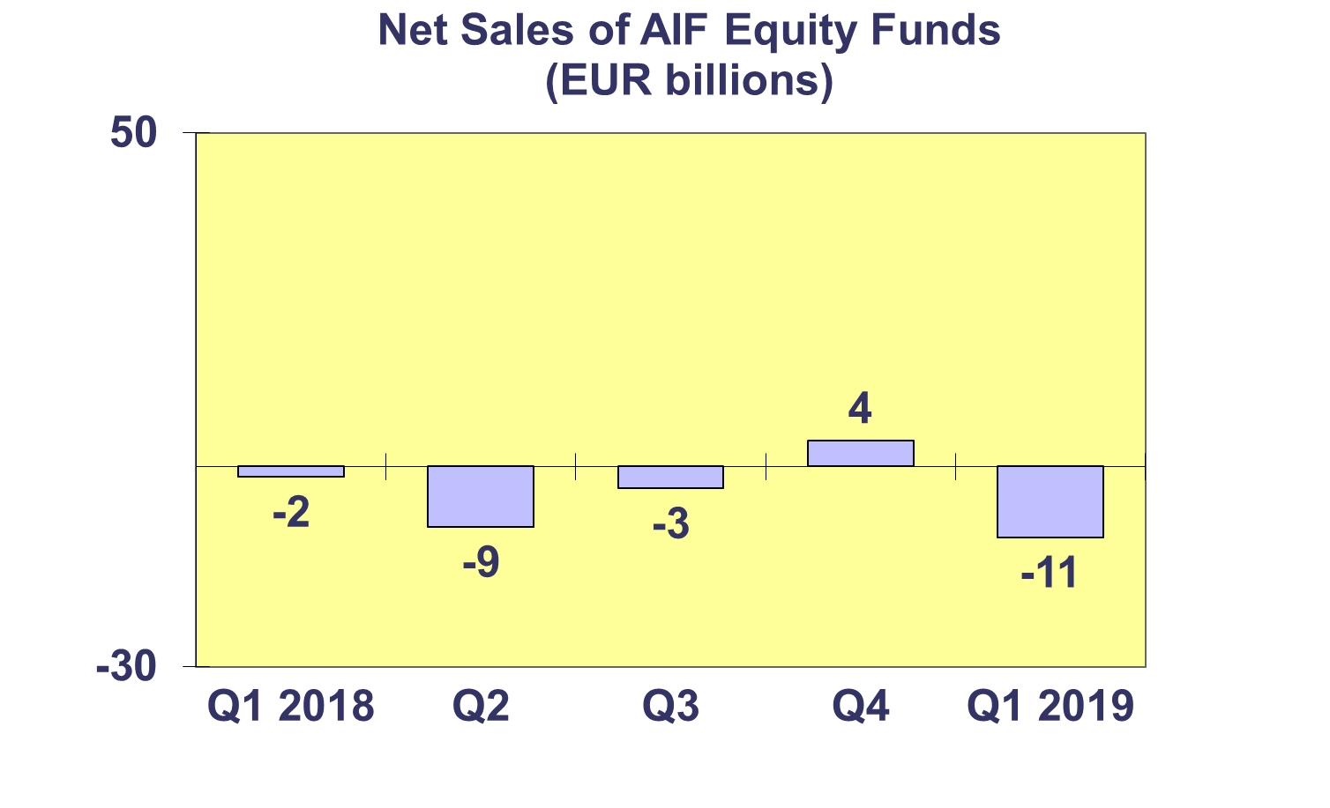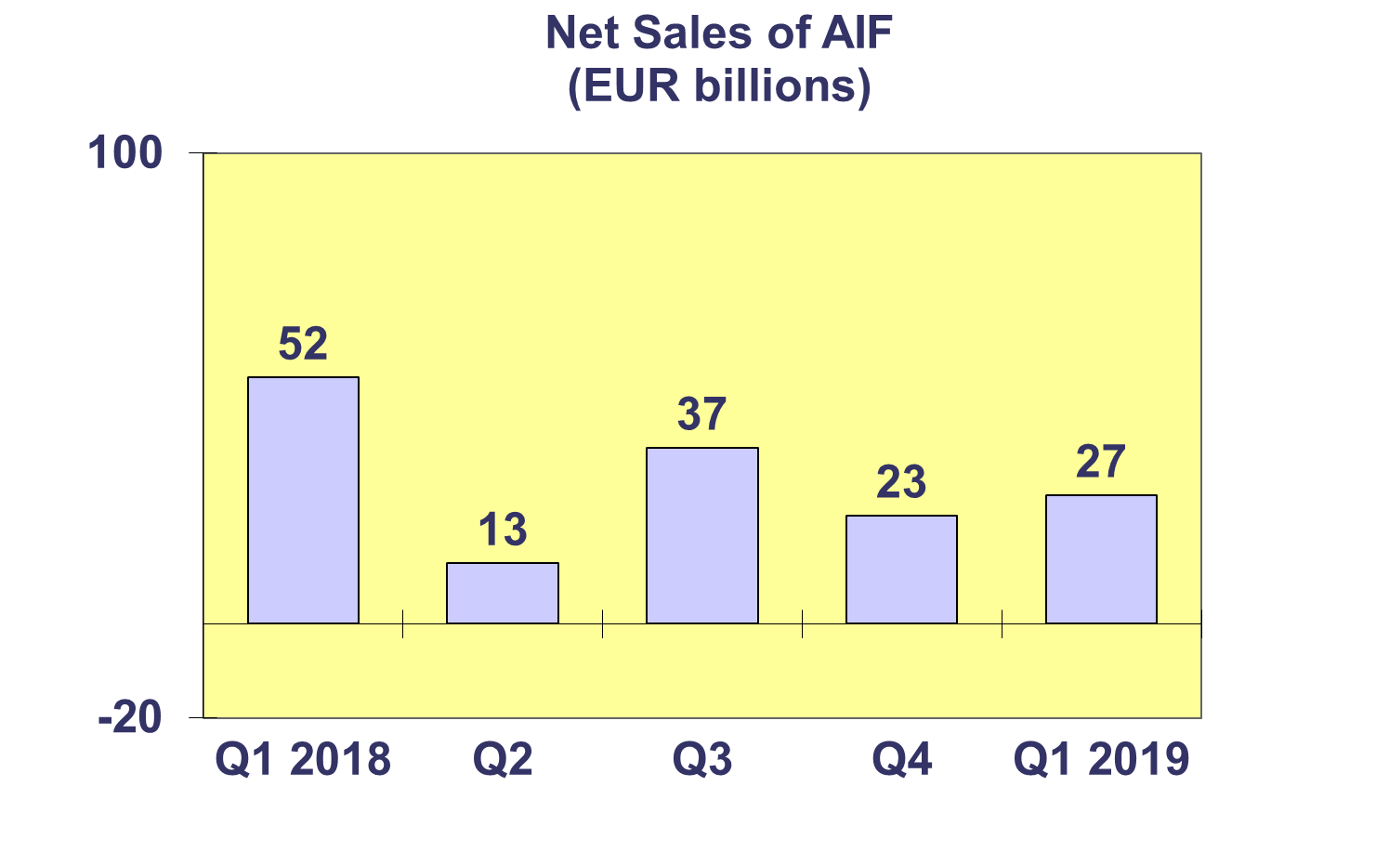**Trends in the AIF Market**

***Net Sales by Country of Domiciliation and Investment Type***

**Net sales of AIFs totaled EUR 27 billion in Q1 2019, with fifteen countries registering net inflows.**

In Q1 2019, net sales above EUR 1 billion were registered in Germany (EUR 26.0 billion), Switzerland (EUR 24.6 billion), Ireland (5.5 billion), Liechtenstein (EUR 2.5 billion) and Luxembourg (EUR 2.1 billion).

The Netherlands registered outflows of EUR 25 billion in Q1 2019, the largest quarterly withdrawal ever recorded for that country. The bulk of these net outflows were related to pension funds’ withdrawals from bond funds as a result of the restructuring of investment portfolios.

**Trends in the AIF Market**

***Net Assets and Number of Funds by Investment Type***

**Net assets of AIFs increased by 6.4 percent to reach EUR 6,247 billion at end March 2019.**

In Q1 2019, all AIF categories, with the exception of money market funds, recorded net asset growth. Equity funds recorded the largest growth (10.7%), followed by “other” AIFs (8.7%) and multi-asset funds (5.7%). Net assets of money market funds decreased by 31.9 percent in Q1 due to large outflows in France.

There were 28,106 AIFs at end March 2019, compared to 28,594 at end 2018.



**Trends in the AIF Market**

***Net Sales and Assets of Institutional AIFs***

**Net assets of institutional AIFs, which are AIFs reserved for institutional investors, increased by 6.9% to EUR 2,592 billion at end Q1 2019.**

Net assets of “other” institutional funds increased 13.5% to EUR 458 billion, followed by equity funds (9.6% to EUR 245 billion). Net assets of institutional bond and money market funds grew by 5.7% and 5.1% to EUR 593 billion and 1,060 billion, respectively. Institutional real estate AIFs experienced a net asset growth of 3.3% to reach EUR 224 billion at end Q1 2019.

Institutional AIFs recorded net sales of EUR 53 billion in Q1 2019, up from EUR 34 billion in the last quarter of 2018.



**Trends in the AIF Market**

***Net Assets by Country of Domiciliation***

**Net assets of AIFs increased 6.4 percent in Q1 2019, with 20 countries recording an increase in net assets.**

The five largest domiciles all recorded net asset growth in Q1 2019, with the largest growth in the United Kingdom (11.7%), followed by Ireland (10.0%), Germany (5.9%), Luxembourg (4.7%) and France (2.5%). Elsewhere in Europe, net assets grew strongly in Liechtenstein (20.3%) and Denmark (9.0%).

The large increase in net assets in Switzerland (37.7%) was driven by strong net sales in Q1 2019 and an increase in the coverage of Swiss funds.



**Trends in the European Investment Fund Industry**

***Net Sales by Investment Type***

**The net sales of UCITS and AIFs amounted to EUR 78 billion in Q1 2019, compared to net outflows of EUR 48 billion in the last quarter of 2018.**

Equity funds recorded net outflows of EUR 38 billion, compared to net inflows of EUR 3 billion in Q4 2018. Bond funds sales turned positive in Q1 2019, with net inflows of EUR 82 billion, compared to net outflows of EUR 48 billion in Q4 2018. Net sales of multi-asset funds totalled EUR 7 billion, compared to net outflows of EUR 7 billion in Q4 2018.

Net sales of money market funds experienced net outflows of EUR 11 billion, compared to net inflows of EUR 20 billion in Q4 2018. Net sales of other funds (including real estate and other funds which do not fit any of the other categories for which information is not available) totalled EUR 38 billion, compared to net outflows of EUR 10 billion in Q4 2018.

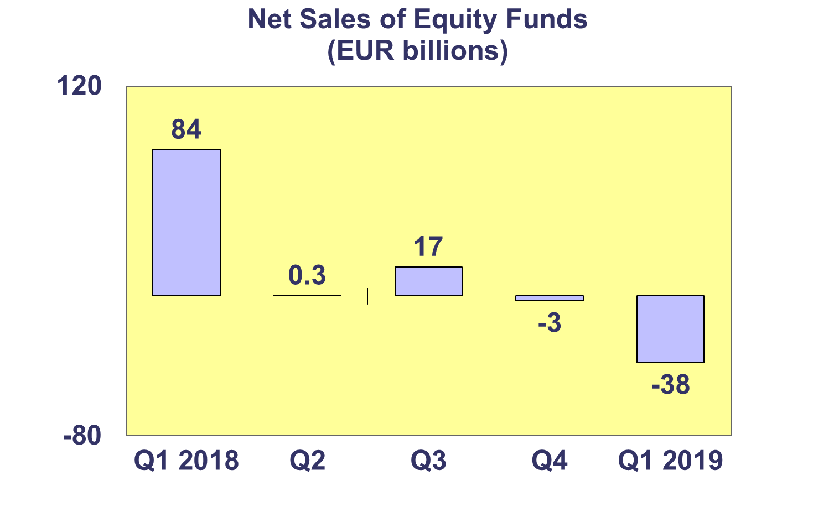

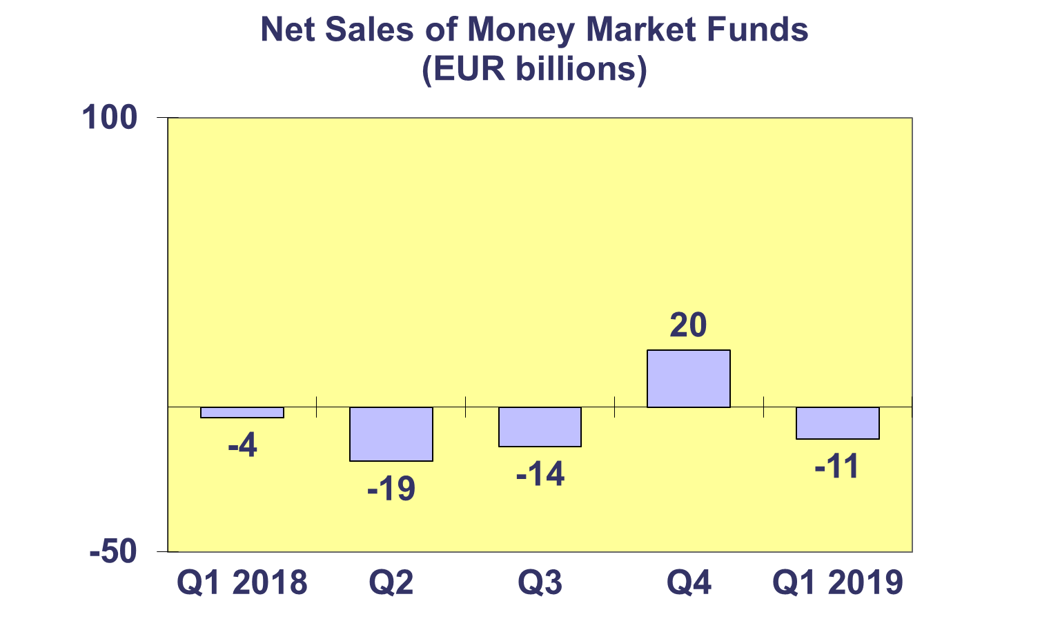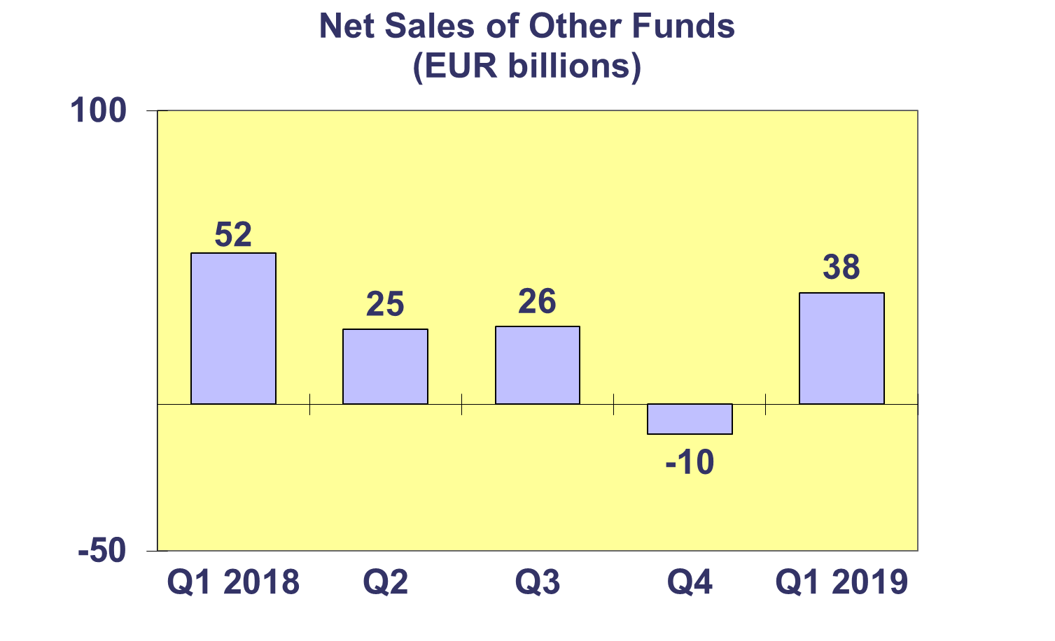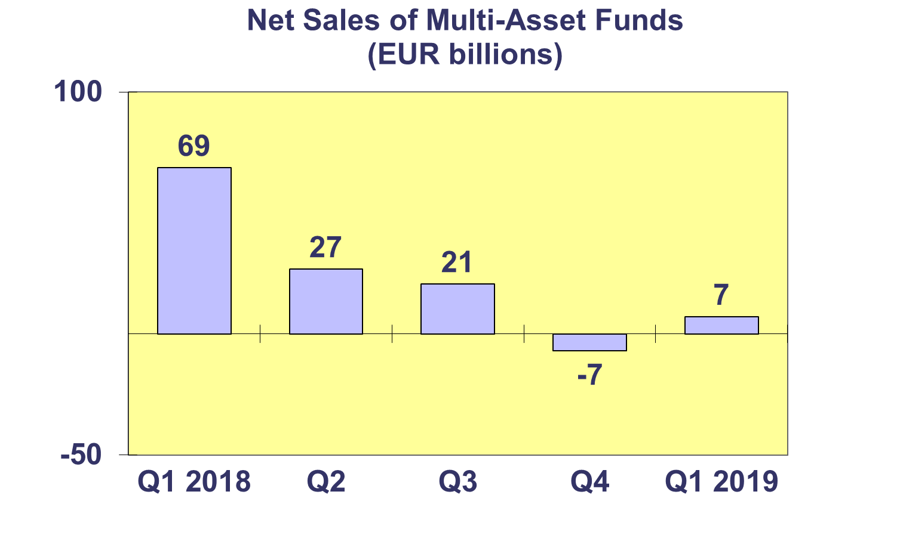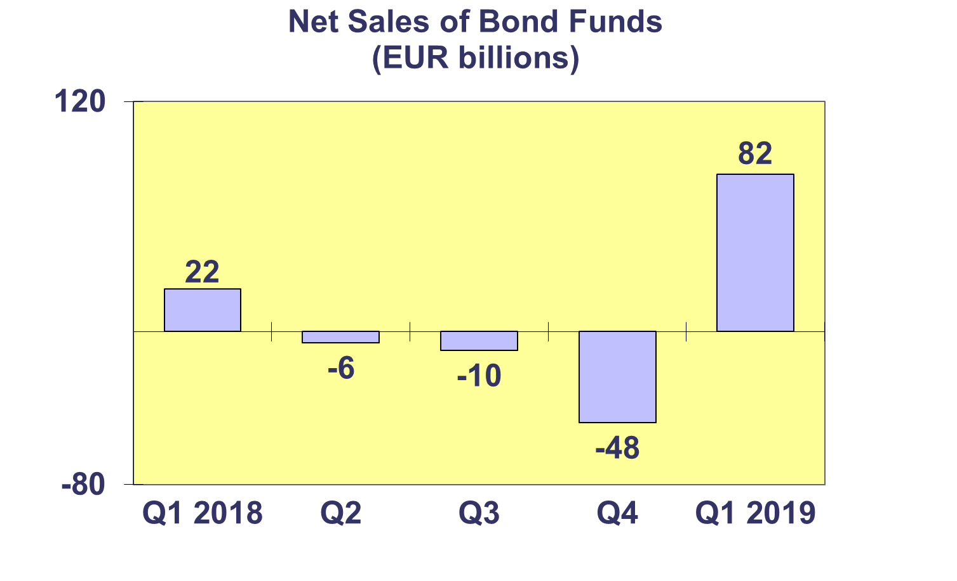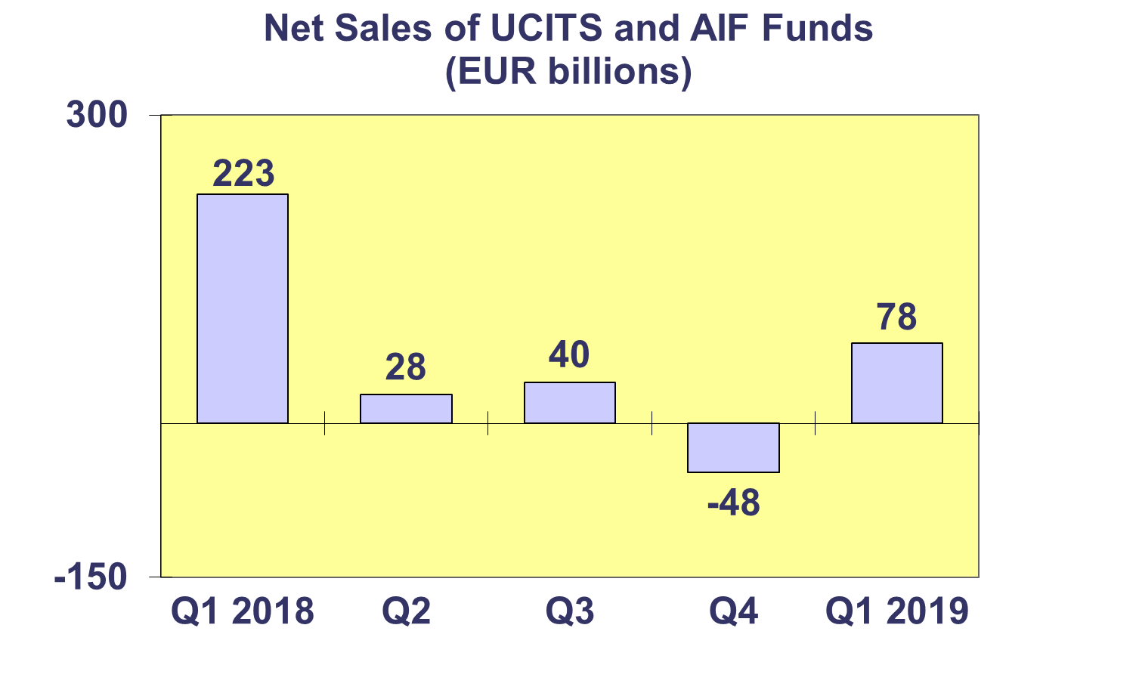**Trends in the European Investment Fund Industry**

***Net Assets by Country of Domiciliation***

**Total net assets of European investment funds increased by 7.2% to reach EUR 16,251 billion at end Q1 2019.**

With EUR 10,004 billion invested in UCITS, this segment accounted for 61.6% of total European investment fund assets at end Q1 2019, with the remaining 38.4% (or EUR 6,247 billion) coming from AIFs.



**Trends in the European Investment Fund Industry**

***Number of Funds by Country of Domiciliation***

**In Q1 2019, the total number of UCITS funds and AIFs decreased by 0.5% to 61,676 funds.**

At the end of Q1 2019, UCITS accounted for 33,570 funds or 54.4% of the total number of European funds, while AIFs accounted for 28,106 funds (45.6%).

