|  |
| --- |
| ***Quarterly Statistical Release*** |

**June 2017, N° 69**

***This release and other statistical***

***releases are available on Efama’s***

***website (***[***www.efama.org***](http://www.efama.org)***)***

***Trends in the European Investment Fund Industry***

***in the First Quarter of 2017***

|  |
| --- |
| **This report was prepared by Alex Carroll, Bernard Delbecque and Thomas Tilley**  **EFAMA**  **The European Fund and Asset Management Association**  **Rue Montoyer 47 - B-1000 BRUXELLES - Tel. 32-2-513.39.69 Fax: 32-2-513.26.43 - e-mail: info@efama.org** |

**Trends in the UCITS Market**

***Net Sales by Investment Type***

**UCITS recorded net inflows of EUR 202 billion during Q1 2017, compared to EUR 78 billion in the last quarter of 2016.**

Long-term UCITS recorded net inflows of EUR 152 billion in Q1 2017, up from EUR 41 billion in Q4 2016. Net sales of equity funds amounted to EUR 29 billion, up from EUR 13 billion in Q4 2016. Net sales of multi-asset funds increased significantly from EUR 10 billion in Q4 2016 to EUR 38 billion in Q1 2017. Net sales of bond increased from EUR 15 billion in Q4 to EUR 75 billion in Q1 2017. Net sales of money market funds increased from EUR 37 billion in Q4 2016 to EUR 51 billion in Q1 2017.

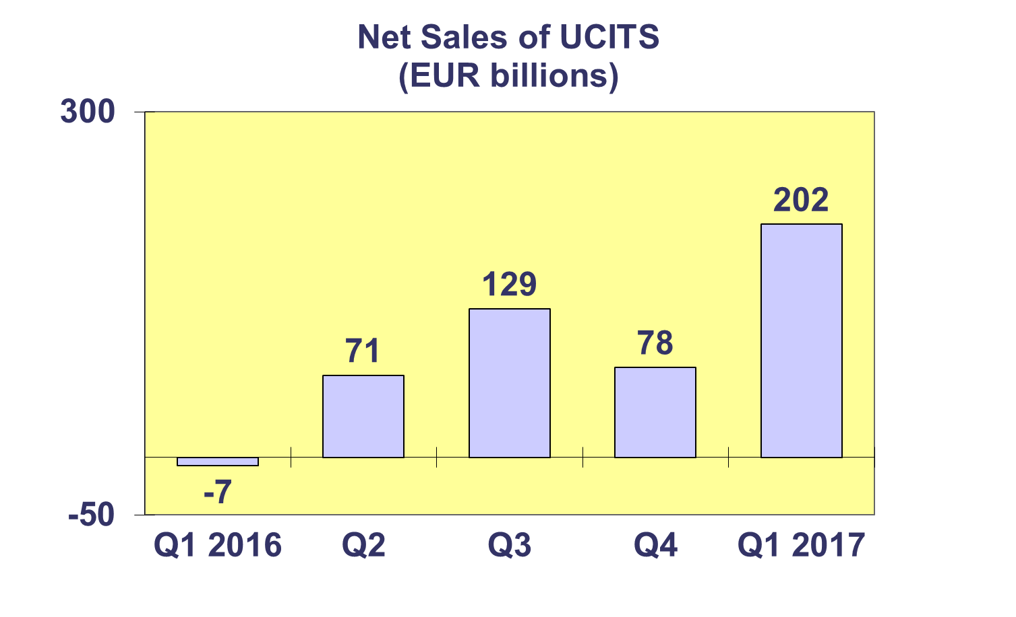

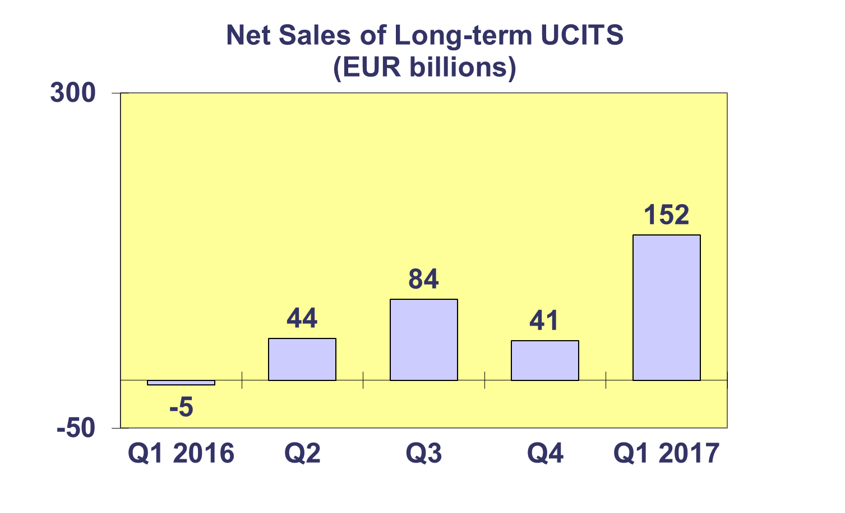

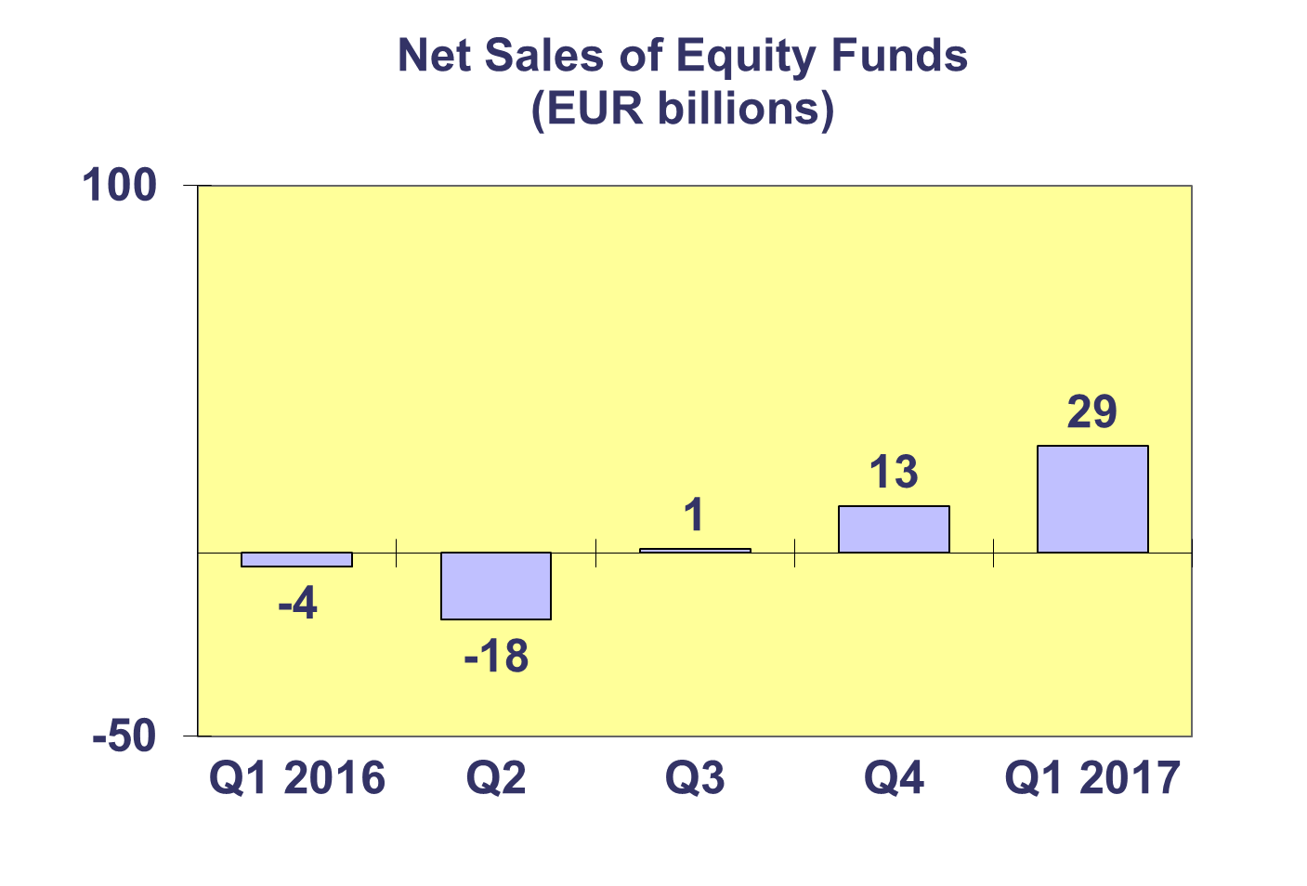

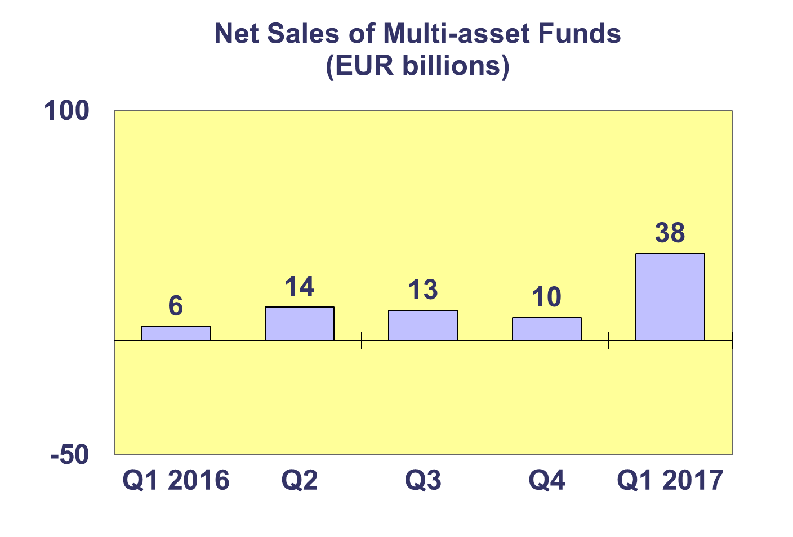

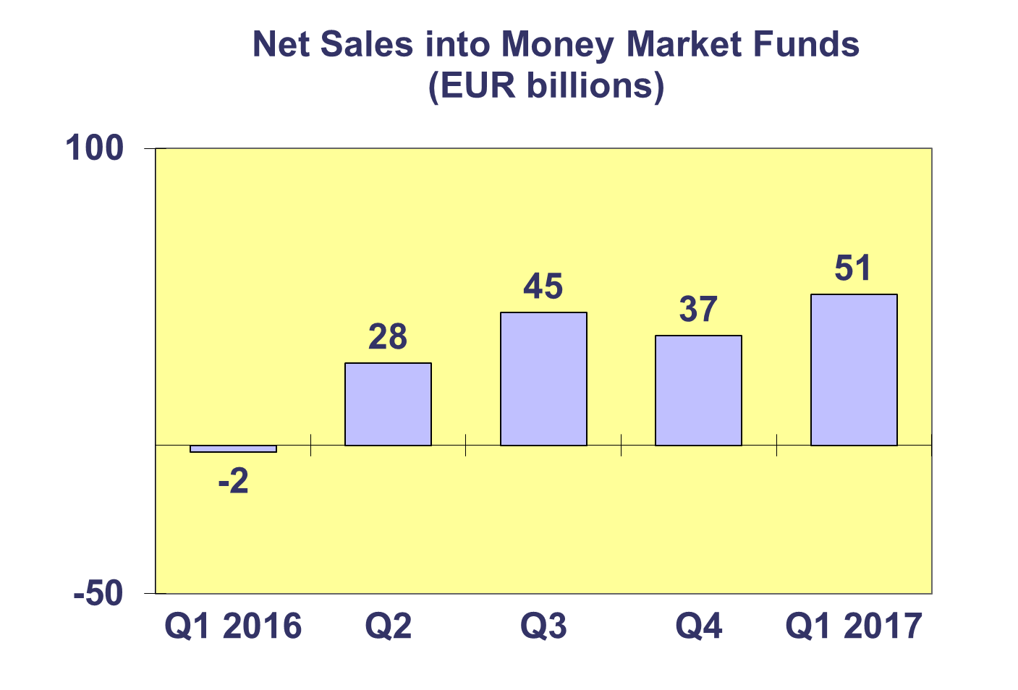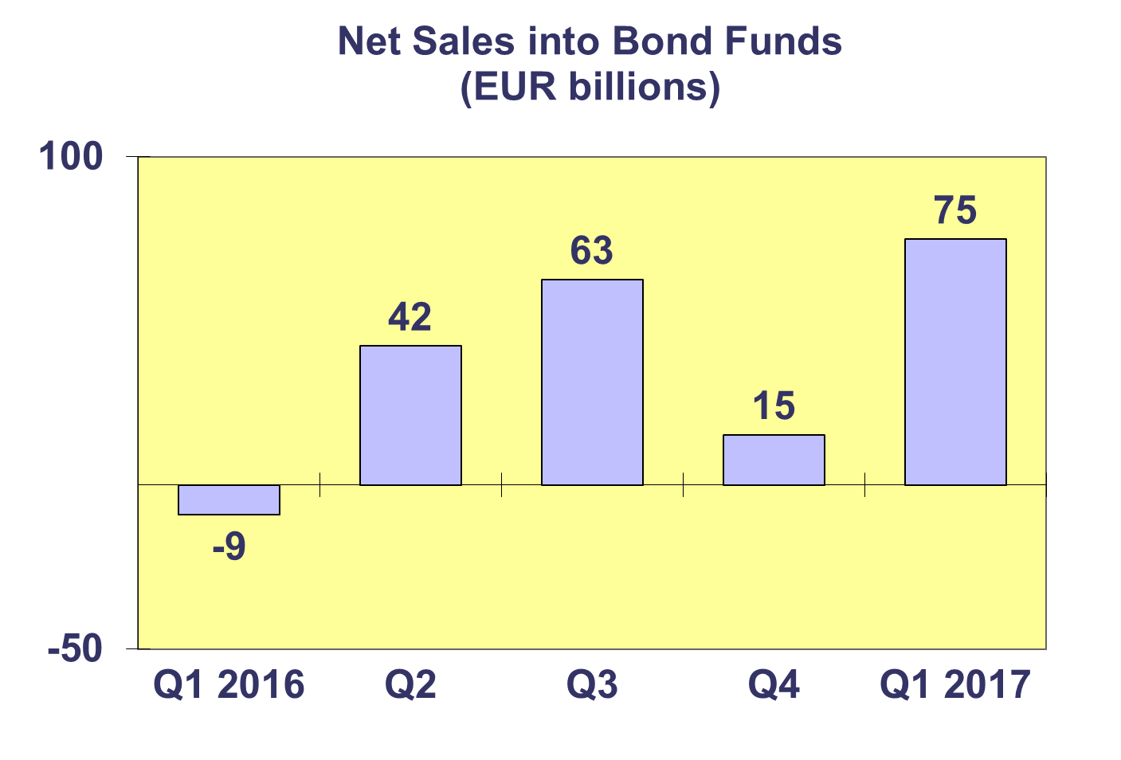**Trends in the UCITS Market**

***Net Sales by Country of Domiciliation and Investment Type***

**Twenty-four countries registered net inflows into UCITS in the first quarter of 2017, with eleven countries recording net inflows above EUR 1 billion.**

Among the largest UCTIS domiciles, Luxembourg attracted net sales of EUR 62 billion in Q1 2017, driven by strong net inflows into bond funds (EUR 24 billion) and multi-asset funds (19 billion). Ireland experienced net inflows of EUR 55 billion, mainly due to strong net inflows into bond funds (30 billion). France recorded net sales of EUR 48 billion, primarily due to net inflows into money market funds. The UK attracted net inflows of EUR 14 billion while Germany recorded net inflows of EUR 5 billion.

Strong net inflows into UCITS funds were also seen in Spain (EUR 6 billion), Italy (EUR 3 billion), Norway (3 billon), Switzerland (2.5 billion) and Sweden (2 billion).

**Trends in the UCITS Market**

***Net Sales and Net Assets of ETF by Country of Domiciliation***

**Net sales of UCITS ETF reached EUR 23.6 billion in Q1 2017, compared to EUR 15 billion in Q4 2016.[1]**

UCITS ETF domiciled in Ireland registered the largest inflows during the quarter (EUR 16.7 billion) reflecting the size of their ETF market. France attracted 5.6 billion in inflows.



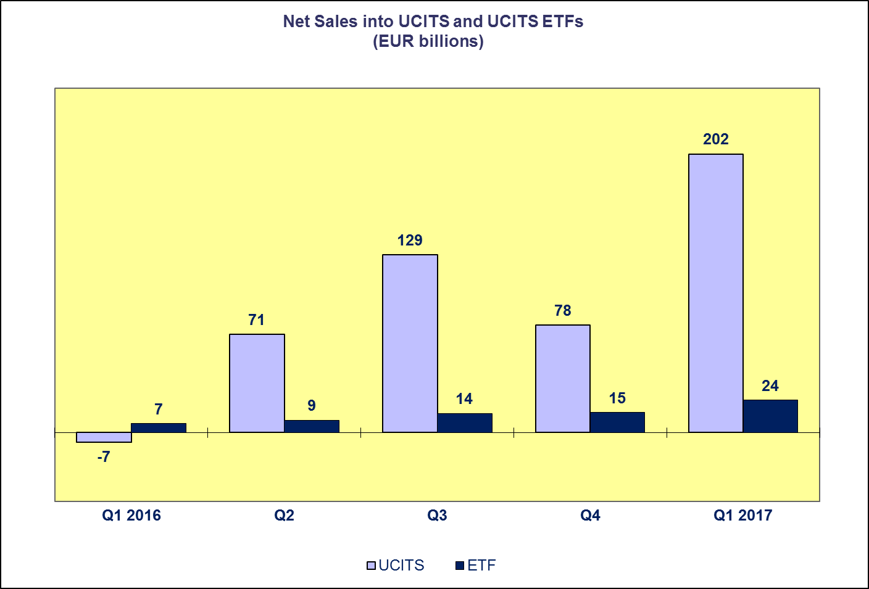**Trends in the UCITS Market**

***Net Assets by Investment Type***

**UCITS net assets increased by 5.2 percent in Q1 2017 to reach EUR 9.112 trillion at end March 2017.**

All categories of UCITS funds experienced an increase in net assets in Q1 2017, with the exception of guaranteed funds and “other” UCITS funds. Net assets of equity funds increased by almost 9% to reach EUR 3,467 billion in Q1 2017. Multi-asset funds increased 7.4% to EUR 1,567 billion in Q1 2017. Bond funds and money market funds follow in this ranking, increasing 5% and 4.1% respectively.

The number of UCITS funds increased from 30,671 at end 2016 to 30,970 at end Q1 2017.



**Trends in the UCITS Market**

***Net Assets by Country of Domiciliation***

**The vast majority of domiciles recorded net asset growth in Q1 2017 as net assets of UCITS reached EUR 9,112 billion at end March 2017.**

All major domiciles recorded net asset growth in the first quarter of 2017. Net assets of UCITS funds domiciled in France increased by 8 percent, followed by the United Kingdom (6.3%), Ireland (5.7%), Germany (5%), Luxemburg (4.5%).

The Nordic countries also experienced net asset growth in Q1 2017: Sweden (5.6%), followed by Norway (5%), Finland (3.1%), Denmark (1.6%). In Southern Europe, the largest net asset growth was seen in Portugal (11.5%), followed by Malta (5.8%), Cyprus (5.6%), Spain (5.1%), Italy (2.2%) and Greece (1.9%). Increases in net assets were also seen in Central and Eastern Europe, with the largest increase in Hungary (85.1%).

**Trends in the AIF Market**

***Net Sales by Investment Type***

**AIF recorded net inflows of EUR 60 billion during Q1 2017, up from EUR 42 billion in the last quarter of 2016.**

Long-term AIF recorded net inflows of EUR 59 billion, up from net inflows of EUR 40 billion in Q4 2016. Net sales of equity funds decreased slightly from net outflows of EUR 5 billion in the last quarter of 2016 to EUR 7 billion in the first quarter of 2017. Net sales of multi-asset funds decreased from EUR 16 billion in Q4 2016 to EUR 13 billion in Q1 2017. Bond funds finished the quarter at EUR 11 billion, up from net outflows of EUR 2 billion in the previous quarter. Net sales of other funds increased from 25 billion in Q4 2016 to 35 billion for this quarter.

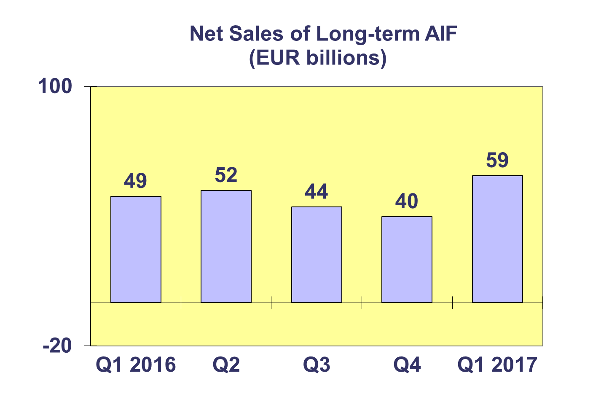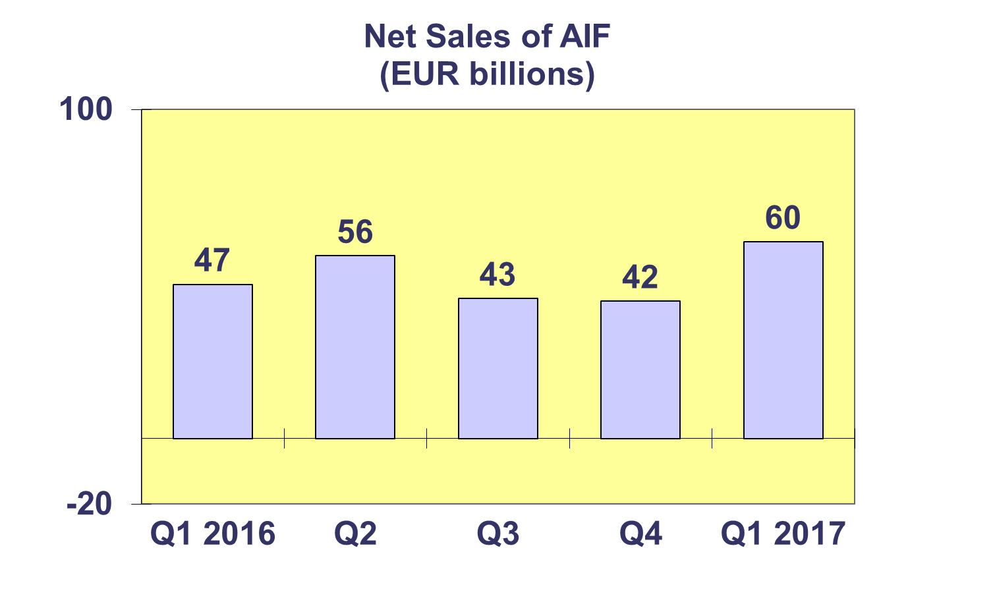

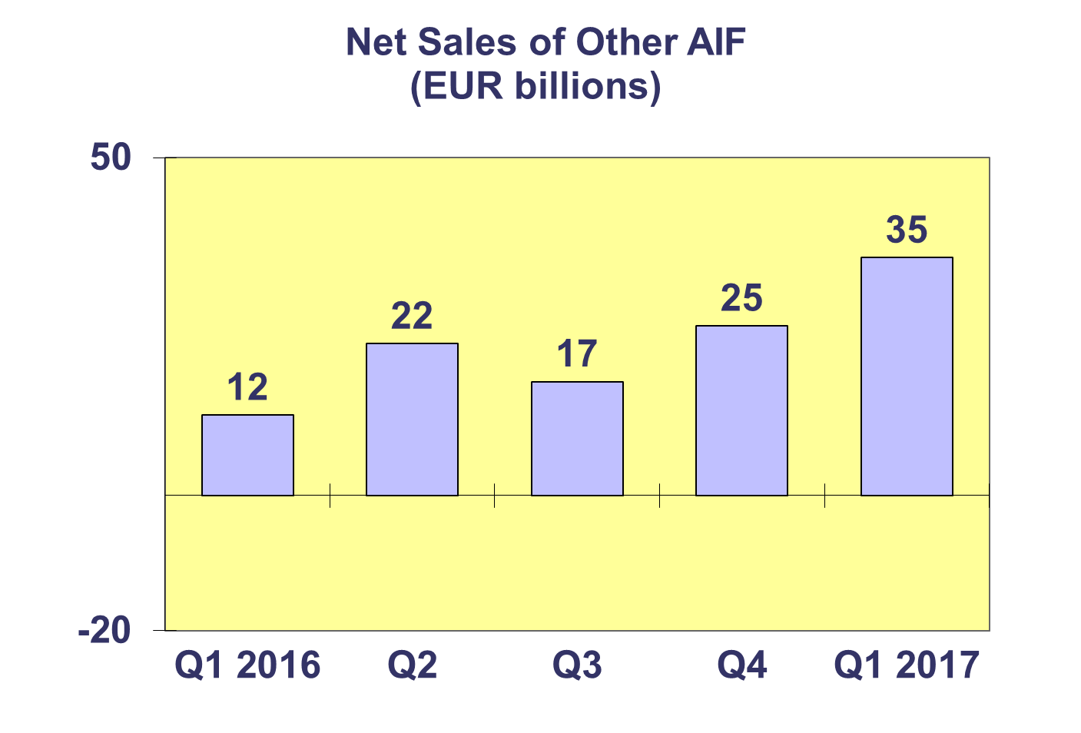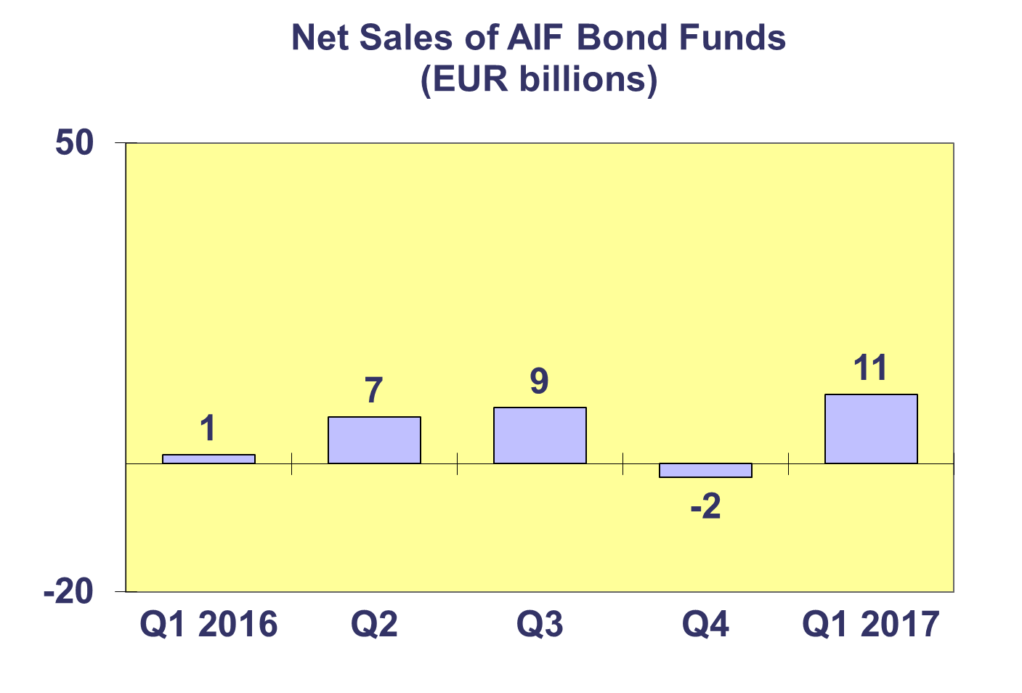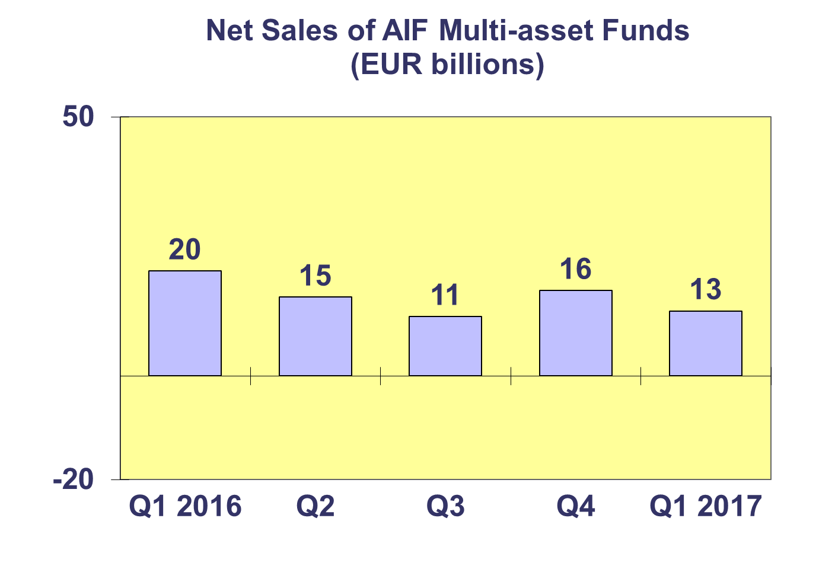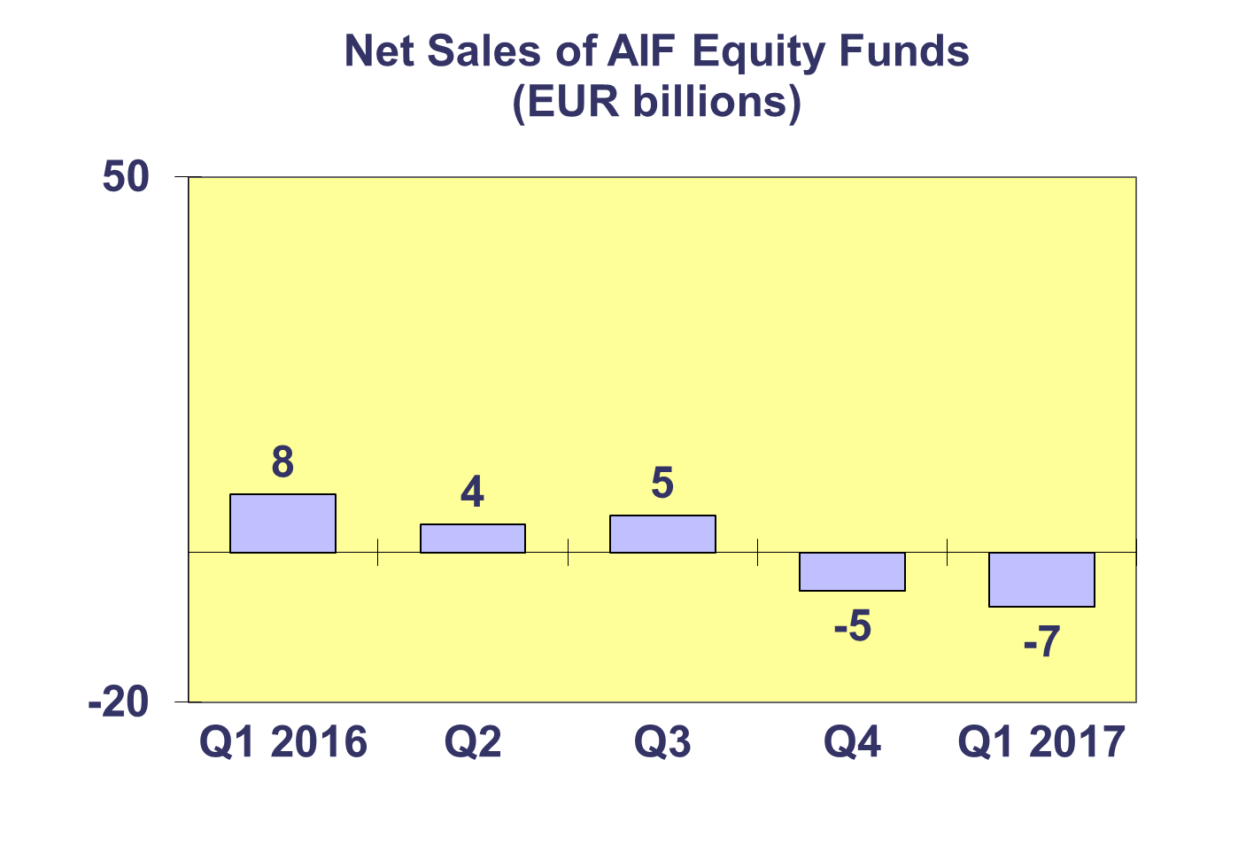**Trends in the AIF Market**

***Net Sales by Country of Domiciliation and Investment Type***

**Net sales of AIF totaled almost EUR 60 billion in Q1 2017, compared to 42 billion in Q4 2016.**

All categories of AIF funds registered positive net inflows during Q1 2017, except equity funds which registered net outflows (EUR 7 billion).

Fifteen countries experienced net inflows into AIF in Q1 2017, with six countries recording net inflows higher than EUR 1 billion. Of the largest AIF domiciles, net inflows above EUR 1 billion were registered in Germany (EUR 26 billion), Ireland (EUR 17 billion), Luxembourg (EUR 13 billion) and France (7 billion). Elsewhere in Europe, net sales greater than EUR 1 billion were recorded in the United Kingdom (EUR 1.7 billion) and Switzerland (EUR 1 billion). Large net outflows were also registered in the Netherlands (EUR 6 billion) and Denmark (EUR 1.6 billion).

**Trends in the AIF Market**

***Net Assets by Investment Type***

**Net assets of AIF increased by 3.7 percent to EUR 5,684 billion at end March 2017.**

In Q1 2017, all categories of AIF recorded net asset growth. Equity funds recorded the largest growth (6.6%), followed by in guaranteed/protected funds (5.7%), multi-asset funds (5.2%), real estate (2.1%), bond funds (2 %) and money market funds (1.6%). Net assets of other AIF, which include AIF funds for which no breakdown according to the underlying fund categories is available, grew by 3%.

There were 28,270 AIF funds at end Q1 2017, compared to 27,938 at end 2016.



**Trends in the AIF Market**

***Net Sales and Assets of Institutional AIF***

**Net assets of institutional AIF, which are AIF reserved for institutional investors, increased 1.9% to EUR 2,687 billion at end Q1 2017.**

Net assets of institutional equity funds increased 6% to finish the quarter at EUR 223 billion. Institutional multi-asset fund net assets increased by 1.2% to reach EUR 994 billion. Net assets of institutional bond and money market funds grew moderately by 0.4% to EUR 572 billion and 9 billion respectively. Real estate fund net assets increased 3.7% to EUR 166 billion. Other institutional funds experienced net asset growth of 7.5% to reach EUR 292 billion at end Q1 2017.

Institutional AIF recorded net sales of EUR 38 billion in Q1 2017, lower than Q4 2016 (EUR 45 billion).



**Trends in the AIF Market**

***Net Assets by Country of Domiciliation***

**Net assets of AIF increased 3.7 percent during the first quarter to EUR 5,683 billion at end March 2017.**

The five largest domiciles all recorded net asset growth in Q1 2017, with the largest growth in Luxemburg (10.8%), followed by Ireland (6.1%), France (3.3%), Germany (2.3%) and the Netherlands (1.3%). Elsewhere in Europe, net assets grew strongly in Poland (10.8%), Sweden (9.6%), Czech Republic (8%) and Belgium (7.1%). The largest decreases in net assets were seen in Malta (4.5%) and Portugal (1.9%).



**Trends in the European Investment Fund Industry**

***Net Sales by Investment Type***

**The combined net sales of the investment fund market in Europe, i.e. the market for UCITS and AIF, recorded net inflows of EUR 262 billion during Q1 2017, compared to EUR 120 billion in the last quarter of 2016.**

Equity funds saw an increase in flows, registering net inflows of EUR 22 billion in Q1 2017 compared to EUR 8 billion in Q4 2016. Net sales of bond funds leaped from EUR 13 billion in Q4 2016 to EUR 86 billion in Q1 2017. Net sales of multi-asset funds totalled EUR 50 billion in Q1 2017, up from EUR 26 billion in the previous quarter. Net sales of money market funds increased from EUR 39 billion in the previous quarter to EUR 52 billion in Q1 2017. Net sales of other funds (including real estate, guaranteed/protected funds and other funds which do not fit any of the categories below or for which information is not available) totalled EUR 52 billion, up from EUR 34 billion last quarter.

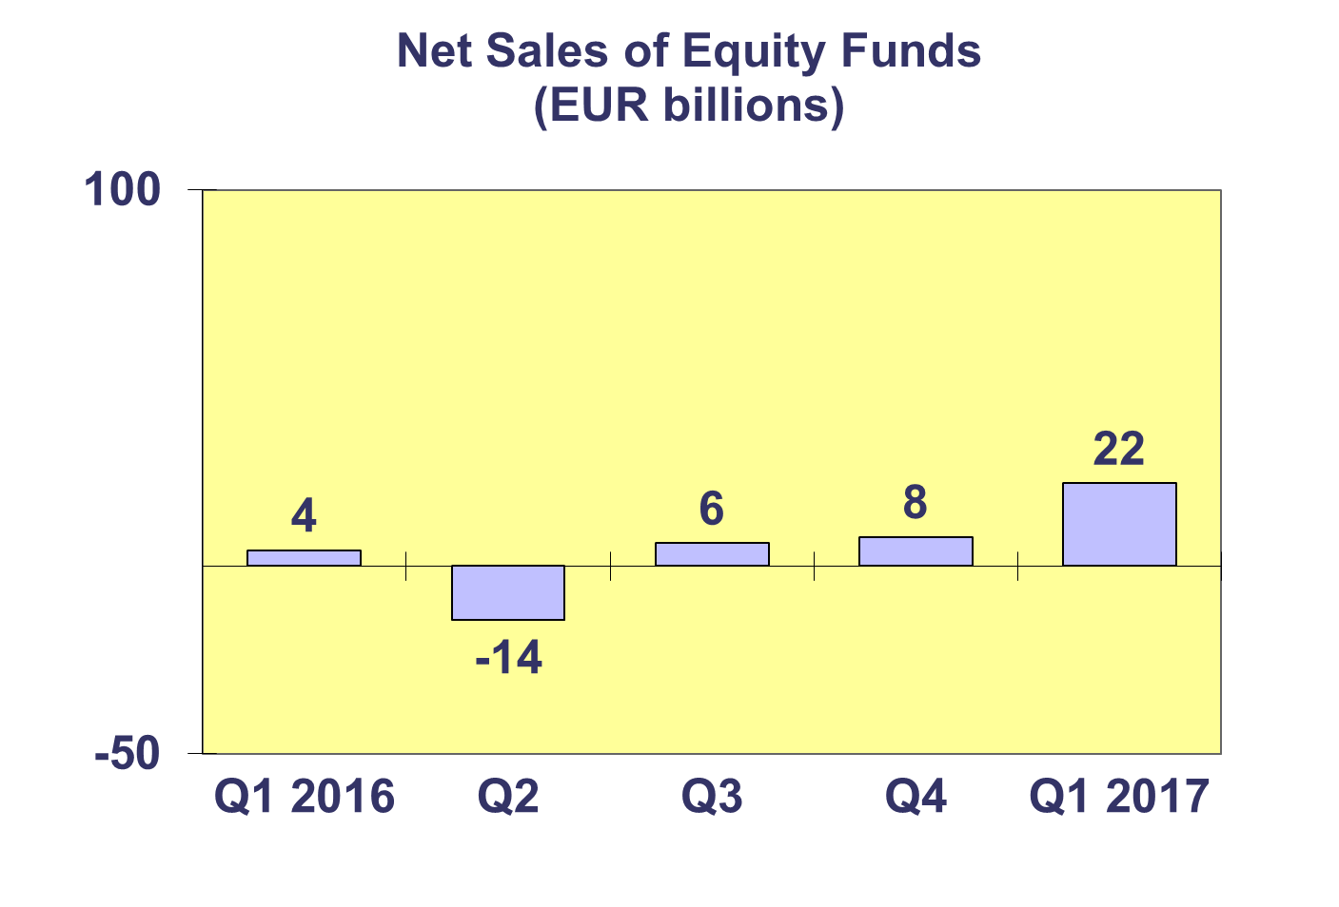

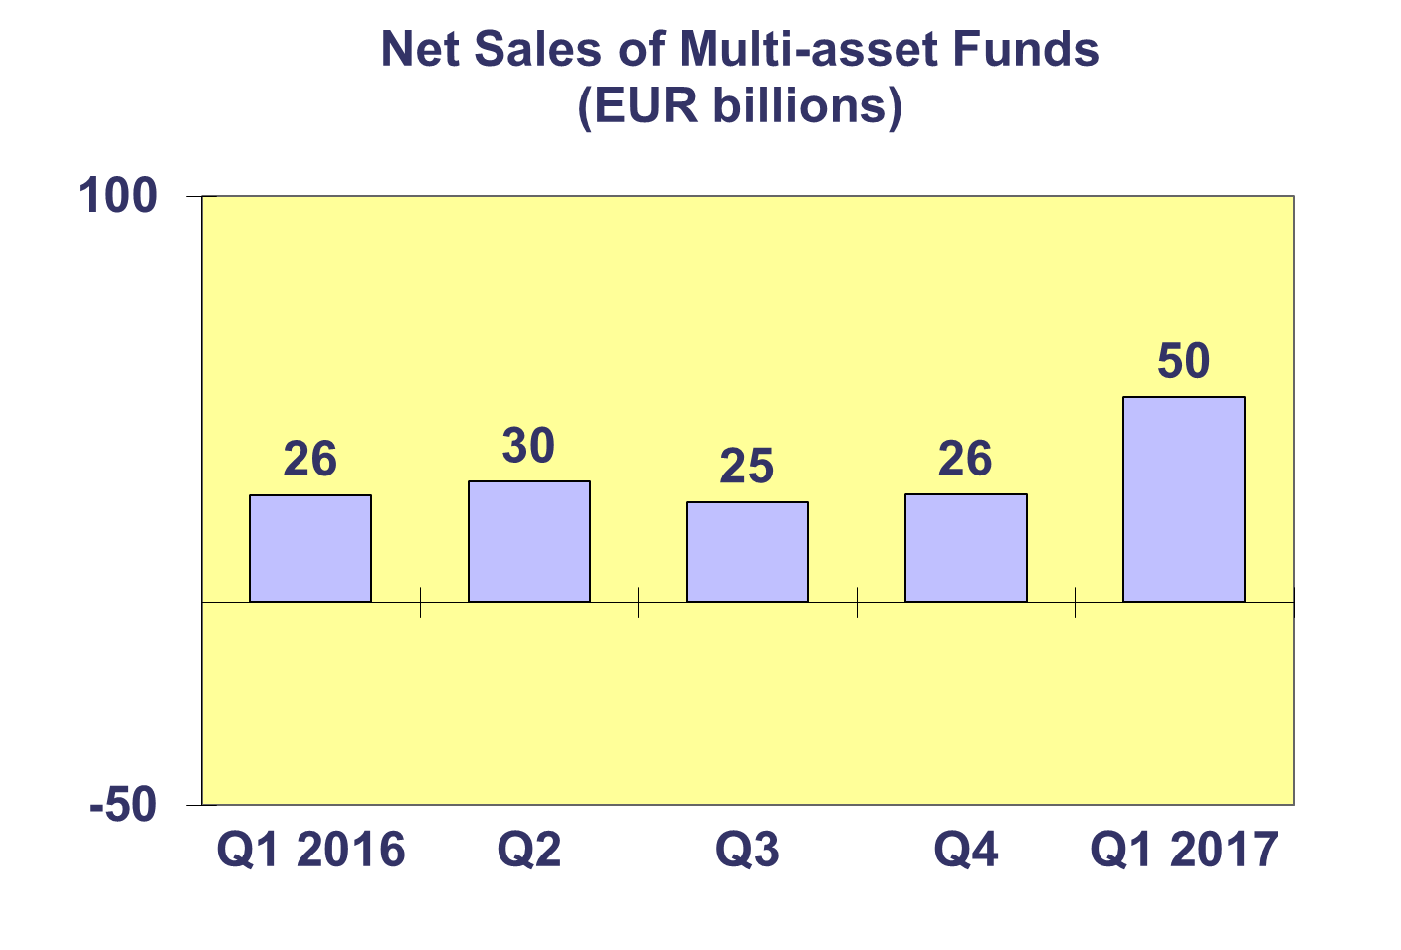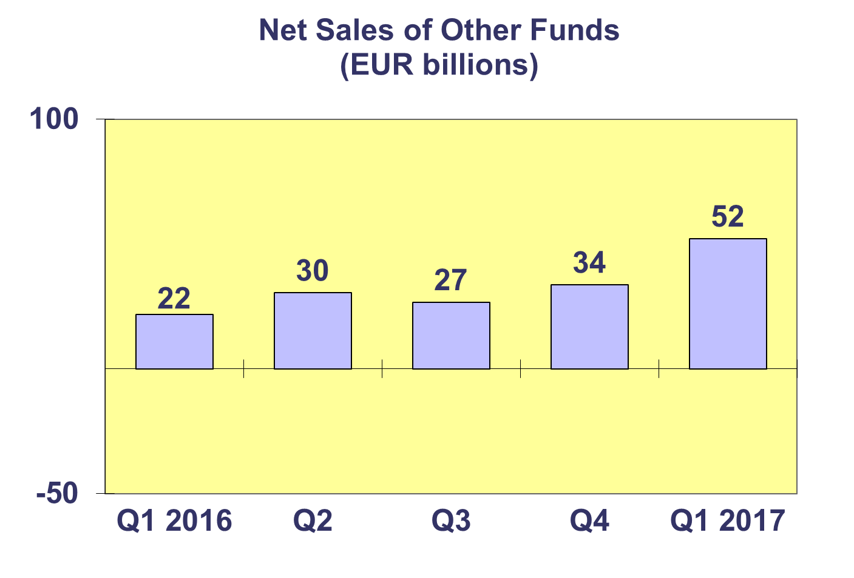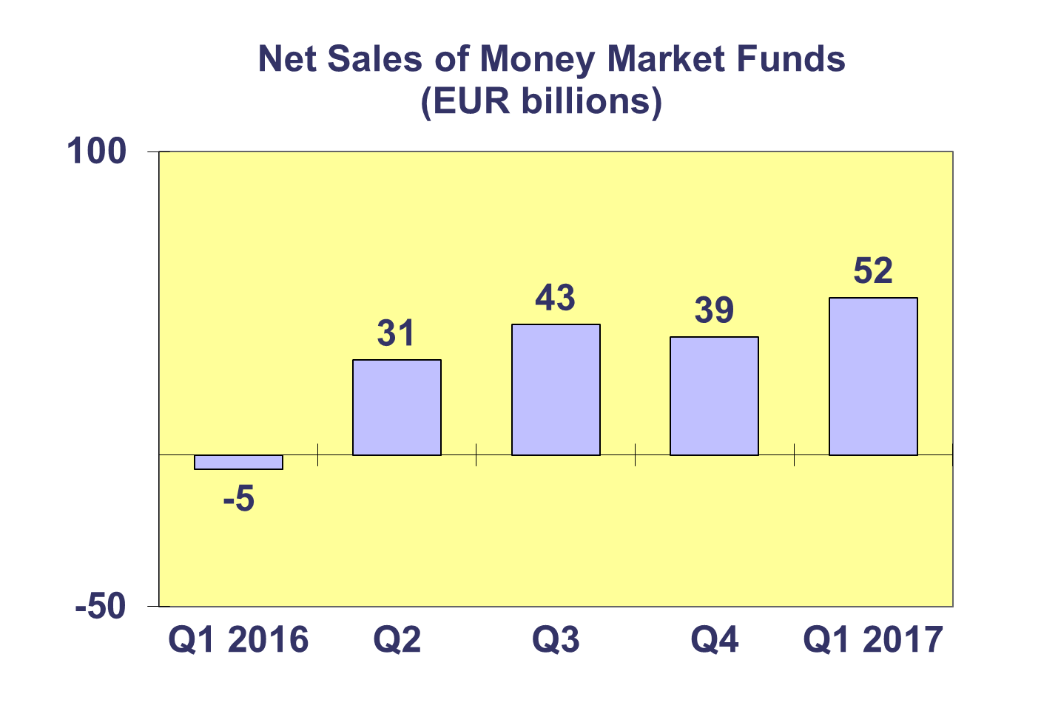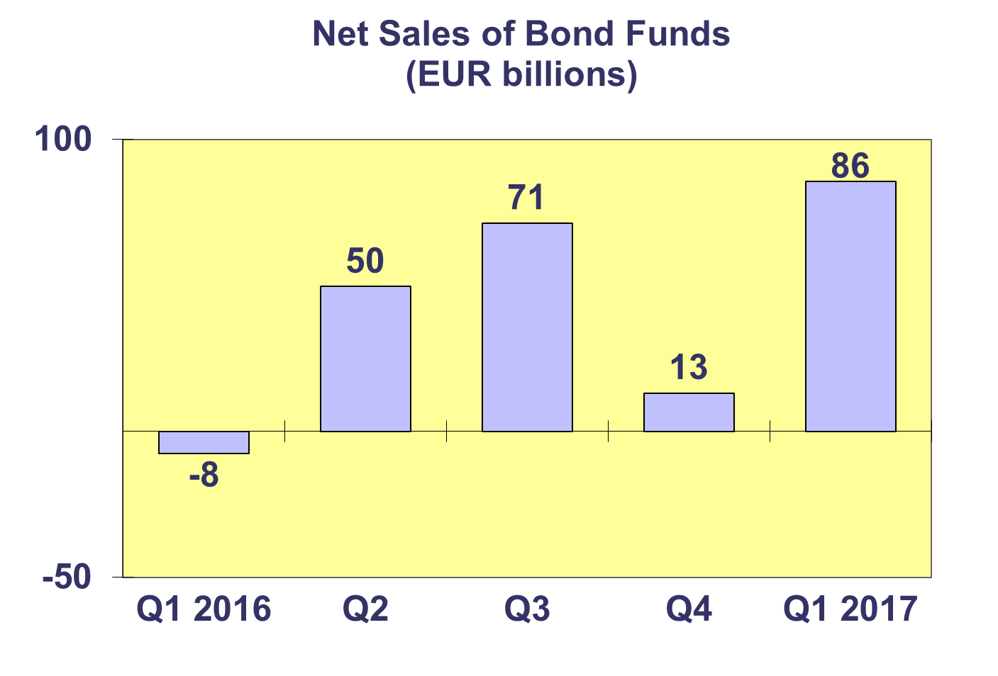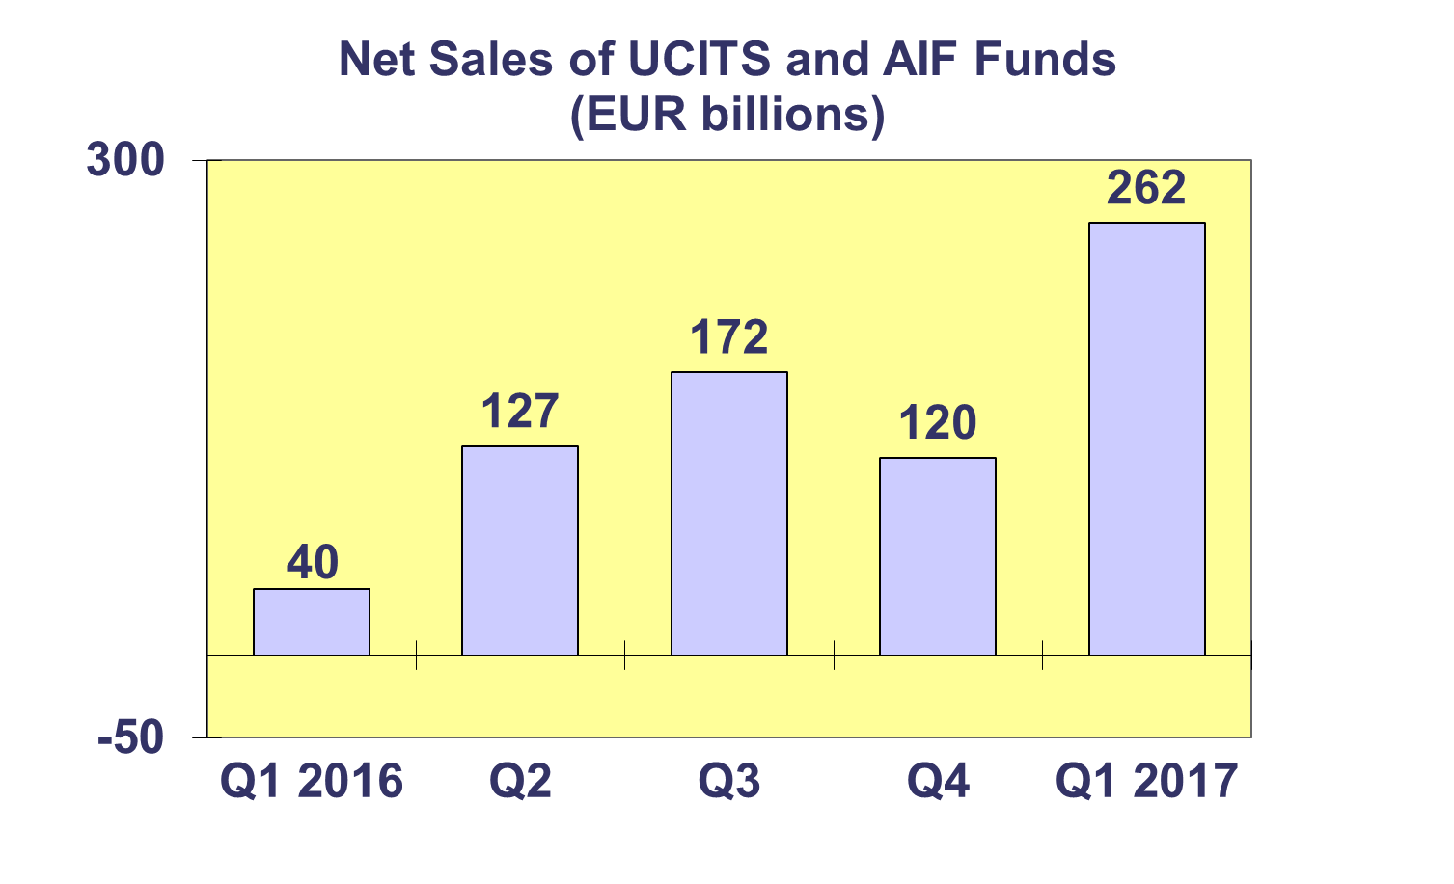**Trends in the European Investment Fund Industry**

***Net Assets by Country of Domiciliation***

**Net assets of the European investment fund industry increased by 4.6% to EUR 14,795 billion at end Q1 2017.**

With EUR 9,112 billion invested in UCITS, this segment accounted for 61.6% of total European investment fund assets at end Q1 2017, with the remaining 38.4% (or EUR 5,684 billion) coming from AIF.

**Trends in the European Investment Fund Industry**

***Number of Funds by Country of Domiciliation***

**In Q4 2017, the total number of UCITS and AIF funds increased by 1.1% to 59,240.**

At the end of the first quarter of 2017, UCITS accounted for 30,970 funds or 52.3% of the total number of European funds, while AIF accounted for 28,270 funds (47.7%).



1. Please note that this data does not include net sales of UCITS ETF domiciled in Luxembourg.